THE KIDNEY CENTRE
Post Graduate Training Institute

PROFILE

A group of dedicated volunteers are responsible for the establishment of the first hospital in Pakistan specializing in the treatment of all kidney related diseases under one roof.

The goal of this 100-bed, not-for-profit hospital situated in the heart of the teeming city of Karachi, is to provide treatment of kidney related diseases free of cost to all poor patients who are many, in a developing country like Pakistan. It is also worth mentioning that there is a high incidence of renal disease in our country.

Work on this community service project began in 1985 and as soon as was possible, a small dialysis unit with just two machines was set-up, while construction of the rest of the building was still in progress. Now 18 years later, it is an up-to-date medical facility providing comprehensive renal care to thousands of the poor Pakistanis. The Kidney Centre has been a centre of excellence in caring for patients with renal ailments be it Nephrological or Urological. We have already established kidney transplantation facilities and are providing training to doctors in post graduate disciplines of Nephrology and Urology at the hospital, both of which were our primary targets since inception.

The Kidney Centre to-day provides 24 hours service in Emergency care and Diagnostics. This hospital offers the following facilities:

Operation Theatre

Four fully equipped operation theatres catering for all types of urology procedures (general urology, endo-urology, neuro-urology, reconstructive urology, prostatic disease surgery, urethral stricture, erectile dysfunction and live related ethical transplantation).
Number of Beds
100 beds inpatients facility.
Emergency
24 hours Emergency facility with ten beds and two emergency Dialysis machines.
Lithotripsy
Non invasive technique for kidney stone removal.
Diagnostics
24 hours facility for all pathological and histopathological tests including X-ray, state-of-the-art CT Scan, ultrasound and Color Doppler.
Dialysis Unit
Round the clock maintenance dialysis facility with 32 state-of-the-art Dialysis stations. The Kidney Centre is the largest maintenance dialysis facility in Pakistan.
Pharmacy
24 hours Pharmacy.
OPD & Consultant Clinic
Free Filter clinics are held in OPD from Monday to Friday. Patients are examined and initial diagnostics undertaken to ascertain nature of illness. Patients with kidney ailments are referred to consultants.
ICU
Fully equipped ICU with exclusive Dialysis machine; monitor for each bed and four ventilators.
Cardiology Unit
For kidney patients having cardiac problems.
Physiotherapy Unit
For dialysis patients needing physiotherapy.
Gastro-enterology Unit
For dialysis patients having liver and gastro-intestinal disease.
Nutrition
Qualified Dietician is available for nutritional advice assessment and management.

Budget

Description | PER PATIENT |  | For 100 Patients
Description | Per Month | Annually (Rs) | Annually
- Each Bicarb Dialysis @ Rs. 2255/- x 13 dialysis per month (average) | 29,315/- | 3,51,780/- | 35,178,000/-
- Inj. Erythropoietin @ Rs. 3230/- | 3230/- | 38,760/- | 3,876,000/-
- Routine Laboratory test Rs. 1000/- | 1000/- | 12,000/- | 1,200,000/-
- Routine Medicines Rs.1000/- | 1000/- | 12,000/- | 1,200,000/-
Total (in Pak Rupees) | 34,545/- | 4,14,540/- | 41,454,000/-
Total (in US Dollars) | US$ 575.75/- | US$ 6,909/- | US$ 6,90,900/-

Hence, Annual Cost of Dialysis of 100 patients | US$ 6,90,900/-
11% Transaction fee | US$ 75,999/-
TOTAL AMOUNT REQUESTED | US$ 7,66,899/-

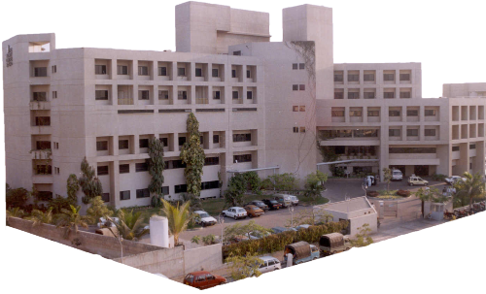

Front view of the Kidney Centre Post-Graduate Training Institute Karachi, Pakistan

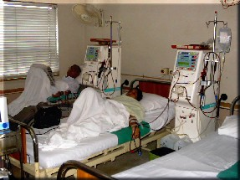
Dialysis being carried out on an end-stage-renal-disease patient in dialysis hall. The dialysis hall came up in 1989.
MAIN DIALYSIS HALL
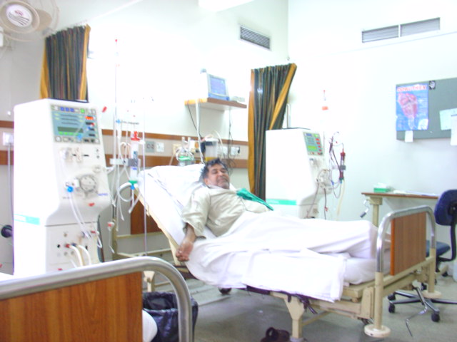
Emergency dialysis being carried out in Emergency Department
EMERGENCY DEPARTMENT

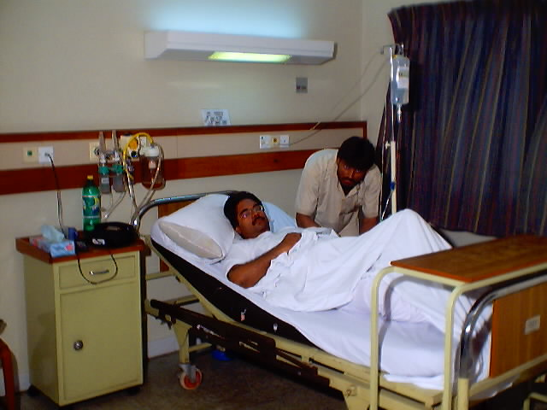
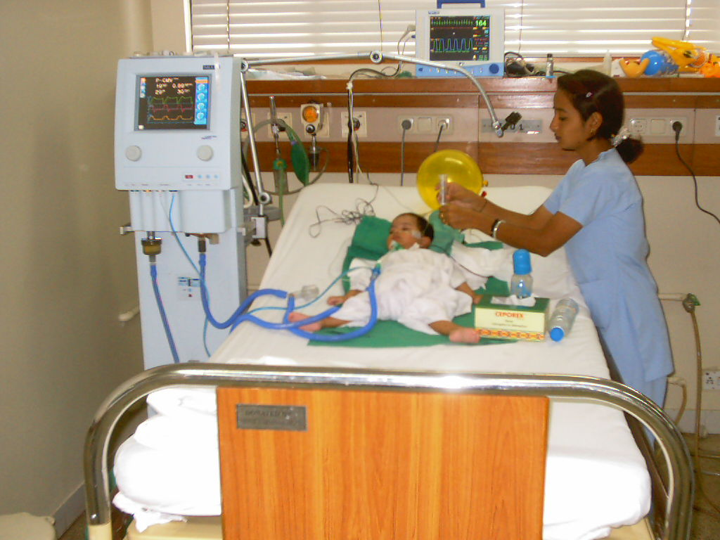
Patient admitted in adult ward
GENERAL WARD (ADULTS)
Paediatric patient under treatment in ICU
INTENSIVE CARE UNIT

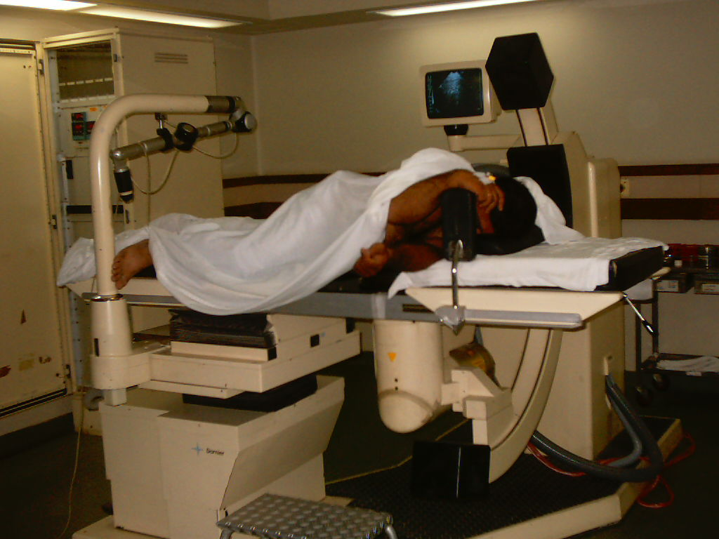
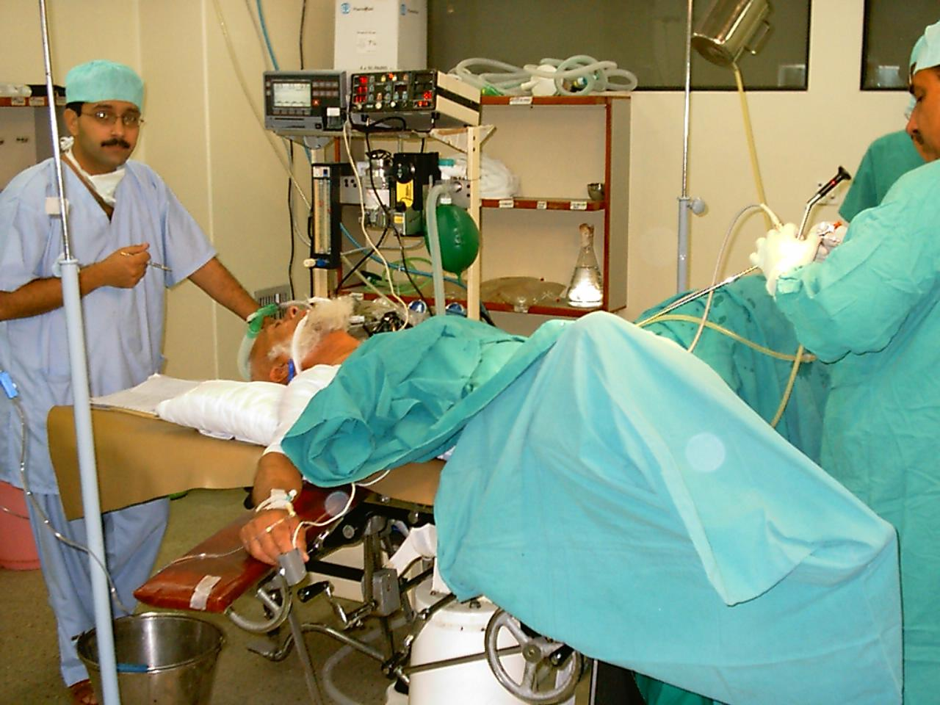
.Lithotripsy being performed in Lithotripsy department
LITHOTRIPSY DEPARTMENT
Patient being operated upon for prostate removal in Operation Theatre (3rd floor)
OPERATION THEATRE

