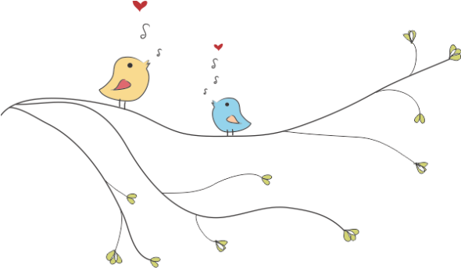
Sound for Silence NPC
Registration number: 2012/186373/08
www.soundforsilence.org ▪ Promed Building, 73 Fontein Street, Ficksburg, 9730

- INTRODUCTION
- 17 babies with hearing loss are born in South Africa every day - 2 of these babies in private hospitals and 15 in public hospitals.
- Only 14% of private hospitals and less than 1% of public health care facilities in South Africa offer a hearing test for every baby after birth.
- That means that most children with hearing loss born in South Africa will only be diagnosed when they are toddlers (some are even older), because of the lack of universal infant hearing screening programmes.
- These children will NEVER have the same opportunities for development, education or applying for jobs as adults as their normal-hearing friends and friends with hearing loss who were diagnosed as small babies.

- WHO WE ARE
Sound for Silence is a brand new exciting organization passionate about children with hearing loss and providing audiological services to the children with hearing loss and their families in the rural areas.
We are strong believers that early hearing detection and intervention (EHDI) services for children with hearing loss are of utmost importance in providing these children with equal opportunities for optimal development comparable to those of their normal-hearing peers.
We feel even more strongly that EHDI services should be comparable to international standards and accessible for ALL children with hearing loss, especially those living in the rural areas.
We aim to raise funds to establish EHDI programs in the rural areas of South Africa, where the biggest need for these services are.
We are registered as a non-profit company, and are in the process of registering as a non-government organization and public benefit organization, in order to raise funds for our mission.

- WHERE IN THE WORLD ARE WE?
We are very privileged to live and work in one of South Africa's most beautiful areas, the Eastern Free State, which is situated in central South Africa, right on the border between South Africa and Lesotho.
Our area falls under the Setsoto Municipality, which governs the towns of Ficksburg, Clocolan, Senekal and Marquard. The town of Ficksburg is the main administrative town in this area, with a population of about 8 307 (Census 2010). It is an important agricultural area where crops like corn, sunflowers, cherries, and asparagus are grown. There are four primary healthcare clinics in Ficksburg and its adjacent township (Meqheleng), as well as a district hospital. The nearest secondary regional hospital is inBethlehem, roughly 100km to the northeast, and the nearest tertiary hospital (which is THE ONLY hospital in the Free State province which offers diagnostic audiological services for children under 4 years of age) is in Bloemfontein, approximately 200km to the west.

- THE PROBLEM
Children with hearing loss born in the rural areas of South Africa face a bleak future in the absence of EHDI services. Not only are their chances of early identification next to nothing, but should they get diagnosed by some sort of miracle, access to services in bigger towns and cities are severely limited due to poverty and lack of resources and infrastructure. If a parent and child are reliant on the public healthcare sector, a routine appointment with an Ear, Nose and Throat specialist may turn into a three-day excursion, of which they have to spend the nights in the waiting room of the nearest regional hospital (100km from our area), waiting for the public transport to take them to the tertiary hospital (another 200km away from our area) the next morning and vice versa.
Furthermore, due to lack of manpower, the specialist services at the tertiary hospitals (including Audiology, Paediatrics, and Ear-, Nose and Throat services) are way overbooked, and a four-month old infant referred from our screening programme may have to wait 5 to 6 months for a diagnostic audiological work-up at the tertiary hospital.

- WHAT WE’VE BEEN DOING SO FAR…
An independent infant hearing screening pilot project in 2009 at two of the four primary healthcare clinics were conducted, where every baby under a year that attended the weekly immunization day at the clinic for the duration of 2009 were screened. Certain obstacles and flaws in the service delivery system were identified, and in June 2012 we have launched a NEW and IMPROVED universal infant hearing screening programme at all four primary healthcare clinics in our area, based on the results from the pilot project.
The new rural infant hearing screening project (RIHS Project)
So in June 2012, we've launched our new rural infant hearing screening project (promptly named the RIHS Project) after we've carefully considered the flaws and obstacles observed in the pilot project, namely:

- That we had to drastically improve our return rate of infants who come back for the second screen.
- That we had to reduce the number of infants referred for medical attention.
- That the majority of people in our area are unable to afford the extra expenses accompanying hearing loss, for example hearing aids, travelling costs to Bloemfontein, batteries, earmoulds, repairs, etc.
These issues were addressed by only screening those infants receiving their 6- and 10-week immunizations, so that we have at least one more chance (at their 14-week immunization) if they need to come back for a second screen. The prevalence of middle ear disorders in this age group is also very low, therefore the referral rate for medical attention is also kept at a minimum. So far, it's been proved to work like a bomb.
Here are some of our initial statistics:
- From June 2012 to July 2013, we have screened 544 babies.
- 60 of these babies were referred for a follow-up screen at the clinic.
- 40 of these babies came back for follow-up (71% return rate).
- 1 infant was referred for a diagnostic hearing test, and presented with bilateral hearing loss.
- 2 infants were referred for diagnostic assessments, and we are still awaiting the results.

- THE PLAN
First of all, we would like to expand our universal infant hearing screening programme to include the primary healthcare clinics in the other towns of the Setsoto Local Municipality - 2 clinics in Clocolan, 3 clinics in Senekal, and 3 clinics in Marquard.
Then we would like to establish a diagnostic facility in Ficksburg where children referred from the screening programme can receive a full diagnostic audiological work-up, as well as follow-up appointments such as hearing aid fittings, hearing aid verifications and validations. Free of charge.
We would also like to establish an auditory-verbal parent guidance programme, which will provide these families with weekly parent guidance sessions as well as weekly and bimonthly support groups.
We also want to conduct ethically sound, culturally appropriate and area-specific research regarding rural children with hearing loss, in order to improve our service delivery and to contribute towards the body of research in the field of paediatric audiology.
Finally, we would like to establish a fund from which hearing aids, FM systems and cochlear implants can be funded if necessary.

