MARY MOTHER OF PEACE-MEDJUGORJE CHARITY, Inc.
8617 Irvington Avenue, Bethesda, MD20817-3603, USA; Tel 1 301 530 5416
Fax 1 301 530 3422; E-mail: mmpcharity@rcn.com ; Web: www.mmpcharity.org
 EIN # 52-2248969; CFC # 7825 

Contacts: Claudine Dussert, Ph.D., President and Bernard Dussert, Treasurer
Working in Partnership for Implementation with the Local Faith-based NGO:

INDIA for Kerala and Tamil Nadu
6F Thadikaran Centre, Palavirattom, Kochi - 682025 Kerala, India; Tel 91 484 309 5859/ 233 8685; Fax 91 484 255 5354; E-mail: manojsunny@jesusyouth.org ; jyglobal@jesusyouth.org
Contacts: Manoj Sunny, International Coordinator, Berly Earnest, Coordinator Relief Activities, Mathew Sebastian, Field Operations Supervisor, and Rev. Fr. Jose Narithookil, Chairman and signing authority.

TSUNAMI RECOVERY PHASE II, SOUTHERN INDIA

Providing post-tsunami help to 250 villagers, 20 urban families and 25 girl students
for livelihoods recovery, home reconstruction, medical care and school enrollment
in Kerala and Tamil Nadu, India.

September 01, 2006
TECHNICAL WORK PROPOSED TO BE FUNDED

Post-Tsunami Recovery
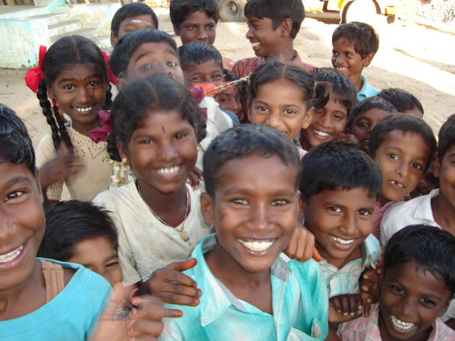
MMP-MC/JY Recovery and Reconstruction Project Southern India

1. Project Objective, Scope, Needs and Target Beneficiaries

Tsunami relief phase is now completed and we are in a post-tsunami phase. As relief gives way to the long and difficult process of reconstruction –implementation and healing take time, project is focusing on specific actions for about 400 poor people to rebuild their life in Chennai and in five tsunami affected villages:

Two at Challanam/Karunagapally and Edavanakad/Pallithodu near Kochi, Kerala;
And three villages at Ambedkar Nagar, Kuppankulam and Pethankuppam near Cuddalore, Tamil Nadu.

God-parenthood is part of this project because experience in 2005 has shown it has a strong impact by helping poor children go back to school and receive medical care on a case by case basis.

Project was designed to complement the actions under way by major NGOs and official aid while avoiding duplication of efforts, and to maximize efficient implementation in well-targeted villages and communes/panchayats as needed.

The geographic scope of project is limited to areas where young local volunteers from Jesus Youth have assessed needs during several weeks after the tsunami, monitored evolving needs over time, and supervised field activities during more than a year (2005/06). The President and Treasurer of MMP-MC visited disaster and project areas in January 2006 after making a personal donation to the Charity to cover their travel cost.

Assessments and supervision are a continuing process and new project data are fine-tuned as we progress in our knowledge of situation and real needs, village by village, and through actions undertaken.

2. Actions include:

(a) Providing household utensils, clean water, food supplements, clothes, medical care, school supplies, 20 sewing machines for young village women at $100 each, a few fishing nets at US$155 each (if needed), and technical assistance/training for livelihoods recovery including women (sub-total of US$4,500) ;

(b) Repairing and rebuilding homes in disaster areas (10 homes at US$2,000 per home);

(c) Protecting and sponsoring children through a God-parenthood program in Kerala and Tamil Nadu (10 children at US$550 per child for a year) and helping orphans (Food and necessities for 20 orphans in Kerala for 10 months: US$5, 000);

(d) helping 25 tsunami-affected girls finish high school in Chennai (St Joseph Shelter in Santhome managed by Ms. Backiamary: US$9,600 for one school year); and

(e) carrying out surgical operations in private local hospitals to save the life of poor children who survived the tsunami, on a case by case basis (US$9,900 for major surgery such as cardiology; US1,000 for minor surgery such as ear, eye). Only minor operations are planned for this project (US$4,000).

Sub-Total estimated cost: US$48,600

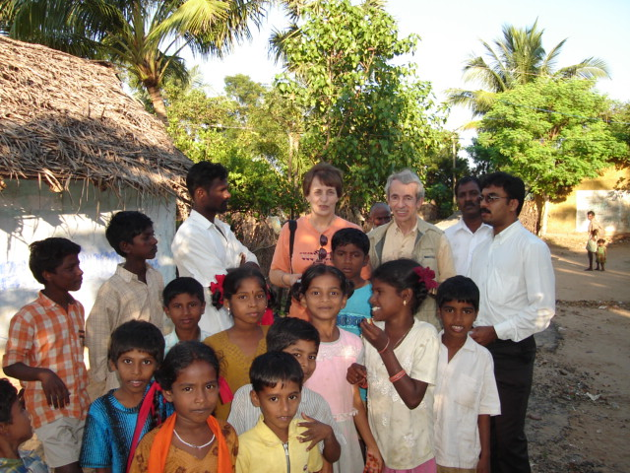 | 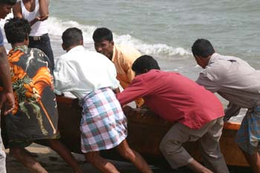

Fishermen have resumed their productive activities to feed their families, which were left with nothing after the tragic devastation of the tsunami. With the first phase of project (emergency relief) completed no more fishing boats are needed. The focus now is therefore on home reconstruction, flood protection work at home and village level, medical/dental care, access to school for tsunami affected girl students and assistance to families in difficulty: clean water supply and electricity connection; food supplements; school tuition; medical assistance; clothing; small equipment such as sewing machines, kitchen utensils, back to school items.

4. Other needs and recovery

Replacing killed livestock for a few families
Dispensary/Hospital support (one selected)
School and orphanage support (one of each, with special focus on protecting children and orphans so that they can heal from the trauma)
Post trauma psychological services (as needed)
Bikes for people living too far from school or work
A few computers including one for the girl students’ house in Chennai

Sub-total estimated cost for other basic needs: US$20,000

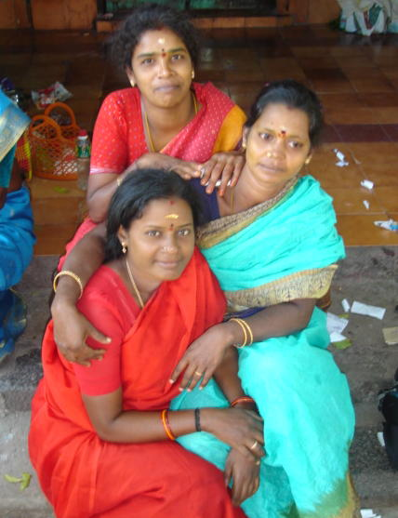 | 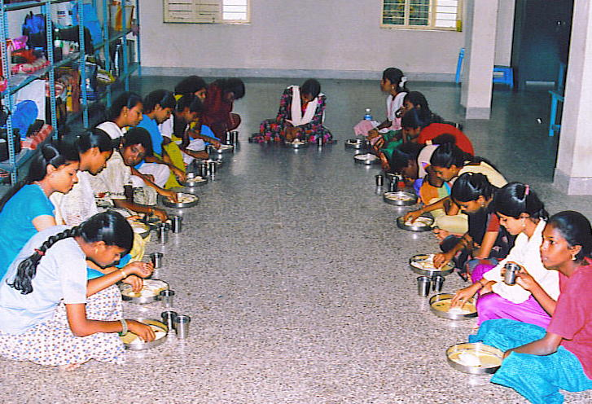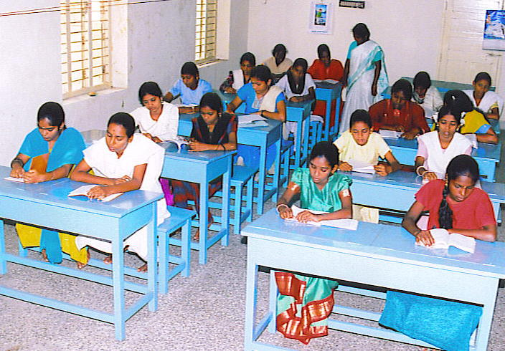

6. Beneficiaries

Poor fishermen families who had nothing left and must feed their families
Orphans and widows
Villagers without houses
Volunteer humanitarian workers helping beneficiaries by responding to urgent situations and needs
Micro-enterprises (encouraging private productive activities and employment)
Farmers and primary rural credit societies
An orphanage, a dispensary/ hospital’ and a primary/ middle school

7. Disbursement/Implementation period

September 2006 to April 2008 (recovery and reconstruction is taking more time than distribution of basic emergency relief supplies; school year is from June to March)

8. Project Management

Project management is done by local volunteers under the supervision of MMP-MC and its local partner JY. Names and contacts are in cover page of this business plan. Depending on funds available over time, project implementation will be phased in gradually, and project scope may be reduced or expanded accordingly.

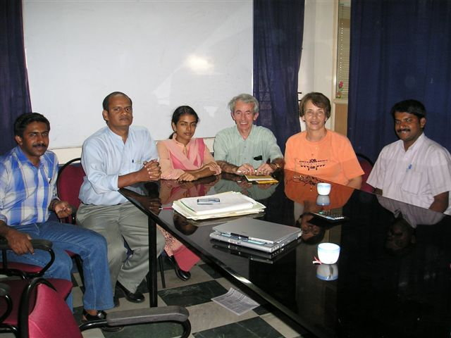

Signature authority for MMP-MC is the President, Dr Claudine Dussert and/or the Treasurer Bernard Dussert. MMP-MC Board members (7 Directors) are unpaid volunteers. Signature authority for JY is Rev. Fr. Jose Narithookil, Chairman.

Financial management of funds received is handled by MMP-MC under the responsibility of its Treasurer. MMP-MC bank account is at Bank-Fund Staff Federal Credit Union, Washington DC, ABA # 2540-7417-0 for credit to Mary Mother of Peace-MC’s Account # 383 610-S8. Transfers to JY in Kochi, India, are made directly through FCNR A/c 2474, South Indian Bank. For more details on MMP-MC and JY please visit Web sites www.mmpcharity.org and www.jesusyouth.org . Thank You. God bless you.

SUMMARY BUDGET

For currency conversion: US$ 1 = 45 Indian Rupees; 100 Indian Rupees = US$ 2.25
US$ 1 = 0.76 Euro; 1 Euro = $ 1.30

Project Estimated Costs are in US$

Home repairs and reconstruction 20,000
Equipment, materials needs/Livelihoods recovery
(including sewing machines, bikes, computers) 14,500
Other needs and recovery (orphans’ support, dispensary,
school, and house for tsunami affected girl students) 23,600
God-parenthood (it includes health care for God-children) 5,500
Project medical program (basic health and surgery) 5,000
Operational local support
(transport, lodging, volunteer expenses) 3,430
Project management (including travel) 8,430

TOTAL COST September 2006/April 2008 80,460

Projected Disbursement Schedule: $10,125 in 2006; $44,600 in 2007; $25,735 in 2008

Budget will be shared among the two regions of Kerala and Tamil Nadu and of the beneficiary villages/urban areas according to needs and funds made available over the 2006/2008 implementation period. Tentatively, budget needed from September 2006 to December 2007 is estimated at US$54,725, i.e. about 67% of total cost. Special grants from private foundations and corporations, and public contributions are envisaged and are sought. Individual benefactors contribute and participate in particular in the God-parenthood program. MMP-MC is a small non-profit organization known for its high standards of financial discipline. The Charity overhead ratio is about 5% or less.

Explanatory Notes on Cost Assumptions:

Costs were estimated by volunteers on the ground during assessment visits in disaster areas in January/February 2005 and are revised on a regular basis. Last revision took place in summer 2006. Unit costs were recouped with data available from the government of Kerala and Tamil Nadu. For currency conversion, the exchange rates above were used. Project costs are updated/ adjusted as necessary in cooperation with local partners and reliable experts and volunteers.

Expected Project Impact

Positive long-term impact is the result of prompt action/funding: when a safe environment is re-created with basic needs--proper housing, clean water, health-- 400 people will live normally again; children will go to school, key for the future. It is essential to ensure that the recovery effort does not exacerbate existing inequities and that all people being helped are on their way to a better and safer development path than they were prior to the tragic tsunami.

The humanitarian assistance NGO MMP-MC, Inc is a mission and faith-based 501 (c) 3 tax-exempt non-profit emergency relief organization helping orphans, homeless children, poor families and refugees of all faiths rebuild their life and improve their living and educational conditions, and regain dignity. MMP-MC financial performance ratio of admin + fund raising cost to total donations received is less than 5%.
Claudine (a former university professor) and Bernard (a World Bank official, ret. and consultant to WB and UN development agencies) live in the Washington DC area. They are the project supervisors, in coordination with Manoj Sunny, Berly Earnest and Mathew Sebastian , and in cooperation with project benefactors.
JY is an international Catholic youth movement born and based in Southern India, and also registered in America. Its special focus is on a God-centered life, prayer, fellowship and actions of charity including humanitarian assistance and emergency relief. JY International Coordinator Manoj Sunny has been invited to a prayer breakfast meeting at the White House in February 2005 and again in 2006.
Two children of tsunami affected fishermen families were operated in 2006: Joseph Enok, one year old, operated in Kochi for heart surgery (major operation) ; Jinsha Babu, 14 year old, for an ear infection, which prevented the girl to hear (minor operation). She is now doing well at school.

