As part of the trip, Kathy selected 5 artisans out of 20 artisans for the summer trip. Selection was done based on merit and how well they’ve incorporated the design instructions provided previously on their pottery. Here is a short bio of the selected:

Guojunhua (Dangzhen Picchu)
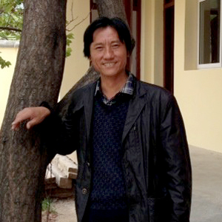
As the leader of the group and spokesman for the community, Dangzhen has been practicing Nixi Black Pottery for 37 years. During the cultural exchange, he looks forward to understanding chemical makeup of the Nixi clay and all the technical elements to be able to speak intelligently about it and teach other potters in the Nixi village. He looks forward to learning everything about foreign arts and US culture. He also wants to test their clay to understand its composition.

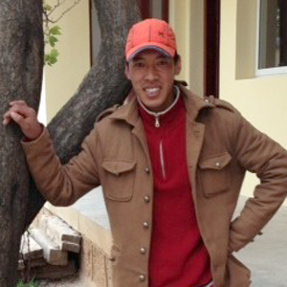
Zhishi Qilin
Zhishi has been practicing Nixi Black Pottery for 14 years. He looks forward to learning different firing techniques, better finishing and how to arrange surface decorations around the pottery in a more interesting way. This cultural exchange is important to him because he'll experience the US culture and apply what he learned to his own work to benefit the entire community.

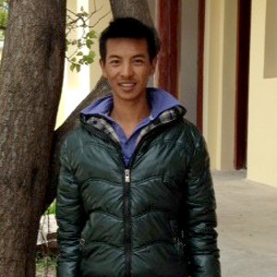
Chuidian
For 12 years, Chuidian has been practicing Nixi Black Pottery. During the cultural exchange, he looks forward to learning new, sustainable and eco-friendly techniques from foreign artists. To Chuidian, experiencing the outside world and meeting new artists will help him share and teach new techniques to younger artisans.

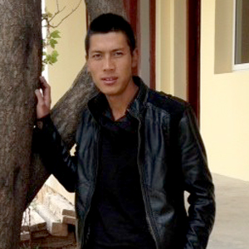
Li Xiao Ming (Yudian)
After finishing three years of higher education, Yudian has been working in his uncle's pottery business for five years. With his schooling, Yudian could have sought work outside the Nixi tradition but he chose to stay in the village which he loves, to help his family continue the ancient practice so he can pass it onto future generations. During the cultural exchange, he looks forward to meeting foreign artists, learning their techniques and how they run their pottery businesses.

Dingzhu
As the youngest of the group at only 18 years old, Dingzhu has been practicing Nixi Black Pottery for three years. He's excited to visit US artisan workshops and museums. During the cultural exchange, he looks forward to learn more about carving and other ways of surface decoration. This experience will help improve his technique, which in turn will help their craft.

