The Current Crisis
As a result of all these assaults, the water in Gaza is polluted with untreated sewage, agricultural chemicals, and it is brackish from seawater. Gaza’s water contains high levels of nitrates, chloride and fluoride, and other pollutants that cause significant health problems, including parasitic infections, kidney disease, heart disease, damage to the nervous system, cancers, weakened bones and teeth and “blue baby syndrome,” a life-threatening type of anemia that primarily affects infants.

After six decades of pressure on a limited water source, diversion of the water for Israeli use, the blockade on supplies to repair and maintain water systems, and military attacks, the quantity of water in Gaza is inadequate and the quality is dangerous.
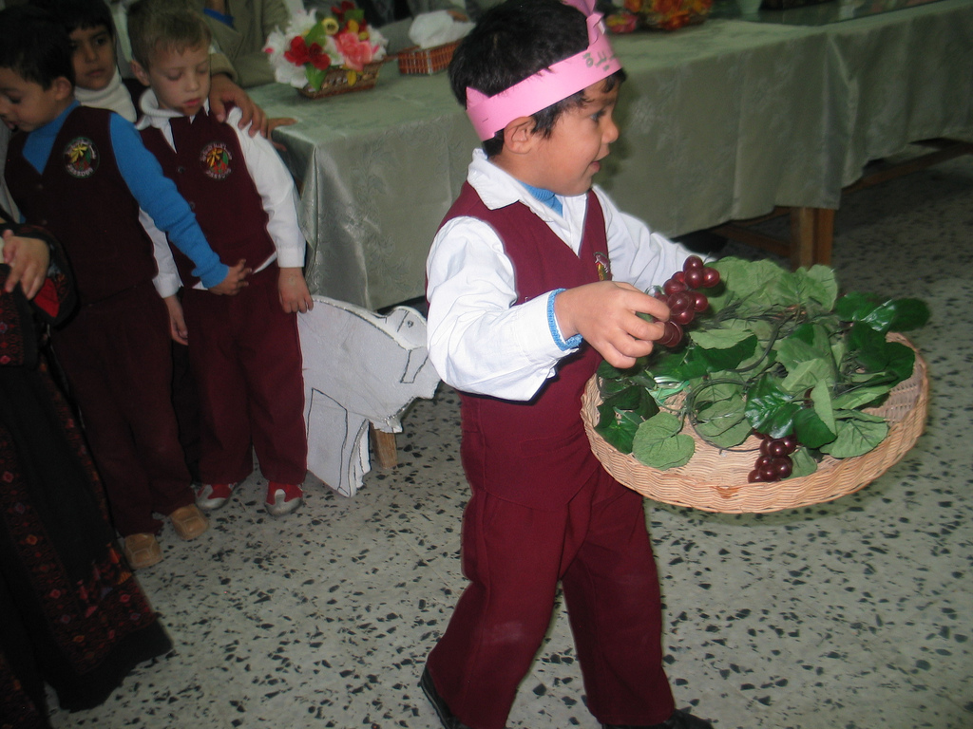
Only a just and lasting political solution will ensure Palestinians’ access to clean, safe water. The Middle East Children's Alliance supports and works for an end to Israeli apartheid and Palestinians’ right to return to their land and control their natural resources. However, our work on the ground is to meet the most pressing and immediate needs of children.

The goal of MECA’s Maia Project is to provide safe, clean, drinking water for tens of thousands of Palestinian children by working in partnership with community organizations to build water purification and desalination units in schools and towns throughout the Gaza Strip. MECA plans to continue the Maia Project until we have installed a unit in each of the 221 UN schools in Gaza refugee camps and hundreds of kindergartens and pre-schools in throughout Gaza.
A boy from Afaq Jadeeda's kindergarten performs at the opening ceremony for the water purification system at Bureij Boys' School. photo: Afaq Jadeeda

Project Background
This project began when the Student Parliament at the UN Boys’ School in Bureij Refugee Camp, Gaza were given the opportunity to hold an election to choose one thing they most wanted for their school: They chose to have drinking water. When MECA’s partner Afaq Jadeeda Association heard about the vote they met with representatives from the school and the Student Parliament, and then came to MECA with the students’ request. MECA provided the funds to build a water purification and desalination unit for the school in 2007, and later decided to make this an ongoing project throughout Gaza. Through the Maia Project, MECA has now funded water units at four additional UN schools in Nuseirat, Beach, and Jabalia refugee camps. The UN schools have morning and afternoon shifts due to overcrowding and each unit provides drinking water for over 2,000 students and staff. We have also funded units for two kindergartens that serve hundreds of young children in the town of Beit Hanoun and in Maghazi Refugee Camp.
Implementation Plan
As MECA raises funds for a new unit at a UN school, the site will be determined by MECA in partnership with community organizations in Gaza, and with input from UNRWA’s Director of Education in Gaza. Our priorities are greatest need, geographic diversity and maintaining a balance between boys and girls schools. Dr. Mona El-Farra and leaders from Afaq Jadeeda Association and Al-Assria Children’s Library will develop the list of kindergartens and pre-schools to receive new units by visiting and meeting with representatives at schools in different areas.
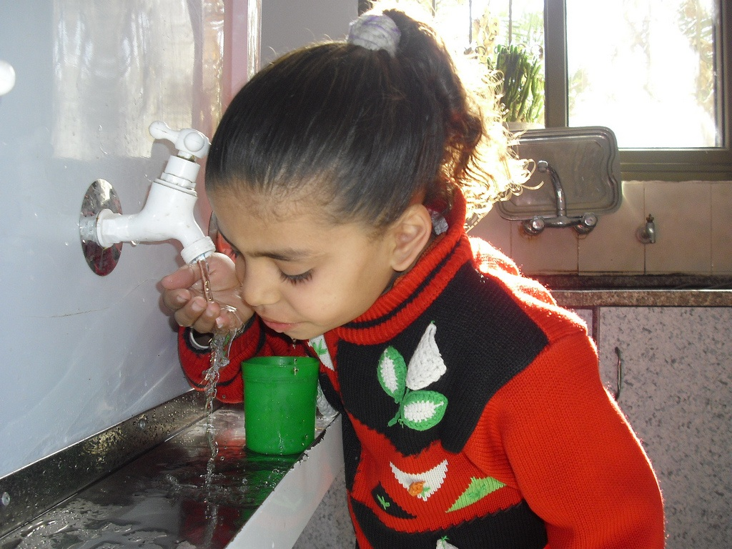
Working with the Supplier
The Gaza-based Abdul Salam Yaseen Company, has a strong track record and excellent reputation. Afaq Jadeeda and Gaza Projects Director Dr. Mona El-Farra have developed a good working relationship with them. Once a contract is drawn up for a new site, the company visits the site to test the water, check the electrical supply, and assess what’s needed for installation. For each site they supply: A complete, fully equipped package type Reverse Osmosis (RO) unit, pipes, wiring, and pre- and post-treatment units, and transportation of the unit and installation of the equipment in the building. Along with the water purification and desalination unit, each school will have new faucets and water tanks installed.
A kindergartener in Maghazi Refugee Camp, Gaza drinks clean water from a Maia Project unit installed in Dec 2009 thanks to supporters in Granville, Ohio. photo: Mohammed Majdalawi
Afaq Jadeeda staff and Dr. Mona El-Farra oversee the work of the company and maintain a clear line of communication between the company and the school to make sure the needs and requirements of both are met and the installation proceeds smoothly. Each installation takes one to two months to complete.
Challenges of Working in Gaza
This project, like any project in the Gaza Strip, has some obstacles and risks associated with it, which MECA has and our partners in Gaza will do our best to minimize. We are working with a local company that manufactures 80% of the equipment for the water purification and desalination units in their Gaza factory. They do not rely heavily on foreign imports and have been able to procure the necessary items since 1999. We don’t expect the progress of the Maia Project to be impeded significantly by the Israeli blockade that prevents the import of construction materials. In addition, the water purification units are small; they are at schools; and they will be in numerous locations, and therefore less likely be destroyed by military attacks. In fact the units could, in an emergency, provide water for the larger community in the event of an attack on local water systems.

Proposal
The Middle East Children's Alliance is seeking supporters to expand the Maia Project to schools throughout Gaza. A large purification unit for a UN school in a refugee camp costs $12,000. The UN schools run in shifts due to overcrowding and each unit provides drinking water for 1,500-2,000 children and staff. A small purification unit for a preschool or kindergarten costs $4,000 and serves 150-250 children. The small units are located in community centers with after-school programs and summer camps, so they provide water for children in those programs as well as the pre-school and kindergarten children.
Dr. Mona El-Farra, MECA's Director of Gaza Projects, encourages children to taste the clean drinking water at Al-Shati Co-Ed Elementary School, Al-Shati Refugee Camp. photo: Mohammed Majdalawi

The Middle East Children's Alliance welcomes the support of individuals and organizations who are committed to making a significant impact on the health and well being of Palestinian children by contributing to the Maia Project.

www.mecaforpeace.org/project/maia-project

