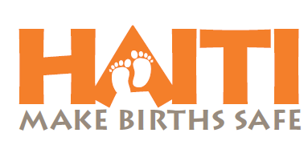
‘Haiti: Make Births Safe’ is a campaign driven by three leading Health NGO’s in North Haiti (Konbit Sante, Haiti Hospital Appeal, The Haiti Health Trust), with a proven track record of implementing major health programs, in partnership with the Haitian Ministry of Health. This campaign is bringing together the specific skills of each, to provide a comprehensive and unique approach to reducing infant and maternal mortality in Northern Haiti.

The Problem
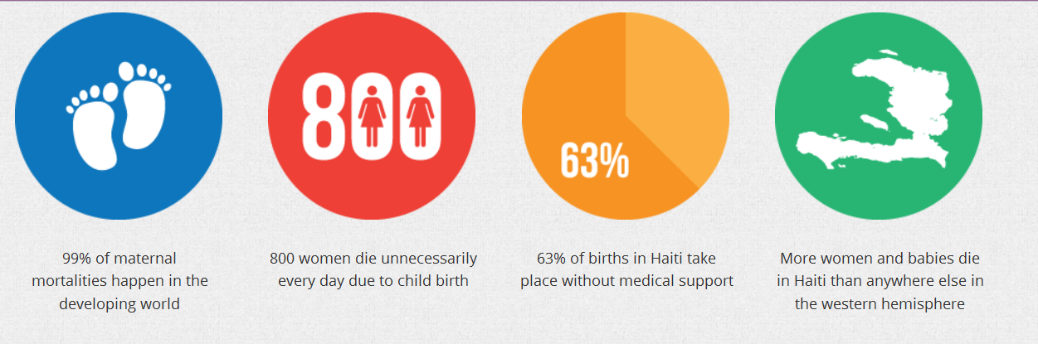

The Solution
Support Haitian healthcare facilities to provide appropriate and accessible care
- Keep a leading 45 bed maternity and pediatric unit open. No woman is refused care for inability to pay.
- Support public birthing center to be able to be open 24 hrs a day as a referral site for skilled delivery and emergency care.
- Provide free tubal ligations for women who desire them but are unable to pay.
Support Community Interventions
- Staff and supply mobile prenatal clinics in the poorest neighborhoods to reach women currently not accessing health centers
- Develop safe birthing plans with all women attending prenatal services
- Improve access to education through community health worker home visits and rally posts in highest-risk areas
- Provide safe birthing kits for pregnant women who will be delivering at home
- Train traditional birth attendants in safer hygienic birth practices, recognition and referral of obstetrical emergencies, and recognition, first response, and referrals for newborn emergencies.
- Provide free emergency transportation for obstetrical or neonate emergencies.
- Conduct post-partum visits by community health workers within 2 days of delivery to evaluate the health of both mother and newborn.
- Support mothers and fathers clubs for new parents,
- Promote immediate and exclusive breastfeeding for first 6 months of life.

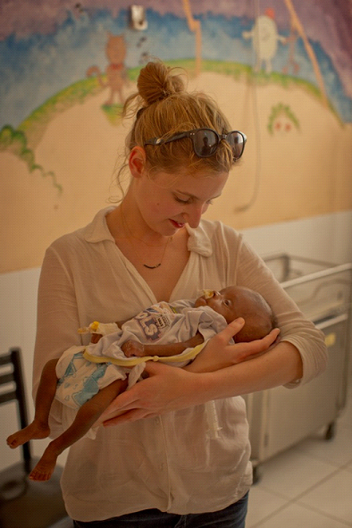
THE DOWNTON ABBEY EXPERIENCE
We’ve partnered with Downton Abbey star, Laura Carmichael (AKA Lady Edith) and Omaze.com, to give you an exclusive opportunity to win a trip to England, visit the Downton Abbey set, and hang out with cast…including afternoon tea and dinner with Lady Edith and some special guests. Chance to win will coincide with the US Downton Abbey season, beginning in early January. Details for entering will be available soon on www.healthybithing.org.

What can you do?
- Support the Campaign directly by donating your time or resources to promote it.
- Sign up for e-mail updates on the website.
- Spread the news about the opportunity to win the “Downton Abbey Experience”
- Involvement in future events (to be announced).

Contacts for more Information:

EMAIL: info@healthybirthing.org

WEBSITE: healthybirthing.org

US CONTACT INFO: Haiti: Make Births Safe
362 US Route 1
Falmouth ME 04105
207.347.6733 (Attn: Danny Muller)

UK CONTACT INFO: Haiti: Make Births Safe
25 Coney Hill Road
West Wickham
Kent
BR4 9BU
0044 (0) 208.462.5256 (Attn: Carwyn Hill)

