Tchimpounga Chimpanzee Rehabilitation Center

Tchibebe Island Development Plan

May, 2013

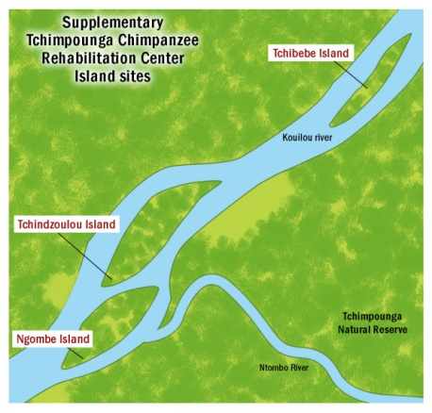

Tchimpounga Island Expansion
Since 1992, the Institute has received over 190 orphaned chimpanzees. Today more than 160 chimps reside in the Tchimpounga Chimpanzee Rehabilitation Centre. The original site has long since surpassed its capacity. In cooperation with the Congolese Government and other partners, JGI is creating an improved long-term site on three Kouilou River islands for the orphaned chimpanzees.
JGI has already completed initial construction on Tchindzoulou Island, and has transferred 11 chimpanzees. Major financial investment is required to continue the Institute’s progress in completing this project, and to continue moving chimpanzees to the island sites.
Tchibebe Construction Project- $500,000 remaining

Tchibebe Island is the next priority for JGI. The smallest of the three islands, Tchibebe is 17 hectares in total, and will have one primary enclosure, as well as one small hospital enclosure. Once Tchibebe is finished, it will house between 30 and 35 individuals.

Tchibebe Island Primary Development Phase – $342,000 remaining
The initial phase of Tchibebe’s buildout includes all the structures and elements required to move chimpanzees to the island. JGI staff have already completed the plans for the island, as well as the temporary dock, and the dormitory is nearly finished, with only $2,000 remaining from a $100,000 total project budget. JGI needs $342,000 to finish the initial development of Tchibebe Island, which will build the food prep building, purchase prefabricated galvanized paneling for the structures, and the fenceline. In addition, these funds will allow JGI to purchase all the necessary equipment and materials to transfer chimpanzees to Tchibebe.
- Mapping and Planning – Completed
- Temporary Dock – Completed
- Dormitory – $2,000 remaining
- Paneling – $190,000 remaining
- Food Preparation Building – $40,000 remaining
- Security Fencing – $20,000 remaining
- External Works – $10,000 remaining
- Boat – $20,000 remaining
- Chimpanzee Transfer – $12,000 remaining
- Miscellaneous – $45,000 remaining
Tchibebe Secondary Phase – $158,000 remaining
The secondary phase of Tchibebe Island’s buildout will put the finishing touches on the structures and will include a permanent dock for transportation of staff and supplies, as well as accommodations for staff.
Group Three Chimpanzees

Group Three is a mixed group of 30 males and females between the ages of 10 and 15. Their enclosure is one of the smallest enclosures at Tchimpounga, and has only artificial structures for shade and climbing. Petit Prince and Timmy are just a few chimpanzees in Group Three who are ready to be moved to a new home.

Petit Prince--Tiny, two-month old Petite Prince was brought to Tchimpounga in 2000 after being found tied up in a bag inside of a truck. JGI staff had to work quickly to save his life. Petite Prince’s right leg was nearly severed, almost certainly by an illegal snare-trap, and he was in extreme pain. Luckily, with expert medical care, JGI staff were able to save Petite Prince. Once he was fully healed, Petite Prince began to enjoy rough-housing with other orphan chimps and spending time with his human caregivers. A few years ago, Petite Prince’s fondness for human company turned out to be very lucky for Lydia, one of Tchimpounga’s caregivers. When out on a forest walk, Lydia was leaning on a tree watching the chimps play. The Petite prince looked at her and began to jump and and down while giving cries of alarm. Lydia looked up and saw a poisonous snake sliding toward her through the grass, and was able to move away in time. Petite Prince is such a special chimpanzee, and deserves to be able to roam free in Tchibebe’s forest.

Timi—Timi arrived at Tchimpounga in 2002. Timi was a young orphan who had been sold to villagers as a pet, likely after his mother was killed for bushmeat. When he was brought to Tchimpounga, Timi was very weak and seemed to be depressed. However, once Timi was integrated with other orphan chimps like him, he began to gain strength and make friends. Now he is a very active chimpanzee who loves to play with coconuts as if they were balls, tossing them into the air and catching them just in time with his legs and arms. We at JGI would love to see Timi be able to play free in the forest of Tchibebe Island, where he will be able to climb trees, swing on vines, and live a more natural chimpanzee life with his group-mates.

