Dear Colleagues,
Greetings from Namwera, Malawi
Namwera Aids Coordinating Committee (NACC) would like to share with you, our valued donors; the second progress report for “Send a Vulnerable child to school in Malawi” project.

NACC would like to express her profound gratitude to the Global Giving for the technical and financial support rendered to NACC; we would also like to thank individual donors for their financial support.
Send a vulnerable child to school in Malawi Project is not only improving access to education to vulnerable children in the rural and underserved areas of Mangochi, Malawi, but also building confidence and hope to the abused children. During the quarter, the project has supported 14 (9girls/5boys) new children with school uniform and writing materials. School uniform is an issue in rural and underserved areas, schools does not allow pupils to attend classes without school uniform, it is a compulsory. They do this to minimise stigma and discrimination among the children yet limiting access to education to the underprivileged.

Success story
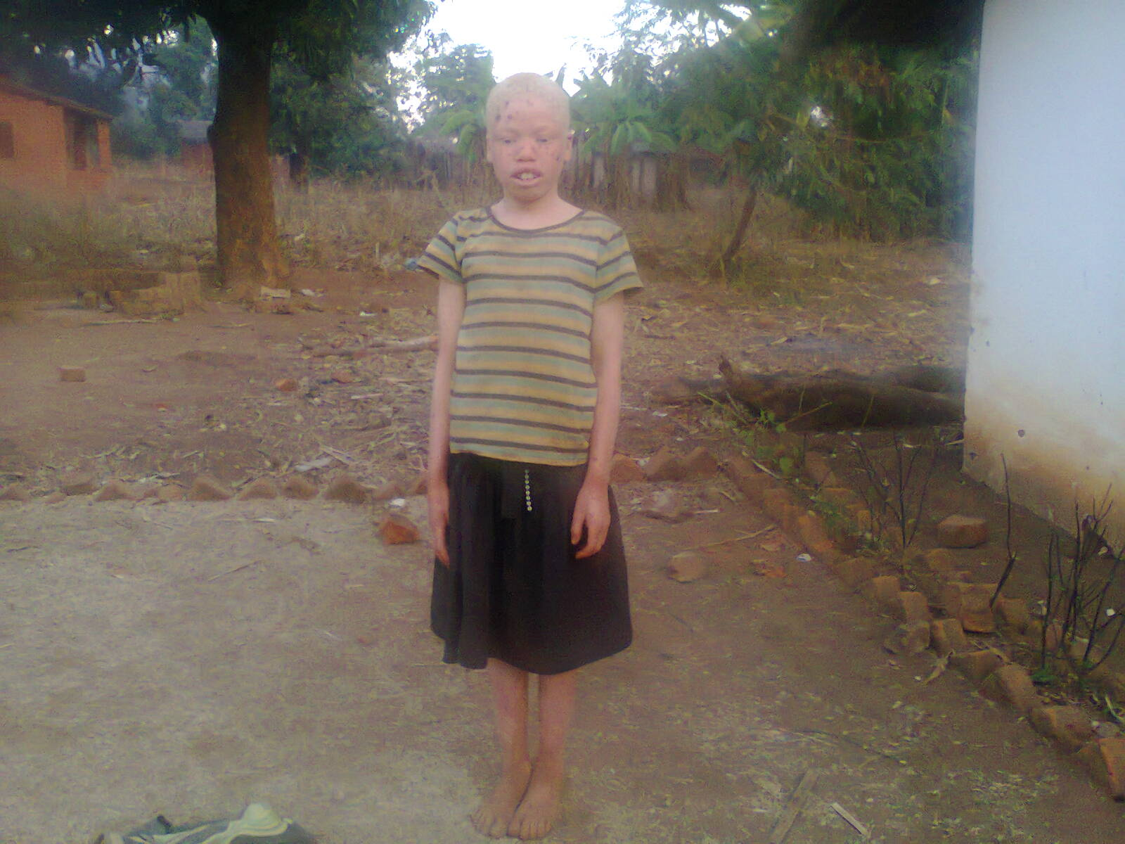
Ester is a 10 year old girl of Kaloka village. She is studying at Primary school and she is in standard 4.
Ester has been one of the girls who had difficulties in accessing primary school education, her mother is poor, she could not afford to buy school uniform and school development fund as a result she was not allowed to attend classes. Secondly, Ester was been mocked and ridiculed by her classmate and teachers because of her skin colour. Her mother and relatives were not comfortable with her; they discouraged her to go to school because they thought that she was bringing shame to the family. The project counselled Ester and her parents on the importance of education and also address psychological related problems. She is now happy and attends classes regularly.

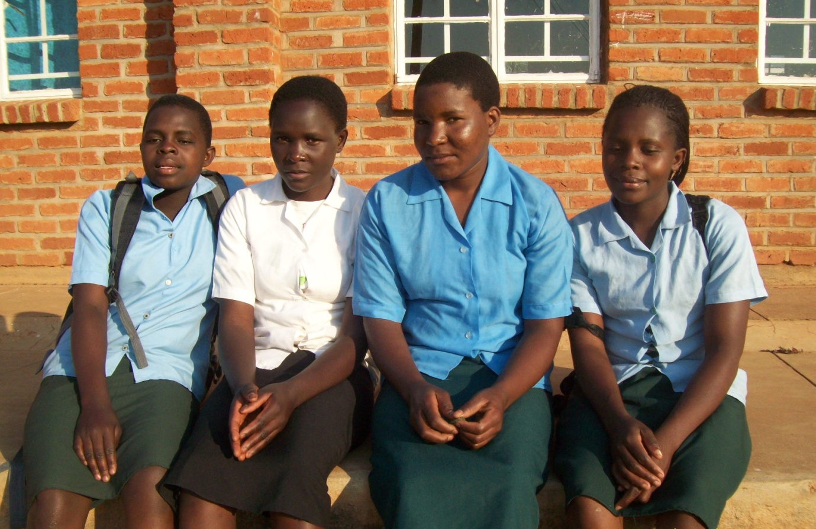
From left are Mphatso, Maganizo, Tuweni and Sophret.
Because of your support, these girls are completing their Secondary school level at Majuni and Namwera Community High School. They are currently sitting for Malawi School Certificate of Education. It was not easy but because of your support they have made it.
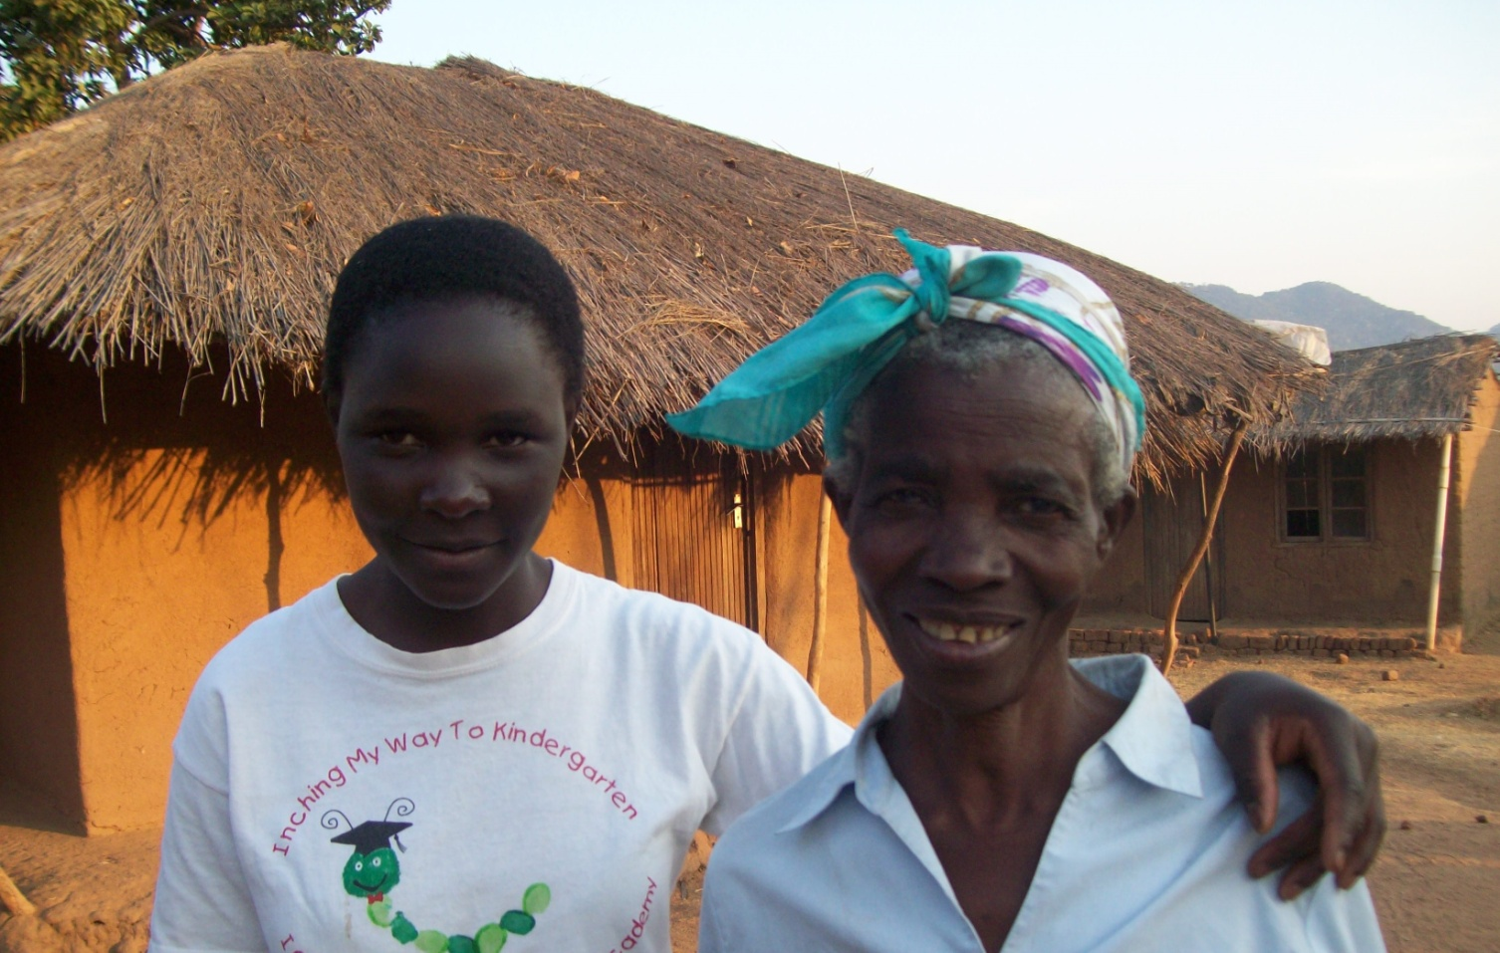
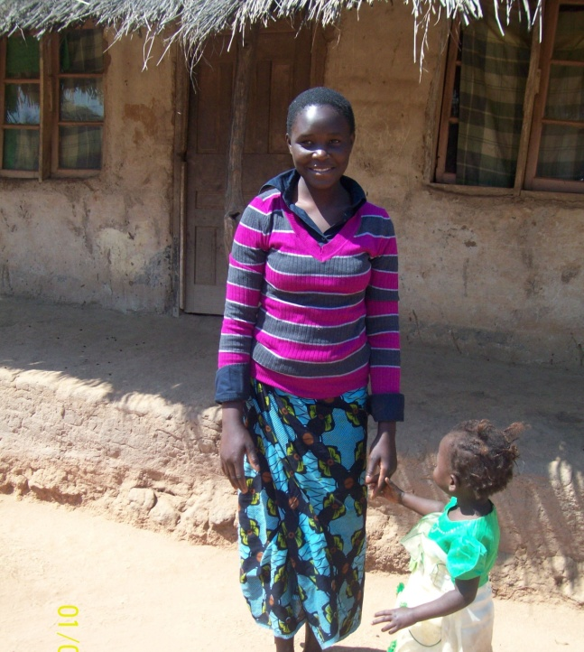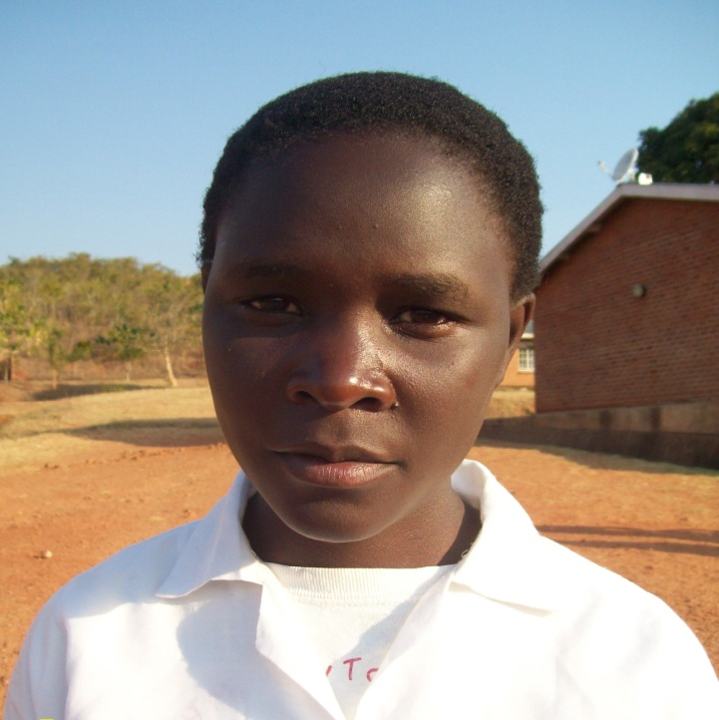

The above pictures are showing Maganizo with her grandmother, then her daughter and herself.
Maganizo lost her both parents when she was at school. As usual, she took over her parent’s role of taking care of herself, her three siblings and her grandmother. Life became very hard for her; she could do casual labour to support her family while attending school. Eventually, she could not afford to get the basic needs for the family and school fees and was chased away. In the process, she got pregnancy and her place at the high school was declared vacant. After delivery Maganizo wanted to go back to school but the only stumbling block was lack of school fees and scholastic materials. We are grateful to report that your support has ignited her dreams, now she has a hope and is completing her Secondary school level at Namwera High School (Secondary School).
“Life is full of challenges, ups and downs, I loved my mother and my father, and they provided me everything. When I lost my parents it meant a lot to me. I lost my childhood, my basic rights that included education, food and nutrition, health care and many more. I thank all the people who have contributed to my cause. Now I can for see my bright future” Said Maganizo.

Send a vulnerable child to school in Malawi Project would like to express her profound gratitude to Global Giving for the technical support and to all the donors who are donating for the cause. Your money is changing the lives of the underprivileged in the rural and underserved areas in Malawi.
It is our hope that you will continue supporting these children to realise their dreams.

Saeed Wame
NACC - Executive Director

