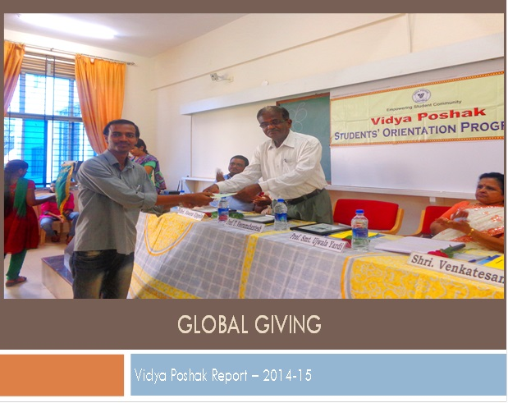

Activities Report -2014-15
Name of Implementing Organization with Address | Vidya Poshak  Yashodha Sadan, Vidya Giri, Dharwad, Karnataka
Name of Contact Person with Mobile Number | Mr.Venkatesan-91+9845038017  Mr.Kartik-91+8861201828
Name of Donor | Global Giving
Programme Location(s) | Karnataka
Details of Projects Supported by Grant | Financial Assistance, Bridge Camp, Library & Program Support
Beneficiaries Covered | 361
Cause Supported | Nurture Merit (Financial assistance, Residential bridge camp & Library services )
Reporting Period | April 2014 to 20th March 2015

About Charity Partner
Vidya Poshak, India is a registered Non-Government Organization (NGO), serving education community. The organization was started by a group of compassionate people in the year 2001 at Dharwad, Karnataka with the aim of supporting financially challenged bright students.
About The Project (Know the project you supported)
Nurture Merit Program (Adult Education)
Program Goals: An initiative to support the underprivileged bright students to pursue higher levels of literacy leading to employment.
Program Activities: Nurture Merit Program Is a well-designed, structured and focused program to support bright students coming from economically challenged families. The support is extended to post 10th grade students to continue their college/higher education till completion of graduation leading to a meaningful employment. The program has the following integrated services.
- Financial Assistance: This will cover college fees, transportation and exam fees. Along with this additional amount for coaching is given.
- Books & Library Services: Academic text books are lent to the students through libraries and book banks located in rural places. Student will get academic text books on their demand to read for 1-year and then the same books are put in circulation.
- Training through Residential Bridge Camps: Supported student will attend a 9 days residential bridge camp every year to enhance communication/life skills and employment opportunities. Along with this we ensure creating good, sensitive citizens for the society.
Target Group: Students from rural villages of Karnataka where the parents are mostly farm labours and the families live in poverty, parents have no formal education and the student is the first scholar to do higher education from the family.
Global Giving – Scholars Update
- Analysis of Assistance – Nurture Merit
Course | Financial Assistance |  | Skill Development |  | Library & Academic Books
 | No of Students | Amount in INR | No of Students | Amount in INR | No of Students | Amount in INR
11th Grade | 11 | 60833 | 40 | 120000 | 88 | 105600
12th Grade | 5 | 22500 | 30 | 82088 | 91 | 109200
Degree (Non Prof Course) | 9 | 30556 | 50 | 100533 | 29 | 34800
Degree (Prof Course) | 1 | 7000 | 0 | 0 | 1 | 579
Technical Course | 3 | 17000 | 0 | 0 | 3 | 3600
Total | 29 | 137889 | 120 | 302621 | 212 | 253779

Special Note:
- INR 72,023.00 donation amount is utilized for Student Screening, Student Academic follow up, Program Support - Nurture Merit

- Social data
Gender | No of Students | Amount Supported
Male | 149 | 2,86,527.00
Female | 212 | 4,07,762.00
Locality | No of Students | Amount Supported
Rural | 321 | 6,11,978.00
Urban | 40 | 82311.00

Financial Utilization Details 2014-15 (April 2014 to March 2015)
Grant Received for the year 2014-15 in Indian Rupees | INR 7,95,782.00
Grant Utilized | INR 7,66,312.00
Break – Up of Utilization
Financial Assistance | INR 1,37,889.00
Residential Bridge Camp | INR 3,02,621.00
Library Services & Youth Development | INR 2,53,779.00
Student Screening, Student Academic follow up, Program Support & Admin Support- Nurture Merit | INR 72,023.00
Amount carry forward to next year | INR 29,470

Vidya Poshak – Overall Summary & Highlights

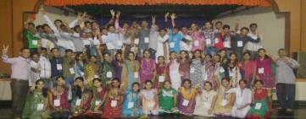

  - 2012+ Students assisted financially to continue their Education with an overall contribution of INR 110.0 Lakhs directly by Vidya Poshak in 10 districts.
  - More than 80 students studying in Engineering streams are placed through campus placements with an average salary of INR 3,30,000 per annum
  - 150+ students who have completed general degree courses have been placed in reputed companies
  - 6 Libraries & 28 book bank centres are extending free library services to the needy student community.
  - 10483 students utilised library services including the computer facilities (Between April – Nov 2014 )
  - 18543 books were issued to students for home use. Now we have overall more than 77,000 books worth 9.3 Million Indian Rupees.
  - 1400+ Students were assisted to continue their higher education by our partners with a fund of INR 64.0 Lakhs.
  - 100% Applicants home was visited by the volunteers.
  - 545 student’s successfully completed graduation during the year 2013-14.
  - 50+ students cleared CPT&IPCC Exams (An Entrance exam of Charted Accountancy)

Vidya Poshak – Residential Bridge Camp
Residential bridge camp is an important component of the training package offered to the student community by Vidya Poshak. It, in fact, is a bridge between the student and his dreams
For the year 2014, 18 camps were planned to cover 800 students and as on 30th December 2014, 16 camps have been organized covering 700 students. Out of 700 students 120 Students were Global Giving supported students.

Project Related Photographs
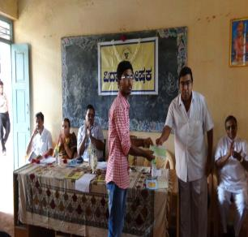 | 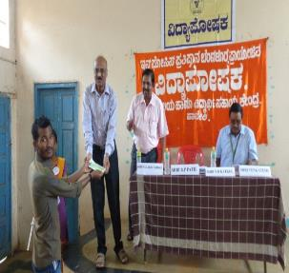
 | 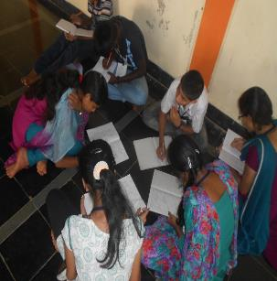
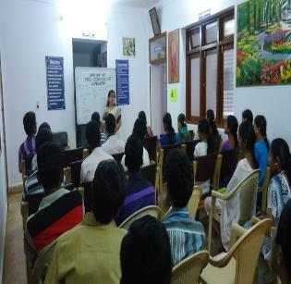
Media Coverage
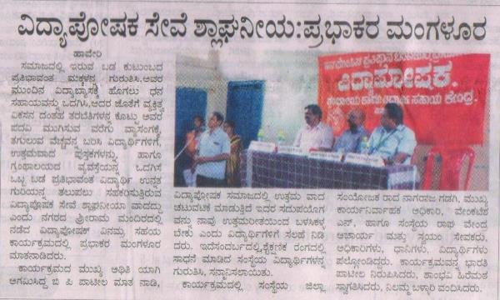

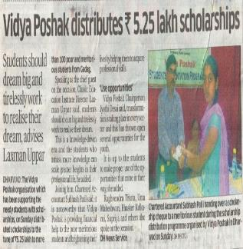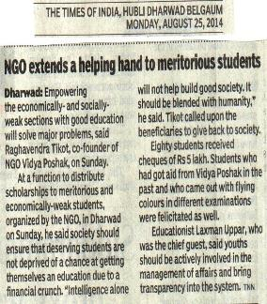

Sample Students Profiles
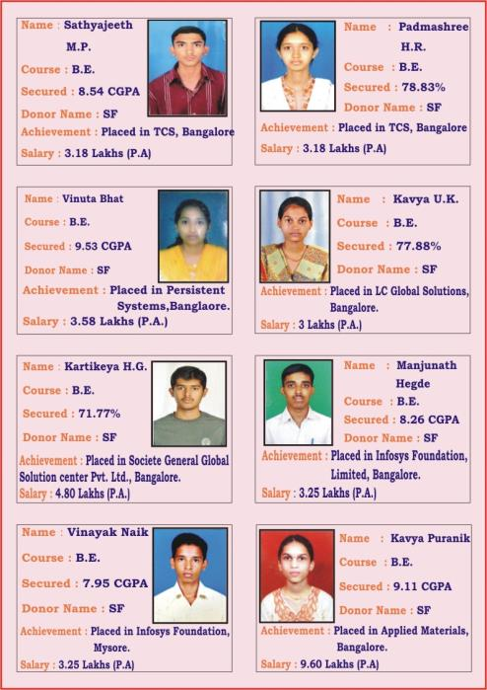
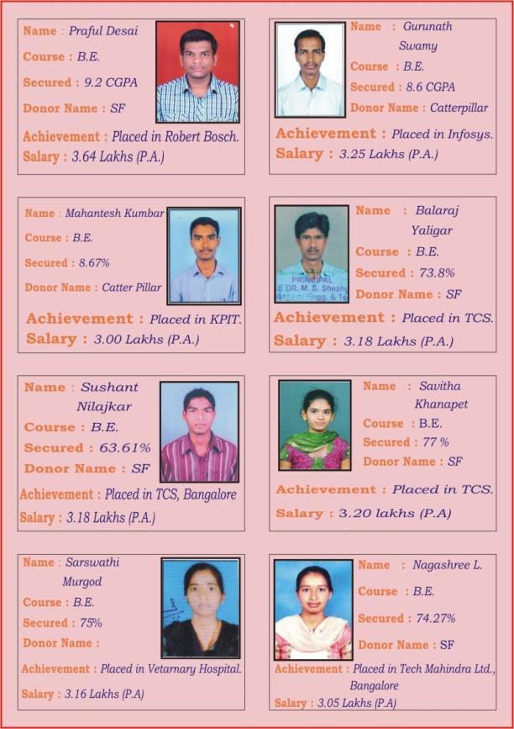
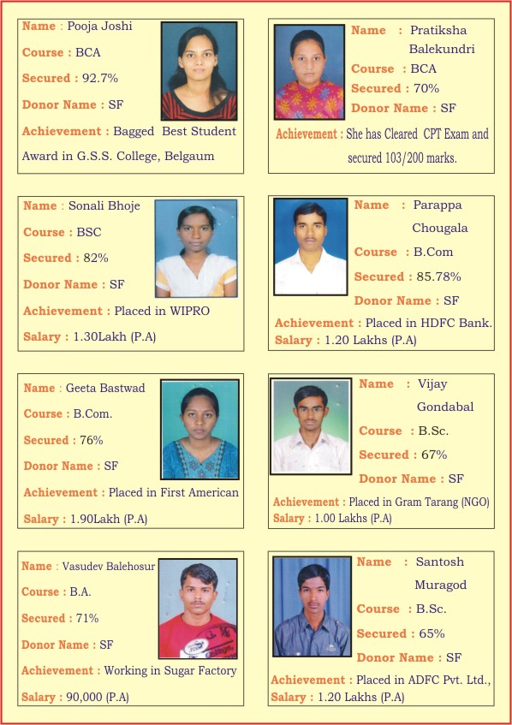

Sample Achievers Profiles – More @ http://vpstudentprofiles.blogspot.in/2014/12/vidya-poshak-achievers-profile.html

From Charity Partner Desk
We place on record our sincere gratitude to Global Giving for supporting the Nurture Merit Program that has been impacting lives of thousands of students.

