SUMMER 2011 OUTREACHES IN PICTURES

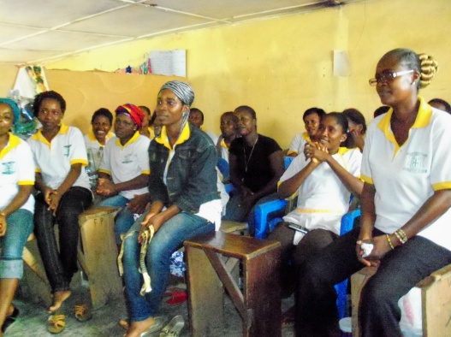

Giggles and smiles during discussions on reproductive health
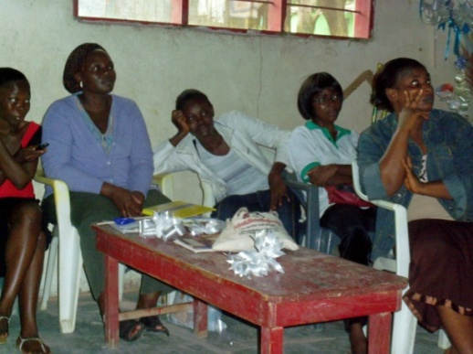

A group of students with tools down listening with rapt attention

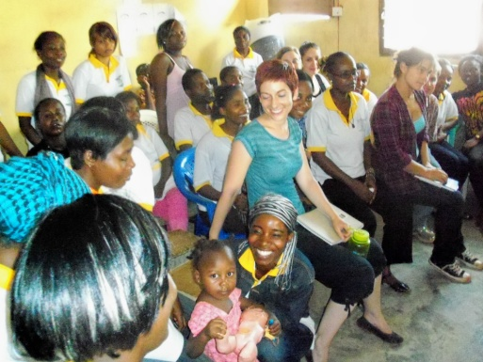

WISE interns interacting with a young mother and baby at a vocational school
A skit to generate discussions at a vocational school

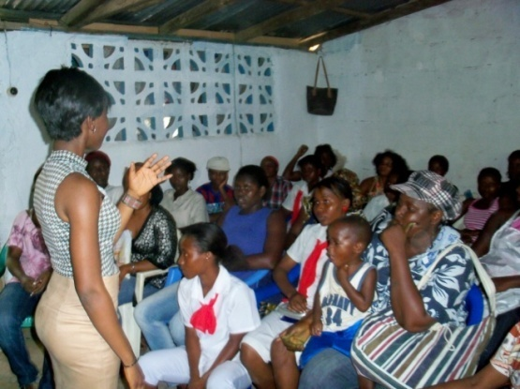

WISE staff leading a discussion at vocational school (mothers sometimes bring their children to school)

