Preschool of Future for rural poor kids in China
The 5th report
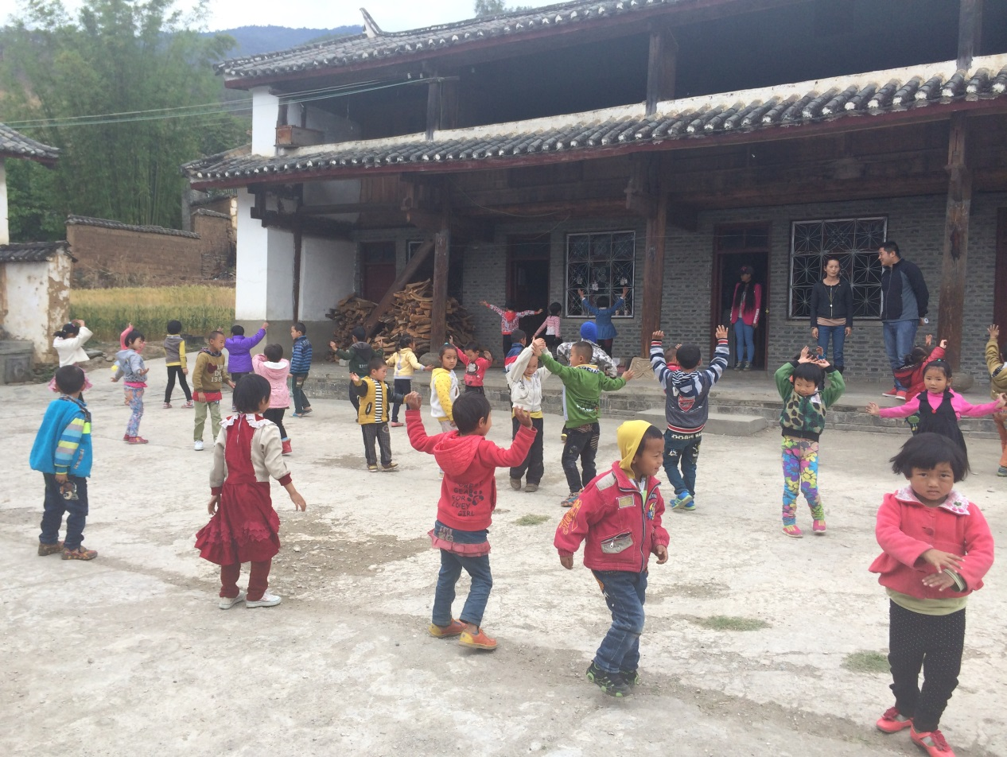

Since April 2013 till July 2014, Shanghai United Foundation and Humana People to People together have strived to promote Globalgiving online donation “Preschool of Future for rural poor kids in China” project in different channels – organization website, QQ, Facebook, Emails and information spread among friends. Now we already have 55 donations total amounting 2845 USD, and left 3968 USD.

Thanks to all the donors for the support to this project!

In this period, Deputy Director General of Yunnan Provincial Department of Education visits POF Zhenkang.

On May 15th, 2014, Ms. Wang Jianying - Deputy Director General of Yunnan Provincial Department of Education, Ms. Zeng Liqiong – Director of the preschool education office in Yunnan Provincial Department of Education, Mr. Huang Chengshu – Director of Lincang City Bureau of Education(BoE), Mr. Cao Yubao – subprefect of Zhenkang County, and Mr. Zhou Shirong, Director of BoE of Zhenkang County, came to visit HPPC Preschools of the Future (POF) in Zhenkang County; accompanied with Mr. Michael Hermann, Country Representative of HPP and Ms. Siri Holmebakk, Project Director of HPP Kunming office.

The BoE delegation was very satisfied with what they saw during the visit. They admire the great contribution and dedication that HPP has made to three year preschool education. They also said the education system will fully support HPP POF and do their best to help solve any related problems HPP faces.
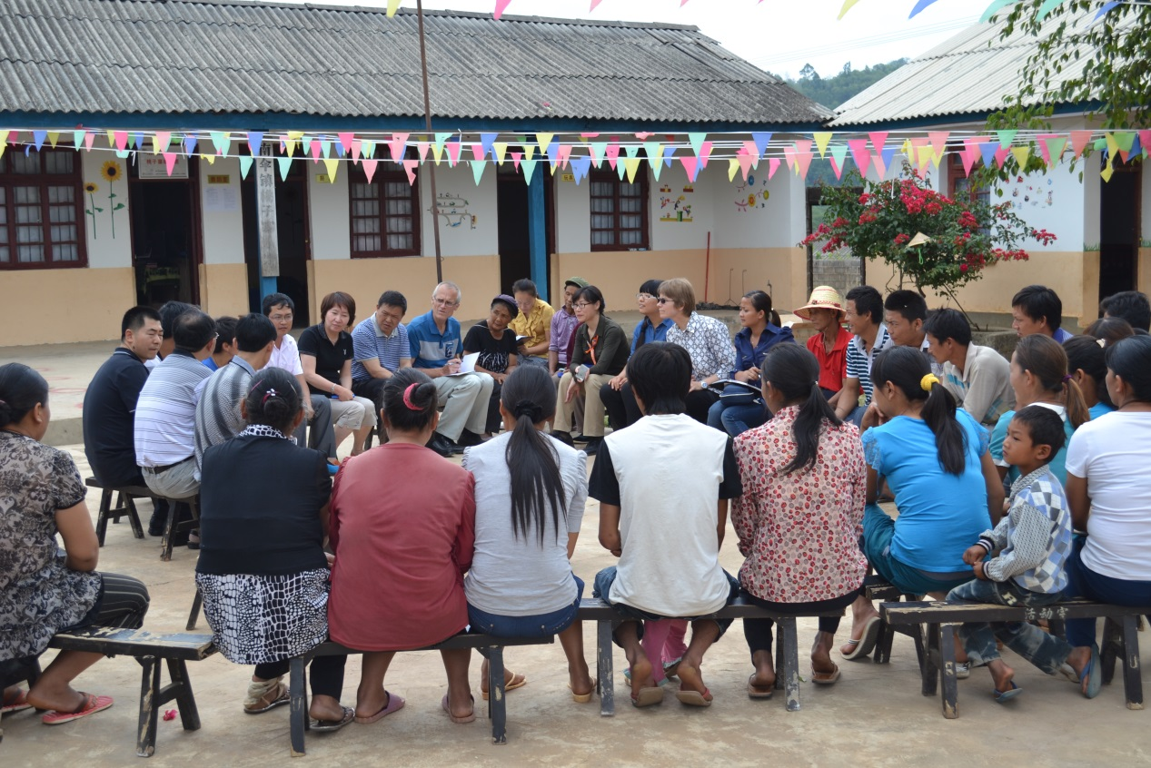
Participate parent meeting in Taozizhai

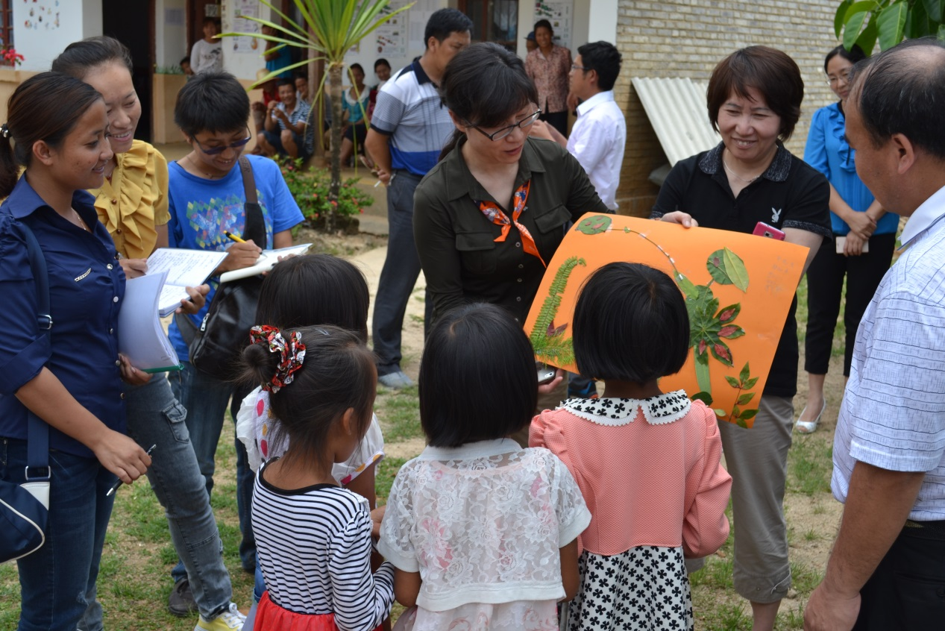
Handmade gift to “big friend” by kids from Taozizhai Preschool
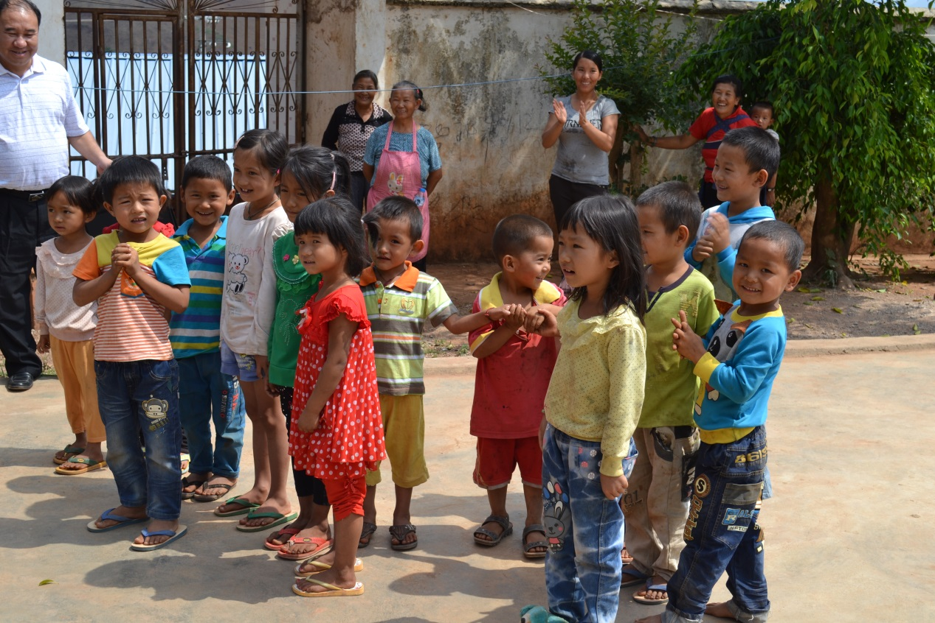
Students welcome the guests!
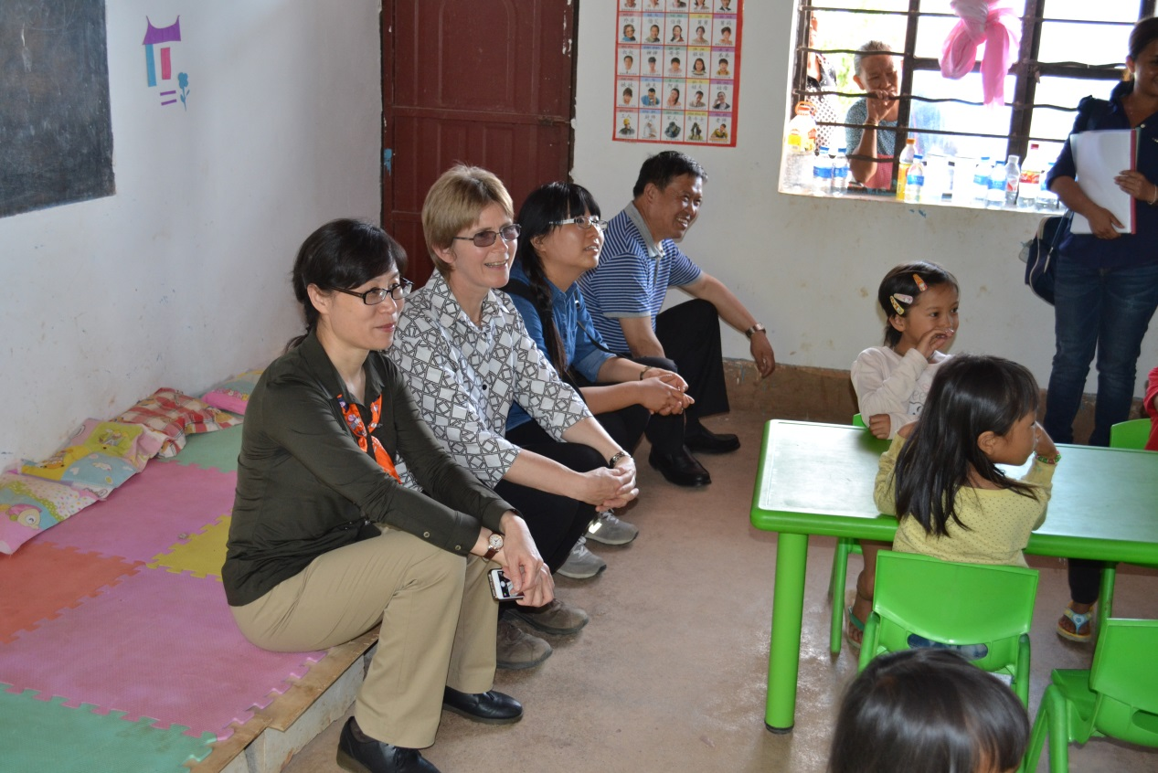
Observe the teaching activity at Bangxiaodi Preschool
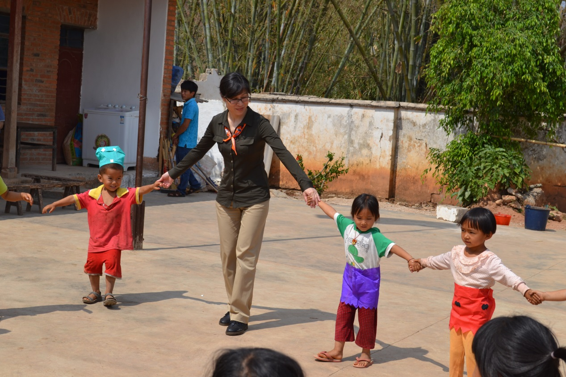
Ms. Wang Jianying joins in the kids’ games.

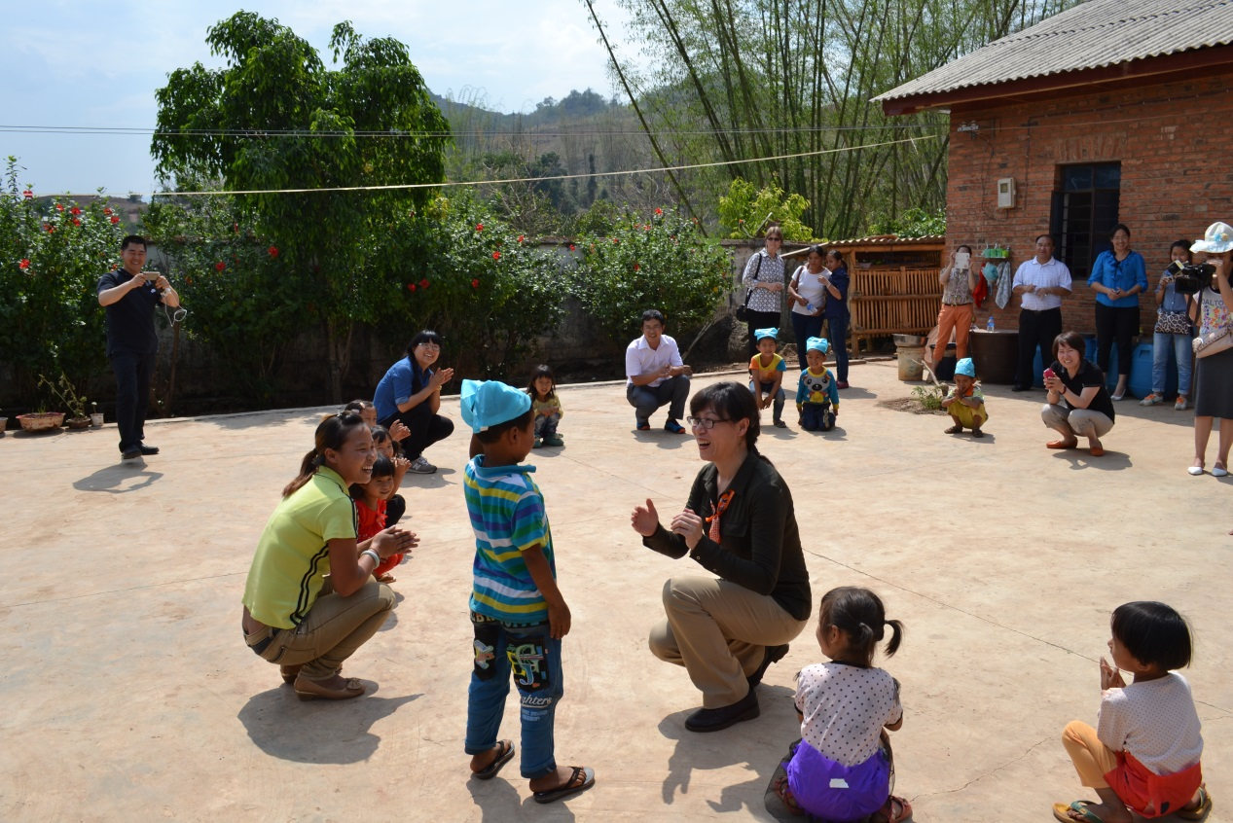
Ms. Wang Jianying plays the “Find My Friends” game

On June 1st it was International Children’s Day, many HPP projects held activities and celebrations. Children and their parents enjoyed participating in activities and performances together.

Children’s dancing performance was the best part of POF Butuo’s activities. You can see how hard the children rehearsed, and how happy they danced!

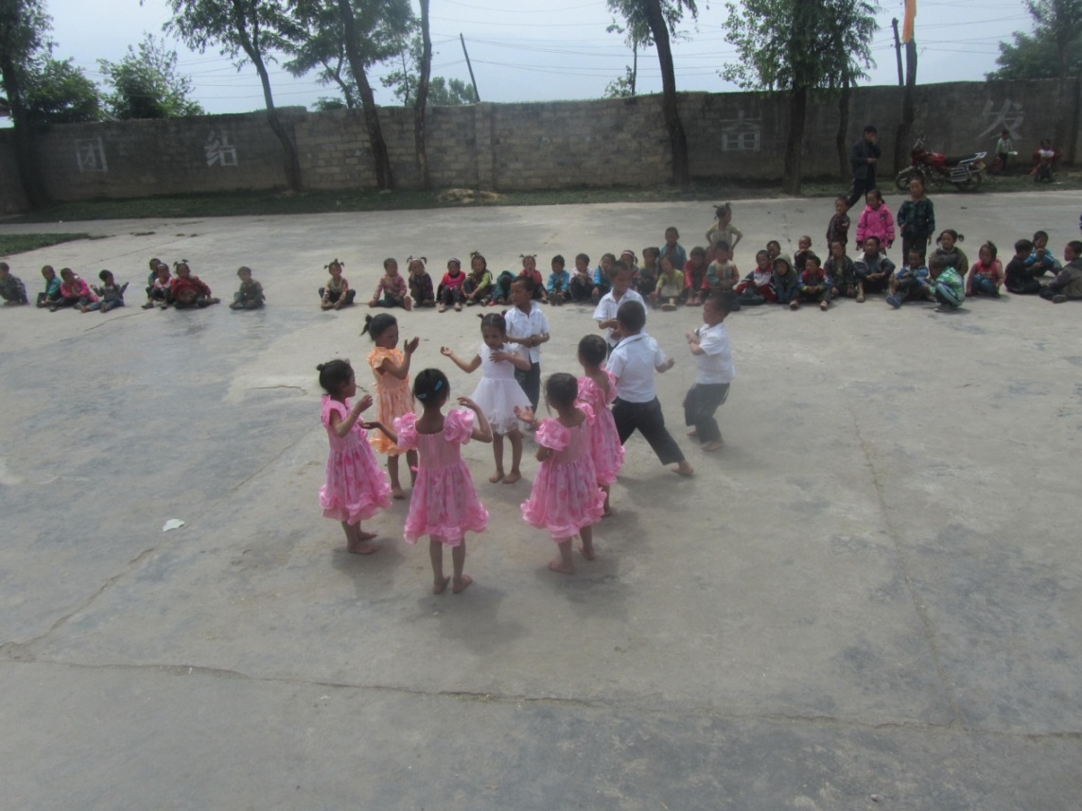

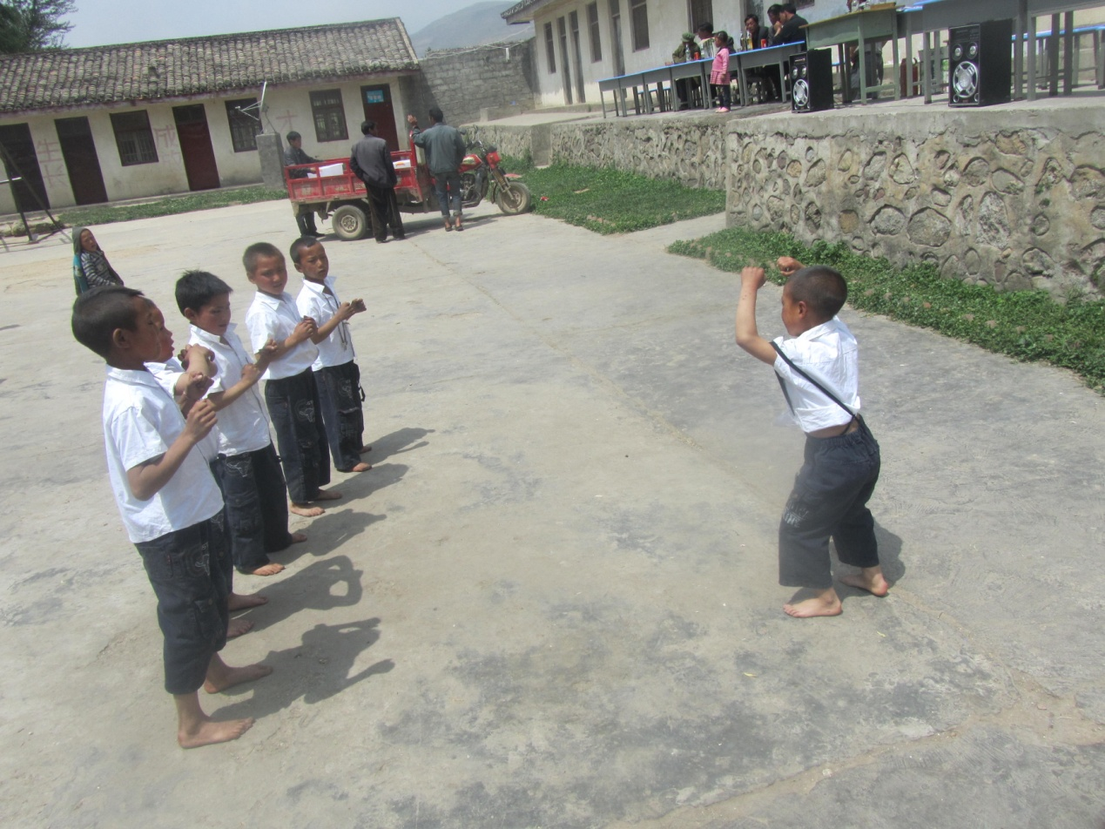

HPP POF model class, POF Zhenkang, organized an interesting Children’s day activity, which included an environmental element to it, in which parents and villagers participated..

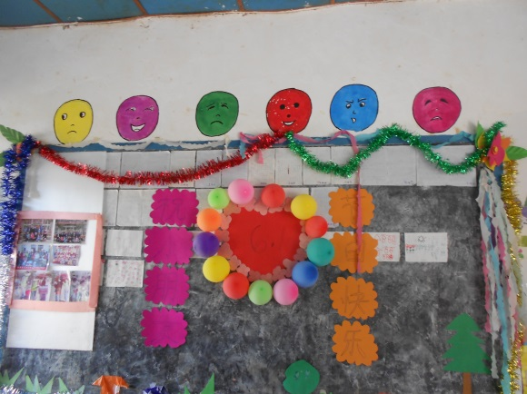
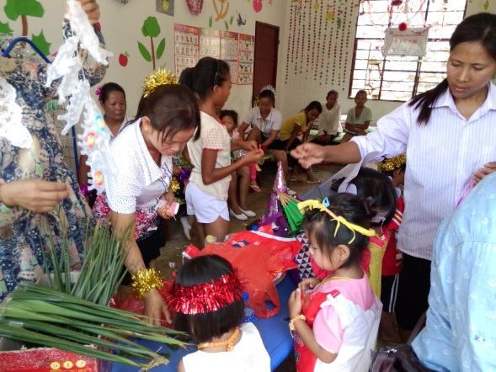

“Grow-up, Happy 6.1” Exhibit our DIY green jewelry, necklace and costumes.
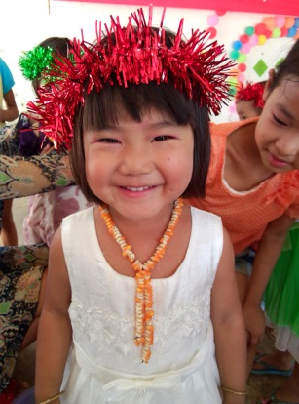
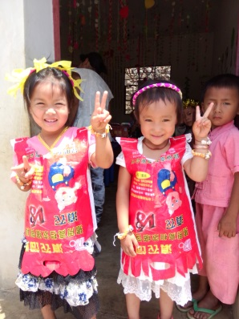
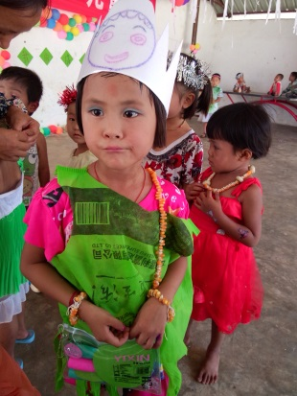

My Children’s day, I am happy to put on a show!
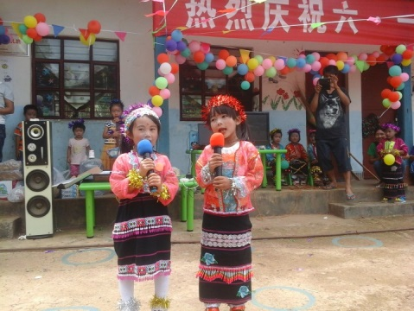
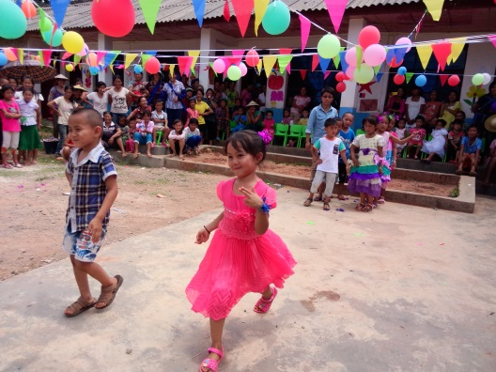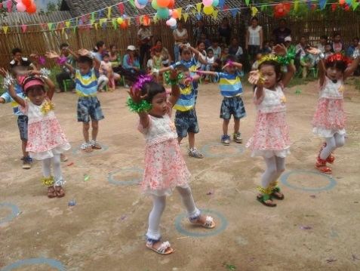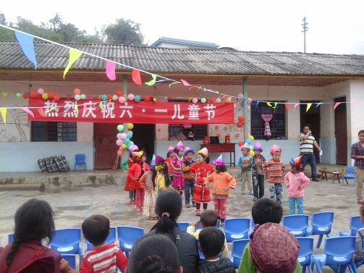

Two happy little “flowers”

Playing many interesting games
