Preschool of Future for rural poor kids in China
The 3rd report
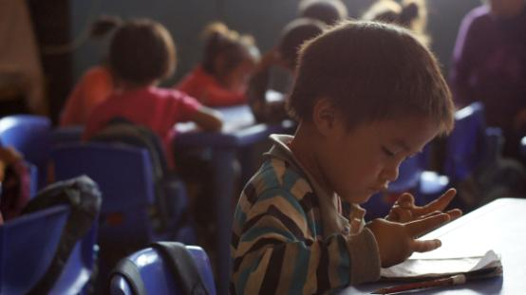
Since April to July 2013, Shanghai United Foundation and Humana People to People together have strived to promote this globalgiving online donation “Preschool of Future for rural poor kids in China” project in different channels – organization website, QQ, Facebook, Emails and information spread among friends.

The significant results:
- Now we already have 27 donations total amounting 1,887 USD.
- Thanks to the Globalgiving project, a Canadian school contacted us for sponsorship and this is still under negotiation.
- Thanks to Globalgiving new year “Last chance project” , we acquired an obvious increase in donation.

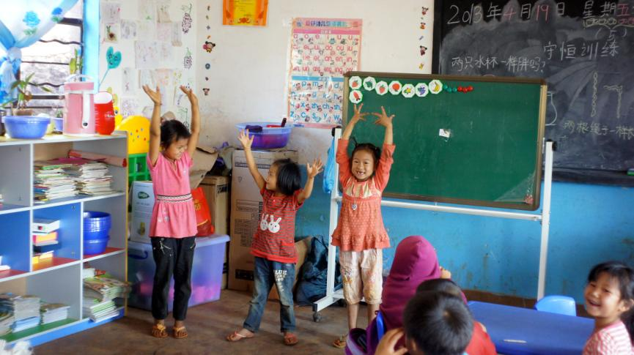

Thanks very much for the support of all of our donors!

Project progress:

- In Zhenkang, the project just opened 12 new classes. From 2008 till now, accumulatively 2362 children have been benefited from POF project. Up to date, there have been 25 classes with 669 children in Zhenkang Preschools of Future.

2. HPP and Sohu.com co-launched “Rural Preschool Plan”
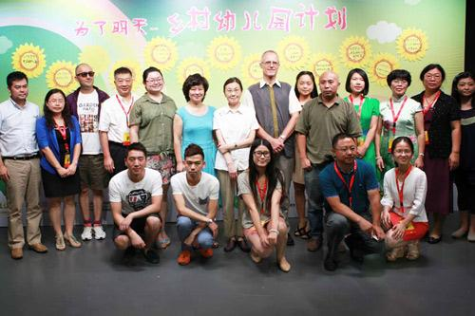
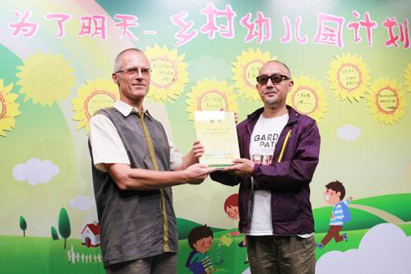

The press release of the “Rural Preschool Plan”was held in the Sohu Media Building. The plan was co-launched by more than 10 organizations, such as SohuGongyi, Sohu baby, CCTF (China Children and Teenager’s fund), and Humana People to People China. The famous Hostess Ju Ping from CCTV also attended this ceremony as a goodwill ambassador.
During the ceremony, famous actor Yao Lu received the appointment letter of honorary principal in HPP Yunnan Zhenkang Shua Bu Chang village Preschool, winning the award for the “Most handsome POF principal”. This preschool has already started classes now and is the first preschool in the history of Shua Bu Chang natural village. Yao Lu said: “I am extremely proud of it. And I am willing to work hard for it for the rest of my lifetime.”

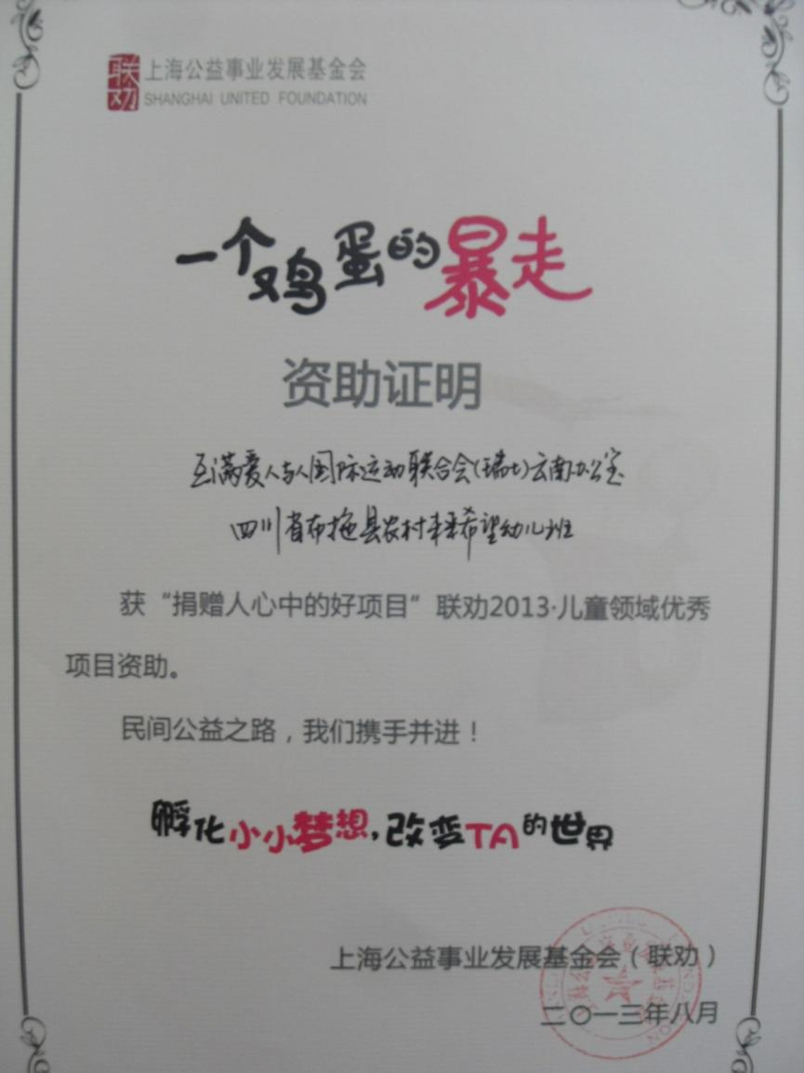
The large-scale public fundraising activity “Walk for one egg” hosted by Shanghai United Foundation has supported HPP POF project for two years. Shanghai United Foundation (SUF) cooperated with HPP China on the online fundraising activity on the Yahoo Gongyi and Global Giving websites, which have had good results. HPP’s project operations are well received by SUF and donors and HPP has been one of SUF’s key partners. Due to the excellent project operations, SUF awarded “Best project according to donors” certificate to HPP POF in Butuo county during the “Best project according to donors and outstanding Children’s project in walk for one egg activity” ceremony on August 24, 2013.

As an international grassroots organization in the Chinese public welfare arena, all of the projects of HPP are rooted in remote rural areas of western China. Let us go forward hand in hand for Chinese public welfare!

Next steps:
- Humana continue to promote this project
- Humana contacted American and European NGO partners. We are going to start a promotion in US and Europe national wide.

