Preschool of Future for rural poor kids in China
Second report

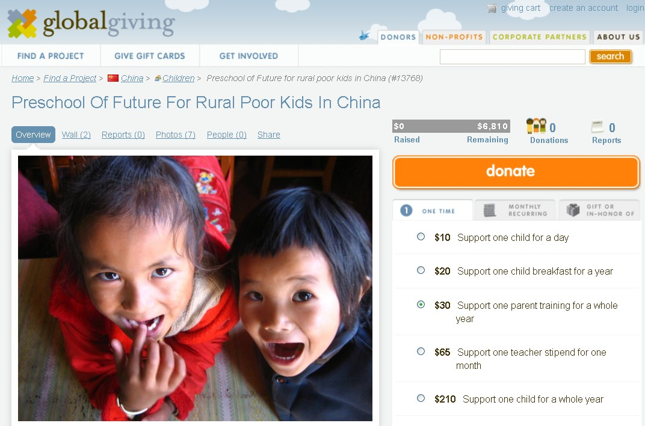

Since April to July 2013, Shanghai United Foundation and Humana People to People together have strived to promote this globalgiving online donation “Preschool of Future for rural poor kids in China” project in different channels – organization website, QQ, Facebook, Emails and information spread among friends.

The significant results:
- Now we already have 7 donations total amounting 255 USD.
- Because of globalgiving project, a Canadian school contacted us for sponsorship and this is still under negotiation.

Thanks very much for the support of all of our donors!

Next steps:
- Humana continue to promote this project
- Humana contacted American and European NGO partners. We are going to start a promotion in US and Europe national wide.
- Third party Study:
A 3rd party project evaluation report just published in August which well showed the impact of the project.
Comparative sample control group study of 30 64-month old children enrolled into HPP community preschool compared to 30 non-enrolled children of the same age and background in order to evaluate the impact of the program.

Child Development Area | Score Increase
4 types major and fine movement dev. | 44.3%
2 types language development | 38.4%
4 types cognitive ability development | 37.8%
2 types learning skills | 108.2%
3 types of sociality development | 20.2%
Sichuan Normal University, July 2013
- In Zhenkang, the project just opened 12 new classes. From 2008 till now, there are accumulatively 2362 children benefited from POF project. And now there are 25 classes with 669 children in Preschools of Future Zhenkang.
