We provide our abandoned children opportunity to interact with other children in our playroom. We have watched our long term abandoned children develop to a potential that has amazed us. Lydia (has Cerebral Palsy) can use augmentative communication well using a donated ipad. She joins other children during play activities such as hidden pictures search puzzles, games, coloring and more.
Serah (developmentally delayed teenage girl) can walk around very well. Her vocabulary at around 5 words is still poor. Our abandoned baby staff work hard every day to ensure these children and more grow to their potential.
We recently received siblings: Wilson 7 years, Samuel 5 and Joseph3 years for accommodation at our centre. They were rescued from abusive parent by the children’s department of Eldoret. They were put under our care as they continue to find them a permanent home. Their photo is below;
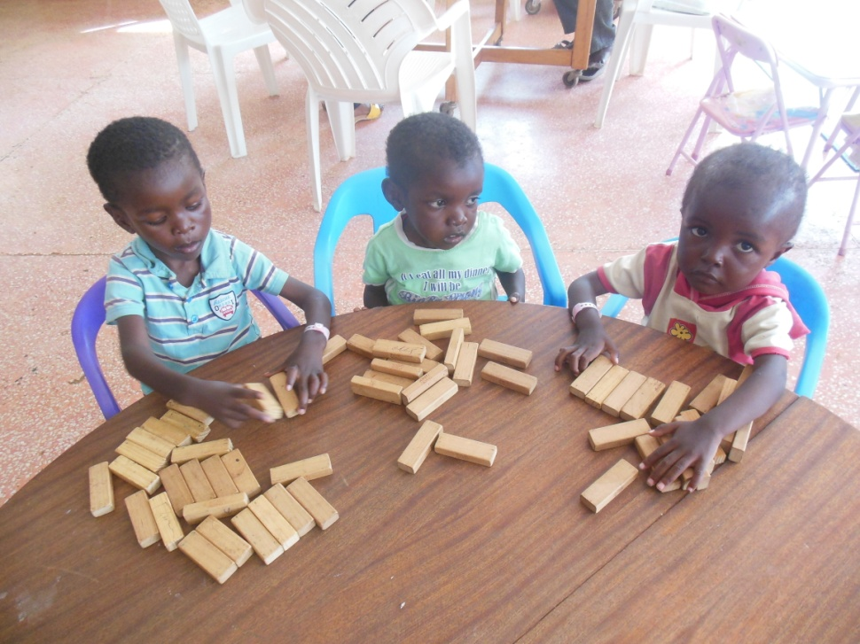
From left: Wilson, Samuel and Joseph
Please watch a clip showing a summary of our work: Sally Test Paediatric Centre-2014
Thank you for your continued partnership.

