Six month old **Ethan** is a new addition to our family. He was abandoned at field in a nearby estate in Eldoret town. Two others are **Kevin** and **Zablon**. Kevin was abandoned in the hospital by his family after realizing he had hydrocephalus. Through our intervention, Kevin has had a shunt fixed to drain excess fluid from his brain. Our baby centre staff take daily head measurements to monitor changes. Our most recent addition, Zablon, tested HIV positive so was put on ARV treatment. Our long term special children are still with us: Lydia, Serah and Dinah. Serah is now able to walk around while interacting with recovering children who visit our playroom for a variety of activities planned by our teachers.

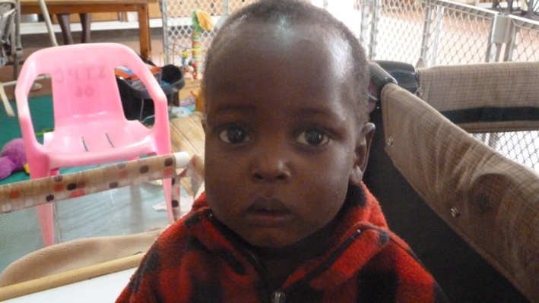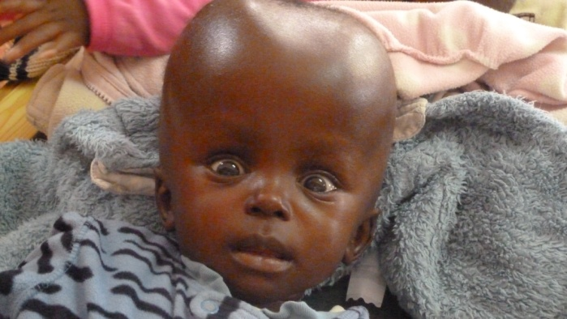

**Zablon Kevin**

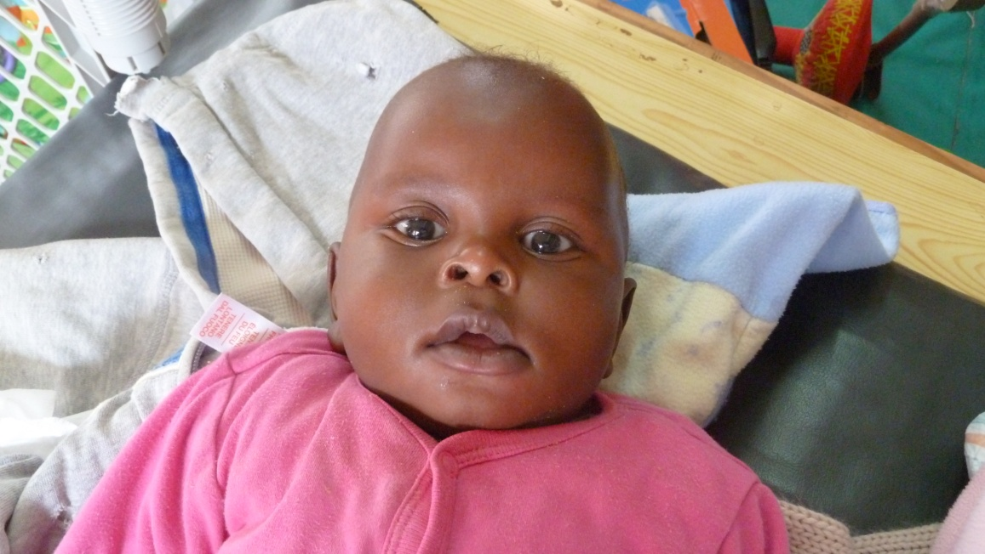

**Ethan**

Your continued support ensures we give hope to these children. Donations we have received enabled us buy food, formula, fresh milk, cereal and clean drinking water for the children. Thank you for the partnership. Our project link is **http://globalgiving.org/projects/beginning-life-with-hope**