Four of our children got new homes in December 2014 before our Christmas break. Two of our long timers, Serah and Lydia, were not lucky in 2014 yet again to get homes or foster parents. Donations we received enabled us pay two of our baby centre staff so as to spend the Christmas holiday with Serah and Lydia at the Sally Test Pædiatric Centre. Thank you for the continued support.
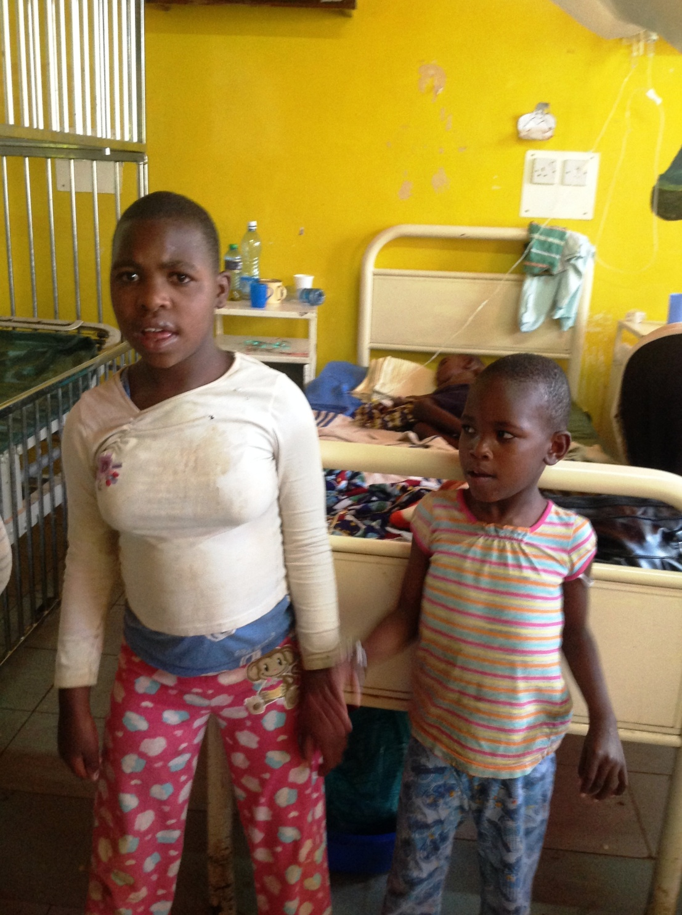
Serah and Lydia in the wards of MTRH

