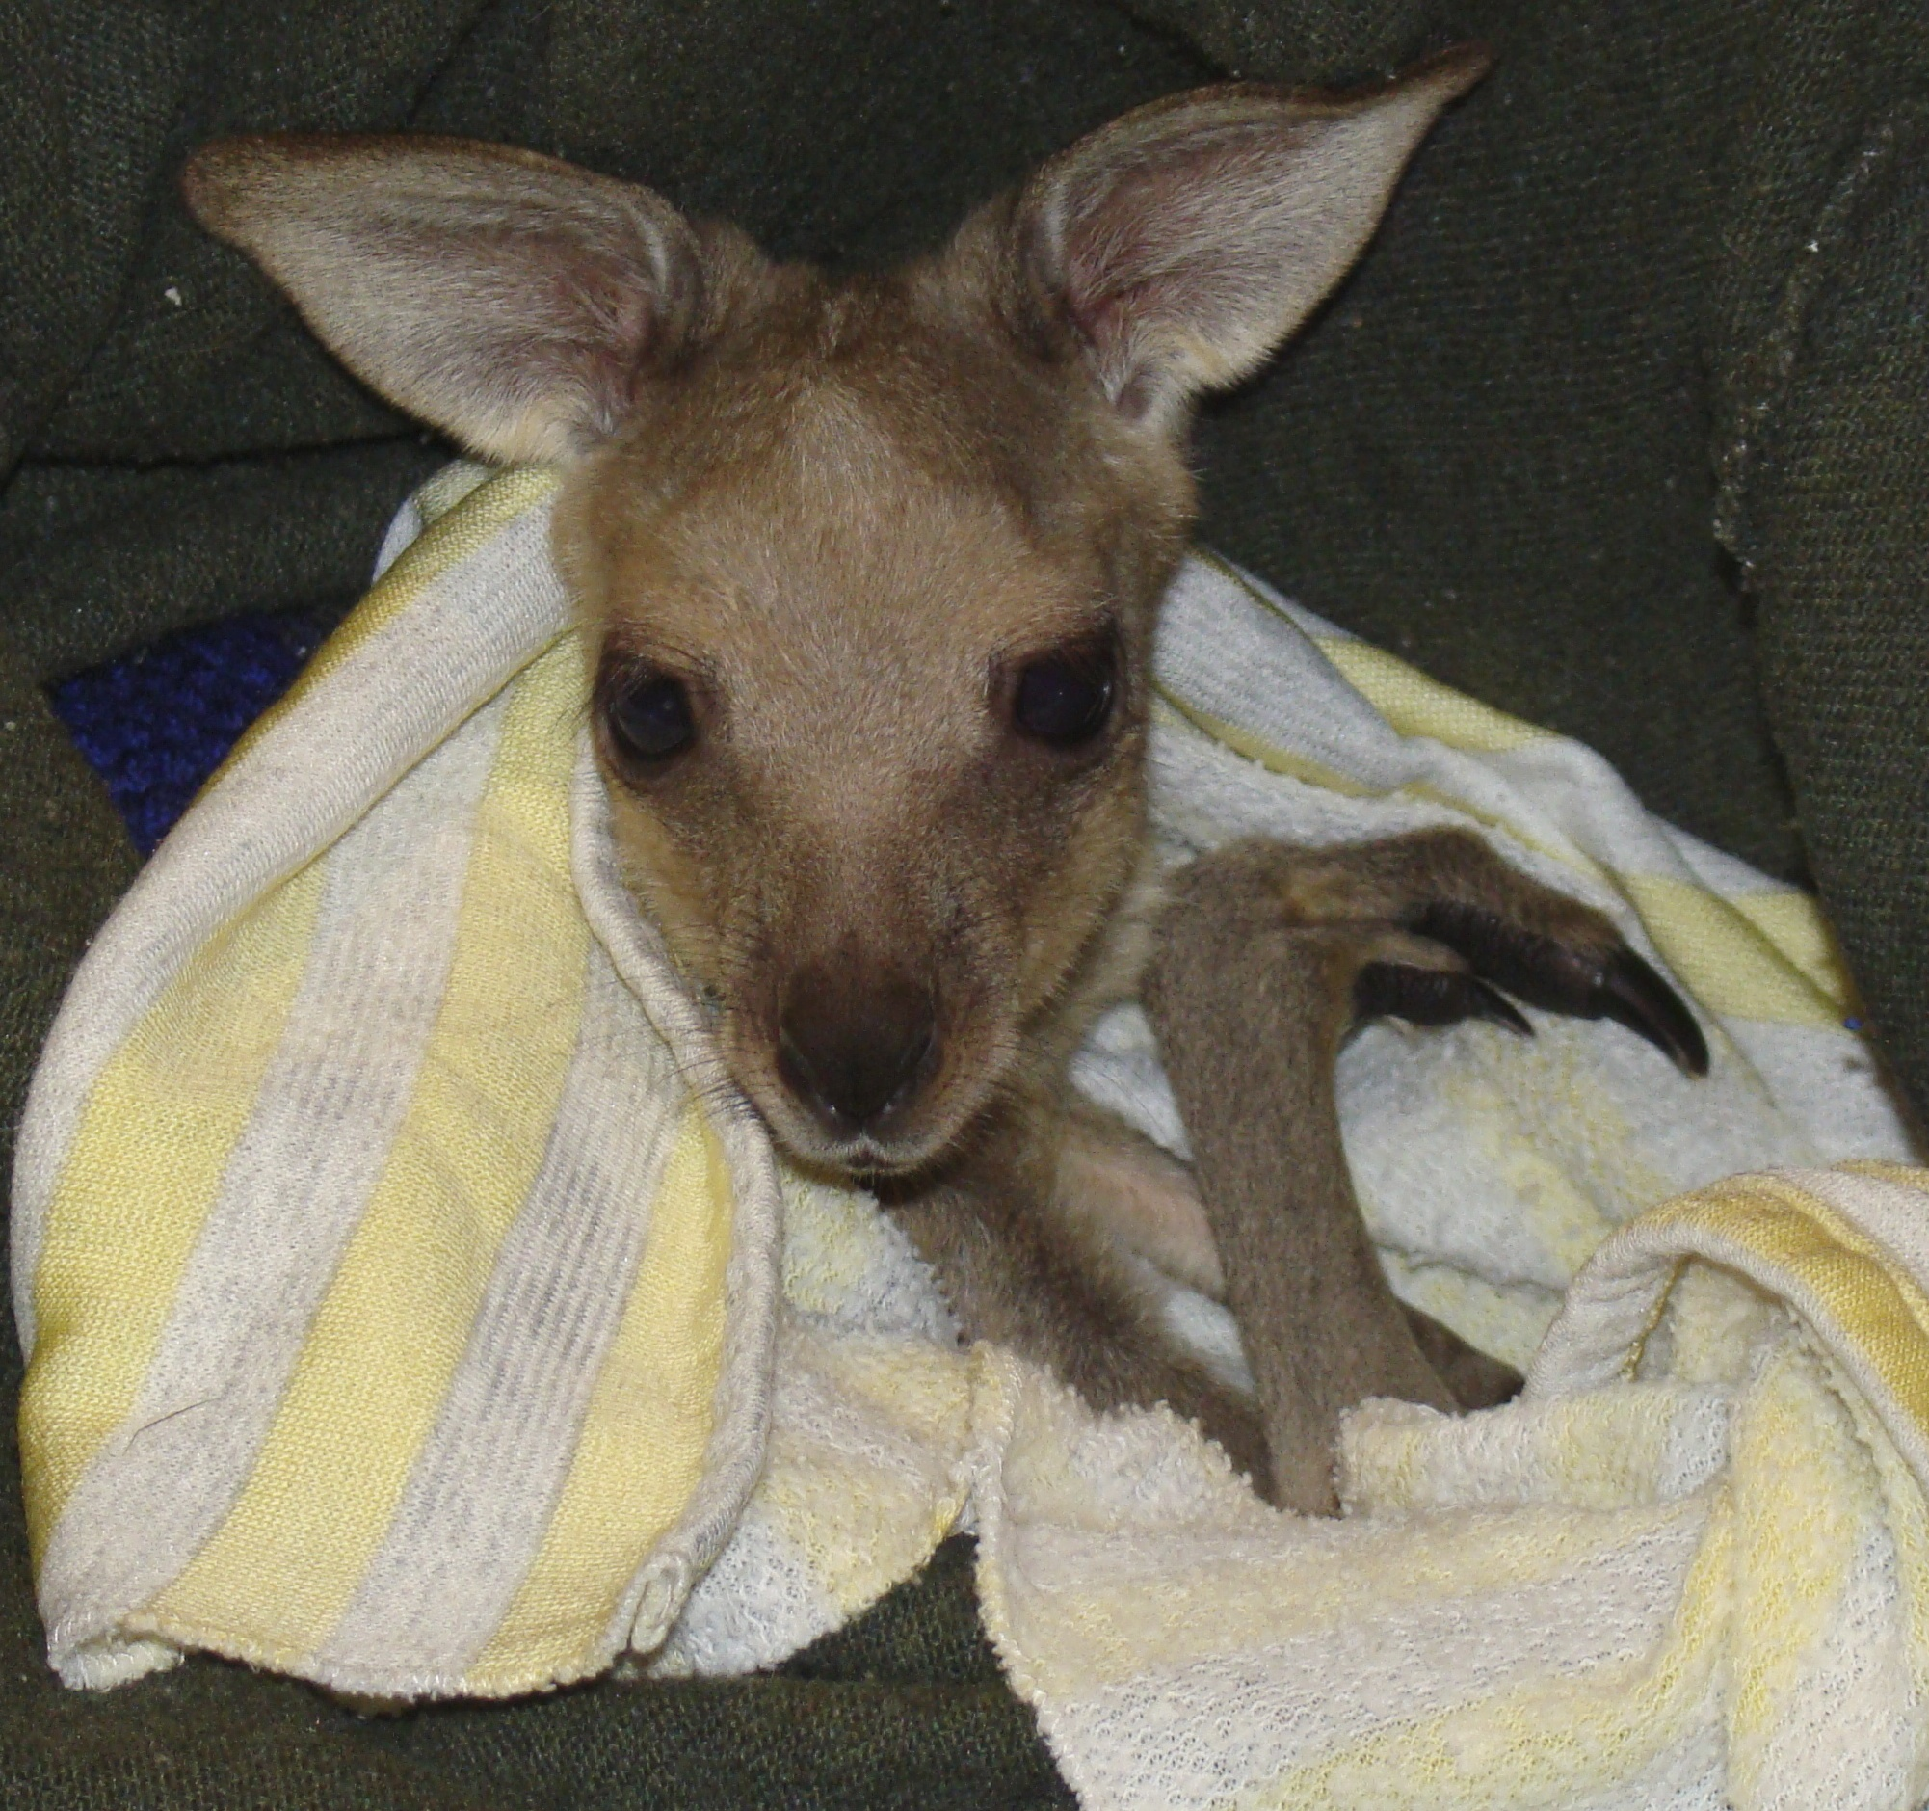

Naming Competition

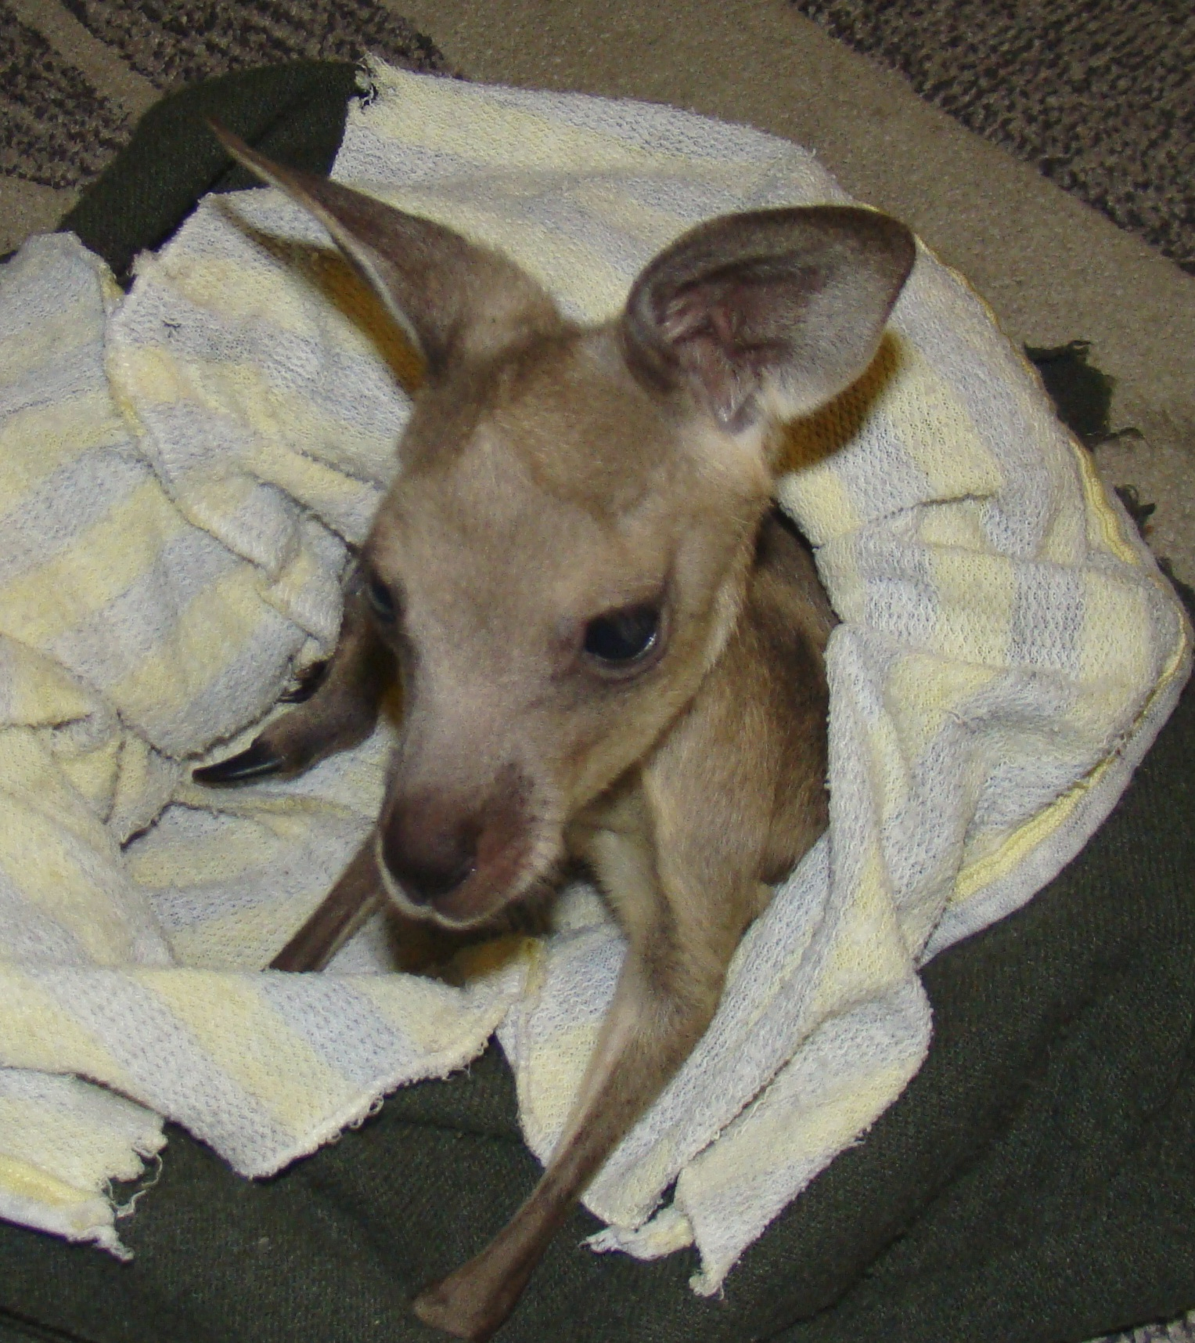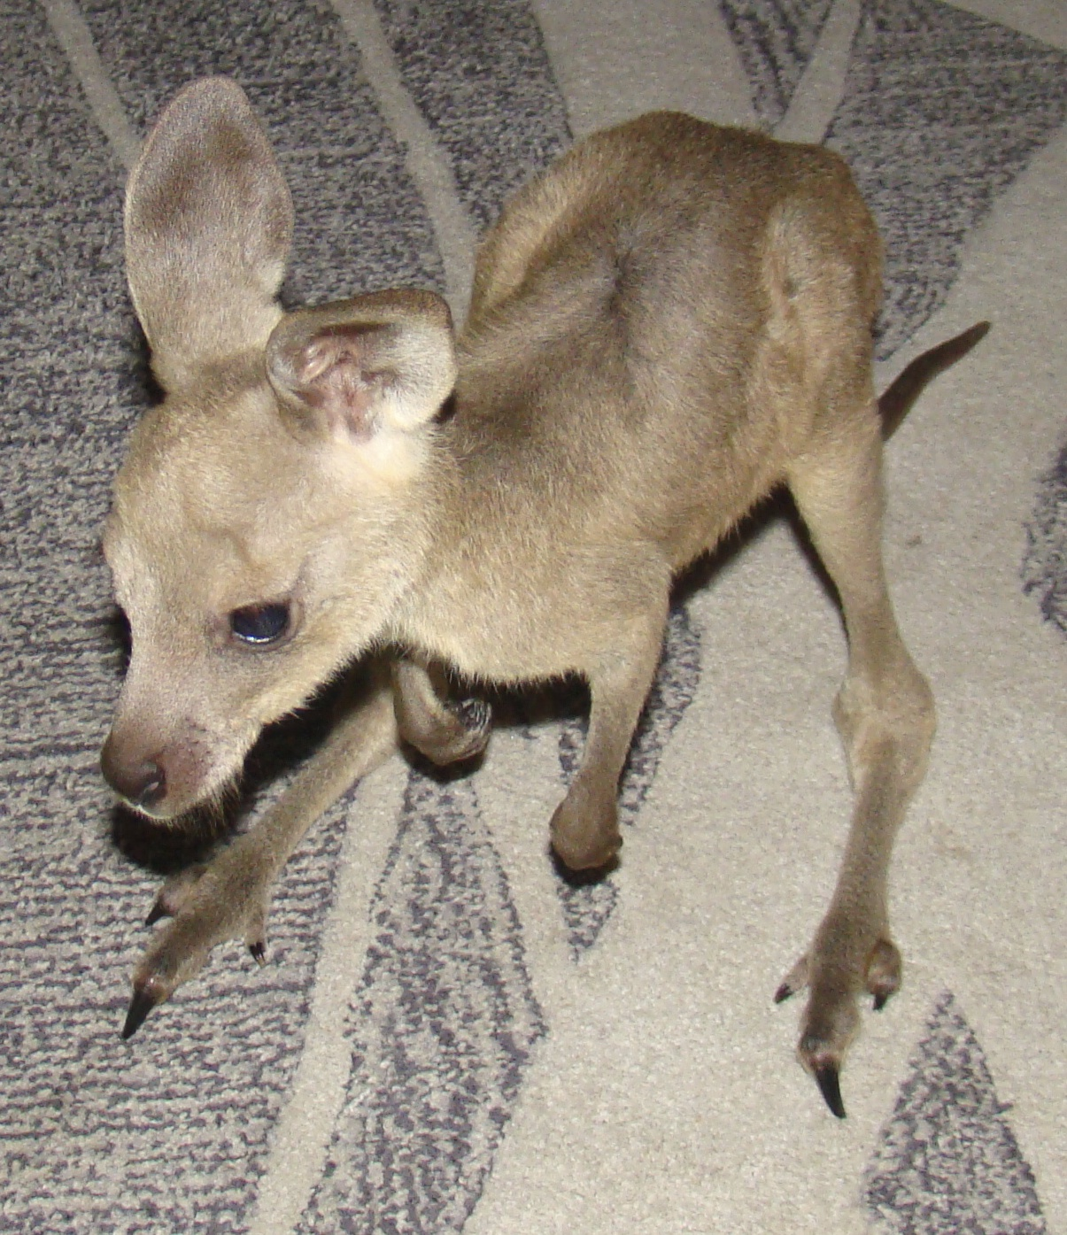

If above survey link doesn't work, please key in below into your browser:

http://www.surveymonkey.com/s/GNYZWXN

Every donation made to the "Rehabilitate Wallabies and Kangaroos in Sydney" project on the Global Giving site for the month of July can submit a name via this [Online Survey](http://www.surveymonkey.com/s/GNYZWXN).

At the end of July the winning name will be announced on our project page.

I'm a female Eastern Grey Kangaroo joey. I am approximately 61/2 months old and very cute.

I'm drinking and putting on weight, but I need a name. Please help.

Thank your for your support, every donation counts and helps us to care for Australian Native Wildlife. We appreciate your input and hope that you continue to support us.

Best of luck to you all ☺