Proposal for
Mama Africa Children’s Transitional Home.

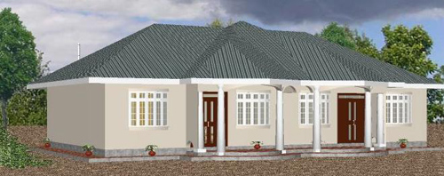
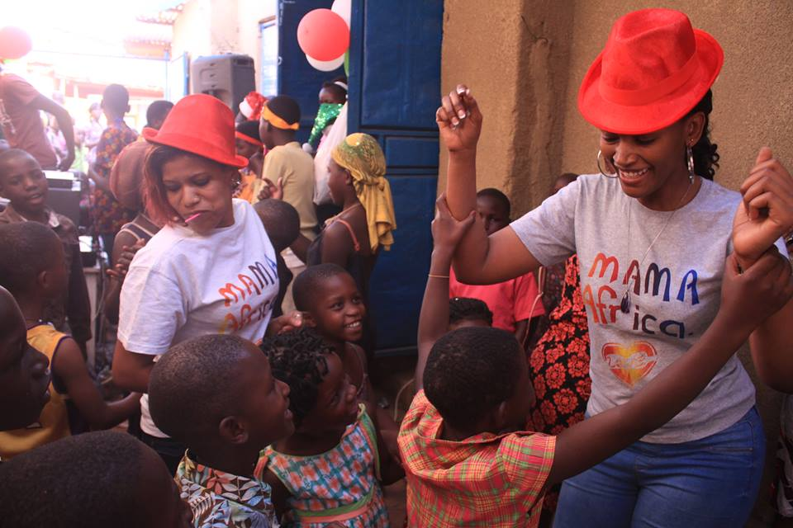

Table of Contents Page
Introduction ……………………………………………………………………………………. 3
Background ……………………………………………………………………………………. 4
The Proposal ........................................................................................ 5
Mission and Policy Statement ……………………………………………….. 5
Aims and Objectives …………………………………………………………….. 5
Goals ……………………………………………………………………………………. 5
The Home ………………………………………………………………………………………… 6
The Children ......................................................................................... 6
Médical Care …………..………………………………………………………………………. 7
Qualified Staff …………………………………………………………………………………. 7
Volunteer Placement ………………………………………………………………………. 7
Estimated Funding Needed ……………………………………………………………… 8
Getting Started …….……………………………………………………………….. 8
Individual Homes ……………………………………………………………………. 8
Monthly Maintenance Costs ………………………………………………… 8
Proposed Sources of Funding…………………………………………………………….. 9
Fundraising Ideas ................................................................................. 9
Management and Contact Détails …………………………………………………… 10
Board of Directors ………………………………………………………………… 10
Committee Members ............................................................... 10
Contact Details ......................................................................... 10

Introduction
Mama Africa is a non-profitable organization founded by Winnie Kyewalabye in the year 2008 with the mission of bringing hope with love to meeting the spiritual and physical needs of vulnerable children and women in Uganda, through strategic partnership, ministering and undertaking specialized and sustainable child focused initiatives."(For every child, life in all its fullness”)

Since our launch we have served over 200 children by providing meals, shelter, emotional support and education. We believe – as we know you do – that every child in this world, either from east or west has a right to good food, safe drinking water, shelter, clothing, health care and an education. Our goal for the children we serve is that they will not only have their daily physical, emotional and educational needs met, but that they will have the vision to be leaders in their generation in Uganda and beyond. Do achieve this, we want to take them out of the slums and build them a home that will be a clean, safe and inspiring place to live. But we cannot do it alone. We need your help!

WHO ARE WE?
We a Christian humanitarian Organization registered by the Uganda Government (S. N.G.O NO. S.5914/10612).It's head offices are located in the slums of Kosovo Zone, Kulekaana salaama Sub-County, and Kampala District. In August 2008, Mama Africa the Voice Uganda changed from being a community based organization to the NGO status.
Mama Africa the Voice Uganda is a team of dedicated Ugandan members with a commitment to give hope to the orphaned, street children, women and children from impoverished families.
MISSION
Mama Africa the Voice Uganda is committed to meeting the spiritual and physical needs of vulnerable children and women in Uganda, through strategic partnership, ministering and undertaking specialized and sustainable child focused initiatives."
Our VISION for every child, life in all its fullness!
Mama Africa the Voice Uganda envisions an improved quality of life of Vulnerable Children and women in Uganda with quality Education, proper Accommodation and Health Care as well as the tools and support to lead a Godly life.
SOME FACTS ABOUT UGANDA
The Ugandan children that we serve are among the millions of children worldwide that are born without access to safe, clean water, food and basic healthcare. Education for these children becomes a luxury in life of basic survival.

These are the major problems they face:
- Years of drought has left thousands of people with failed crops and little to no access to drinking water. This has increased malnutrition and mortality in children*.
- The past wars and HIV/AIDS which left thousands of children orphaned and vulnerable after their parents and relatives were murdered by fighting communities
- High levels of HIV/AIDS related cases resulting in young children being left orphans, in the care of the aged population, who are unable to look after them
- High levels of poverty with nearly 7.5 million people (1/4 of the population) still earning less than one dollar a day*. This has resulted in high numbers of;
- Malnutrition
- Illiteracy
- Street families
- Drug and alcohol abuse
- violance
- Teenage pregnancy
- Child abuse, exploitation, neglect and abandonment
And early death from preventable diseases, such as malaria, cholera, TB, typhoid and measles. The average life expectancy in Uganda is only 57 years -65 *.
* Sourced from www.unicef.org
OUR STORY
Winnie Kyewalabye was herself a vulnerable child born in the slums of Uganda. The challenges she faced motivated her to change her own circumstances so that she could help those around her. When she was 13 years old, she began taking children into the tiny home she shared with her mother. Soon the home was overflowing. So they got another home. And Mama Africa was born. In the midst of overwhelming need, she gives what she can and trusts that God will supply the people and the resources that are needed. And so the ministry has grown.
"If we are to reach real peace in this world . . . we shall have to begin with the children."(Mahatma Gandhi)
As God has placed us into positions to Restore 68 orphaned, street children’s lives in the slums of Kosovo Kampala and the rural areas of luwero district kaiyindu village in Uganda, many lives have been changed and transformed. Not all come back but among all that you and I have impacted 1 will always come back to that place that is called home. Luke 17:11-19 recounts how Jesus Healed Ten Men with Leprosy. Only 1 came back. But that one glorified God.
Together friends and Mama Africa family we have wondered what we can do to help these underprivileged kids. It is here that we all dreamed of providing these children with a loving home, an education and some much needed medical care.
Winnie left her full time job to a commissioned job and all her saving to rescue, restore, rehabilitate and Empower children, women and the community. It has been a journey but kept the dream alive of one day building a home. After further discussions with friends and the team, we decided to share the dream and vision. Nearly everyone who has become part of Mama Africa the Voice Uganda family contacted said that it was also a dream of their own and would help out in any way possible. We have gained Moral support, Prayers and commitment from compassionate people from all around the world, and with that the ball started rolling with the dream of Mama Africa children’s home.
The Proposal
Mission and Policy Statement
To provide a stable foundation that is rooted in education and health care for orphaned, vulnerable, deprived and destitute children who have lost their own family. We will provide a loving and safe, family environment that enables children the right to a happy, educated, skilled and healthy life.
The 'WHAT'
- Provide love, food, shelter, clothing, education, safe drinking water, medical care and career opportunities to orphaned, deprived and destitute children
- Help cut down the number of street children in the Ugandan society
- Reduce HIV/AIDS related cases, through education and prevention
- Improve access to education for underprivileged children, by creating a sponsorship program
- Help children who are not academically inclined to acquire technical skills, which will allow them to support themselves in the future
- Continue the close working relationship with Government Rescue Centers and Children’s Homes in order to help provide the local community sustainable with the fundamentals needed in their society.
- The "HOW"
Build a children transitional home that will raise, nurture and re-habilitate children, aged 2 and above.
Employee trained, knowledgeable and caring staff to guide the children down the right paths
Fence and utilizing the land in a way that it will become self-sustainable by growing our own crops, buy milking cows, install a rainwater tank and by creating a poultry farm
Gain constant sources of funding to maintain the project.

SOURCE OF FUNDING
Mama Africa the Voice Uganda ,Child Sponsorship program funding is provided by individual and sponsors supporting specific children with $25/month for a sponsorship The construction of the Mama Africa children’s home will cost $, 56,041 which must be raised in its entire
The Home
Mama Africa the voice Uganda has already acquired 3 acres of land on the outskirts of the town of Kaiyindu kalule village, in Uganda. The rural area 24 km and is lush and fertile, which will provide us with excellent conditions to make our home as self-sustainable as possible.
"This amount of $56,000 will cover the construction and one year's maintenance of the transitional home itself (with sleeping accommodation for up to ten children in each dormitory and a house mama) Each house will act as an individual home, with up to 10 children (boys and girls) and a house mama. Each home will comprise of male and female bed and bathrooms, a bedroom for the house mama, living area, dining room, kitchen, store and laundry.
There will also be a two storey community centre with two training classroom, a library, computer room, TV/DVD
There will also be a relative playing field, a small poultry farm and a communal shamba (farm) with crops such as maize, cabbage, spinach, potatoes, carrots, bananas, and avocado and mango trees. As time progress, we would like to manage and sell our crops and eggs to provide us with more funding.
The Children
The un-resettled majority of children will come to our homes from Government Rescue Centers, via the probation, police and community leaders. Children are placed into these centers by government officials after they have lost their families for one reason or another and have no one else to care for them. Some have lost their families due to ill health, death, or abandonment; some have run away due to the abuse and desperation within their own homes, or some are simply lost. Most of the children have been taken off the streets by police and brought to these Rescue Centers.
After all avenues of tracing for their parents or relatives to care for the children have been exhausted, Mama Africa will take these children into our transitional home and care for them as if they were our own. Before we own vocational primary school, they will attend a nearby public primary school, from grade 1 to 8, and then attend a secondary school (grade 9 to 12). We will also provide vocational training for those children not academically inclined. Nursery classes will be held at the home. This transitional home will always be there for the children, even when they leave to pursue their own dreams. They will always be able to call it their home.
We will provide everything a child needs to prepare them to gain the most they can out of life. Counseling will be a high priority as these children have been through more hardship then most of us can imagine.
Medical Care
The children will attend a nearby medical clinic/hospital when they fall ill. There will be a small medical clinic/store on site in future. All staff working at Mama Africa the Voice Uganda will be trained in Senior First Aid so minor injuries and illnesses can be treated at home. In time Mama Africa would like to extend their clinic to the surrounding community.
Qualified Staff
All staff working for Mama Africa the Voice Uganda will be qualified, caring and professionals. Additional training will be provided to our staff including, sensitivity training, cultural diversity awareness, HIV/AIDS awareness and prevention, emergency and safety procedures and hygiene awareness. This will provide them with skills to teach, communicate and build relationships with the children as well as the volunteers within their placement.
Volunteer Placement
A volunteer placement program will be established once the home is up and running. The program will allow persons from our global community to experience Mama Africa the Voice Uganda and the Ugandan lifestyle. Volunteers will stay at the children’s home, but have their own area in the community centre. They will be involved with the day to day running of one of the homes, helping the house mum with household chores, preparing the children for school, teaching/educating, counseling, playing and of course provide some much needed love and care. Simply being there for the children is one of the best things you can offer, as it brings the biggest smile to their little faces.
There will be an opportunity for the volunteers to see the beauty that Uganda has to offer. Having a well-rounded approach to volunteering in Uganda will enhance the quality of the lives that participate on the program, the children and the Ugandan tourism industry.
Any volunteer wishing to be placed at (MATVU) will undergo an application process before placement will be approved. This is a safety measure to protect all parties involved. Volunteers will also be asked to pay a fee to (MATVU), which will provide them with housing, meals, cultural sensitivity and diversity training. A caretaker will ease them through their time spent in Uganda.
Mama Africa the Voice Uganda will always guide on housing for the volunteers before their community centre construction during the time of building, so any volunteers wishing to help out with building is welcome to stay here. Please contact us at admin.mamaafrica@gmail.com for more information.
Estimated Funding Needed
Mama Africa the Voice Uganda is starting from square one. Land is acquired already, fencing the land as phase 2, Toilet and water drilling and then construction of the children’s home. There will also be monthly maintenance costs, all of which is described below.
By contributing to this campaign, you'll receive a chat with messages from the children. You'll also enjoy the satisfaction of knowing that your generosity will help make life less stressful for orphans and vulnerable children.
Mama Africa the Voice Uganda is counting on your support. Please go to globalgiving.org or email us at admin.mamaafrica@gmail.com to make a donation. Every donation, no matter what size, is greatly appreciated and will be put to excellent use. Thank you in advance for your willingness to support the efforts of Mama Africa Children’s Home and make a difference in our country.
Getting started Exchange rate: $ 2900
Item | Price (Ugandan Shillings) | Price (US Dollars)
fencing 3 acres 600 meters Barbed wire | 840,000 | $ 290
Treated Poles | 750,000 | $ 259
Nails | 100,000 | $ 35
Labor, stacking poles and digging holes | 500,000 | $ 173
Approving plan fees to council | 2,500,000/= | $863
Toilet construction | 14,500,000/= | $5,000
Water well | 7,000,000/= | $2,413
Total | 26,190,000/= | $9,041

Individual Home
Item | Price (Ugandan Shillings) | Price (US Dollars)
Home construction | 101,500,000/= | $35,000
Home furnishing | 34,800,000/= | $12,00
Total | 136,300,000/= | $47,000
Proposed Sources of Funding
Mama Africa the Voice Uganda is looking for separate entities to sponsor and fund an individual home, church or company. Each Dormitory wing will be dedicated to the sponsor who will be allowed to choose its name and will be responsible for the building and monthly costs of their home. They can choose to be as involved in the project as they wish.
We are looking to gain sponsorship and support from international donor agencies, churches and charities for the costs of building and maintaining the community centre. We welcome friends like you who will run fundraising events globally like Uganda, Australia, Canada, America and everywhere that God places you to support the vision of the children’s home and will also have monthly supporters helping to fund our monthly maintenance costs.
Funds will be generated locally via several small projects on the land i.e. the poultry farm. Crops will be grown to cut down on costs and to become as self reliant and sustainable as possible.
Fundraising Ideas
Place a donation jar at your workplace
Raffles
Churches
Poker / casino / games nights
Trivia nights
Barbeque day / night
Music / comedy nights
Golf tournament day
Car boot market
Bingo nights
Sponsored run – Half marathon, marathons
For more information or to donate please go to www.mamaafricaorganization.org

Management and Contact Details
Board of Directors
Founder/CEO: Winnie Kyewalabye
Vice President: Rev. Elijah Musoke
Chairman Board: MR: DITHAN KADDU
Treasurer: Namiiro Esther
Team Adviser: Mr. Frederick Sssimbwa
Social work& Secretary: MRS BRENDA BIRUNGI MAINZA
Contact Details
Winnie Kyewalabye
Phone: +256772643684/0702643684 Uganda
Email: admin.mamafrica@gmail.com
Website: mamaafricaorganization.org
Face book group: ‘Mama Africa Children’s Home’

ACCOUNT NAME: MAMA AFRICA THE VOICE UGANDA
ACCOUNT NO.8702865195800
SWIFT CODE: SCBLUGKA
P.O.BOX 72111 KAMPALA
PLOT 1156 NDEEBA

