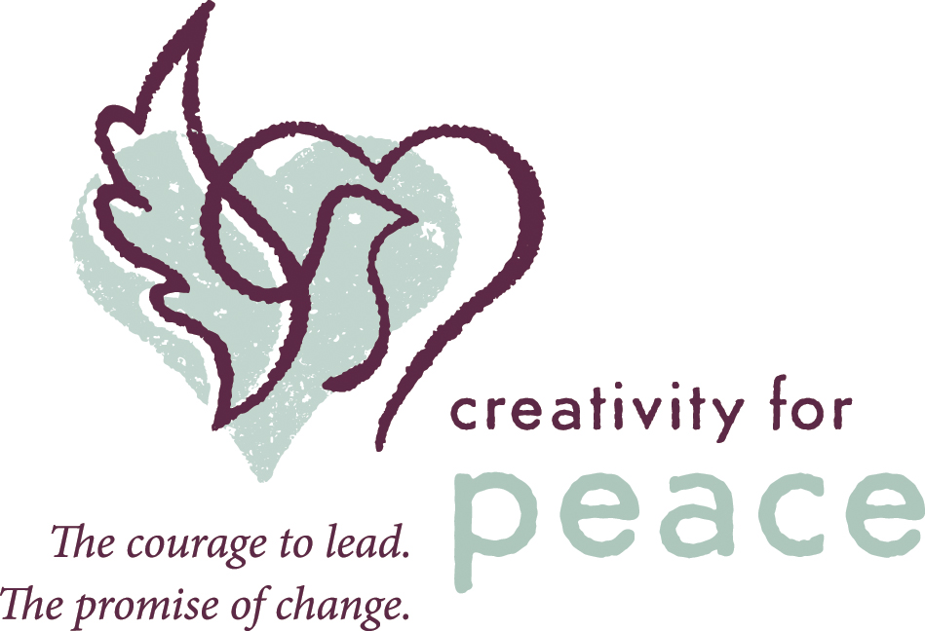
A TEN YEAR
JOURNEY OF HOPE

The first Creativity for Peace summer camp held in 2003 grew out of the simple yet bold dream of founder, Rachel Kaufman. She passionately believed that if young women could be removed from the conflict in order to spend time together, hear each other’s stories, create art, share meals, and have fun, the fear and hatred that separate them would disappear. They would meet not as Israelis and Palestinians, or Jews, Muslims and Christians, but as teenage girls.

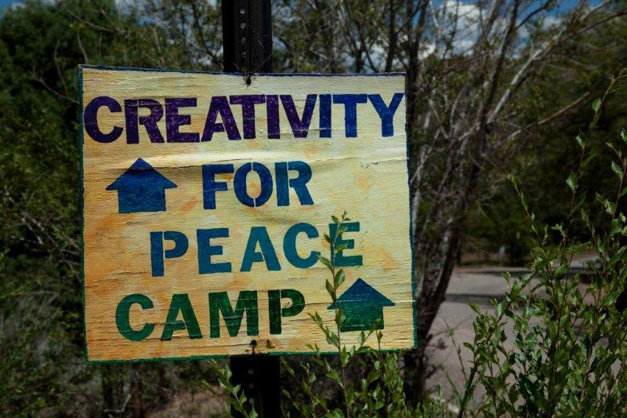
Ten years on nearly 200 teenage girls have attended camp in the safe and beautiful New Mexican wilderness, away from the war and propaganda of both sides. Our unique three-week program combines dialogue, art and social activities, starting a process of transformation that will profoundly change the campers. As stories are shared, anger expressed, fears and hurts exposed many tears are shed. But over time, hearts open. Israelis see Palestinians crying for Israeli family and friends lost to suicide bombers and rockets and lost to the army; Palestinians see Israelis crying for Palestinian family and friends lost in bombings and lost to checkpoints and blockades. AND HERE THE HEALING STARTS with understanding and compassion for the enemy.

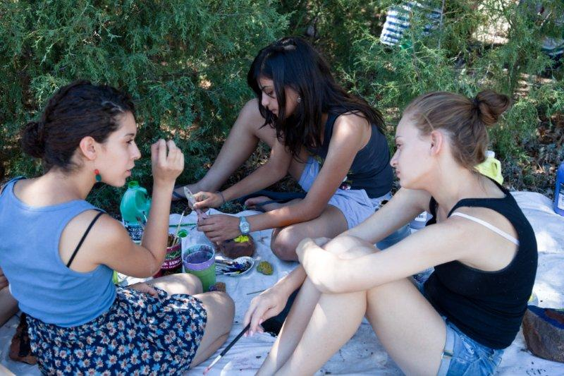
The friendships created at camp are enduring. During the bombings in Gaza and the rocket fire in Israel last December, among the cries of anger and anguish, our Creativity for Peace group saw an outpouring of love and concern. Girls reached out to each other across the divides of war.

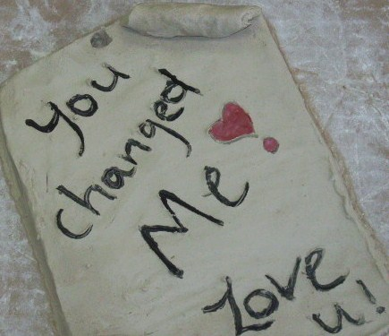
This endurance, in part, comes from our commitment to support campers when they return home. This is the hardest time for them. At camp they start to see the conflict through the eyes of the heart, and for this they are called at best “naïve,” but more often “traitor.” To help them face these challenges we run a year-round support program open to any young women who has attended camp in any year and an advanced young leader training program for those who want to make leadership and peacemaking an integral part of their lives.

Our overall mission is to train young Palestinian and Israeli women to partner as leaders by breaking down barriers of anger and prejudice, facilitating friendships, and inspiring action to promote peace in the region and internationally.

A few other things it’s good to know about us:

We only work with girls and young women - we believe they have the greatest capacity to achieve peace. We are inspired by women such as Ellen Johnson Sirleaf of Liberia, Aung San Suu Kyi of Burma, and Betty Williams and Mairead Corrigan of Northern Ireland, all of whom are Nobel Peace Prize Laureates.

There are other reconciliation programs for young men in the U.S., Canada, Europe, and the Middle East, plus a single-gender camp avoids many religious and logistical complications.

We work in-depth over the long term - we choose to work with fewer participants at greater depth in order to instill changes more likely to last for a lifetime.

We have developed a model of collaborative leadership - our programs are 100 percent balanced between Jewish Israeli and Palestinian and our training centers on teaching young women to work in partnership with the other side. We focus on cross-border leadership with women.

Our organization is entirely funded by private foundations and individuals – that’s why we need your support! PLEASE DONATE NOW!

To learn more, please visit www.creativityforpeace.com or contact Frances Salles, director, operations at frances@creativityforpeace.com or (01) 505-471-4802.

