Residential Learning Breaks Feedback Report
The money has made a real difference to the lives of many young people, helping them gain new qualifications and paying for visits to Avon Tyrrell, that otherwise wouldn’t have been possible. Below are examples of young people who have been funded by this (and other) revenue strands.
Below is a breakdown of how the money was used and some feedback from groups, so you can see what a difference it made.
Beneficiaries | Amount awarded | Activity
Bracknell Forest Young  Carers, Bracknell | £1,039.35 | It helped pay for seven young carers to have a full board activity weekend at Avon Tyrrell.
Mountbatten School, Romsey | £900 | Helped pay for students to do Avon Tyrrell Forest School’s programme in February and March 2012.
Helen and Douglas Elephant House, Oxford | £693 | Helped pay for eight young people to visit Avon Tyrrell in August 2012. All young people either have a sibling with a life-limiting condition or siblings who have recently died.
LCET, Luton | £500 | Support for a weekend visit to Avon Tyrrell on 23rd to 27th July, 2012.
Oak Grove College, Worthing | £320 | Helped pay for two people with learning difficulties to visit Avon Tyrrell on the 15th – 18th May 2012.
Solo, Reading | £1000 | Helped subsidise a group of young single mums and their children to enjoy a residential visit to Avon Tyrrell in July 2012.
Beaufort Primary School, Woking | £390 | Helped subsidise a trip for two young people on low incomes to attend a residential trip to Avon Tyrrell in June 2012.
Two families from Southampton | £180 | Paid for two families on low incomes to attend The Big Bike Bash, 18th – 19th August 2012.

Oak Grove College, West Sussex | £400 | Contributed towards the cost of two young people’s visits on the 11th - 13th March 2013.
Winchester Young Carers Project | £202.50 | Activity day for eight young carers aged 8-11 on 5th April 2013
St John's Church - Hythe | £189 | Contributed towards a five-day break at Avon Tyrrell in December 2012
WAC Performing arts college, London | £500 | Paid for young people with learning difficulties to visit on the 5th - 9th August 2012
Shepperton Youth Centre, | £629.40 | Contributed towards the cost of 20 young people’s visits to Avon Tyrrell on the 18th-20th February 2013.
TOTAL | £8000
Feedback from some of the groups helped by Wettons money

Bracknell Forest Young Carers
Bracknell Forest Young Carers had a brilliant weekend and carried out an excellent report, which will be submitted with this report.
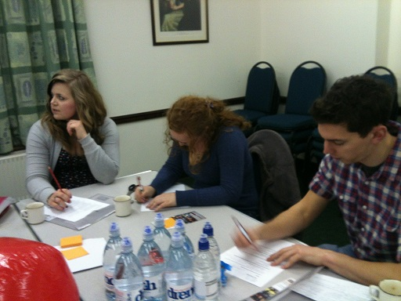
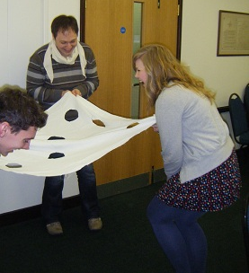
Stand Against Violence
Young people have nearly completed their BTEC in Peer Education. Their communication skills have really improved and they have gained so much confidence from taking part in this qualification.
Young people during the sessions

Mountbatten School, Romsey
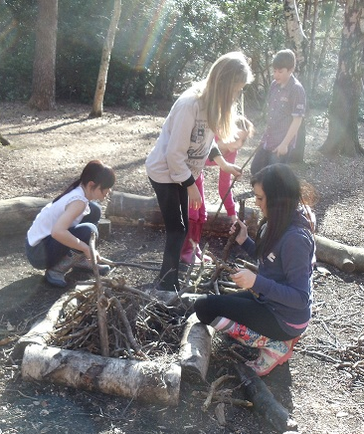
The bursary paid for two six-week Forest School’s courses for students from Mountbatten School. Thirty young people took part in the course.
Young people learnt many useful skills like fire building/lighting, safety with knives etc. The kids really enjoyed the experience and friendships have been firmly cemented in little groups. Some children who were having problems and not wanting to come to school have really grown in confidence and their attendance has improved. They have definitely benefited from being outdoors and having some space and freedom.

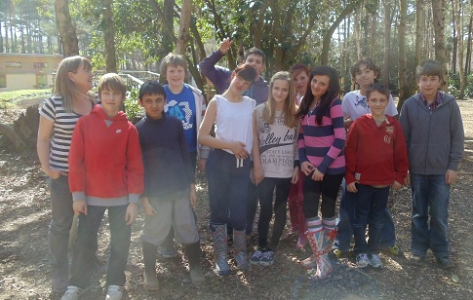

Here is feedback from some young people:
“I enjoyed making loads of different foods, I’ve learnt how to make a fire and I love doing teamwork.”
“I love walking and making lots of food”
“I love Forest Schools, it was fun and the bread is really nice and yummy and Louise and Ellie are really nice.”
“I liked making the fire and cooking.”

Helen and Douglas Elephant House
Young people were able to take time out from their caring responsibilities at home. By participating in a number of activities where they needed to work together, they learned valuable team working skills. They have been able to meet up with other bereaved young people or young people who have a sibling with a life limiting condition, and therefore no longer feel so isolated.
They were able to participate in a number of activities which many of them had never tried before and most likely would not have the opportunity to ever try. They made new friends. Their self-esteem improved as a result of trying new things and achieving in new areas.

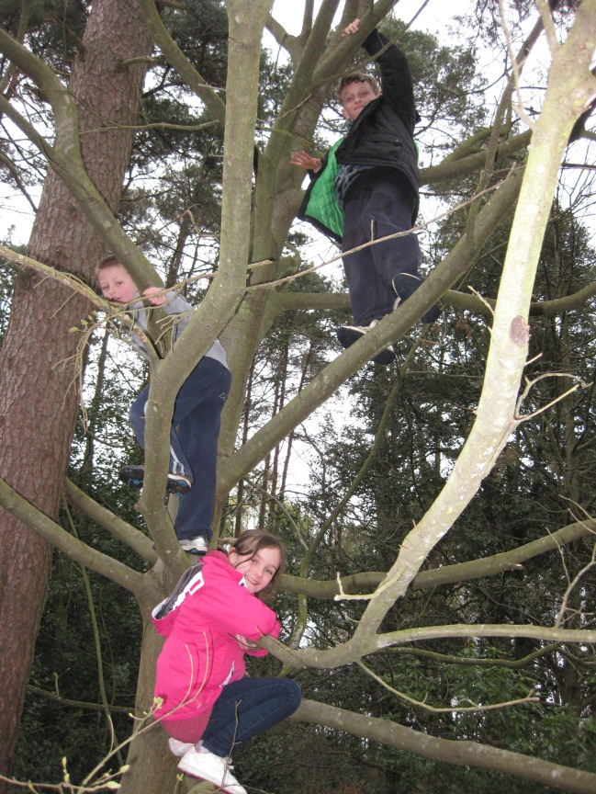
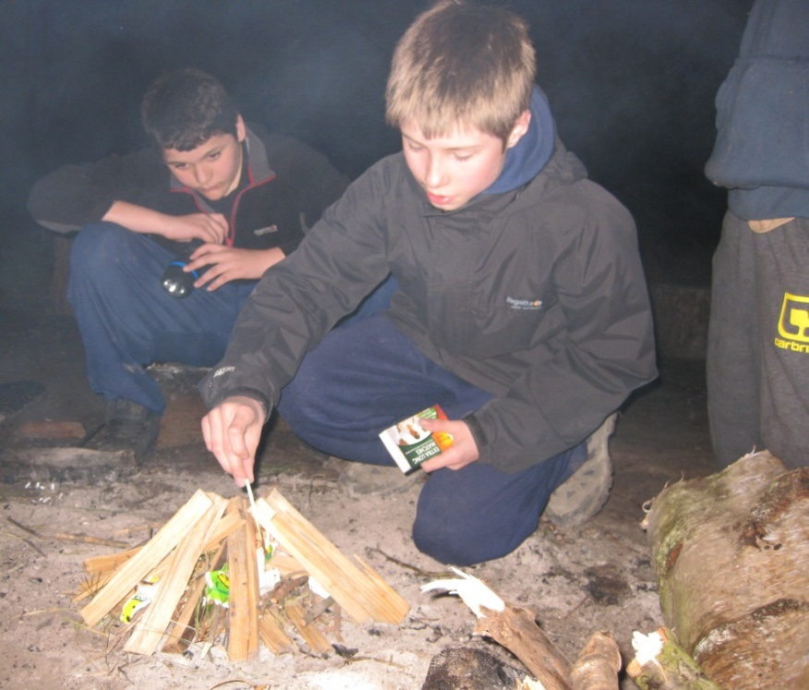

LCET Luton
Big Fish, Little Fish, LCET Summer Camp 2012

Big Fish, Little Fish was held at Avon Tyrrell, it was bigger and better than anything we’ve ever done before. We took 55 young people away with us from a variety of backgrounds. Approximately half of those are children in care, and many have experienced, or are still experiencing, difficulties with self-harm, managing their anger, self-worth, and difficulties with reaching their potential. Thanks to Wettons support we were able to take 39 young people who otherwise would not have been able to attend.
We were very excited about the trip and worked hard to ensure that there was something for everyone, from relaxing by the lake, keeping warm by the campfire and walking on the local beach. We offered young people quite a physical challenge too. They went on the zip wire, swam in the pool and our crazy challenges tested our campers to the limit.
Meet Tamera
Tamera is a young person we’ve known for a few years now and it’s only because of funding from Wettons that Tamera has been able to join our summer camp.
She had to live with her auntie because things were so bad her mother couldn’t take care of her anymore. She blamed herself and started to develop very low self-esteem. It was at the summer camp that she found other young people who could relate to her story. Hearing stories from her peers, she broke free of the belief that things were her fault. It’s these kinds of relationships that have developed on Big Fish, Little Fish; the kind of friendships that come out of shared experiences and ones that stand the test of time.
Tamera remains a regular member of our Wednesday night drop-in café. It’s here that she can continue the friendships she has built up and have the opportunity to build new ones too.
Once again, thank you Wettons for financially supporting our summer camp, it has made a genuine difference.

Oak Grove College
This has helped young people develop their social and emotional skills and also their daily living skills and independence. They were able to also take part in adventurous activities such as canoeing and high ropes. These were amazing experiences that they would not have had the opportunity to experience had they not been able to come to Avon Tyrell. On behalf of the young people, thank you so much.

Beaufort Primary School
The bursary paid for Blaise and Nia to attend a five-day residential trip to Avon Tyrrell.
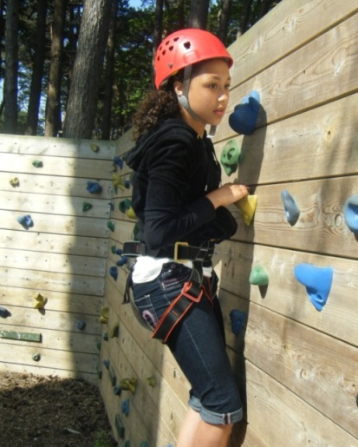
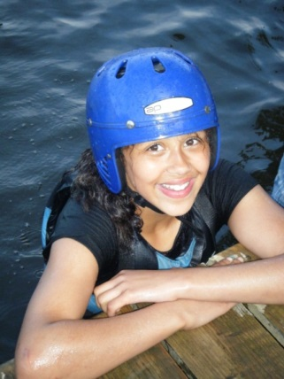
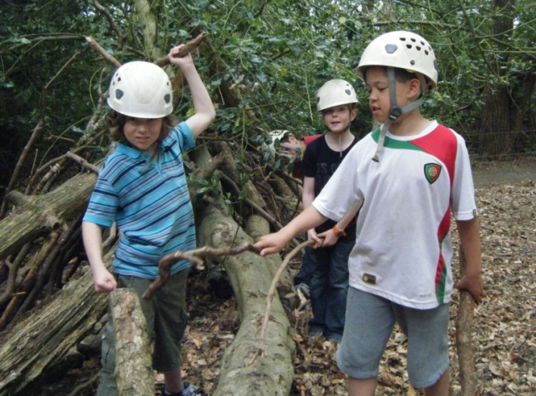
Blaise and Nia had an amazing time at Avon Tyrrell. They did team building exercises, climbing, abseiling, raft building, mountain biking and a treasure hunt in the New Forest. They also sat around a campfire and toasted marshmallows. On the last day they built a den and jumped in the lake! This wouldn’t have been possible without the generous support of Wettons, so thank you so much.
