GLOBAL GIVING INCOME-GENERATING ACTIVITIES
January – March 2012

NEW BENEFICIARIES ASSISTED DURING THE REPORTING PERIOD
Six very poor and needy women from Gulele sub-city, Woreda 5 and five from Arada sub-city, Woreda 7 are separately preparing and selling different food items (traditionally called Baltina) in shops in their woredas. Although, each woman desired to be in business, financial problems prohibited them from starting. Their need and demand was identified by local leaders and each woman was recommended for the Global Giving income generating fund.
Along with providing them Global Giving income generating activity (IGA) seed money, they all received skill training for three days on business management, recording daily income and outcome, market surveying, and handling customers. They were also provided with awareness creation training on sexual and reproductive health, reproductive rights, family planning, HIV and AIDS, and harmful traditional practices.
They have all started running their businesses properly. They are registered and were given certificates by their respective woreda microfinance enterprises. The newly selected IGA beneficiaries are linked with their respective district administration microfinance office to attain legal status and access ongoing training and loan service. The microfinance office also helps the women secure a work place and provides other relevant supports like market assessments. All of these services help them to build a sustainable business.
The total number of Global Giving IGA beneficiaries through March 2012 is 77.
New IGA beneficiaries profile
Tigist Bekele is living in Gulele sub-city, woreda 5. Her husband is a day-laborer and they have three children, two of them are female and the other one is male. All of the children are attending school. Tigist is a house wife with no paying work. Life was very difficult for them and with the very limited income they were unable to properly feed and support their family. Therefore, the Gulela sub-city women’s association’s executive body realized their problem and recommended Tigist to get Global Giving IGA support.

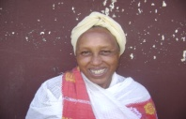
Zinash Bulto also lives in Gulele sub-city, woreda 5. She is working as a house maid. Her husband died, leaving her with five children. It is difficult for Zinash to properly feed and support her family alone. She had difficulty sending all of her children to school and fulfilling their necessary school materials and clothing. Though Zinash has many skills and a great desire to make different traditional food (baltina) to sell, a lack of money prevented her from starting this small business. Eventually, she applied for IGA support. The Gulela sub- city women’s association’s recommended IGA support and provided her with the seed money to start her desired small business by organizing with other Global Giving IGA beneficiaries.
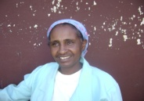
LISANWORK YTAYE also lives in Gulele sub-city, woreda 5. She lives with her husband and her five children. They have very limited income, which is not enough to properly feed and support their large family. Lisanwork had a desire to be engaged in a small business (selling baltina) to change her family’s living condition. Thus, she applied to the sub-city women’s association to be provided with Global Giving IGA support, and she was given seed money to start her desired business
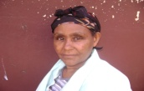
EMEBET MAMO lives in Gulele sub-city, woreda 5. She is a housewife. Her husband died, leaving her with six children and without support. Emebet has skills in preparing traditional food. She tried to engage in selling food items at a smaller level to support her large family. However, though she worked hard, the income she earns from this business was not enough to properly feed her family. The woreda women’s association, clearly understanding her problem, provided her with seed money to expand her business. Then Emebet started working on small business by organizing with other IGA beneficiaries. She is very pleased and grateful for Global Giving and Path finder International for the support they provided her.
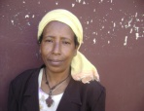
GENZEB GETACHEW similarly, lives in Gulele sub-city and woreda 5 with her six children. Her husband died and the family was left with no support. Life for Genzeb become hard and bitter - to the point where her family spent a day without any food. Genzeb then applied to her sub-city women’s association to get Global Giving IGA support. After getting the seed money, she started working in small business and joined the organized micro finance enterprise.

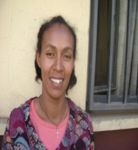
MEKDES GISILA is also living in Gulele sub-city, woreda 5 with her husband and their four children. They have a very little income, which is not adequate to support her large family. Though Mekdes is a young energetic woman with a lot of experience in home economic products who wants to engage in small business to improve her family’s life, a lack of initial money prevented her from realizing her desire. She heard about the Global Giving IGA support from her friend and she applied to the sub-city women’s association for seed money. After receiving support, Mekdes started working on the small business along with other group members with great pleasure and enthusiasm.

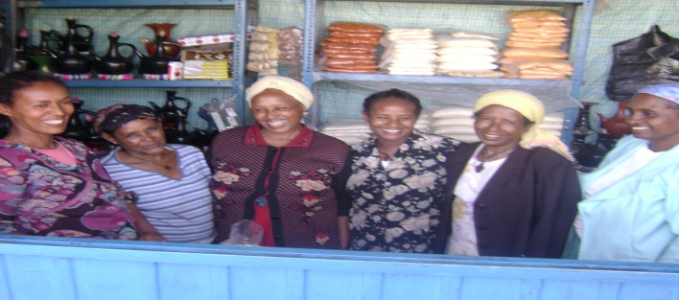

The organized group of Global Giving IGA beneficiaries from Gulela Sub-City selling baltina. All of the above Gulele beneficiaries have expressed their heart felt pleasure and gratitude to Global Giving and Path finder International for the financial support.
The following four women were selected from Arada sub- city women’s association based on the criteria indicated in each of their profiles.
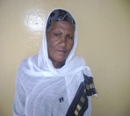
Abozenech G/ Wold is living in Arada sub-city, woreda 7, with her two female and two male children. She is divorced from her husband. Abozenech did not want to sit idle. She tried to do very small business of selling food items, but the income she earned was not enough. Though one of her children graduated with a diploma, she has not secured a job so far and Abozenech needs to support the family. Abozench applied to the Arada sub city women’s association to get Global Giving IGA support. The sub-city association recommended her to be a member of the IGA beneficiaries and she was given the seed money to expand her business and improve her family life.

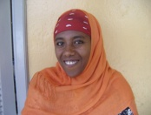
Almaz Demo also lives in Arada sub-city, woreda 7. Her husband died and she is responsible for taking care of her two children. Almaz tried to sustain her family life through a very small income from selling food items, but life got harder as the living conditions became more expensive. Sending her children to school became difficult. Thus, Almaz wanted to get some support and expand her business to change her family living condition. She applied to the Global Giving IGA support, received seed money, and engaged in the small microfinance enterprise “Baltina” with other beneficiaries. Almaz said, “I am very lucky getting this support, I am very pleased. I will do all my best to render my skill along with my fellow members. I will make anything possible to change the living condition of my children and myself. For this, I genuinely want to express my deep gratitude to Global Giving and Path finder International for this important and life-saving support. This support creates great confidence and pleasure in our entire future endeavor.”

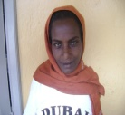
Aregash Senbet also lives in Arada sub-city, woreda 7. She has three children and her husband is a day-laborer working for a very low wage. They were living in very poor conditions and the income they earn is not enough to properly feed their family and send their children to school. Aregash needed to start a small business to support her family. She heard about Global Giving IGA support and applied to the sub-city women’s association, and received seed money. She became a member of small micro finance enterprise and started working with the organized group of other beneficiaries.

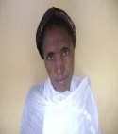
Emebet Abebe is also living in same sub-city and woreda, along with her pensioned husband and her five children. Two of her children have completed their high school education, but are jobless. It is the limited monthly pension salary that covers the immediate need of the whole family. Emebet wanted to start a small business to support her family and change their poor living condition. She applied to the Global Giving IGA fund. She got the IGA seed money and started running a small business by organizing with other micro finance enterprise members.

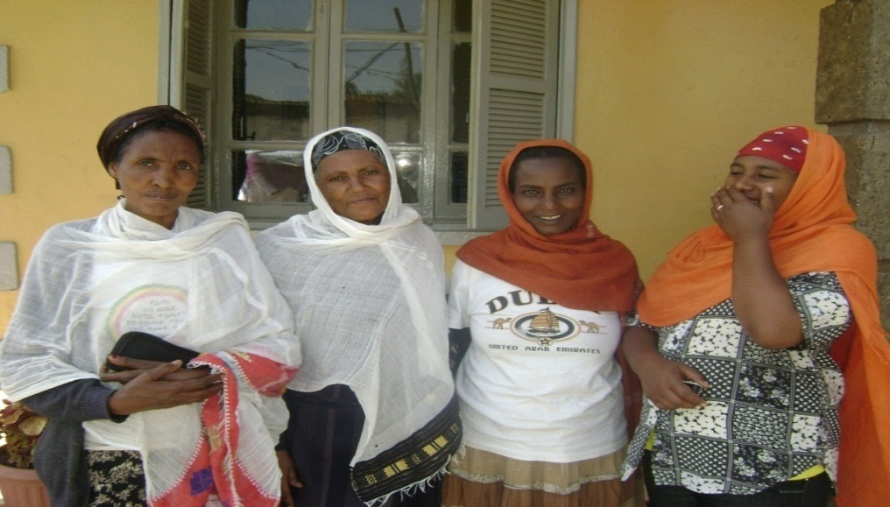
The women from Arada sub-city who formed an organized microenterprise.

