
PATHFINDER INTERNATIONAL
GLOBAL GIVING INCOME-GENERATING ACTIVITY
JANUARY – MARCH 2011 REPORT
Photos and Stories

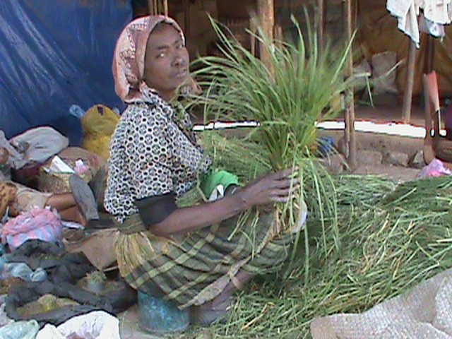
Mamitu Asefa lives at Arada Sub city Kebele 16. She has a daughter and a son attending 5th and 8th grade respectively. She also helps her aged mother who requires a great deal of support. Mamitu received IGA funds to prepare and sell injera, a local bread. She stated, “Before receiving Global Giving support, life was tough for me and my family, but after I received the Global Giving IGA grant, I started selling tea and bread and retail reeds for coffee ceremonies”. Her new business has enabled her to take care of her family.

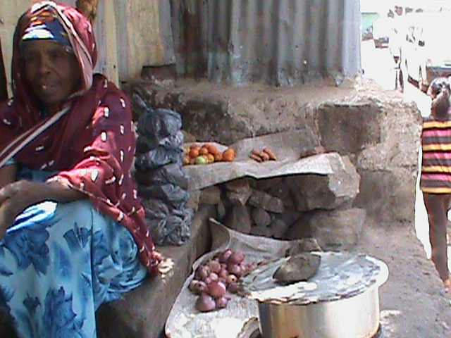
Getie Asfaw lives at Arada Sub-city Woreda 2. She works as a house-maid, living with her unemployed husband and 11th grade son. Getie used to preparing injera (local bread)and living off the proceeds. However, because of financial problems, she was forced to stop her business, and her family faced great hardship. However, after receiving financial supported from Global Giving, she restarted her small business and she has been able to purchase an electric stove. This has allowed her to prepare greater quantities of injera and serve more clients. In addition, Getie is now engaged in vegetable, fruits and charcoal retail. She said, “Thanks to the Global Giving financial support, me and my whole family are food secured and I able to cover monthly house rent, electricity and water bill, and buy all necessary school materials for my son, and also able to pay the monthly community social welfare contribution and has started the weekly saving of birr 5.”

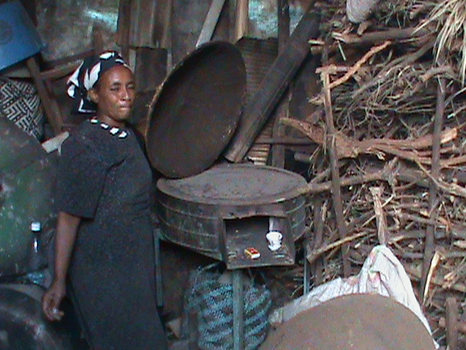
Asefash Mengesham, who lives at Arada Sub city Woreda 9, is a single mother who are raising three children; two of whom are 6th and 8th grade students. Asefash used to sell different kinds of processed food products, but due to financial shortage, she was forced to stop her business. As a result of this she was in great difficulties to feed her children. After she was selected to receive Global Giving support, she was provided with a seed grant to restart her small business. Asefash is now engaged in baking injera (local bread). She prepares 25 injera every day and earns birr 50 through sales. Asefah states, “I am very grateful for the Global giving support. Now I am able to provide for my family and buy the required school materials. My family and I are living very happily and we have psychological relief. In the future, I am planing to expand my business and to improve my life.”

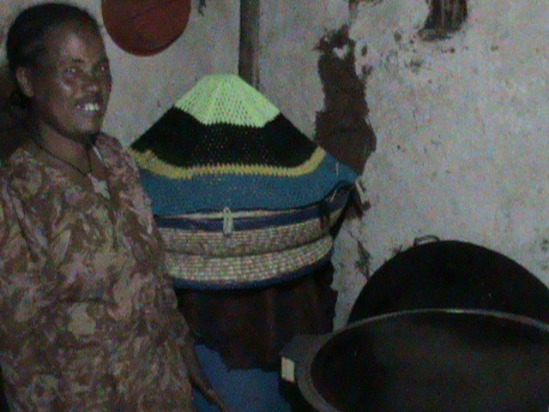
Kasanesh Belete lives in Gulele Sub-city woreda 5. Kasanesh is a widow with 3 children, who are students in the 12 th, 10 th and 7th grades. Formerly, she sold lottery tickets, which provided her with little profit. With this income, she was unable to feed herself and her children. Fortunately, she was selected to receive Global Giving support and was provided with a seed grant of birr 1500. Currently, she has started baking and selling injera to the canteen of weaver’s association near her neighborhood. With the profits, she is now able to properly support her 3 children and invest further in her business.

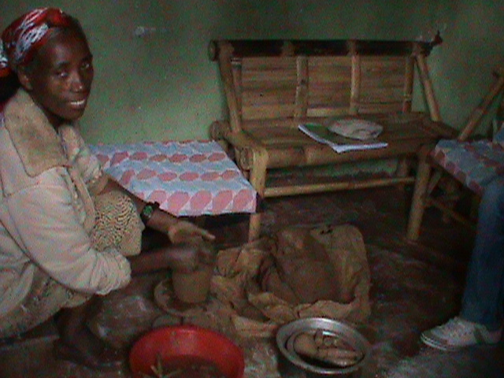
Yeshewa Mebrate Takele lives in woreda 5 Gulele sub city. Yeshewa is a HIV-positive widow and cares for her 3 children. Even though she has experience at pottery work, she could not continue working in this trade due to financial and health problems. Recently, Yeshewa was selected to receive Global Giving support and she was provided with a seed grant. With this money she purchased clay mud, wood, cow dung for the preparation of the ceramics work. She is designing and preparing various ceramic objects for sale. Yeshewa Mebrat is very grateful for the Global Giving support and is delighted to be re-engaged in the ceramics business and able to support her family. Yeshewa indicated, “with the money I got from the business I am able to improve my house and able to buy shoes for my two children, to cover the monthly house rent, and pay electricity, telephone and water bill, Although I am HIV-positive, the Global Giving support has given me the motivation and hope to lead my life peacefully and properly with my family”.

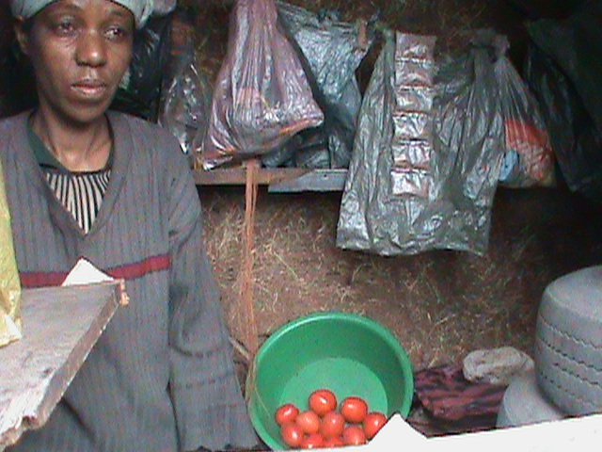
Worknesh Aygoda is living in Gulele Woreda 4. She has 2 children and was widowed when they were infants. Worknesh is engaged in charcoal, vegetable and fruit selling. Due to the economic crisis, she was having difficulty running her business and supporting her family. However, as she said, “before getting Global Giving financial support life was very difficult for my family but with these funds I am able to run my small business properly, and to support my children, who are now attending their school consistently. In the future, I am planning to work hard and expand my business to support my children’s education in a better way.”

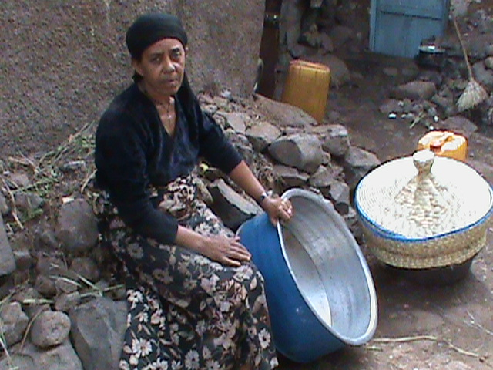
Tsige Asmamaw is living in Gulele Woreda 2. After receiving Global Giving support she started baking and selling injera bread. In addition, Tsige sells household utensils. The combined income enables her to provide food for her family and provide her 3 children with the necessary school materials. She also is able to cover her monthly house rent, electricity and water bills, as well as other social payments. The support from Global Giving has enabled her to greatly improve her life.

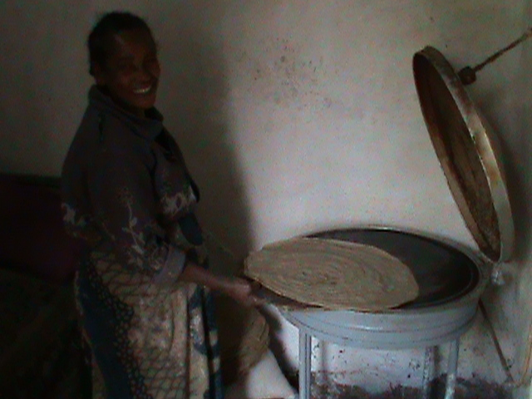
Etagegn Bika is a single mother living with her 3 children. Formerly, she was trying to support her family by preparing and selling Injera bread. However, because of financial difficulties, Etagegn was unable to run her small business effectively and could not provide food for her family or send her children to school. After identifying her problem, she was selected as Global Giving beneficiary and provided with the seed grant. With this money she re-started her small business. She bought an electric stove to bake injera, which helped her to increase her output and income and improved her living conditions. Etagegn explained “Thanks to the Global Giving support, me and my family are happy and our living condition has improved. We are able to get our daily meal properly’. Etagegn is very happy with her business and she is hard working woman with very high enthusiasm.

