ADDIS ABABA WOMEN’S ASSOCIATION
GLOBAL GIVING INCOME-GENERATING ACTIVITIES
SEPTEMPBER – DECEMBER 2010 REPORT

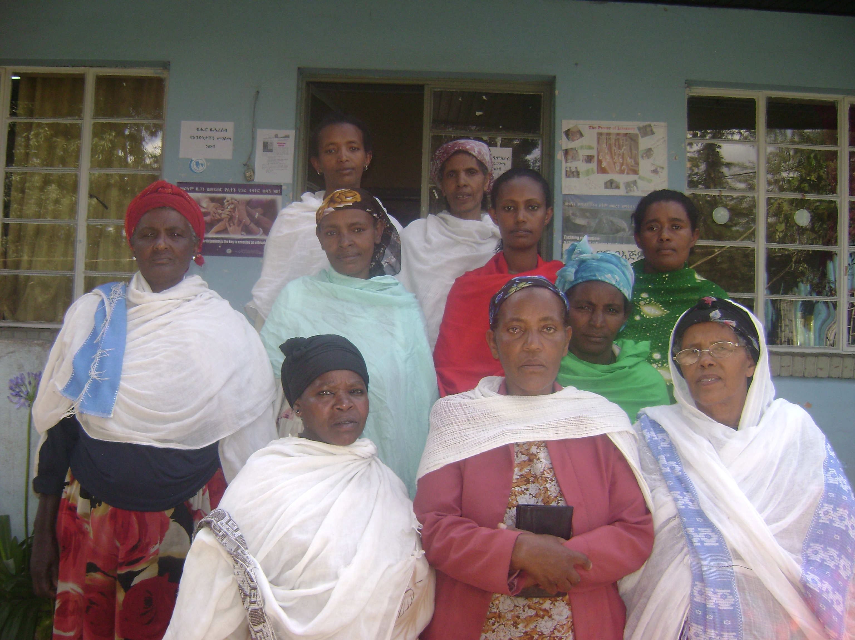
10 beneficiaries organized in cooperative groups

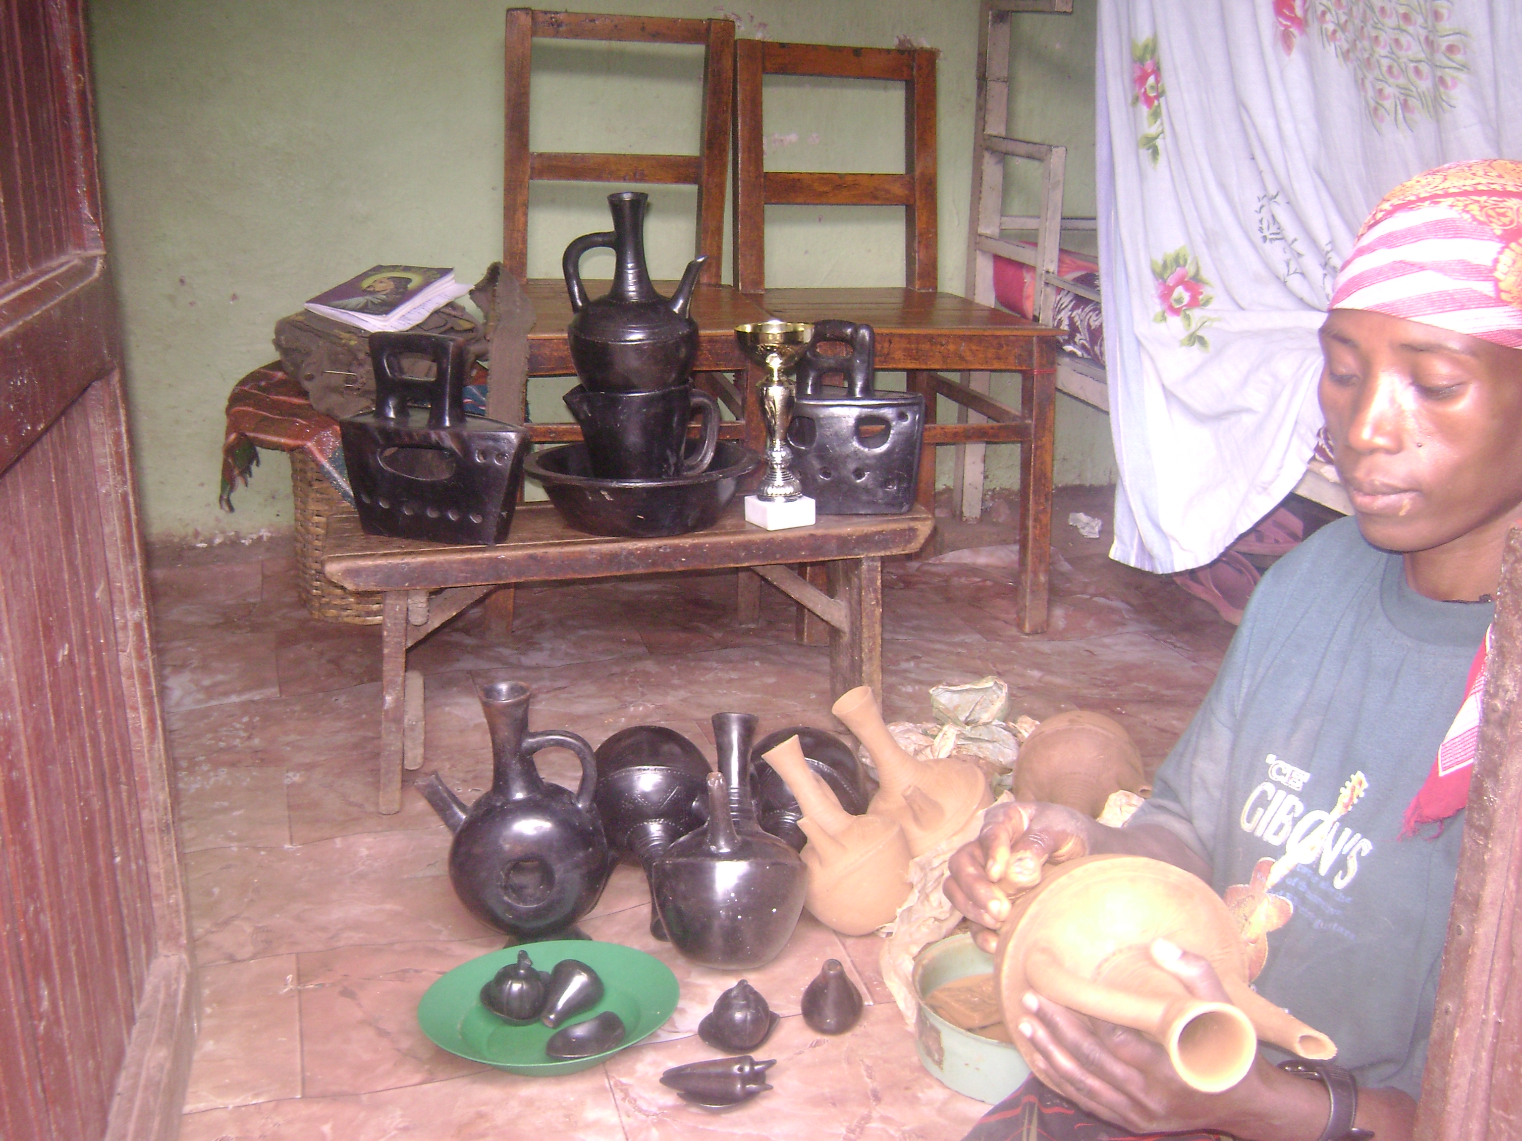

Yeshwamebrat with her design products

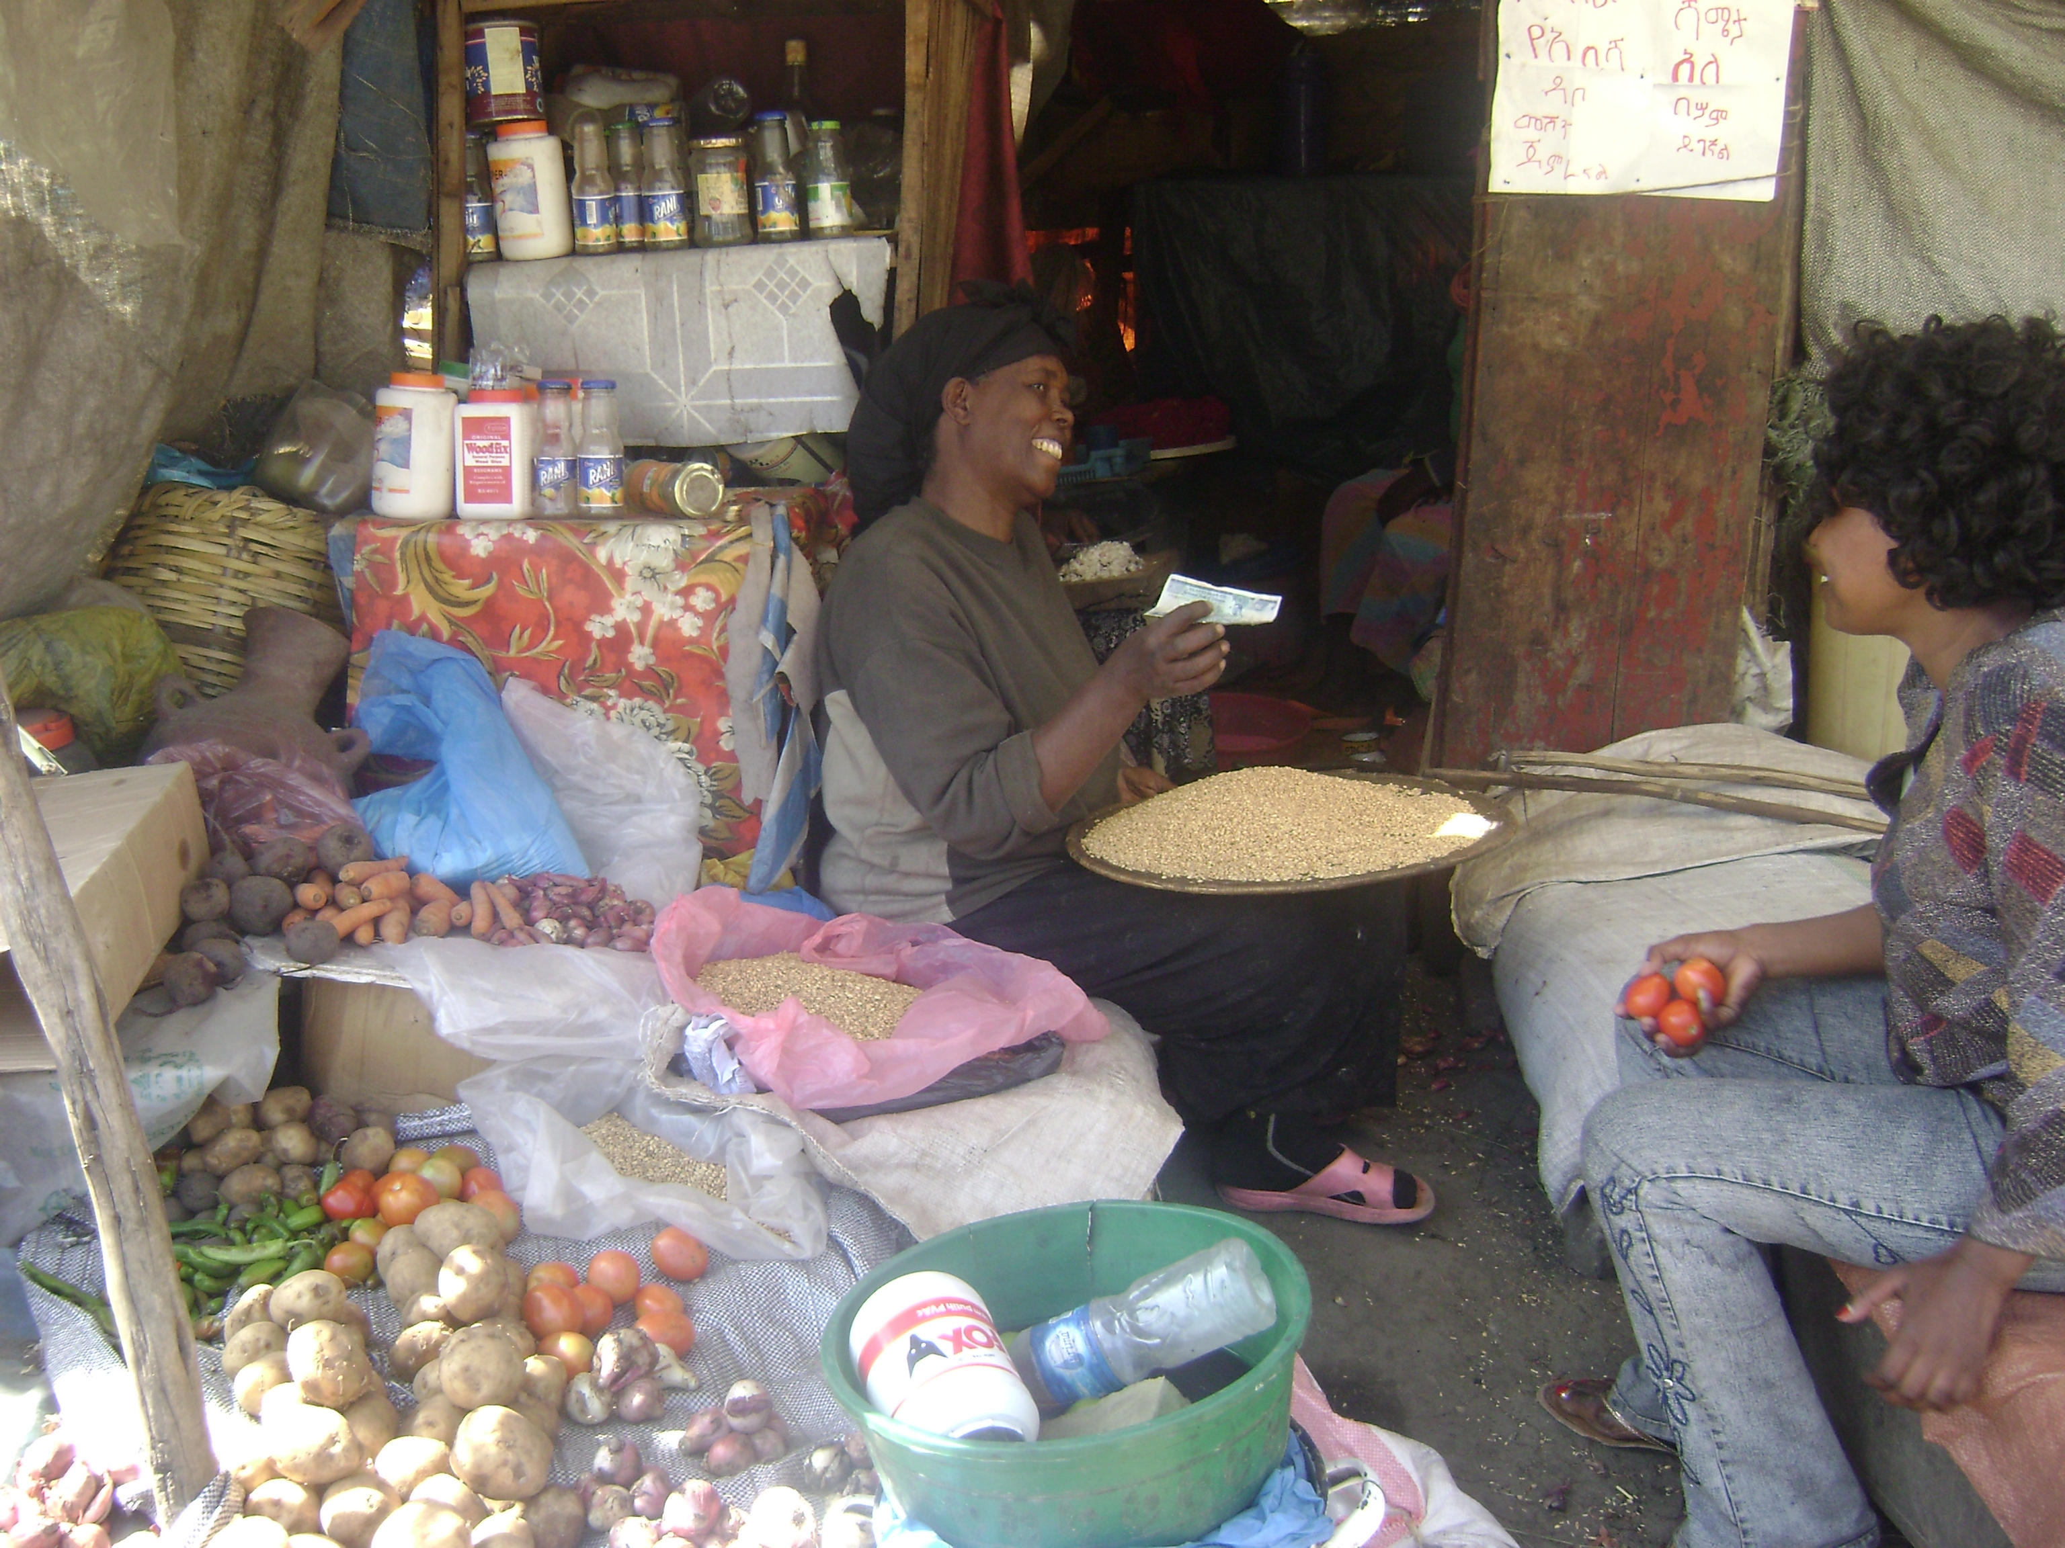 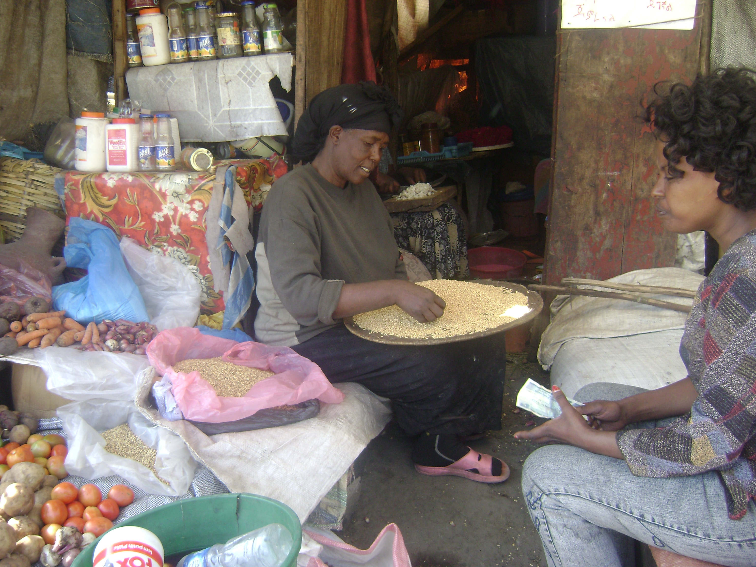Abaynesh at her business center

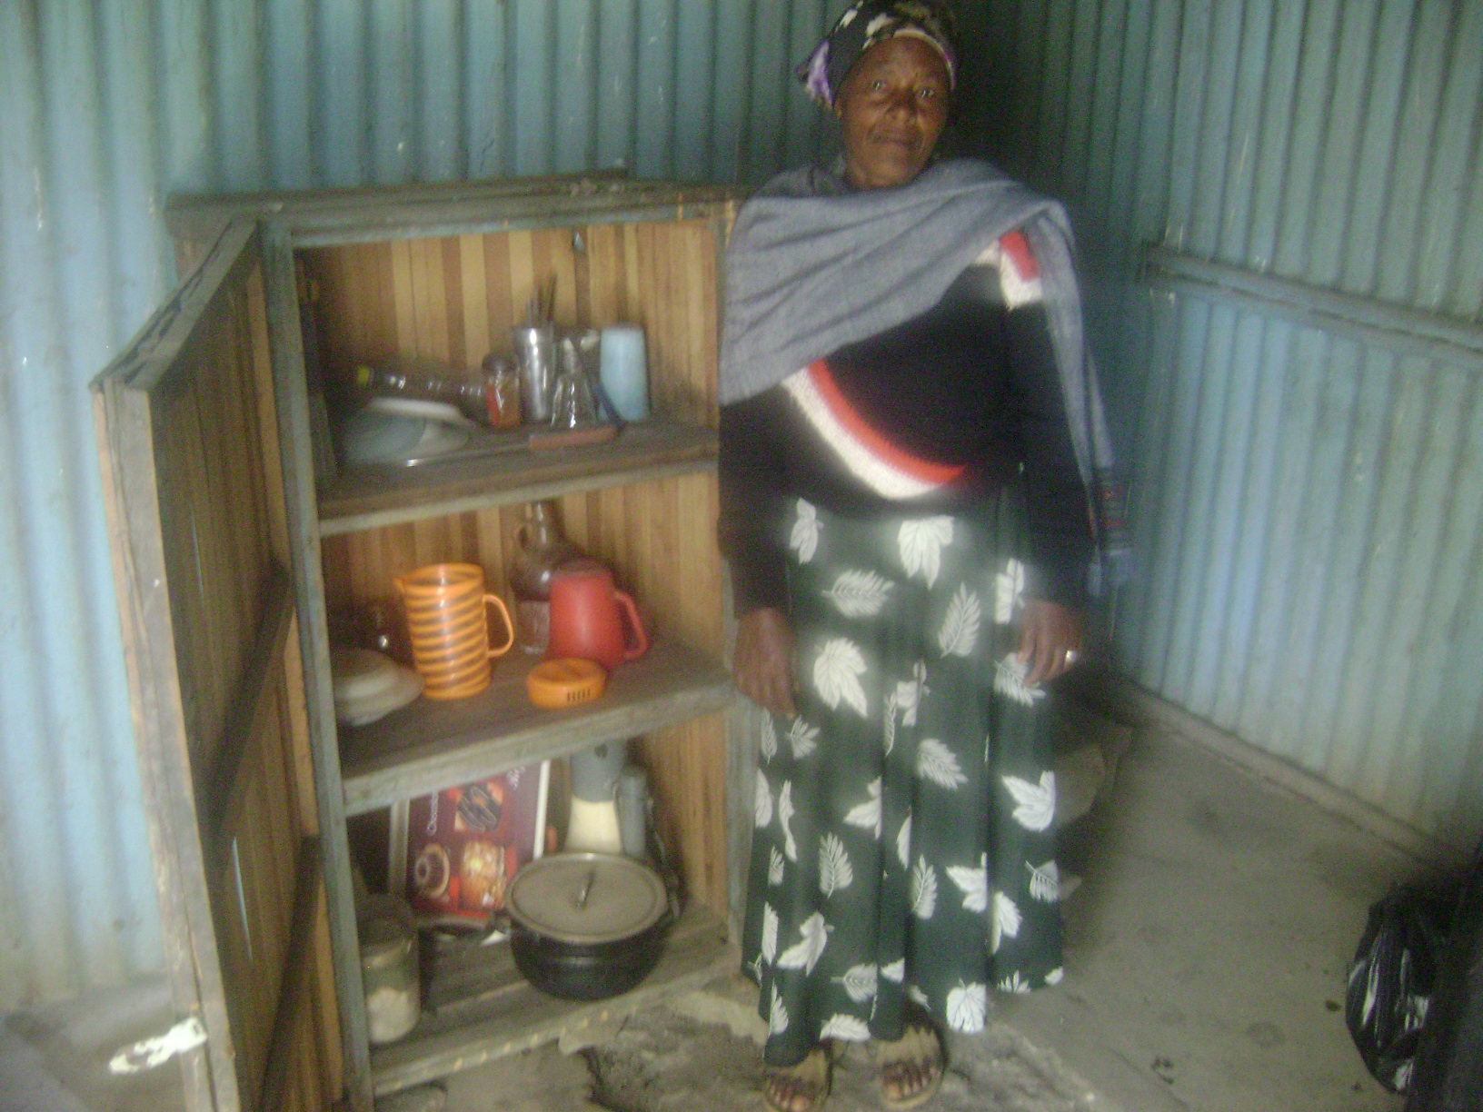

Simegene at her coffee shop

