GLOBAL GIVING IGA REPORT
April – June 2012

During the reporting period, five new IGA beneficiaries were selected from Arada Sub-city, Woreda 3. They organized themselves as one group to work together to raise and sell poultry. These newly-selected beneficiaries were provided with 2000 ETB seed money and a three-day training on credit, saving, and poultry production by the Arada microfinance enterprise. In order to facilitate their work and ensure the sustainability of their business, they got legal status and were linked to the microfinance office at their district administration so that they can access the training and loan services, secure a safe working place, as well as use other relevant supports like market assessment.

The total number of IGA beneficiaries is now 82 and a total of 167,705.00 ETB has been distributed so far.

ARADA AND GULELE SUB-CITY GG IGA BENEFICIARIES PROGRESS REPORT
Enhancing gender equality and enabling women to exercise their human rights and make decisions addressing the issue of economic dependence is of no controversy. Economic empowerment addresses not only the economic needs of women, but it is also a very important tool that helps women gain social and political empowerment. For a woman economically dependent on a man, telling her now and then about negotiation of safe sex would be meaningless without supporting her on gaining self-employment and developing the capacity to negotiate for safe sex with her partner. It is also true that making decisions at home the level and enabling women to exercise their human and reproductive rights requires them to be economically empowered.
Beyond this, self-employment/economic empowerment of women has a number of outcomes:
- Improves their negotiation skills
- Creates access to information through contact with various people
- Experience sharing
- Develops their self-esteem
- Improves their social value
- Grows decision-making capacity
- Enables participation in public affairs
As previously reported, several of the women funded through GlobalGiving have started their own businesses. We want to showcase 13 GG IGA beneficiaries, seven from Arada and the rest from Gulele, who have started running their own businesses. Both of these beneficiary groups from Arada and Gulele have been provided with a work location or shop by the local women’s association. To ensure the implementation of the activities as per the project plan, we followed up and monitored all the activities of each of the two organized groups as follows:

- ARADA BENEFICIRIES
After getting the skills training on business management, they bought one electric oven and stove, two big plastic barrels, a kettle, different drinking cups, glass and all the required equipment. They have started baking and selling 80 enjeras (local bread) per day. They also prepare and sell different kinds of local drinks such as Tella, Shameta, and tea to the surrounding community. They charge birr 2.75 for each enjera, birr 1.00 for each cup of tea and piece of bread, and Birr 3 for each Shameta. In order to attract and gain more clients, they have chosen good prices as compared with the other surrounding enterprises. All of them work in the morning and afternoon shifts and record their daily expenses and income as they learned during the training workshop.

During the three-day training much emphasis was given on:
- How to choose the appropriate poultry rearing place
- How to choose the best hens for eggs and meat
- How to keep their cages neat and clean
- How to follow their health and give medication
- How to feed them and when
- What kind of cage should be used depending on the number of hens
- Type of shade and ventilation required
- Day-to-day activities and the like
- How to save money

Even though it is almost two months since they started their business, they are all pleased and have great enthusiasm for running their shop and sharing all their responsibilities equally.

The following are some photos taken while working during their shift.
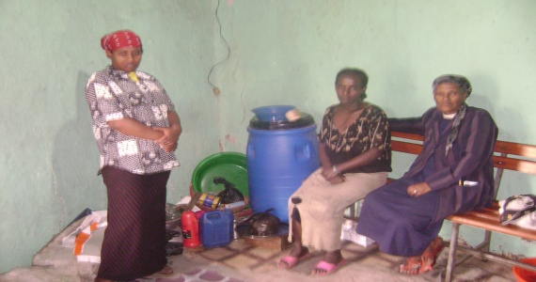
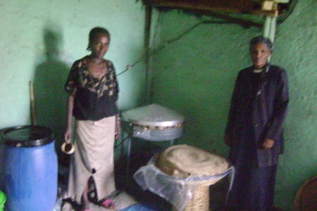
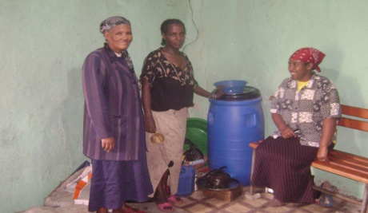

- GULELE BENEFICIARIES
The Gulele beneficiaries have given a name to their organization: “Dagim-Birhan,” meaning renaissance. This is to emphasize that they and their families, with the new self-help empowerment provided, would gradually achieve good financial status. They additionally identified themselves as an example that women should not remain dependent on her husband, but must be independent and self-reliant.

They are preparing and selling home products such as spiced pepper, shiro, dabo-kollo, besso, (local food items) and all kinds of varied products. They also sell flowers, sugar, ceramics products and the like. Fortunately their shop is situated on the main road, attracting numerous individuals to be clients. This helped them to perform their duties very well and be profitable, and their life is changing in a good way.

Both the Arada and Gulele sub-city beneficiaries expressed and extended their delightful and warm happiness and gratitude to Global Giving, and they have the confidence and the courage to show great returns in the near future.

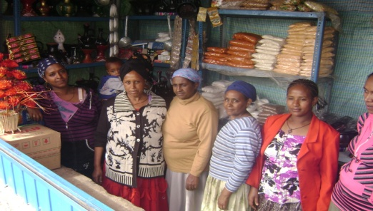
The following photo demonstrates the Gulele beneficiaries with their different kinds of products ready for sale.

Profiles of New Beneficiaries

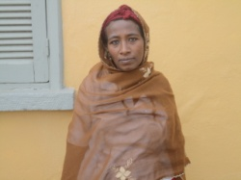
Kidist Negash lives in Arada sub-city, Woreda 3. She is divorced and lives with her three children. Because of financial problems she is unable to properly support her children’s schooling. Thus, among the two children who used to attend school, only one is able to continue his education and the other one has been forced to drop out of school. Because of her poor living condition, Kidist was chosen to receive this GG IGA financial support.

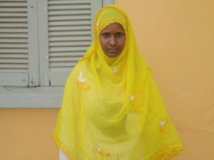
Habiba Mohammed is also from the Arada sub-city and woreda. She is a housewife and does not have a job. Her husband is working as a daily worker for a small earning. They have two children (female and male) attending school. Their life was very difficult, as their income was not enabling them to properly feed and support their family. Therefore, Habiba applied to the Global Giving IGA fund to start her own small business to help her family. She was chosen toreceive the funds and is organized in the poultry production business with other IGA beneficiaries.

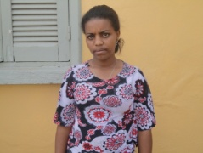
Buzuwork Girma is living in the Arada sub-city and woreda. She completed grade 8, she is married and has two children. Her husband is an employee at a wood work production earning very little money. Buzuwork did not have a job, so she applied and was nominated to get the IGA fund and is organized in the poultry production team.

Yenenesh Wudneh is also from the Arada sub-city and woreda. She dropped out from 8th grade and stays at home without having any job. Thus she applied to the GG IGA fund to engage herself in small business and become self-reliant. She was selected and is organized in the poultry production group.

Taddelech Demisie lives in the Arada sub-city and woreda. Her husband has died and she is supporting her six children alone. Four of her children completed grade 12 but are unemployed. Supporting her large family became difficult for Taddelech and she strived to engage in small business. Thus, she was nominated to get GG IGA funds and now works in poultry production.

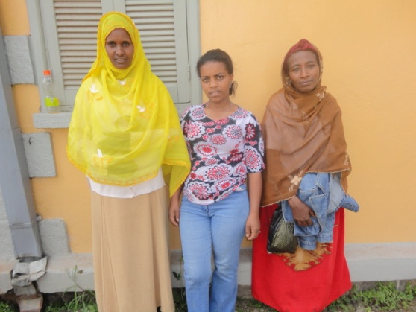

Finally, all of the beneficiaries expressed their appreciation and heart-felt gratitude to Global Giving for the seed money they were provided.

