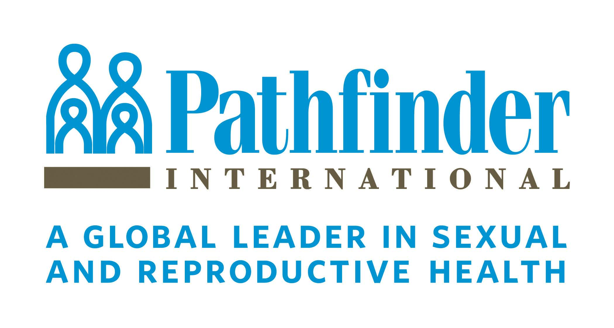
Pathfinder International
Educating and Empowering Girls in Ethiopia
GlobalGiving Quarterly Report
Mar 2015 – May 2015

BACKGROUND
GlobalGiving donors have continuously supported Pathfinder International to empower the most vulnerable women and girls in Ethiopia since May 2008. The support aims to reduce the number of girls dropping out from school due to financial constraints and to equip them with life and leaderships skills. So far, Pathfinder has recruited 104 female students from very poor families: 77 from Addis Ababa and 27 from Amhara region have received grants.

UPDATE
The funds received from GlobalGiving donors from the period of March-May 2015 have been utilized to continue supporting girls who want to carry on with their education without financial limitations. The generous support from GlobalGiving donors has helped our female students by providing 150 birr per month (US $7) to cover basic costs for school. By forming an association of their own, the girls have been meeting monthly to discuss problems they encounter as female students and come up with solutions as a group. Furthermore, the study group initiated by them in the last reporting period has aided them to improve academically by helping each other out and discussing challenges in different subjects such as mathematics and physics.
We are unable to report significant updates this quarter due to the ongoing summer break in Ethiopia. The schools will resume classes in September and we look forward to providing more updates in the future.

