GLOBAL GIVING SCHOLARSHIP REPORT
April-June, 2012

As indicated in the last quarterly report, we have a total of 70 GlobalGiving scholarship beneficiaries. There were no new recruits during this reporting period as the school year is coming to a close; however, a one-month scholarship extension was given for ten girls whose accounts ran out of money before they were able to take their exams and complete their school year. Additional students will be recruited at the beginning of the Ethiopian school year and be provided with 24-month scholarships dependent on funding levels.

The names of the students who received the scholarship extension are Beletu Dangachew, Abebu Taffa, Woinshet Zewdi, Fikirtemariam Chefikee, Zeritu Haile, Haregewoin Abera, Seblewongel Tariku, Filagot Bogale, Yenenesh Gashaw, and Fikirte Tenne.

Total number of scholarship beneficiaries to date
SN | Grade | Number of Girls | Remarks
1 | 6 | 1
2 | 7 | 7
3 | 8 | 4
4 | 9 | 12
5 | 10 | 16
6 | 11 | 9
7 | 12 | 14
8 | Joined University | 6
9 | Left for unknown reason | 1 | Efforts have been made to find her and return her back to school.
 | Total | 70

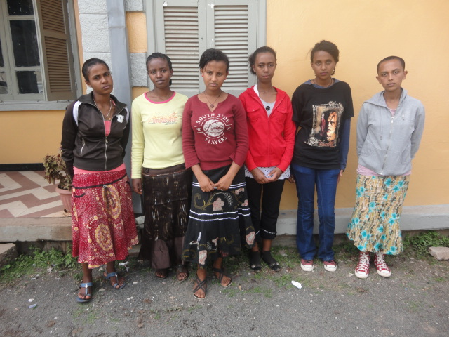

This photo is only of six girls. The rest of the four are absent because one is at university, one was sick and the other two had exams at the time of the picture.

