Third General Report

Project Name : HOPAD Children and Women Capacity building Project.

Partnership : Global Giving USA and HOPAD Child and Women Promotion Society, Nepal.

Project Completed :
- 31 Marginalized women 6 months Tailoring
- 20 Orphan children three months educational support
- 75 children received School Tie and belts with educational materials
- 30 Women needy women completed Embroidery professional three months training.

Ongoing Training:
- 30 Marginalized Tailoring
- 30 Embroidery
- 18 School stationary materials for needy children.
Project Directed By: Purna Bahadur Khatri
Dear Sir/ Madam
(Our honorable Donors and Global Giving Management Team)
Namaste!
From HOPAD Family, Nepal.
First of all HOPAD give more Priority to do effective project management for the target group of the project. On the reporting process, in our project evaluation, it is good and effective. It is in the rural mid western area of Nepal, where our Global giving projects is ongoing.
Thanks to the many great generous donations, we were able to run our project permanently on the Global Giving website, which will hopefully help us to keep up sustainable help for needy women and children in the rural areas of Nepal. It is only possible from your support with love. It is not only concern project named but it is effective for the empowerment women and supports the needy children educational development of Nepal.
1. A. Women Project:
- 6 Months Tailoring Training:
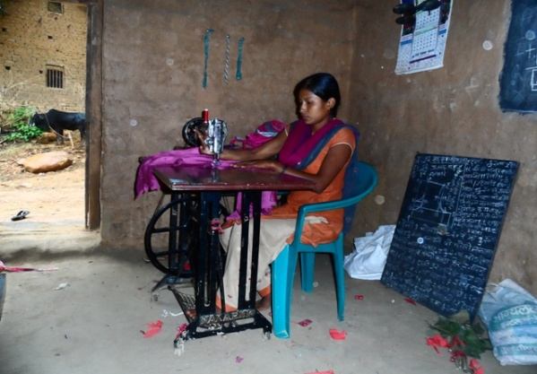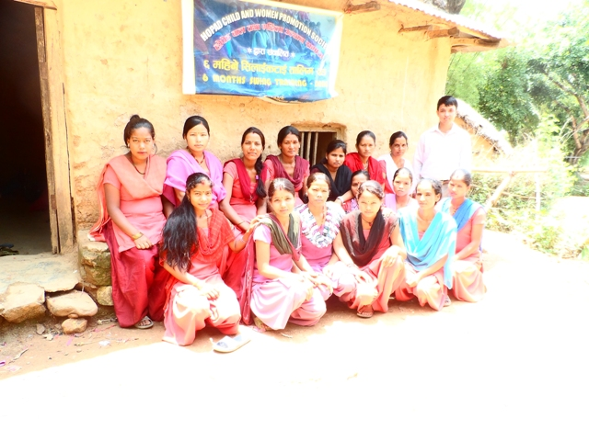
A (Women participant swing cloths for her personal uses) and for their evaluation we provide them a pair of cloths to them for sewing for themselves. They are really prefect in their training. They finished it in two days with few machine uses. They are 31 in two groups, 15 for first Group and 16 in second groups for training. It is successfully completed last three week before and last 25 days project was break for rice plant agriculture work in field. They spent 6 hours per day for effective practice.
- 3 Months Advanced Course professional Tailoring Training:
Since last two week, 20 women are participating in advanced course training for their professional work. This tailoring project is professional and selected best for their business development in the rural area of Dang. It helps to change the life and economic standard in their family life from their children better education. It also helps to extend their source of income and become more independent. Our target not only girl/women trained but also support their children in to get quality education for their better tomorrow.
B. a. 3 First months Embroidery Training:
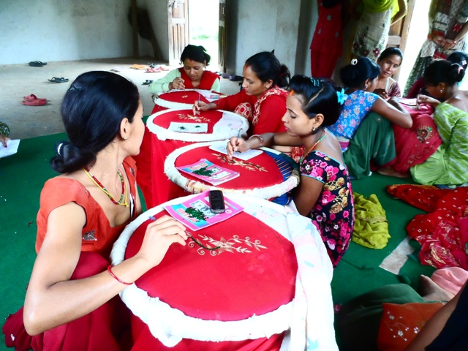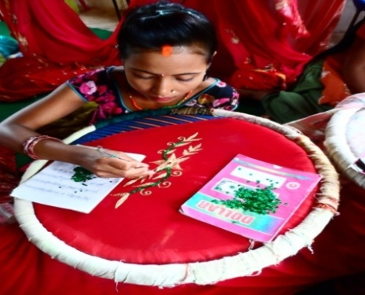
30 women completed for their professional capacity building embroidery training program. They are happy in their achievement. They were in two groups with 15 -15women /participant per groups.
It was fruitful for their betterment. They are able to use their knowledge in this festival time. HOPAD is impressed from their development of Technical knowledge. They are really excellent in their training. It is finished last month. The farewell program will be within 2 weeks.
- Second 3 months Embroidery Training:
Our second group embroidery program is ongoing since last weeks. It is divided in two groups' morning and afternoon. There are 15 participants in the first group and also 15 in second groups. All total we have 30 needy women in this training program. We are hoping that this program also will be good and honorable for the development of women and support for their children.
2. Children Educational program:
a. Rural area children education program:
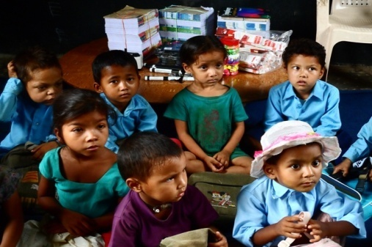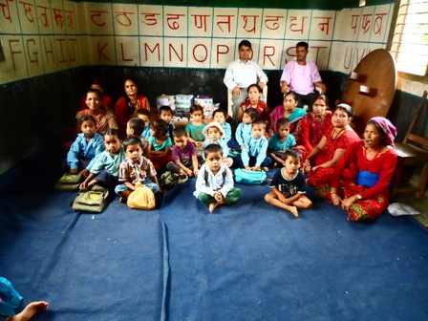
Our children Education program is going well for 16 poor and needy children in rural area Government school with necessary materials for a year. The support will include Tie belt for whole school, English Books and stationary, as well as classroom equipments in front of their poor parents. They need not take any things for their Quality education. It helps to be continuing for School education. 75 children are happy and enjoy with their new Tie and belt.
- HOPAD children education Support:
Due to the lack of support for HOPAD children are also facing financial problem since last January. HOPAD used some donation for orphan children educational fee for their quality education. It helps to attain their final exam for 20 HOPAD children new grade. Thanks, it makes possible to run this program.
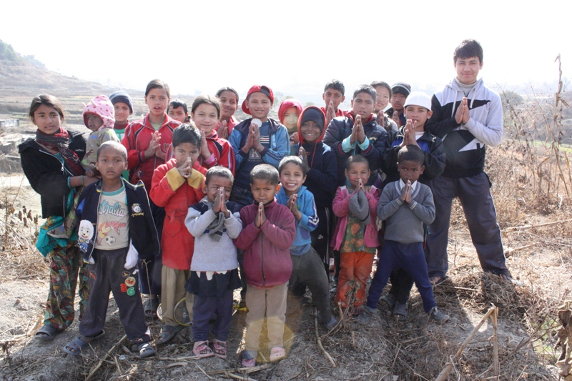
All of you (Donors) are really great to change lives of Nepali women and children. We are waiting for your support and valuable suggestions for better work.
HOPAD also believe that your every support is greater and for this project. We have not enough support for second stage program. Please try to be part of them.
Now, I am unable to keep new picture because I have loss my camera. It would be submitted soon with farewell program.
Thanks
Sincerely,
Purna Bahadur Khatri .
Program Director /Founder President
12June 2013 A.D. Kathmandu,Nepal.

