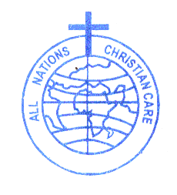
Clean Water for All (CWA)

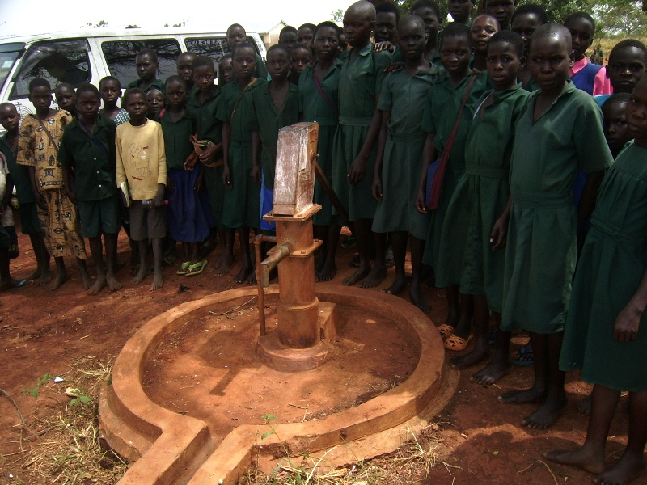

1. Introduction
All Nations Christian Care (ANCC) is a registered faith based charity relief and development organization working in Uganda and Southern Uganda. The organization was born in 1989 out of the deplorable living standards that arose out of the complex emergency brought about by the Lord Resistance Army insurgency. The organization is registered with the government of Uganda under section 16(1) of the Company. It is also registered with the national NGO Board under Reg No. S5914/45. It’s headquarter is located on plot 2, Ayer Road, Lira District, Northern Uganda. Since its establishment, the organization with the help of both International and National partners implemented a number of interventions in the areas of water and sanitation, support to Orphan and Vulnerable Children (OVC), humanitarian emergency response (Relief development), life skill development (vocational education), education, health, food security, livelihoods, and evangelism.

2. Background
Uganda has registered considerable progress on pupils’ enrollments in primary school since the introduction of Universal Primary Education (UPE). The progress lead to reduced gender gap through increased enrollment of girls in primary schools and equitable access to primary education through increased enrollment of pupils from poor households. However, once pupils get to school, they do not always have access to safe and clean drinking water, and proper sanitation.

The limited access to safe and clean drinking water has continued to affect girls’ retention rate in top classes. This is particularly for girls in the menstruation age bracket that are unable bear the shame of attending classes when they have menstruated on themselves. Girls in this age bracket prefer to drop out primary school and stay at home. When they dropout of school, most of them become victim of early marriage and teenage pregnancy. This situation is worse in rural areas where over 90% of Ugandans’ population leave. Majority of this girls who dropout of school, and marry, die in the hands of traditional birth attendants during labor and child birth.

Poor hygienic situation in many rural primary schools as a result of inadequate functional toilet facilities for pupils continues to affect pupils’ education in Uganda. National statistics of toilet coverage is very impressive but the statistics do not take into consideration non functionality of many filled toilet facilities in some rural primary schools.

Access to safe drinking water and sanitation is considered to be a fundament human right that acts as a safeguard to health and human dignity. Good sanitation and hygiene practices can make major differences in people’s health, education, and socioeconomic development. Promoting adequate sanitation, hygiene, and access to safe drinking water will accelerate the progress of two Millennium Development Goals (MDG) Goal 4 (Reduce the under-five mortality rate by two-thirds between 1990 and 2015) and Goal 7 (The proportion of population without sustainable access to safe drinking water and basic sanitation halved by 2015). Sanitation is vital for good health and lead to rise in life expectancy.

3. Objective of the project
The main objective of this project is to improve pupils’ retention rate in 15 rural primary schools through improved proper sanitation and hygiene behaviors. Specifically, the project will:-

- Improve access to safe and clean drinking water in rural primary schools
- Improve access to toilet facilities by pupils in rural primary school
- Increase knowledge on proper hygiene behaviors through increased sensitization in schools and communities surrounding schools
- Reduce prevalence rate of diarrhea among pupils in rural primary schools

4. Outcome
The project will contribute to the following two outcomes:-

- Improved health conditions through increased access and coverage of clean and safe drinking water in rural areas
- Improved hygiene behaviors through decreased open defecation and increased use of improved sanitation and hygiene in rural community and primary schools

5. Planned activities:
The following planned activities will be implemented:-

  - Rehabilitating broken boreholes in 15 primary schools
  - Drilling new boreholes in primary schools
  - Drilling new community boreholes
  - Drilling new community shallow wells
  - Protection of unprotected springs

2.1 Promotion of good Hygiene and Sanitation practices
2.2 Construction of 5- stance VIP lined latrine blocks in primary school
2.2 Training and educating communities on appropriate household water treatment and safe
storage and hygiene promotion
2.4 Establishing and training WASH committees on financial management, operation and
maintenance of boreholes, hygiene and sanitation, WASH related and environmental
protection and management
2.5 Training school authorities on operation and maintenance of latrine and hand washing
facilities
2.6 Promoting village- level WASH related environmental management
2.7 Providing hand washing facilities and other sanitation tools and equipments

6. Programme beneficiaries:
The project will benefit directly six thousand (6,000 pupils) and indirectly five thousand (5,000 household members) through improved access to water and sanitation. Pupils will have adequate access to clean and safe drinking water provided by the project. General health conditions in households whose children are in the targeted schools will improve. Household expenditures on health will reduced thus enabling the household to channel savings from health expenditure to more productive investments. Food security and livelihoods situations in the targeted community will improve. Performance of pupils in the targeted schools will improve considerably.

7. Project Implementation strategy
The project will start with buy-in-meetings with all the relevant Local Government stakeholders. After which another buy in will be held at the Lower Local Governments. A base line survey will then be conducted and findings of the survey will be used for determining the pr project impact at the end of the project life span. Selection of schools for the project will be base on the non functionality of water points and inadequacy of toilets facilities. Toilet design developed by ministry of education of Uganda will guide the construction of toilet facilities. Joint assessment of the water points in schools will be conducted together with the community and their leaders. For schools where new boreholes will be drilled, hydrological survey will guide sitting of water site and this survey will be done by a government hydrologist. Boreholes to be repaired will be selected together with local leaders. The project will be launch publically in order to build strong community partnership and during mid year review, both elected and civil leaders will actively be involved.

8. Monitoring
Monitoring of the program is aim at improving efficiency and effectiveness of the project outcomes, outputs, and activities implementation. The project will employ participatory monitoring where project beneficiaries and community will be fully involved in monitoring of activities implementation. The participatory monitoring will ensure effective implementation of project activities and production of desired results as contained in this document. Project Officer will coordinate the overall implementation of the project. He will prepare monthly and quarterly progress reports that reflect challenges, success, and lessons learnt

1) Photo of filled toilet that pupils in Owinyo P.7 School use (above)
2) Photo of broken borehole that requires major repair in Akwiaworo primary school (below)
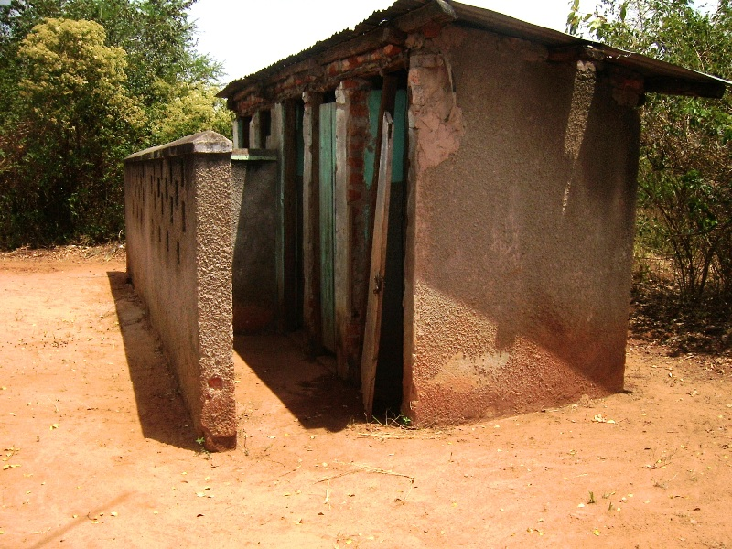
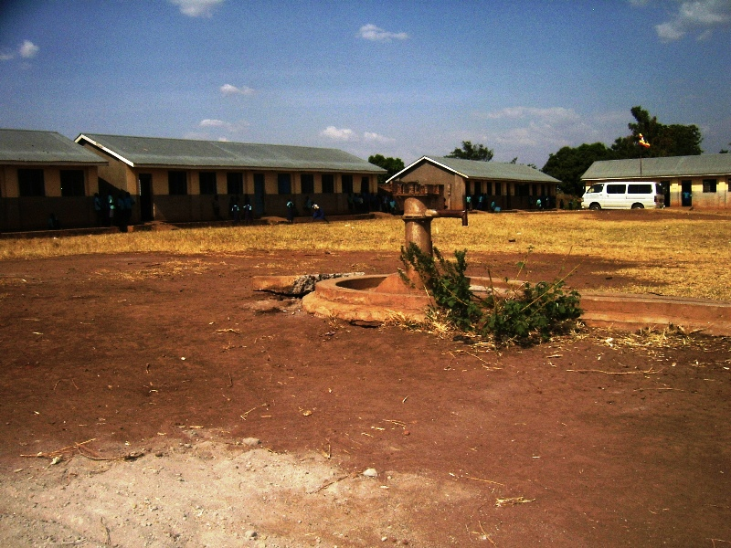
9. Result framework
Outcomes/Results |  | Activity | Expected output
 | Improved health conditions through increased access and coverage of clean and safe drinking water in rural primary schools | - Rehabilitate broken of boreholes in 15 primary schools | 2 broken boreholes rehabilitated and functioning
 |  | - Drill new boreholes in primary schools | 2 deep boreholes drilled in 3 primary schools
 |  | - Drill new community boreholes | 2 deep boreholes drilled in 7 villages without access to clean & safe drinking water
 |  | - Drill new community shallow wells | 2 shallow wells drilled in 5 villages
 |  | - Protecting unprotected springs | 2spring protected
 | Improved hygiene behaviors through decreased open defecation and increased use of improved sanitation and hygiene in rural community and primary schools | - Construction of 5- stance standard VIP lined latrine blocks | 2 blocks of 5-Stance standard VIP latrines constructed in 4 primary schools in
 |  | - Construction of 5 stance drainable VIP lined latrine blocks in rural primary schools | 1 block of 5-stance drainable VIP latrines constructed in 7 districts
 |  | - Train and educate communities on appropriate household water treatment and safe storage, and hygiene promotion | - More households and pupils gained access to improved drinking water services  - Reduced expenditures on treatment of water born diseases by households  - Increased enrolment rate in rural schools as the rate of pupils falling sick is reduced
 |  | - Establish and trained WASH committees on financial management, operation and maintenance of boreholes, hygiene and sanitation, WASH related and environmental protection and management | Broken boreholes will be repaired within a very short period of time with acquired skills and knowledge
 |  | - Train PTA, School Management Committees (SMCs) on operation and maintenance of latrine and hand washing facilities (cleaning, draining latrines, provision of soaps etc) | Reduced rate of illness brought about poor hygiene and sanitation  Improved pupils performance, and retention rate in primary schools
 |  | - Promote village- level WASH related environmental management (e.g rubbish pits) | Reduced disease outbreak in rural communities
 |  | - Provide hand washing facilities and other sanitation tools and equipments | schools have hand washing facilities
10. Project budget

# | Activity | Unit | QTY | Unit Cost  (US$) | Total cost
1.1 | Rehabilitate broken boreholes in primary schools | number | 2 | 1800 | 3600
1.2 | Drill new boreholes in primary schools | number | 2 | 7500 | 15000
1.3 | Drill new community boreholes | number | 2 | 7500 | 15000
1.4 | Drill new community shallow wells | number | 2 | 4000 | 8000
1.5 | Protecting unprotected springs | number | 2 | 3400 | 6800
2.1 | Construction of 5- stance standard VIP lined latrine blocks | number | 2 | 4600 | 9200
2.2 | Construction of 5 stance drainable VIP lined latrine blocks | number | 1 | 6000 | 6000
2.3 | Train and educate communities on appropriate household water treatment and safe storage, and hygiene promotion | Session | 2 | 3600 | 7200
2.4 | Establish and trained WASH committees on financial management, operation and maintenance of boreholes, hygiene and sanitation, WASH related and environmental protection and management | Session | 2 | 3600 | 7200
2.5 | Train PTA, School Management Committees (SMCs) on operation and maintenance of latrine and hand washing facilities (cleaning, draining latrines, provision of soaps etc) | session | 2 | 3600 | 7200
2.6 | Promote village- level WASH related environmental management (e.g rubbish pits) | session | lump sum | 2000 | 1800
2.7 | Provide hand washing facilities and other sanitation tools and equipments | number | 20 | 50 | 1000
Subtotal |  |  |  |  | US$ 88,000
 | 10% provision for administrative cost |  |  |  | 8,800
Grand Total |  |  |  |  | US$96,800

