**2015**

www.sukrupa.org

2/13/2015

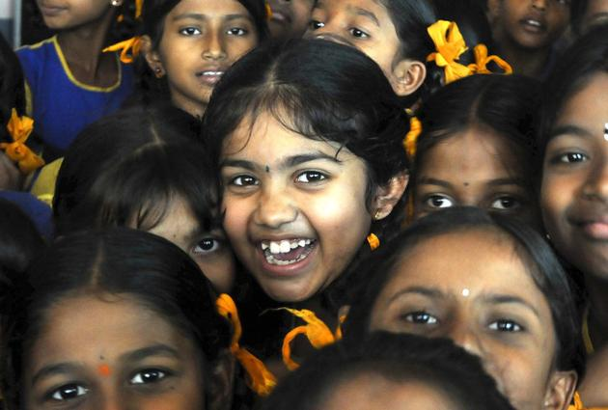TEMP

Education # Empowerment # Environment

**

*Dear Donor,*

*At first, our heartfelt thanks to all of you for your continued support towards SUKRUPA's cause.*

*When I see children at SUKRUPA, I wish I could go back to being a kid again. Those Innocent, Worry - free days ! children know how to just be; the difference between then & now is,  we didn’t grow up with these high-end gadgets, but with  just a few Colorful Wooden Toys “Channapatnada Bombe”.  With globalization & changing technologies together with high competition, sometimes I wonder "Is the school system we follow these days provide all that it takes? especially for the kids coming from underprivileged background, where parents do not know to read or write ? It is this constant quest that has helped us to ensure  that the children are provided with a well balanced mix of academics, creativity (through various arts, technology, field trips, sports, games, life skills) and social values. All of these, can enable them to establish themselves to be more responsible and independent to sustain and grow in this dynamic world. It is indeed a huge challenge, daunting us every year. But with the continued encouragement & support from all our friends, volunteers, corporate & individual sponsors & like minded groups who have stood by us at all times, we have been able make a huge difference in the lives of the children.*

*As the School Year is ending in couple months, Children are preparing for their exams, some of them are writing Board Exams, Teachers are working progressively to bring Great Results!!!*

*We strive to reach our goal with your continued support. “Tons of Thanks” to each one of you who are part of SUKRUPA in creating great opportunities for all our children.*

***Krupalatha Martin Das***

**Executive Director**



SUKRUPA serves below poverty line community, where most of the children are first generation learners born to young parents who do not have basic education and employability skills. Most of the families migrated from rural poverty in search of opportunities to cities and ended up in slums with substandard housing and sanitation facilities inadequate for human dwelling.

*SUKRUPA’s Mission is to help underprivileged children and young adults escape a background of poverty, slum life, illiteracy and ignorance, thereby creating opportunities for their integration into mainstream society.*

https://ssl.gstatic.com/ui/v1/icons/mail/images/cleardot.gif

**SUKRUPA Education Centre**

Pre School – 10th Grade

Provides Free High quality Education, Nutrition and Health facilities to 400 underprivileged children from the slums of Bangalore, India

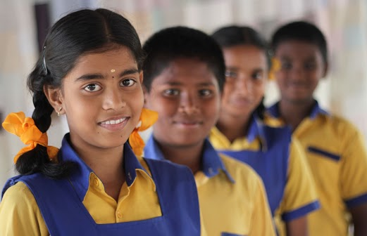

The integrated curriculum at SUKRUPA is distinguished particularly by its emphasis on a balanced education of academics, creativity through various arts, technology, social values and right attitude. This helps them to grow up as young adults who are globally aware, fiscally independent and personally responsible.

Karnataka Rajyotsava

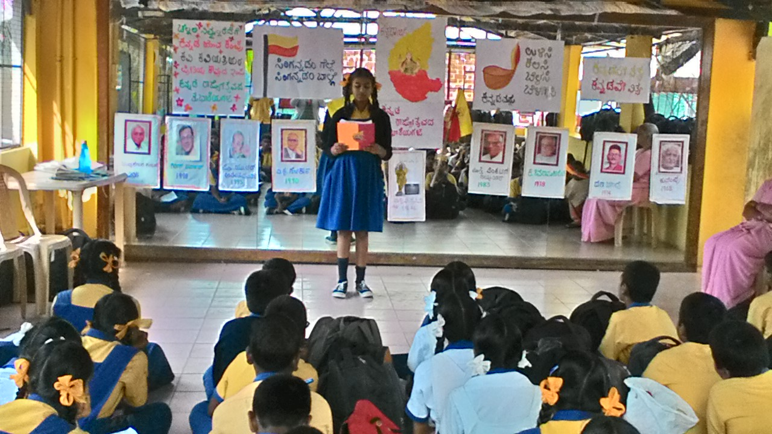The children decided to dedicate an entire week to the rich culture of Karnataka. This year, the school chose to share knowledge about the eight literary laureate from the state who received the prestigious Janapeeth award. They had long hours of preparation, rehearsing speech and noting down facts about the laureates, which were presented during the morning assembly as an exercise to honor Karnataka Rajyotsava.

Fun with Science

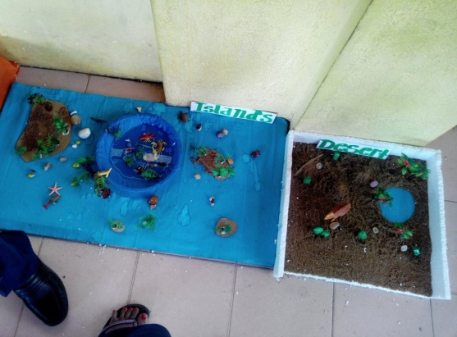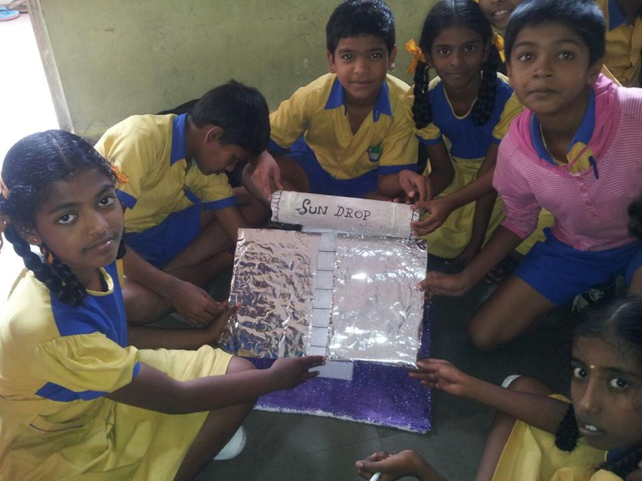

High school children's day was celebrated with CISCO volunteers- with a theam Fun with Science.The programme was organized by through Smile Foundation.

Life skill Sessions

[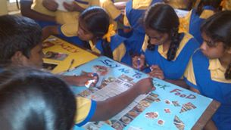](https://www.facebook.com/SukrupaOfficial/photos/pcb.580311468737542/580311152070907/?type=1)

The students of 8th standard, made a collage as part of their activity based life skill class. The topics were; India full of Colors, Say no to Junk Foods, My Family, Save the Earth - No plastics. Ms. Amuda, the teacher of 5th standard, dedicated an activity for children to develop empathy and understanding about people with special needs. She explained the problems of visually challenged people and introduced the Braille script and helped them to learn to write their names using the script.

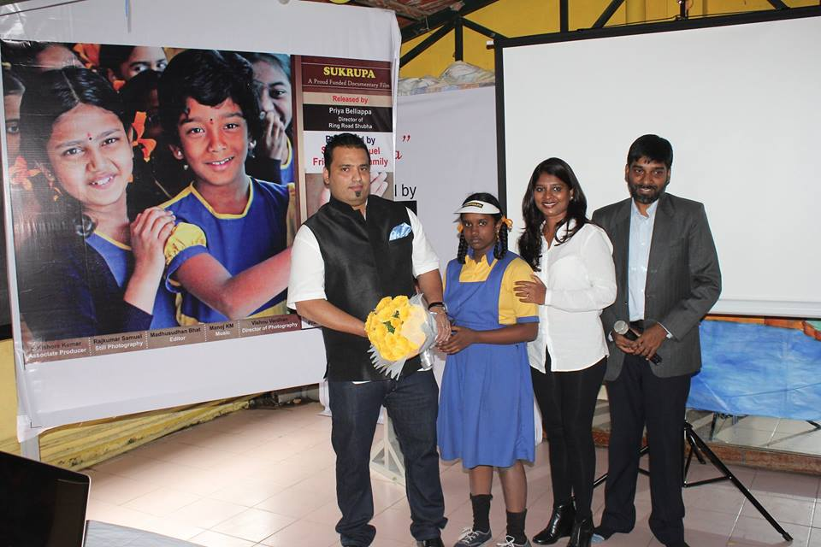Childrens Day Celebrations

A documentary on children’s right to education was screened for children as part of SUKRUPA childrensday celebrations. The narrative of the film is on ‘Education for , education as a birth right.

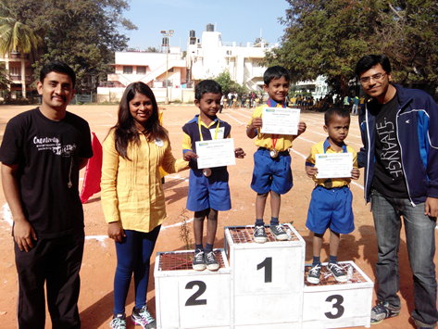

Sports Day

Every child at SUKRUPA look forward to having a special day – a proud day for them to compete and win prizes in front of an audience and especially, their parents. It was the Annual Sports Day on 29th November, for the school. With the pre hits being conducted in the previous weeks, the finalists were all ready to compete and the rest of them to cheer for their favourites on the big day. It was encouraging to see the parents enjoy and having their own bit of fun participating and competing for the events lined-up especially for them.

Orange Day!

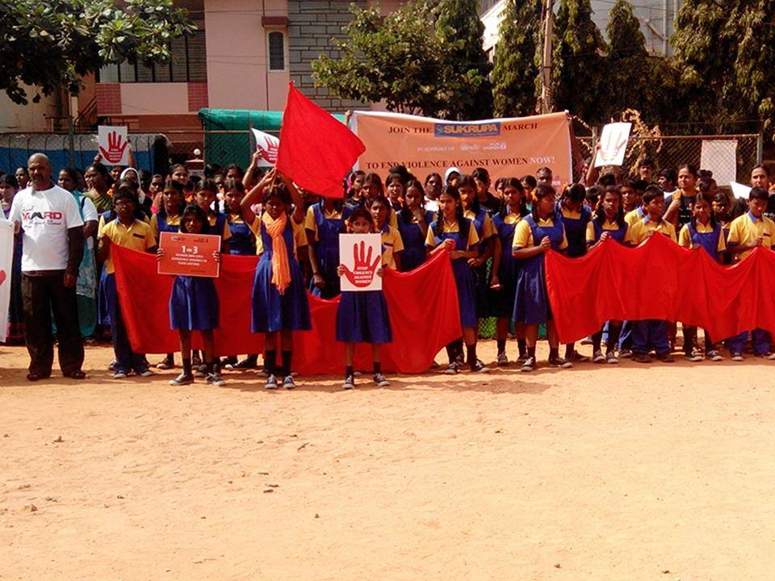

As proposed by UN, SUKRUPA was part of the Orange day, Unite to end violence against women Campaign. To commemorate this cause, the children, teachers, staff, management and the community members went on a rally to pledge for 'No violence against women'.

Little Angel’s Choir Group

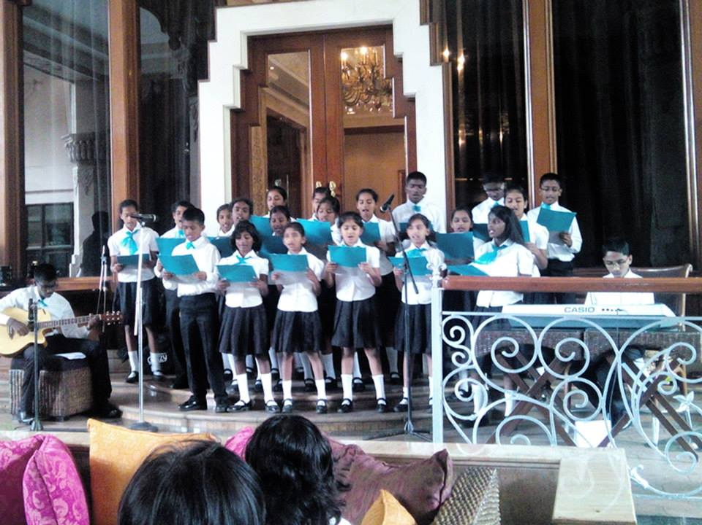December is the season of joy and celebrations! The pulse of the festive mood was felt at SUKRUPA too. It has always been a pleasure for the choir to perform for Overseas Women's Club's pre-Christmas celebrations. The choir performed carols at Leela Palace as part of their celebration. These kind of events always boost the confidence of our children - their eagerness to learn & perform!

Christmas celebration at SUKRUPA

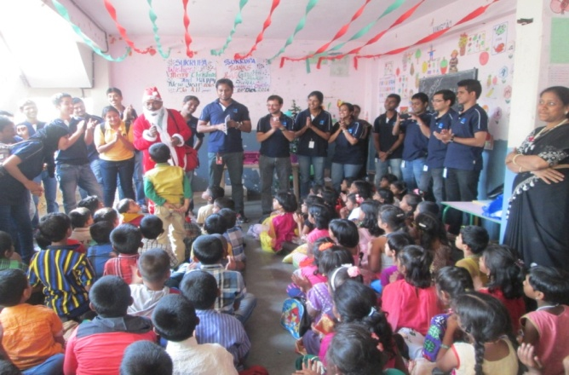

22nd December was a busy day for the children of SUKRUPA. The last day before the winter break! But, that was not all. Celebration was definitely on the card - with a difference of course. So, each class had their own celebrations. More like, which class stands best when it comes to decorating their class. Indeed, a joyful moment for all of us at SUKRUPA!

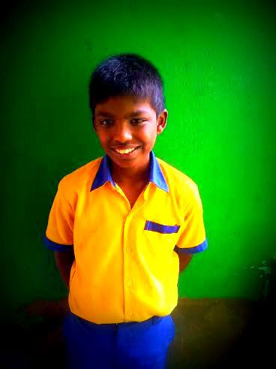

 Gautam

We are immensely proud to introduce Gautam from Grade VIII. He is an extremely talented and diligent student who is liked by his peers as well as by all the teachers at SUKRUPA. His passion and desire for success is evident even through his quiet composure. "My parents struggled a lot to pay my fees and so I want to be successful", he says. His favorite subjects are Mathematics and Kannada. He aspires to become a doctor or soldier someday. At home, he helps his parents with household chores and reads in his free time.

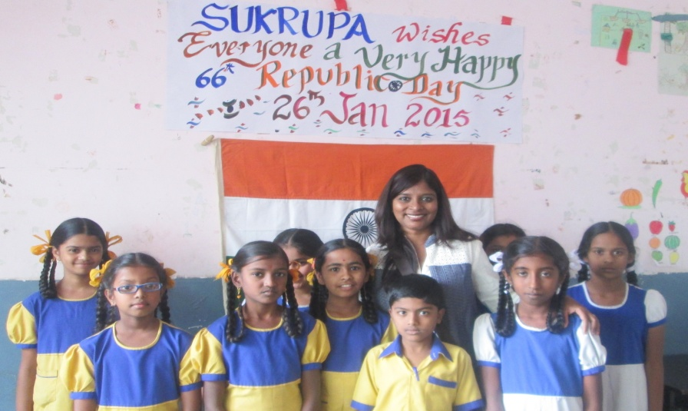

**Imprints of 66th Republic day**

Republic Day symbolizes the solidarity of the country as it unites individuals from different  regions, belief, religions and areas to commend the day with the pride of being an Indian. Special programs were organised at SUKRUPA to celebrate the 66th Republic day. Cultural performances and programs instilling the spirit of patriotism and nationalism were displayed by our children tracing the history and meaning of Republic Day.

SUKRUPA proudly acclaims the National Government's mission "Save girl child, teach girl child" (Beti Bachao Beti Padhao Andolan ) through various campaigns this year.

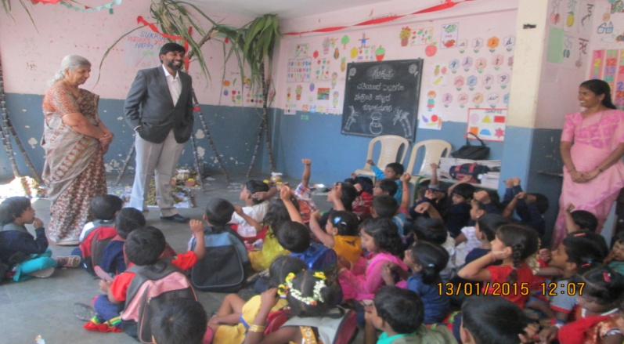

**Pongal Celebrations**  
                 Festivals do not just offer us a temporary reprieve from their daily stuff. it is Imbued with deep inner significance, and very much culturally oriented which is an essential part of ones belief system and practices. We, in SUKRUPA celebrated Ponkal on 13th of Jan 2015 to demonstrate the rich cultural heritage and facilitate this knowledge and tradition to be passed to the next generation.   
 Pongal is a harvest festival of South India, more than a festival it is a traditional occasion for giving thanks to nature, for celebrating the life cycles that give us grain. teachers and children dressed up in coloured cloths,  exchanging pieces of sugarcane, a mixture of fried til,  pieces of dry coconut, peanuts and fried gram. The significance of this exchange is that sweetness should prevail in all the dealings.

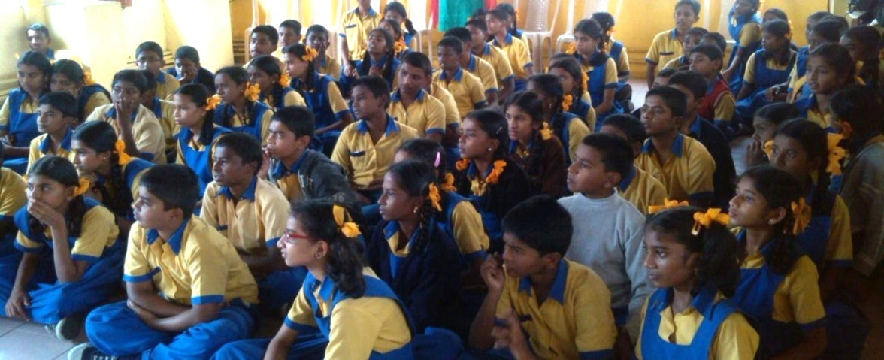

**Awareness session on child abuse and child line**

Child abuse is one of our nation's most serious public health problems. It occurs at every socio-economic level, within all ethnic groups, cultures and religions, But the underprivileged and marginalised children are more vulnerable to it.   Educating children is the best way to tackle it. The awareness program for children of 5th to 10 standard was conducted in two sessions to give awareness on child abuse, self care and what to do when they are at risk.the helpline services available etc. Children actively participated in the program conducted by Ms. Varalakshmi and Ms. Stella, Christ university.



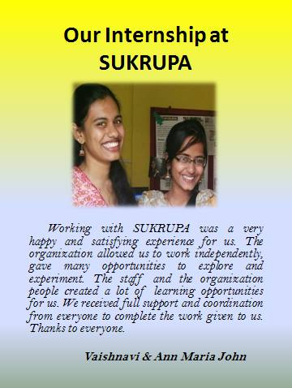

***HOW SUKRUPA CHANGED MY LIFE***

*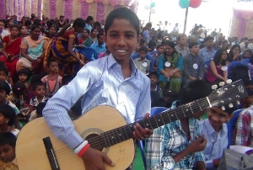I have been learning music for the past five years and, I have experienced a lot. I also learn guitar and keyboard. Music is something that you must feel inside. It brings joy and happiness. I am now part of Bangalore School of Music children’s choir. We go for classes every Saturday. I sing along with the choir in a different scale and pitch. I learn various genres of music. It is really fun learning it.*

*We get opportunities to perform on stage. It is important to listen to each other while singing. It is sometimes difficult to get the right note. But working together, learning the song, preparing for stage performances is a challenge for me. Music has been part of my life. It makes music more melodious and calm. Music adds that extra enrichment to your life. I really love learning music in Bangalore School of Music. I learn a lot through SUKRUPA. Now I am in college but during my days at SUKRUPA, I was given an opportunity to experience music and learn.*

*I have also been given chance to perform on stage; playing the guitar and keyboard was interesting. Especially, during Christmas we go for carols to various organisations and various other places to express the beauty of music. I want to do better in music, learn the keyboard and guitar because music is one of the few things that can help you escape your reality. No matter how bad things are, music has the potential to make you forget all about it. Music can spark any emotion. It can hold memories. You can’t touch music but music can touch you. I love it, I enjoy music.*

***Rajkumar***

**Volunteer with us – Transform lives.**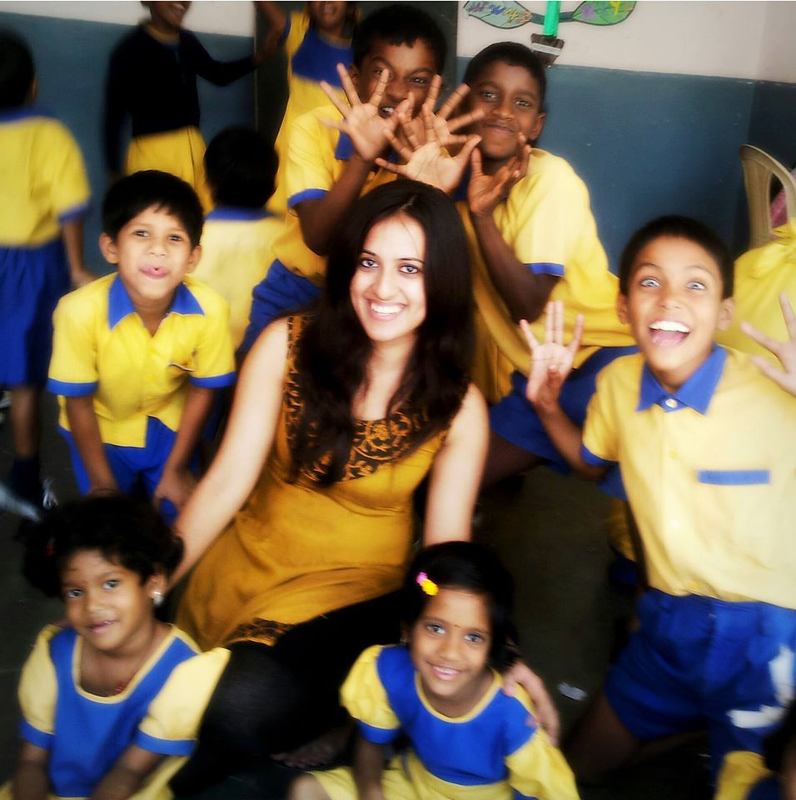

Every educated person has the ability to make a difference in a child’s life you could be that person.

We invite volunteers and interns from all disciplines for serving the communities better. Share your Knowledge, expertise and commitment with us. We are in great need of you.

You can help us in:

* Teaching / Mentoring children
* Contributing towards environmental conservation
* help us with designing posters et al, fund raising etc
* help us on and off during our events, health camps etc
* teaching life skill sessions for children

***If you have the passion to contribute towards social causes, Join us! Volunteer with us .***

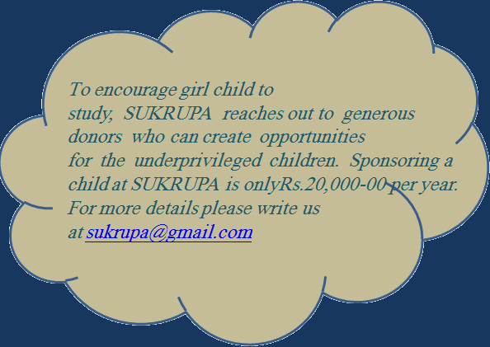

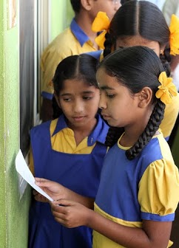

*With the support of sponsors, well wishers, our partner organizations, volunteers and the whole hearted efforts of our team, we have been able to accomplish our goals set for the quarter.*

*The helping hands of Golbal Giving and its great endeavor to catalyze resources, information and fostering socially responsible citizenship to support us is really appreciable.*

*We extent our heartfelt gratitude for all the support and cooperation and looking forward to a long lasting relationship with you*

*Warm Regards,*

***Krupalatha Martin Das***

**Executive Director**



# 15, G R Layout,

Cholanayakanahally, R. T. Nagar Post,

Bangalore – 560 024

[krupa.sukrupa@gmail.com](mailto:krupa.sukrupa@gmail.com)

[www.sukrupa.org](http://www.sukrupa.org)

<https://www.facebook.com/SukrupaOfficial?ref=hl>

<http://us5.campaign-archive1.com/?u=f3a131214c81db7544cb91239&id=ff8aaa3aab>

https://www.youtube.com/watch?v=h2bB74CP_gI

Donations Exempted under 80G Indian Income Tax Act

Registered Public Trust Act (49/04-05)

Registered under FCRA, 12 AA