Dear donors,

A quarterly report submitted by the Youth Network for Health (YONEFOH) for July 2013 to September 2013

We a most grateful for all the efforts each of you have put in to keep this project moving. With the funds you sacrificially made during this period of financial crisis, we were able to make more strides in the sensitization and education of Cameroonian youths against HIV and to carry out VCT which are some of the most effective ways to curb the spread of HIV and AIDS among youths.

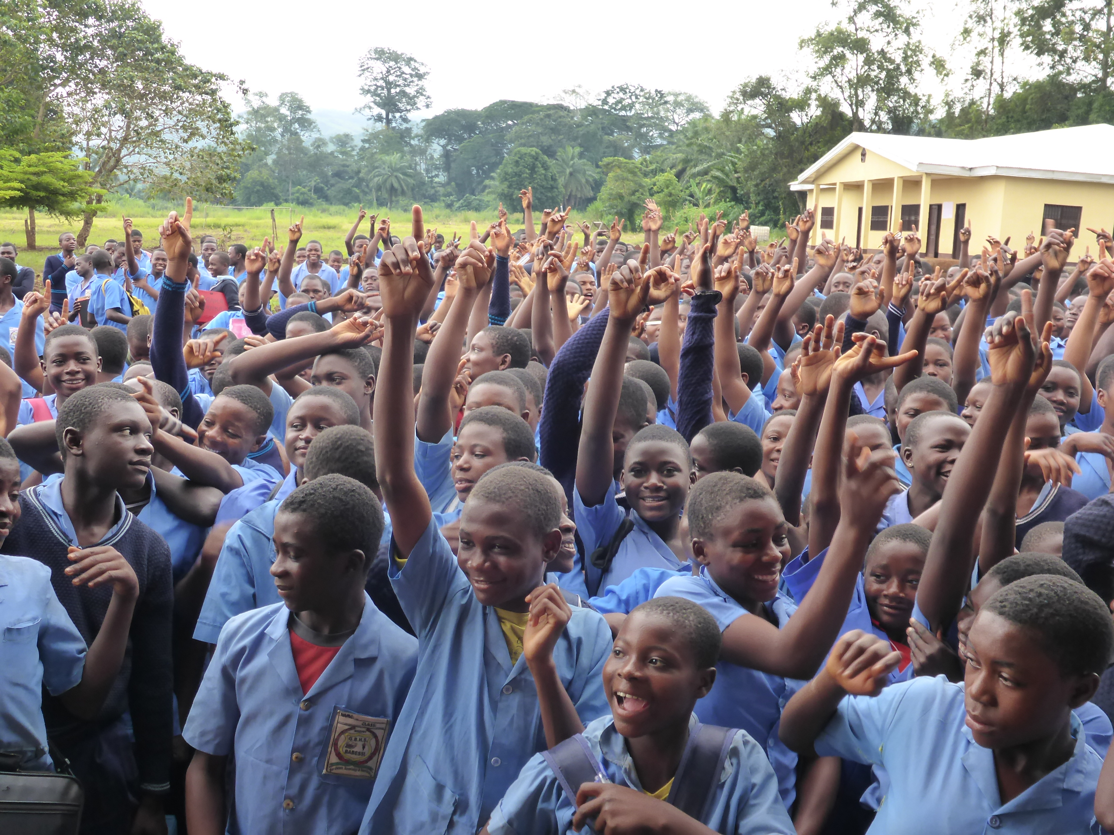
Students indicating to do VCT by show of hand in Babessi

In this quarter we were able to test a total of 1054 youths (of whom school 598 girls and 456 boys); of this number 7 tested positive (5girls and 2 boys). Most of our activities for this quarter were carried out in the communities of Baba1, Babessi, Babungo, Soppo and Limbe which have high needs.
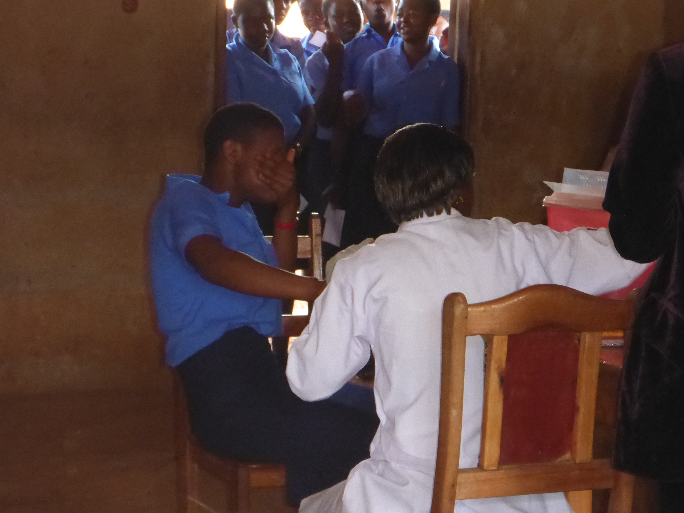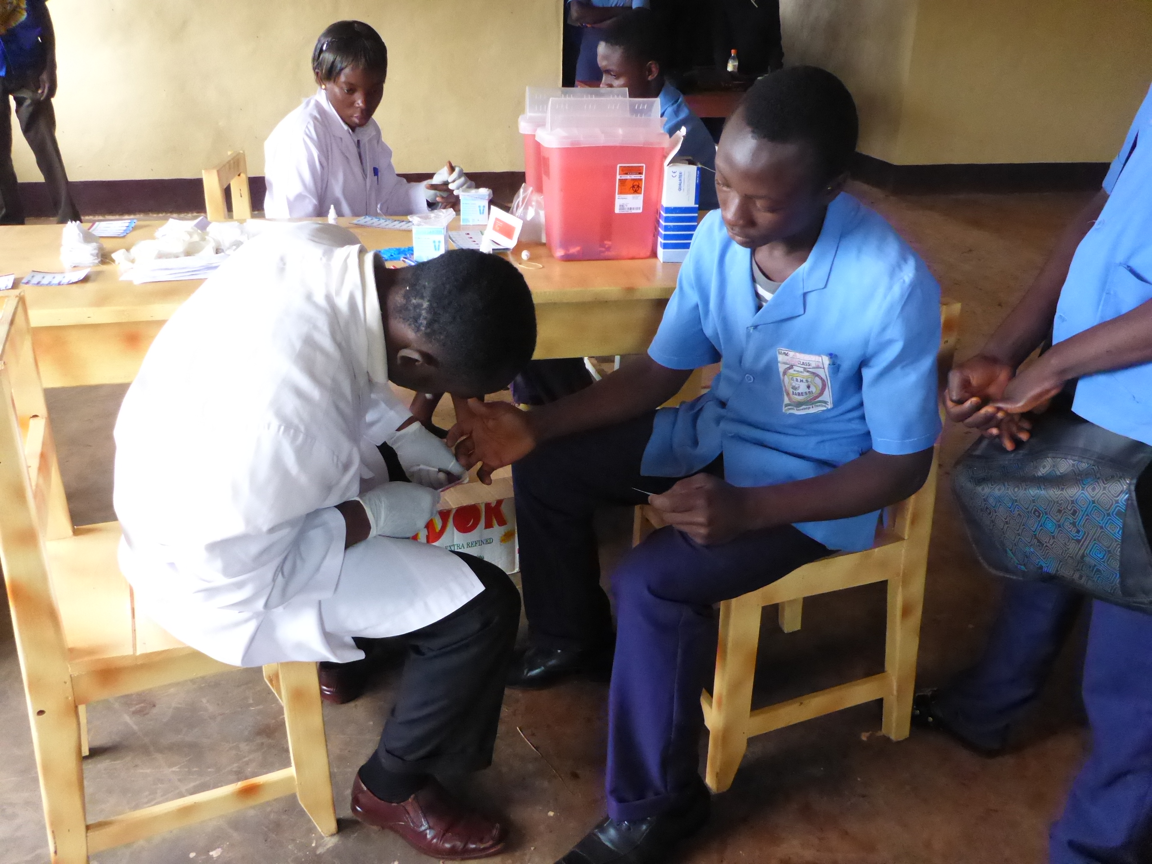
VCT in Baba 1 and Babessi school labs

The YONEFOH mobile team was again reinforced by volunteers from Germany like in previous years following an excellent partnership between CBCHB and Bread for the world in Germany. Selzer Niclas, Nora Jurjeuseu, Claus Caroline and Lohn Annelie will thus be on the team for the next one year. With these additional hands, the program was able to also carry out VCT at non-school milieus such as during youth camps in Limbe and Soppo and during the Fako principal’s conference.
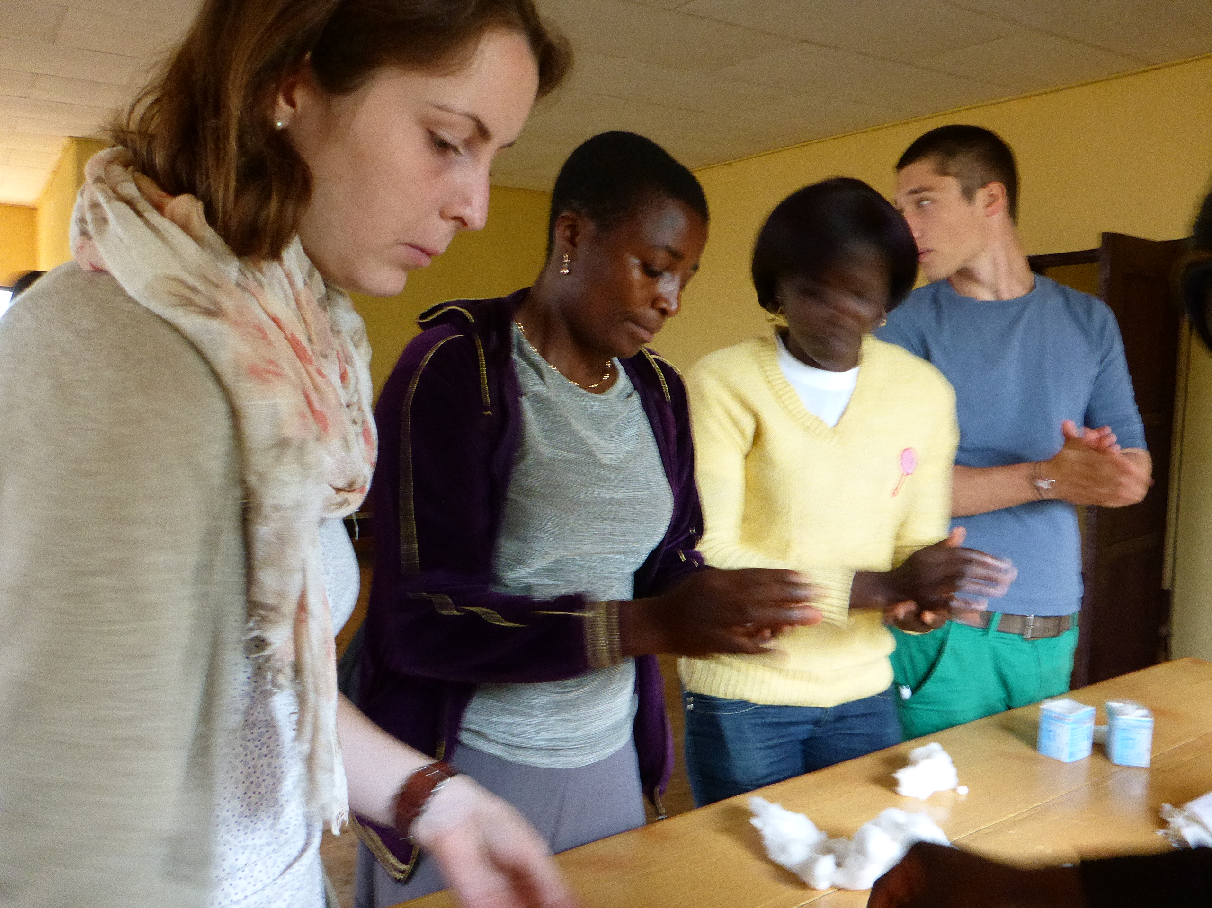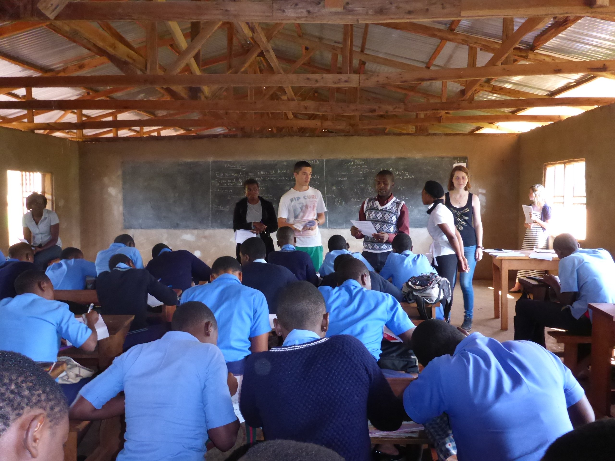
Volunteers and project staff in Babessi and Baba1

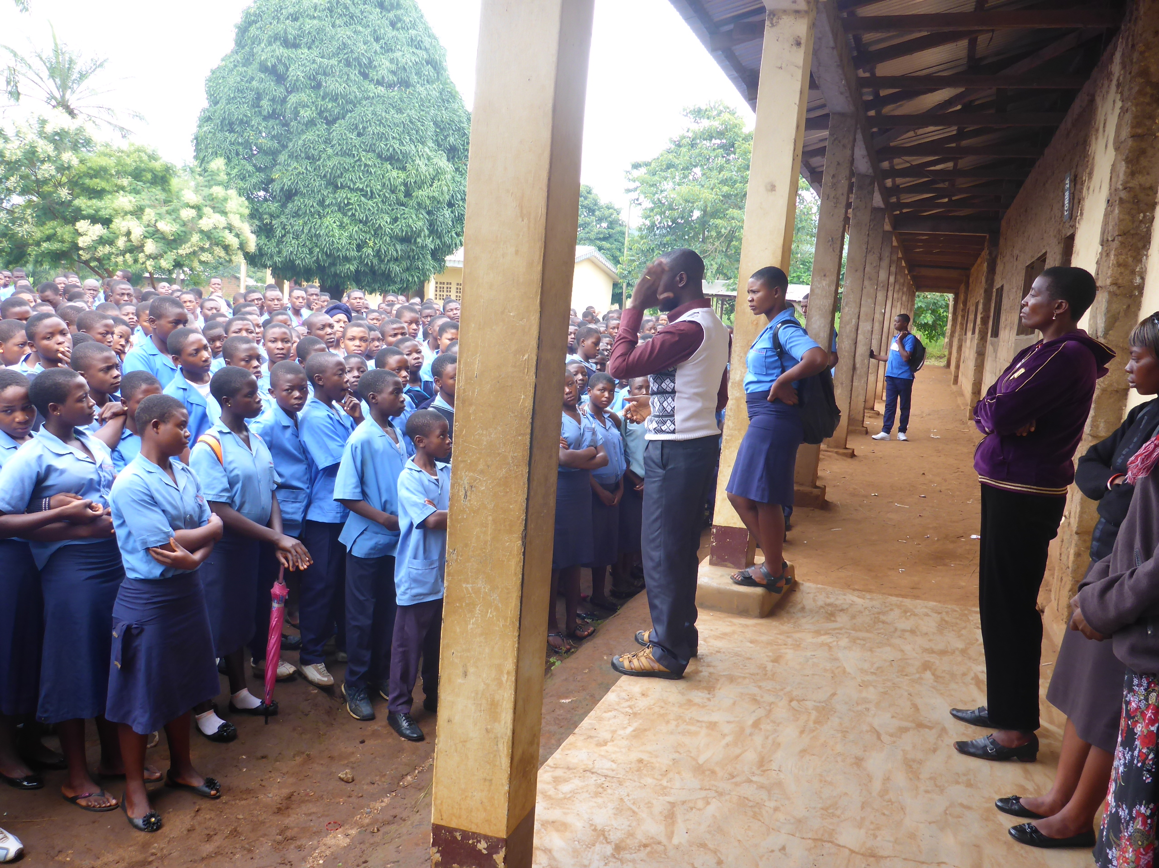
Health talk during morning devotion

Quantitative report for Q3
ACTIVITY | INSTITUTION  VISITED | TOTAL | GIRLS | BOYS | GIRLS  NEG. | GIRLS  POS. | BOYS  NEG. | BOYS  POS.
HIV Testing | Government High School Baba 1 | 304 | 193 | 111 | 191 | 1 | 110 | 1
HIV Testing | Government Bilingual High School Babessi | 344 | 167 | 177 | 165 | 2 | 177 | 0
HIV Testing | Government High School Babungo | 255 | 156 | 99 | 156 | 0 | 99 | 0
HIV Testing | SOPPO YOUTH CAMP | 69 | 39 | 30 | 37 | 2 | 30 | 0
HIV Testing | LIMBE YOUTH CAMP | 61 | 36 | 25 | 36 | 0 | 24 | 1
HIV Testing | FAKO PRINCIPALS FUNCTIONAL CONFERENCE | 21 | 7 | 14 | 7 | 0 | 14 | 0
Total |  | 1054 | 598 | 456 | 595 | 5 | 455 | 2

Total activity expenditure during this quarter
S/N | Activity | CFA | US Dollars
1 | HIV kits and other material | 1,054,000 CFA | $2108
2 | Transport to the sites for HIV screening | 205,000 CFA | $410
3 | Catering to staff | 181,000 CFA | $362
5 | Grand total | 1,440,000 CFA | $2880

Major challenge:
While more schools in different communities keep soliciting our services, funding remains our biggest challenge to meet up with the increasing demand.
Word to our faithful donors:

We are inviting you all for the Year-End Campaign from the 1st of December to the 31st of December 2013. Global Giving would be offering nine (9) bonus awards (including a $3,000 and $2,000 prize!) to the projects that raise the most money from their supporters within the period. We must raise at least $3,000 from 30 donors in order to qualify for a bonus award. Also there would be recurring Donation Match within this special month. During the last 12 days of the year, Global Giving will be offering a one-time 100% match on all new recurring donations up to $200 per donor.

We will be very grateful to have you partake to this end of year challenge with us

You give us your money, we do the job for YOU!

