Dear donors,

A quarterly report submitted by the Youth Network for Health (YONEFOH) for October 2013
to December 2013
We are most grateful for all the efforts each of you have put in to keep this project moving.
Our focus this period was to educate and commemorate the World AIDS DAY (WAD) Celebration. We were able to make more strides in the sensitization and education of 17,633 Cameroonian youths against HIV plus related issues in 45 communities and HIV screening in two communities which are some of the most effective ways to curb the spread of HIV and AIDS among youths which culminated with the celebration of the WAD

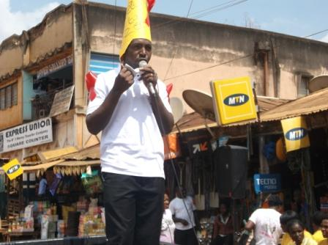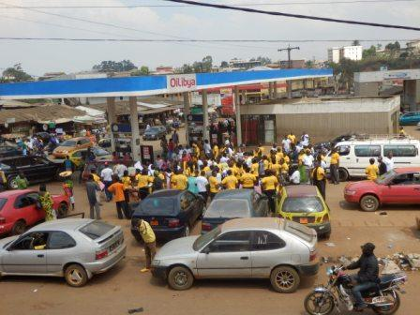
YONEFOH Coordinator delivering health talks in popular spots during WAD

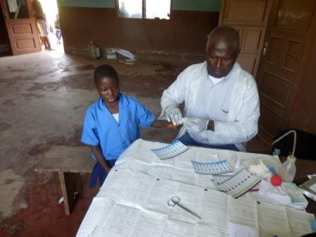
Voluntary counseling and testing for HIV

In this quarter, we were able to test a total of 627 persons with 30 positive; 29 females and 1male (those tested were mostly adult and many of them were women) see appendix

VCT in GBHS Akanunku

HIV Screening statistics
ACTIVITY | INSTITUTION  VISITED | TOTAL | FEMALES | MALES | FEMALES  NEG. | FEMALES  POS. | MALES  NEG. | MALES  POS.
HIV Testing | CWA BAYELE | 420 | 384 | 86 | 355 | 29 | 85 | 1
HIV Testing | HUMAN RIGHT RESOURCE CENTER BAMENDA | 50
HIV Testing | GBHS Akanunku | 157 | 87 | 70 | 87 | 0 | 70 | 0
 | TOTALS | 627 |  |  |  | 29 |  | 1

Total activity expenditure during this quarter
S/N | Activity | CFA | US Dollars
1 | HIV kits and other material | 470,000 CFA | $940
2 | Transport to schools, churches and communities for education on HIV/AIDS and related issues plus HIV screening | 516,000 CFA | $1032
3 | Catering to staff for both education and HIV screening | 191,000 CFA | $382
5 | Grand total | 1,177,000 CFA | $2354

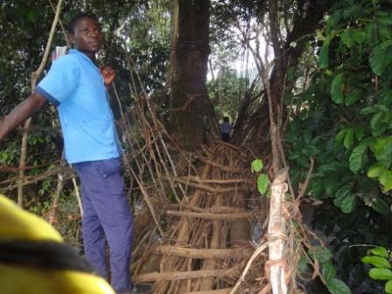
Testimony from Albert
Generally we are always forgotten in my community due to the poor communication network which scares people away. Anyone coming here is obliged to trek at least six hours coming through Widikum or ten hours when coming from Njikwa. I’m grateful you braved the odds to meet us here through the sponsorship of some people I may never know or see. Thank you for coming. Many thanks to Global Giving for the initiative and most importantly, a big “thank you” to all the sacrificial donors for their relentless efforts to help underprivileged persons know their health status. I wish them all a prosperous new year as they keep supporting such ventures.

