**Cameroon Baptist Convention Health Services-Youth Network for Health (CBCHS-YONEFOH) Activity Report (February 2013 to April 2013)**

Thanks to your donation to us through Global Giving, YONEFOH field staff have been able to reach an increasing number of youth in remote underserved communities with primary HIV prevention education. We were able to carry out/strengthen the following areas of our community work using the dollars you generously donated to us:

**Education and sensitization**

By the end of January, 2013 YONEFOH activity report showed that in total 6,101 number of youth were reached with HIV and STI education. Since then, more efforts have been made to reach more, especially in remote areas. The 8,820 students reached this quarter, brings the total number of youth reached with global giving donation stands at **14,921**. New health topics were also emphasized. These include smoking, drug abuse, alcohol, dating, relationships, rape, values self-esteem and abstinence. Despite progress made in this area, more work is still needed to meet the set target of **50,000** youth by the end of 2013.

**Peer educators’ workshops**

For our peer education slot, two peer-educators’ workshops were organized to empower youth to educate their peers. Our studies have proven that young people listen more to their peers on issues affecting them. Consequently, given the right orientation to peers will create a snow ball effect which will create a positive impact among the youths. In regards to this, a total of **561** youth were trained.

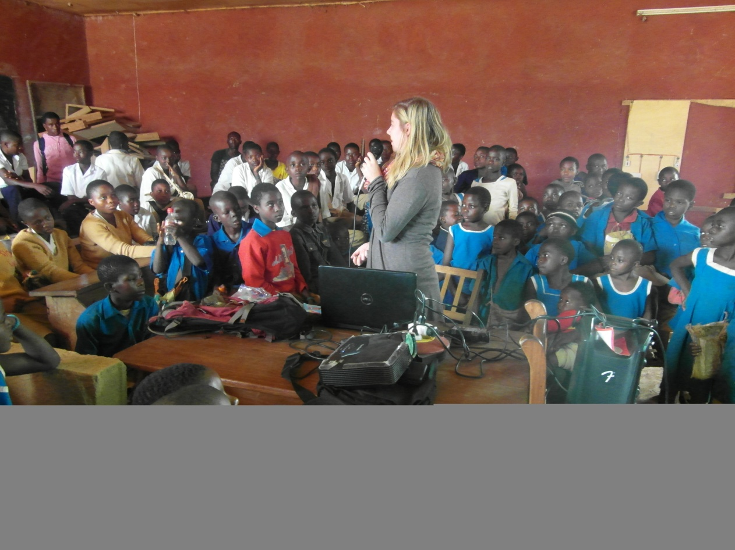

**Peer educator workshop at GTC Balikumbat**

**Voluntary counseling and testing**

A total of **989** persons were tested with **9** positive **7** females and **2** males.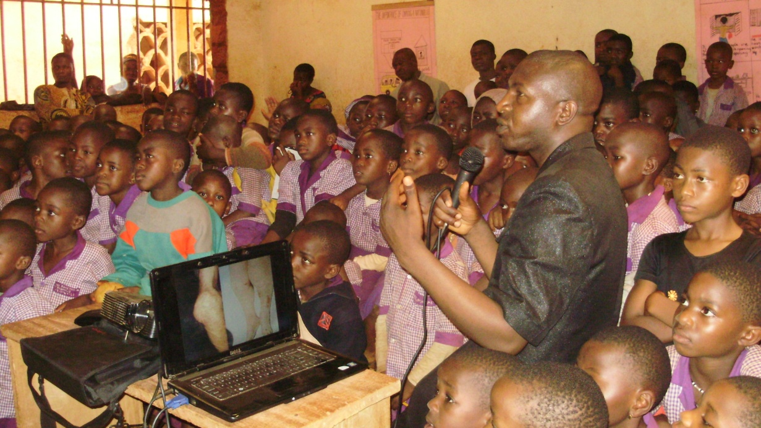

**Health education with primary pupils in Ndop**

**Counseling**

The impact of our education keep drawing many youth to us for counseling thus, a total number of **17** young people were counseled in this quarter in the various offices on issues pertaining to their physical, social, emotional and spiritual lives.

**Feedback**

*“The workshop has helped me to restate my commitment to a good number of decisions I had taken in life that were almost giving way. I thought that with the use of condoms STDs had disappeared. Thanks to this workshop I have learnt they are many more which have come up which I did not even know. Before now only verbal information used to be given on STDs but with the pictures you people projected, the reality of the consequences of premarital sex has been displayed before my very eyes. I commit myself to saying “No” to premarital.*

*I will like to suggest that if possible the pictures of genitals affected by STDs should be printed on papers and distributed so that after workshops like this youth can show their friends who don’t believe such things do exist.*

*Thank you so much.”*

**(Tata Emmanuel GTC Balikumbat)**

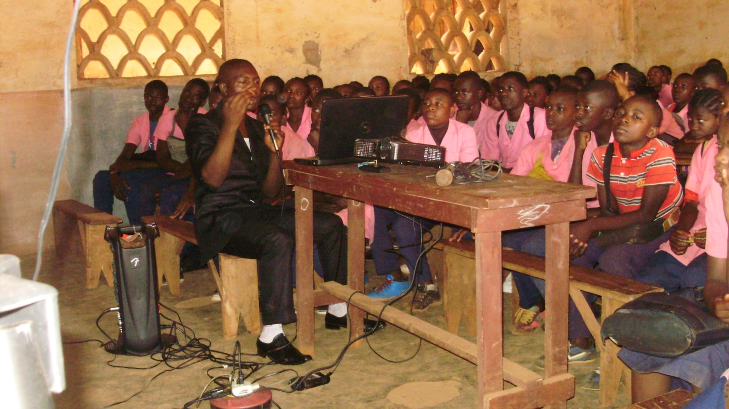 **Peer educator training at Health Services Complex**

**Challenges**

1. Limited finances to meet growing demands.

**Way forward**

1. Continue with education in schools, churches and communities
2. Organize more workshop in schools
3. Follow-up peer educators trained
4. Follow-up of existing health clubs

**Expenses for HIV screening, workshops and Health Education to April**

|  |  |  |  |
| --- | --- | --- | --- |
| S/N | Activity | CFA | US Dollars |
| 1 | HIV kits and other material | 989,000 CFA | $1978 |
| 2 | Transport to the sites for health education, VCT and Workshops | 605,000 CFA | $1210 |
| 3 | Catering to staff | 198,000 CFA | $396 |
| 4 | Workshop expenses | 200,000 CFA | $400 |
| 5 | **Grand total for all** | **1,992,000 CFA** | **$3984** |

**Thanks immensely for your contribution in making us realize this project!**