Kashf volunteers for relief work
Report by: Farzana Sardar
Sungi Development Foundation is coordinating relief efforts in some of the worst hit districts of the recent earthquake in Azad Kashmir, Mansehra, Battagram and Abbottabad. Sungi has been working in these districts for more than ten years and has zonal offices operating in all of them. Sungi’s zonal coordinators are based at each location and they are presently visiting the affected areas with members of other relief agencies.
Kashf is also participating in relief work activities through other agencies to improve the lives of the victims. The following six staff members from Kashf Foundation have volunteered for the relief work at Balakot, the most affected area by devastating earthquake:

- Ms. Shahla Sattar Assistant Finance Manager
- Ms. Farzana Sardar Program Associate
- Ms. Hafsa Sajjad Program Associate
- Mr. Ijaz Ahmed Loan Officer- Baghbanpura Branch
- Mr. Ijaz Ahmed- Loan Officer Ichara Branch
- Mr. Naveed Abbas Loan Officer Wazir Abda Branch

The team reached Abbotabad at Sungi’s head office on Friday 02nd December at around 2pm. Mr. Ishtiaq gave us an orientation session about their base camp, relief work and our duties as volunteers. Sungi Development Foundation had arranged boarding and lodging for Kashf volunteers team. The team stayed for 8 working days and returned for Lahore on Sunday 11th December.

Sungi had arranged nights stay for female volunteers at Mansehra Regional office and males stayed at Balakot Base Camp. Female team leaves 7:30am daily from Mensahra to Bala Kot Base Camp where we were divided into teams for the need assessment of earthquake victims. Kashf team collectively visited some of the worst hit villages of Balakot i.e. Satbani, Pambara, Shohaldara, Ghanol, and Karnol for the purpose of need assessment regarding tents, food and shelter for the earth victims. Other than Kashf team there was another team of volunteers from Tobateksingh.
All volunteers were males there were only three female volunteers from Kashf.

Balakot has 12 union councils Sungi is working in 8 union councils at grass root level communities. Till November, 2005 Sungi has provided food to thirty thousand families, tents and blanket above eighteen thousand families.

Each team was a given target of 150 house holds per day for the need assessment survey. Teams moved from the base came to different villages accompanied with the local men who had the good knowledge about the areas. After assessing the condition of the house and family the team put family’s name in the list and issued them a slip for the required things. The next day they would come to the Base Camp established by Sungi and shows their slips given by assessment team to receive their required things i.e. food, iron sheets, cash and tent.
There was heaps of rubble in every village because every house has collapsed. During assessment we saw many graves in every community. One woman Fatam Noor showed me a grave of her husband and relatives. She said “I have lost my husband, three daughters and twenty close relatives in front of my eyes. My house has totally collapsed. My Muhallah was converted into a graveyard. I don’t know how I will spend my remaining life. I don’t want to survive more…..”
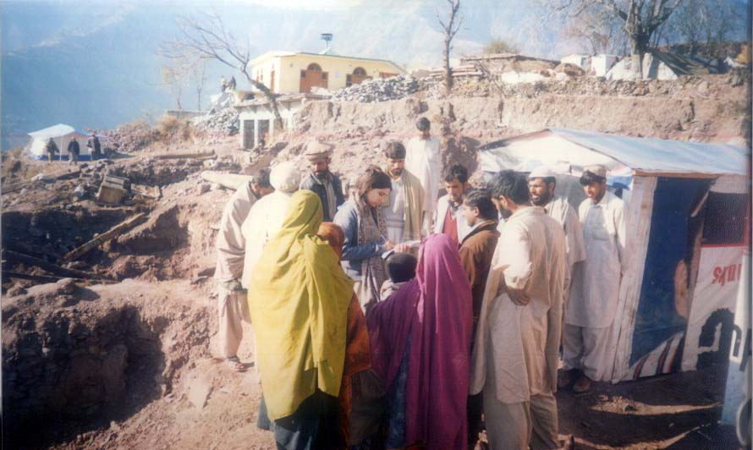
Need assessment visit in Pambara village, Balakot
We met more than four hundred victims who had painful stories.
Zaiwar Jan from Pambara village told us “The tremor jolted us. Every thing vanished away in few seconds. Still every night I am hearing voices of my son and daughter who gave their lives in the school. On that day they wanted to take off from school but I sent them forcefully. My husband saved me from rubble. We spent whole night in the heavy rain and snow with our dead bodies. We spent three days without food but now we have enough food, tent and blanket. We are really thankful those agencies that approached us in these difficult circumstances. Without their help it was too difficult to survive for us. Though no one can compensate our losses and damages but if your help continues we will recover soon”. Zaiwar Jan was a very courageous woman she talked with much hopes and confidence.

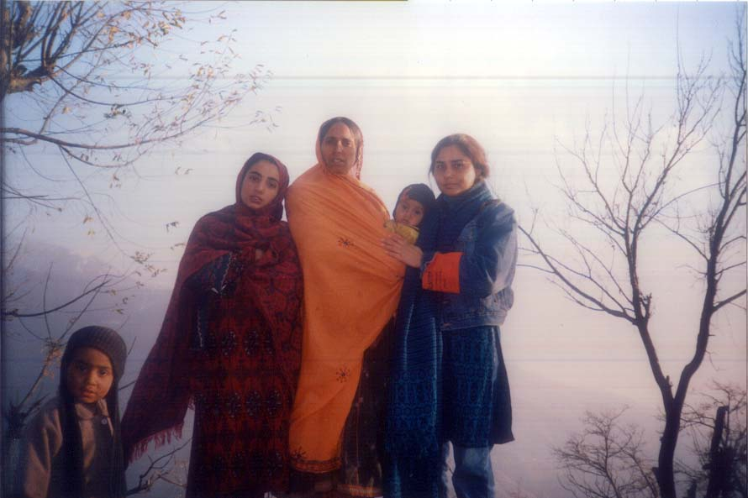
Zaiwar Jan, Village Pambara, Balakot
Fouzia said “At that terrible moment I was in my class room. Suddenly my class room shuddered and we all were under the rubble. All my class fellows, three teachers and four cousins have gone away in this earth quake. I spent almost 3 hours under the rubble. Luckily I could not lose my senses because GOD gave me energy and with the help of Almighty GOD I made the way from the rubble to save my life. When I was running to my home with trembling feet many times I fell down but I didn’t give up my courage and finally I reached to my collapsed home”.
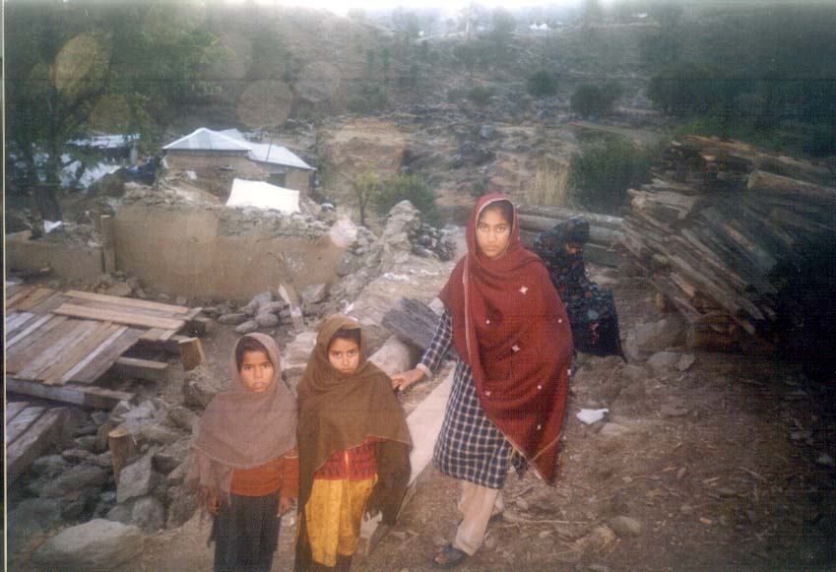
Fuzia a student of tenth class
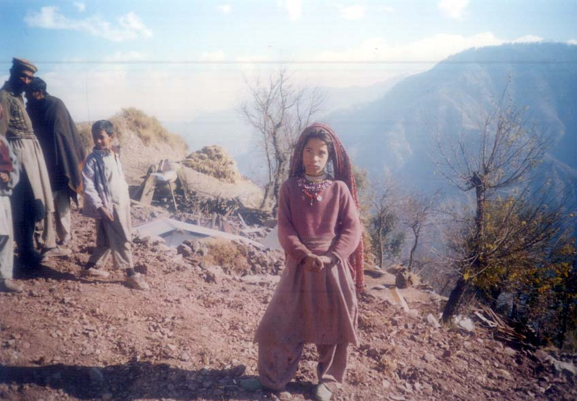
8 years, Gulzar who has lost her school
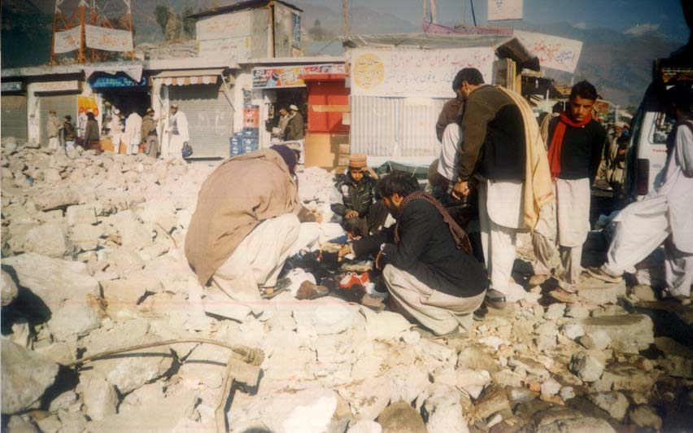
A child is selling shoes on rubble

