PHOTOS
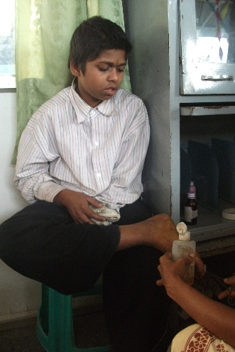 | 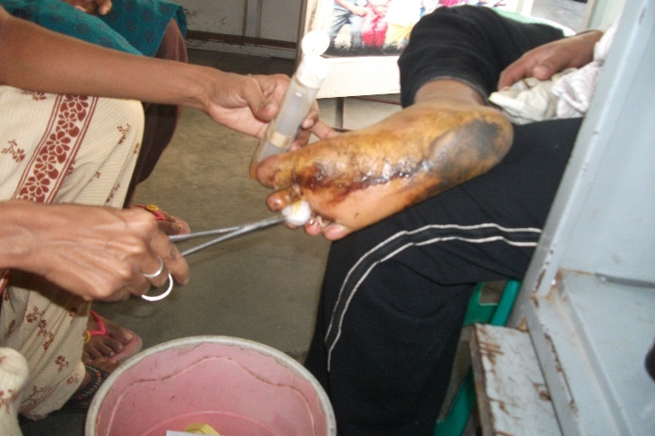
SOCIAL WORKER IS GIVING MEDICAL CARE FOR A RESCUED CHILD | MEDICAL CARE FOR A RESCUED CHILD
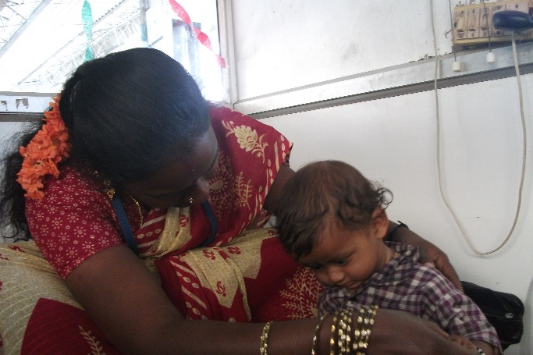 | 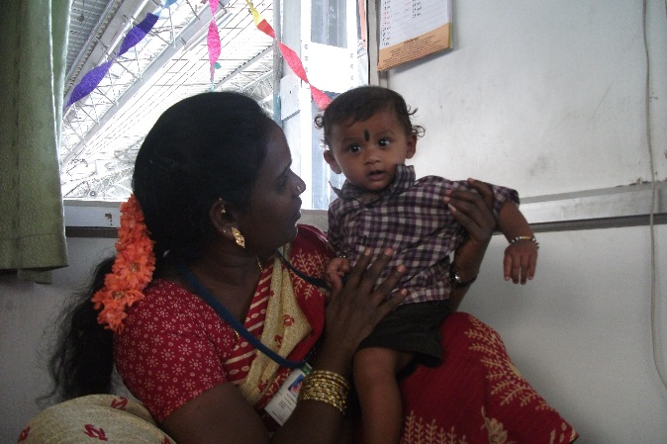
RESCUED CHILD WITH A SOCIAL WORKER. | RESCUED CHILD PLAYING WITH THE SOCIAL WORKER.
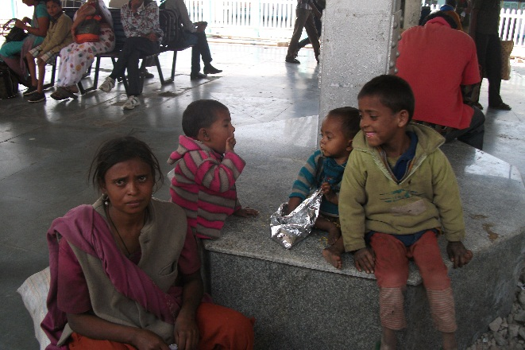 | 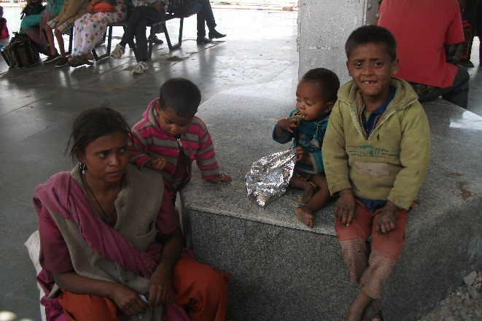
A RESCUED FAMILY | A RESCUED FAMILY
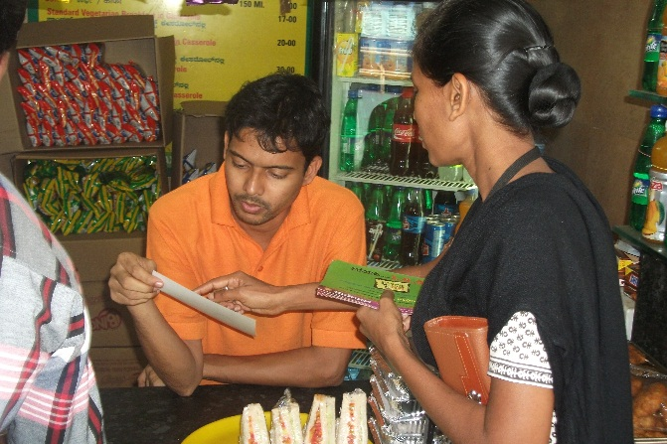 | 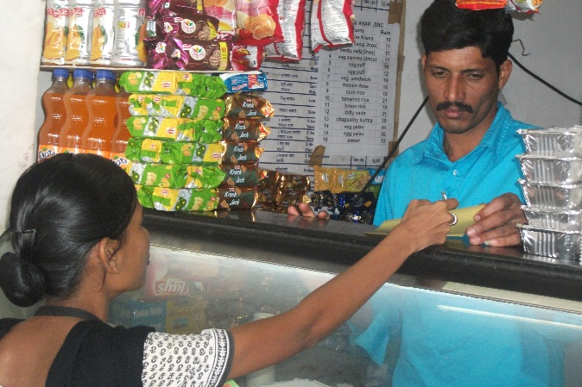
AWARENESS PROGRAM | AWARENESS PROGRAM
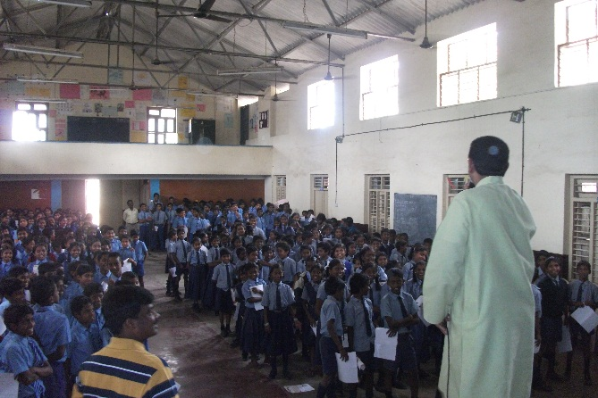 | 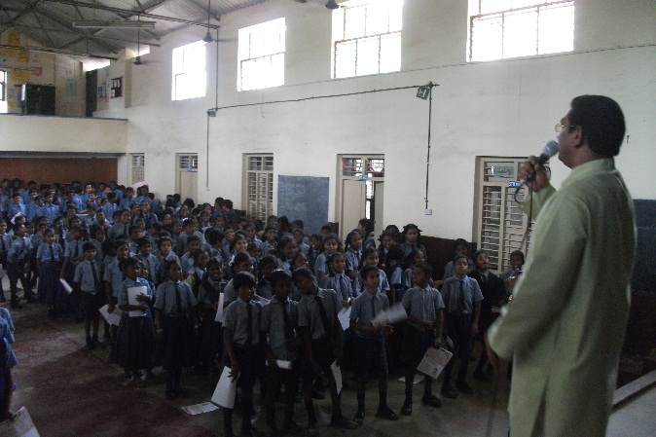
AWARENESS PROGRAM IN THE SCHOOL | AWARENESS PROGRAM IN THE SCHOOL
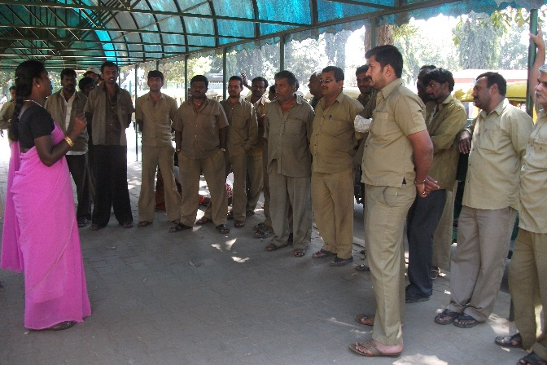 | 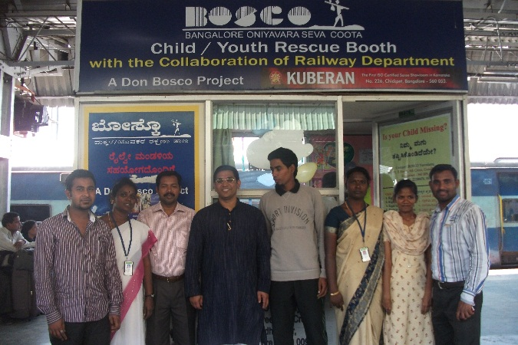
AWARENESS PROGRAM FOR THE AUTO DRIVERS | RESCUE BOOTH

