Stories from One Egg Program

The One Egg Program was initiated by Shanghai United Foundation and 9 NGOs. Up to now the program has been operated for 3 years (6 semesters). The statistics of the 2nd half of 2013 are being compiled and will be published in June 2014. Meanwhile, we are going to share some stories happened during the implementation of The One Egg Program.

Please note: To project the privacy of the story individuals, all below names are alias or pseudonym.

- Story from Chunmiao student center of Yibin City

Xiao feng is a student of Da Wo Town Gao County, Sichuan Province. Originally there were 4 people in her family, i.e., Dad, Mom, younger brother who attends kindergarten and Xiao Feng. Mom left home when Xiao Feng was six years old, and has never been heard of since. Unfortunately, Dad has to migrant to the city to make more money, who has no choice but to place his kids in foster care with neighbor’s house that is not wealthy. Throughout the year the poor family would not have any nutrient-rich foods. The two children can only eat some simple greens and rice which also means they get fewer nutrients and run the risk of becoming nutritionally deficient.

The One Egg Program and government basic nutrition programs were started in Xiao Feng’s school when she was in Grade 3. From then on, Xiao Feng and her younger brother have shared one serving nutritious meal (just for compulsory education students) but two eggs when school snack time comes.

The following photos were taken from project Sichuan site of One Egg Project:
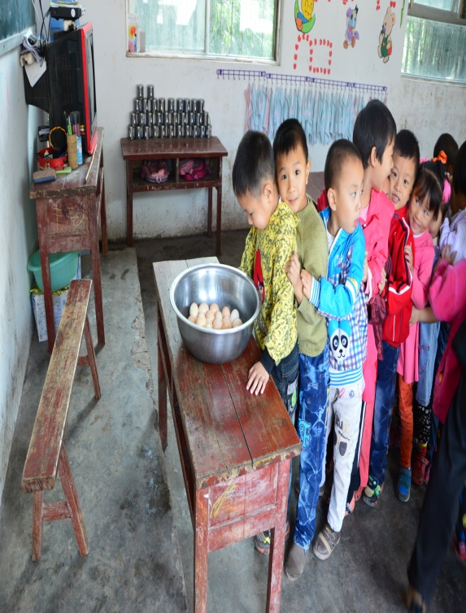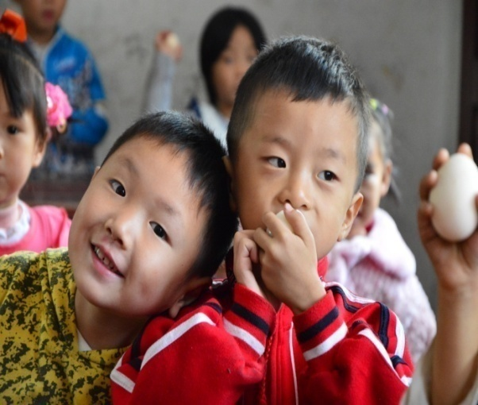
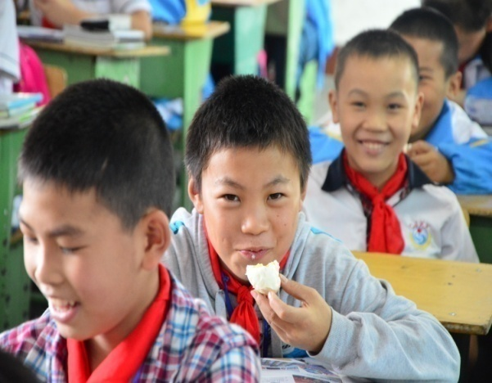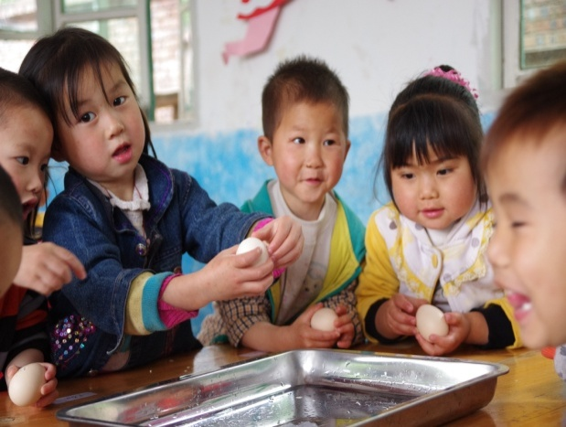

2、Story from Ark Mutual Help Center
Xiao kuang and her sister live with their grandmother in Tiane County, Guangxi Province. Their parents died several years ago. Unfortunately the kids had nothing to live for but the government relief only, which is 100 RMB (approx. U$17) every month. Xiao kuang’s school provides the students with free lunch and supper in learning day but have no breakfast. Xiao kuang is a boarding student and he has pocket money 1 RMB (approx. U$0.17) every week. He often skips breakfast or occasionally buys some cheap biscuits instead. The same situation occurs to his schoolmates.

The One Egg Program was started in Xiao kuang’s school in 2012. Now the program has ensured Xiao kuang and his schoolmates one egg a day as their breakfast. For having one egg a day, those students who are consistently tardy to class have already attended classes regularly.

The following photos were taken from project Guangxi site of One Egg Project:
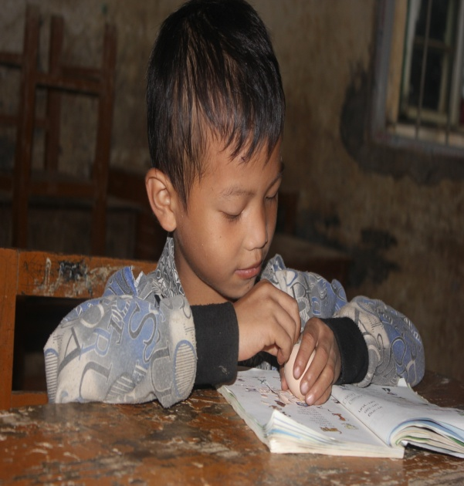
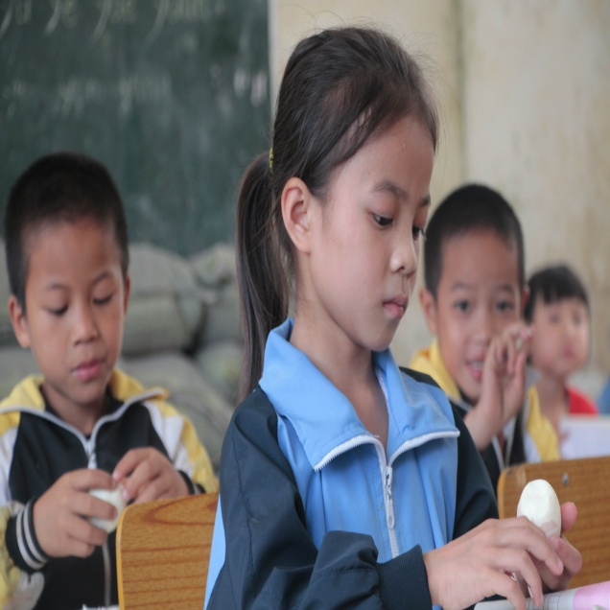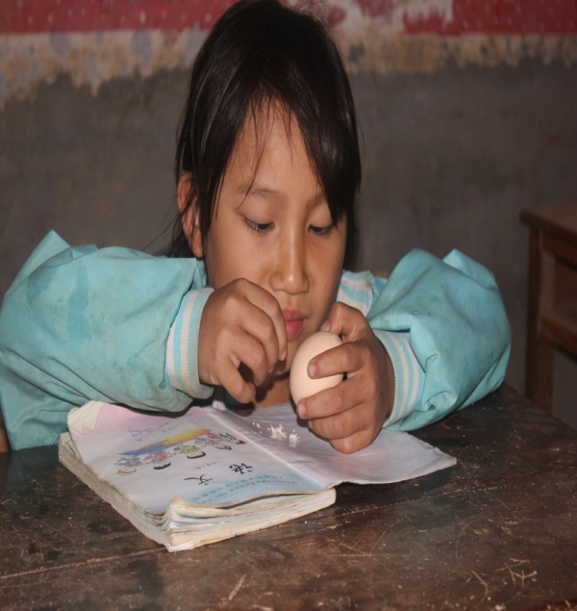

3、Story from Children’s Hope Foundation
Yi Autonomous County where Yi people live in is one of the most extremely impoverished places of Yunnan province. There is regularly shaken by earthquakes, and people are scattered across in remote mountainous regions and they are not well off. Several villages share only one school, and many students have to spend one to four hours on their way to school. Every morning those students who look thin and small for their age get up early and have nobody to prepare breakfast for them or they don’t have the habit of eating breakfast. In one summer camp, Children’s Hope Foundation compared 200 countryside children of Yi Autonomous County with 50 other rural children of the same sex and age. They find the size gap between them is ten to twenty centimeters in height.

Before One Egg Program was launched, 95% of Nanjian Yi Autonomous County’s countryside students didn’t have the habit to have breakfast. The One Egg Program was started there in 2012 and ensured nearly 1,000 students one egg a day for their breakfast.

The following photos were taken from project Yunnan site of One Egg Project:
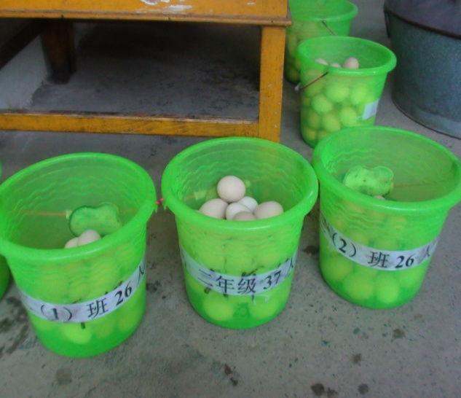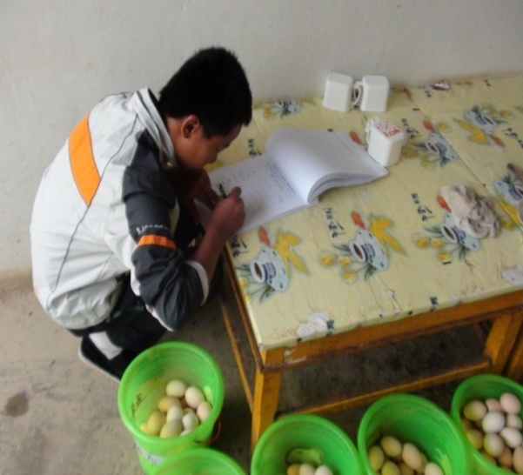
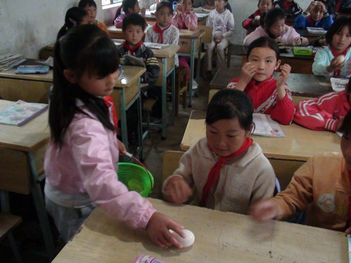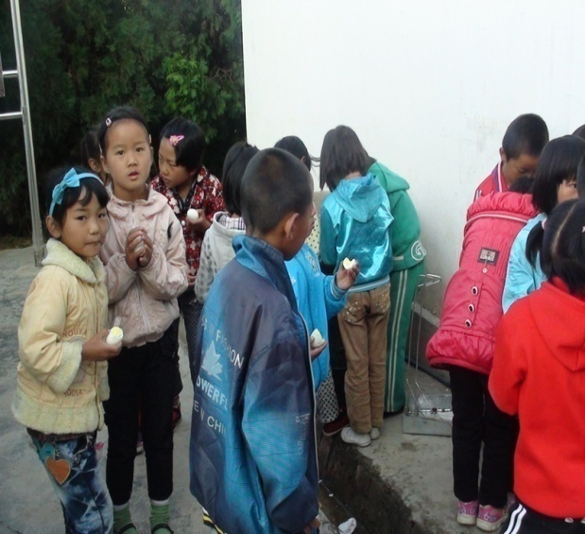

4、Story from Apple-Garden Children Sponsorship Workshop of Guiyang, Guizhou Province
For students and teachers supported by the One Egg Program, one egg is a kind of love and. encourages them to form good behaviors. The following letter was sent from a girl who eats an egg every day in Chunhui primary school of Guizhou Guiyang.

Dear uncles and aunts,
I am a student in Class One, Grade Three of Huihuang primary school. Thank you very much for handing out eggs for us. Eggs bring us good health.
Eating an egg every day can be exciting. Thank you very much for bringing us so tasty eggs. I would study well and make progress every day to reward you for your kindness. Thank you very much again for giving us eggs which is rich in nutrients when we are hungry.
Sometimes, once an egg dropped on the dirty floor, the students never bear to part whit it but immediately picked it up and washed with cold water then ate the egg with gusto.(As the third photograph shooted.)
The following photos were taken from project site of One Egg Project:
