Annual report
2012
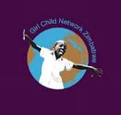

Name of Organization | Girl Child Network (GCN)
Physical Address | 16352 Bazooka Crescent, Zengeza 4, Chitungwiza.
Name of Contact Person | Edinah Masanga – Executive Director
Contact information | girlchildnetworkzim@gmail.com  Telephone(+263)778 237 116 / 772 288 251

MESSAGE FROM GCNZ CHAIRPERSON
I am very happy to write this message since 2012 has been a very progressive year at Girl Child Network Zimbabwe.
This year we appointed new Board members and brought on board a mixture of skill, expertise, experience and institutional knowledge into the organization. We have managed to attract new partners, help more girls, strengthen the organization and move one if not two levels up.
We also welcomed a new Executive Director.
We enjoyed maximum media coverage and I must thank all the newspapers, radios, televisions and websites who covered our work. This helps us to reach more girls. We are indebted to you.
Thank you to our stakeholders and worldwide supporters who remained steadfast supporting the organization.
To our donors; institutions and individuals; who donated in cash and in kind we are grateful and thankful for your continued support lets continue working for the girls again in 2013 and together we can make a big difference.
Our dedicated staff and volunteers lets keep the spirit in 2013 and take the organization to dizzy heights.
Veronica Nyoni
Board Chairperson

Girl Child Network Zimbabwe Annual Report highlights impact of activities carried out from 30 March 2012 to 1 December 2012. During this period we set target results and we worked with all commitment to deliver for the benefit of our target beneficiaries – girls.

GCNZ’s mission is to support and promote girls’ rights, empowerment, and education by reaching out to and advancing the circumstances of Zimbabwean girls wherever they are economically deprived, at risk of abuse, subject to harmful cultural practices, or living in areas of instability.

What We Did Throughout The Reporting Period

Identify and support girls who are at risk of, or who have survived gender based violence

Support, Protect, promote and empower girls’ access to education, and education and support the learning and growth of individual girls.

Combat economic and social inequality so as to
minimize gender based violence

raise awareness
through the various mediums on issues affecting girls

position girls strategically
in areas of empowerment and development

bring in more supporters
to the girls cause
……………………………………………………………………………………………………………………………………….....

Strategies We Used To Achieve Our Objectives
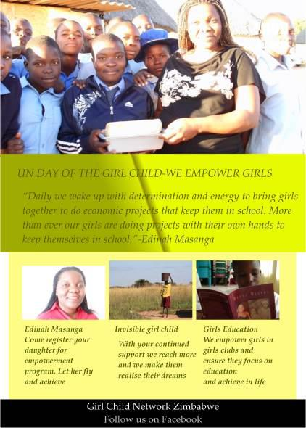
- Reinstatement of girls who have dropped out of school as a result of sexual abuse, orphanage, impregnated and also as a result of HIV illness. Ensure that girls are in school and not at home in which the latter makes them vulnerable to sexual abuse exposing them to HIV infection.

- Life skills training for girls who are unable to continue with school due to other factors other than lack of funds

- Integration of our project Women As Role models in schools. The project pairs a girl with a woman who has done exceptionally well enabling the girl to receive mentorship and motivation to stay in school

- Enrolment of orphaned and vulnerable girls in boarding schools to ensure they get maximum, time to study since from evidence gathered through a desk study of the requests received by GCNZ most orphaned girls are unable to concentrate on schooling as a result of ‘girl child labour’

- Sourcing and Provision of grants for girls in empowerment villages to start income generating and self help projects to prepare them

In All We Do, We Are Guided By

- integrity

- Honesty

- Passion

- Commitment

- Objective

- Action Oriented

- Empowerment

- Team work

- Learning and sharing

- Attention

- Promote
Our Principles And Values

- Integrity - we deliver our programs with truth and openness and know we must remain accountable at all times.

- Honesty - everything that we say and do must show that we are open ,clean in deeds and words and that we tell the truth and only the truth

- Passion - We do everything from the heart .Our work inspires and is inspired by our personal stories and the stories of the women we represent.

- Commitment - we started as volunteers and we will commit our time and resources above what others contribute.

- Objective –we do everything without bias and utmost objectivity, we do not let our emotions crowd our work..
- Action orientated – we believe for problems to be solved we must act.

- Empowerment-everyone we work with or target must be able to stand up for themselves and we should play a facilitative role.

- Team work-we believe the problem needs all of us playing a part and that each part adds up.

- Learning and sharing –we believe that everyday we generate knowledge and others too generate knowledge and the power of sharing knowledge will make us stronger and better. We are an organization with a learning culture.

- Attention – we pay attention to our beneficiaries

- Promote – we strive to promote girls in everything we do

Overview
WHO WE ARE

GCN is a community based, activist, developmental organisation that seeks to promote the rights and empowerment of the girl child in the home, school and community. It is registered under the Private Voluntary Organization Act (9/2004) and therefore enjoys legal status as an official non-governmental organisation in Zimbabwe.

WHAT WE DO

- GCN re-socialises girls (0-16 years old) so that they articulate their individual and collective rights and strategically position themselves to take charge of their own empowerment.
- GCN mobilizes whole communities to eradicate patriarchal structures that dominate the home, school, and community so as to support the development of an enabling environment and to promote and protect the rights of the girl child
- GCN ensures girls at risk and most vulnerable to abuse are rescued and empowered to speak out and, through provision of safe shelter and strong referral to legal and medical aid, stand up to defend their rights
- GCN supports and promotes girls to be in school and advocates for a violence free school environment so that girls get maximum benefits from education

WHY WE ARE UNIQUE

The organisation was built on real life and personal experience by our Founder Betty Makoni and is thus informed by true life events and approaches the problems befacing girls from a practical and realistic approach.

MEDIA AND VISIBILITY

It is important to point out at the beginning tha GCNZ enjoyed POSITIVE media visibility of its work and this has helped us to bring in more support for girls.

18Newspaper reports with pictures, 25Radio coverages (programmes)

101 news appearances on radio, internet and tv, 3 Television appearances

Strategic Review and Organisational Development
Over 100,000 girls club members
In Zimbabwe

A Strategic planning and brain-storming meeting of the trustees and other key stakeholders resulted in a successful strategic review of the organization and also staff and volunteers were able to undergo the latest Results Based Management practice training.

We started the strategic process by reviewing the development journey of GCNZ and where it is now, what is informing its current work and how relevant are its current programmes. This was followed by an analysis of current strengths and weaknesses, opportunities and threats; deciding the best strategic focus according to the vision, mission, goals, objectives, strategies of the organisation taking into account the results from the reflection and analysis.
The process involved all board, all staff [for programmes and administrative support] and external stakeholders. The external partners and stakeholders were necessary to support in the review, reflection and analysis this helped in case they saw what we missed if we did it as a purely internal process. They however did come in at a specific point, and not from beginning to end.

The actual strategic plan was written in collaboration with staff to ensure continued buy-in and capacity building to do similar work in future strategic processes, this was followed by an organisational capacity assessment which was based on a plan developed immediately after the strategic process. This assessment helped determine our readiness to implement according to what we had set out in the strategic plan and also to identify existing gaps, policies, structures, systems in place, the current way of doing things, relationships etc. It was done participatorily to enhance buy-in and ownership of the results which ultimately helped to implement suggested recommendations.

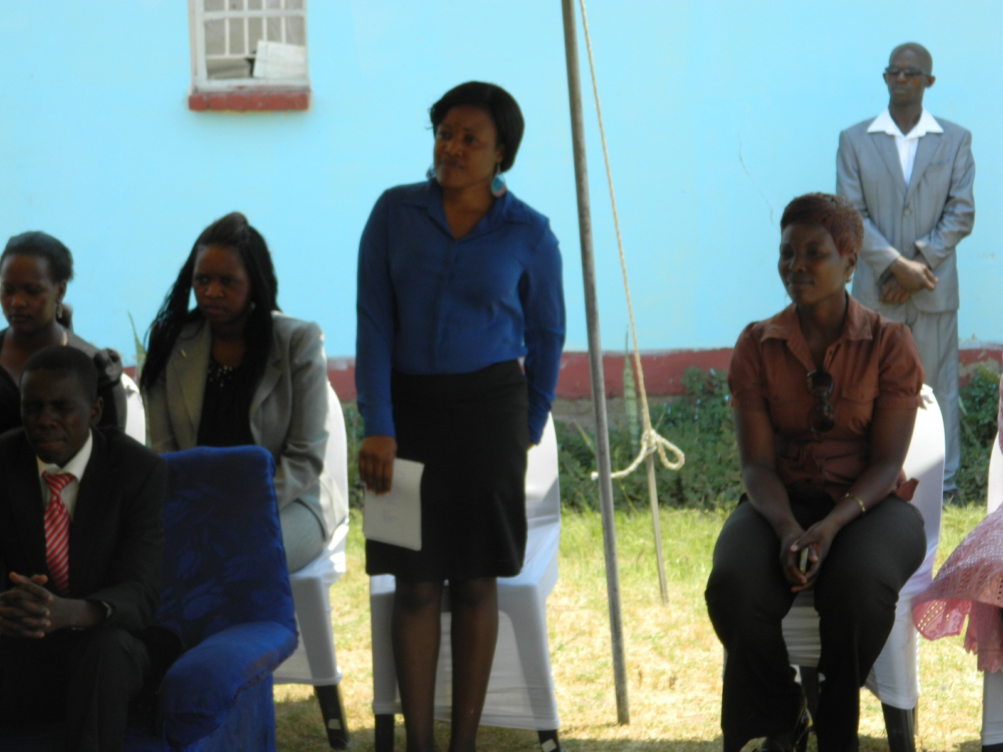
Part of GCNZ staff and Board members

Girls At Risk Support Unit

The girl at risk support unit worked tirelessly to rescue girls from abuse, ensure justice, reunify trafficked girls with their families, reinstate girls dropped out of school and intensified a proactive approach by carrying our community awareness and mobilising the whole nation to shun abuse.
The Girl at Risk Support Unit worked tirelessly to rescue girls from abuse, ensure justice, reunify trafficked girls with their families, reinstate girls dropped out of school and intensified a pro active approach by carrying our community awareness and mobilizing the whole nation to shun abuse.

During the reporting period we received 1340 direct reports to GCNZ through walk in, sms, telephone and via our facebook pages. In all the reported cases girls had been raped, molested and faced serious physical violence.

Our team acted swiftly moving in to get perpetrators arrested and pressuring the courts to mete out justice in a timely manner.

In cases where girls had become pregnant getting termination orders proved difficult as this was characterised by delays and a bureaucratic process which made it difficult for girls to terminate rape pregnancies on time. This endangered girls lives, traumatised them and also posed serious challenges for medical personnel and the organisation.

We recorded measurable success in terms of access to justice as we had 10 convictions with stiff penalties and the other cases are still pending in the courts of law.

There were also cases where girls who had been abused threatened or attempted suicide. GCNZ deployed counsellors and therapists immediately to victims homes or hospital to help the girls deal with the aftermath of rape and traumatic sexual abuse and violence.

Education and Basic needs

Education and basic needs project was faced with serious financial challenges as the organization received high volumes of requests for financial and material support from girls who wanted to continue with education.

In total we opened 500 files for girls who needed support and of these we were able to assist below 100 girls as we had no funding for the project.

The girls requested mainly school fees, uniforms, books, pens and other stationery as well as intellectual support.

Advocacy and speaking out

In our work, speaking out is critical in drawing attention to issues. While the media is a critical player in raising awareness and gaining publicity to issues affecting girls, the media can also perpetrate stereotypes that can fuel sexual abuse and violence against girls.
GCNZ worked with journalists to help them cover stories in a gender sensitive manner. Stories which involve abuse of girls need to be covered in a way that helps combat abuse and not fuel it.

We held two workshops for journalists on gender sensitive reporting and provided ongoing support where journalists needed it.

GCNZ advocacy team and the Director spoke through the media denouncing rapists and making the public aware of the dire consequences that rapists face if the law catches up with them.

In kind Donations

Girls received numerous in kind donations from the USA.
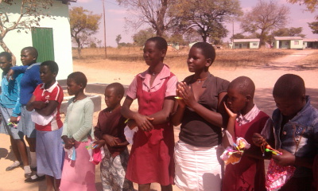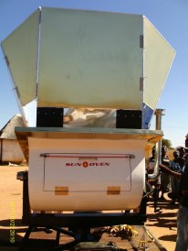

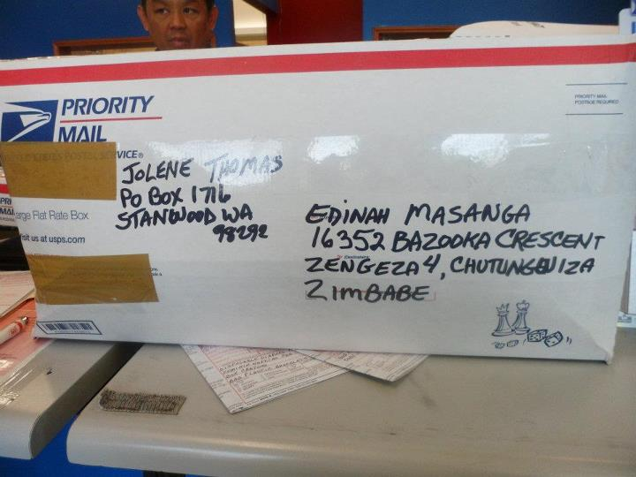

In total from March 2012 we received 350 pairs of underwear, 26 small notebooks, 20 books for the girls reading room at GCNZ head office, 100 pens, 46 pencils, 54 large packets sanitary napkins and toys.

The underwear and stationery was distributed to orphaned and vulnerable girls in the GCNZ Girls Empowerment Villages and in schools.

Sanitary pad sewing Project

After receiving materials, training and a machine from gils in the USA through Kathy Surma and Linda we launched the sanitary pad sewing project at Chihota Girls Empowerment Village.
The project is still in its infancy and in 2013 we hope to make the project large scale and enable the girls to generate income and also gain crucial life skills.
We currently require machines, materials, packaging and volunteers for the project.

Breadmaking project

In line with our internal income generating strategy for girls we also launched the solar breadmaking project. GCNZ Chihota GEV received a solar breadmaking oven from Pink Papaya through GCN Worldwide.
The project was launched successfully.
The project has faced mass production challenges due to lack of a dough mixer and the fact that the oven produces only 4 loaves per forty minutes when working at full capacity. However, full capacity is only achieved by supplementing the sun heat with gas fire. The sun in Chihota raises the oven temperature to about 250 degrees only of which the bread requires a temperature of over 400 degrees to bake on time.
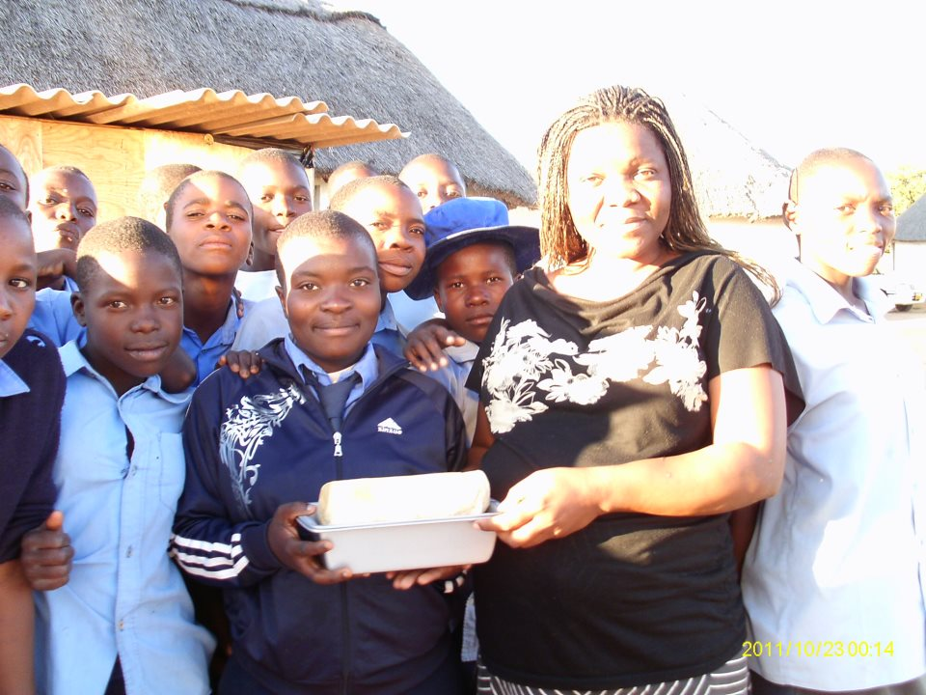
This means in order to produce more bread there is need to have gas supplies and also to operate the oven for twelve hours; all which makes it difficult to make profit since the bread does not sell at high price. In this regard we have made a decision to use the oven for skills building in girls whereby they use the oven every Saturday for training on how to make bread, buns, scones and dough mixing.
However, since Chihota is strategically positioned to make profit from selling bread we consulted professional bakers who advised that the acquisition of an electric bread oven, a dough mixer and baking trays would go a long way in helping girls generate income from breadmaking.

World Children’s Prize Programm

Girl Child Network is the focal point for the World Children’s Prize Programme in Zimbabwe. The programme was implemented successfully form February to May. We managed to reach over 100 000 children. As part of the programme we hosted press conferences, workshops, released press statements and participated in the WCP Global vote in which we recorded 80 000 votes in schools around the country.
By the end of 2012 we trained 100 GCN and WCP Ambassadors as part of a new and enhanced WCP programme with a special project “Rights and Democracy for one million girls”
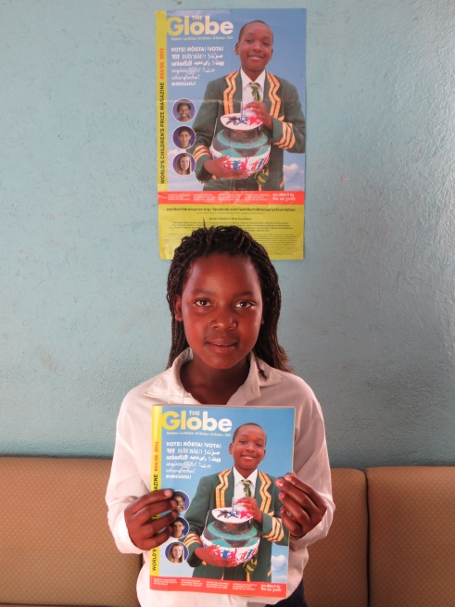
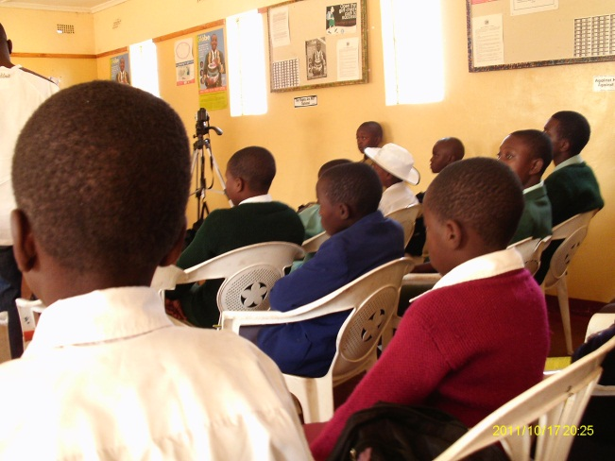

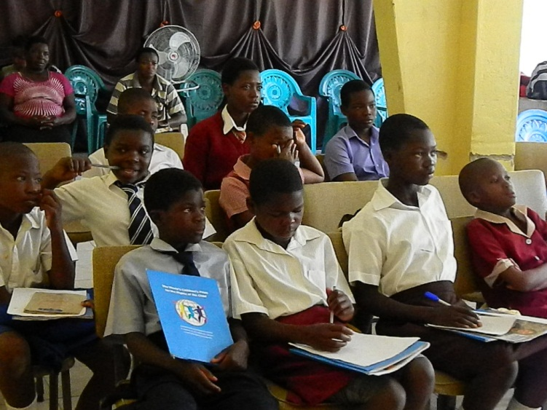

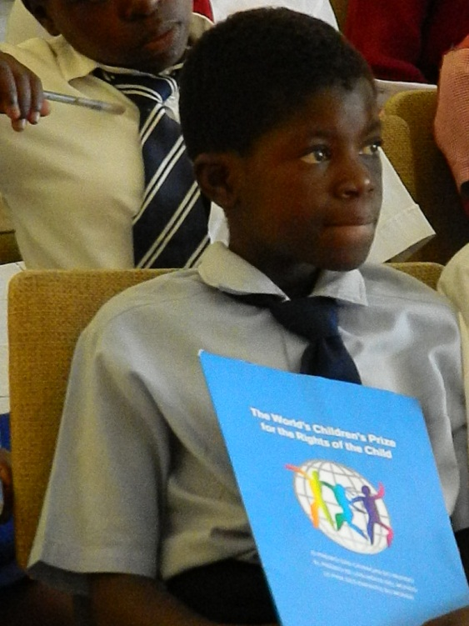

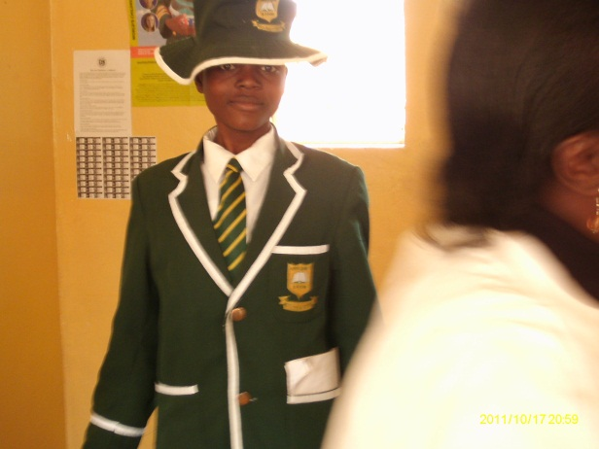

EVENTS

GCNZ managed to commemorate all the relevant events pertaining to our mandate. The girls expressed their voices and gained publicity which is critical in rallying a critical mass.

- International Day of the African Child
This is a very special day for all the girls in GCN since it identifies to one of major strategies, empowerment through education. We hosted a press conference under the theme
“Girls voices”. The press conferences enabled girls to express their voices something which they are often denied based on culture, stigma and other traditional practices that work to disempower girls.

- International Day of the Girl Child

2012 saw the inaugural UN International Day of the Girl Child.
GCNZ celebrated the day in style. We hosted hundreds of girls, journalists and members of the community at our centre in the high density surbub of Chitungwiza. We were also honoured by the Prime Minister’s wife, Elizabeth Tsvangirai, who agreed to be our guest of honour and in her keynote address she denounced rapists as worse than animals and urged community to help stop sexual violence against girls while also emphasizing the critical need to address education needs for girls.
Elizabeth Tsvangirai (L) with GCNZ Director Edinah Masanga
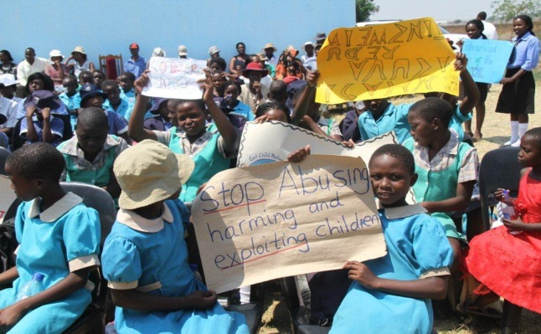
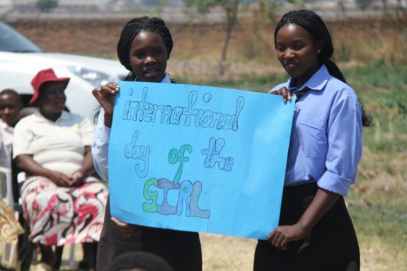
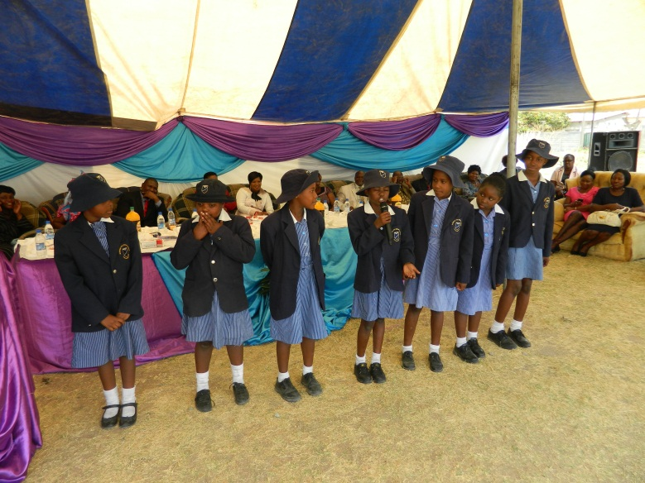

- Remember Girls Concert

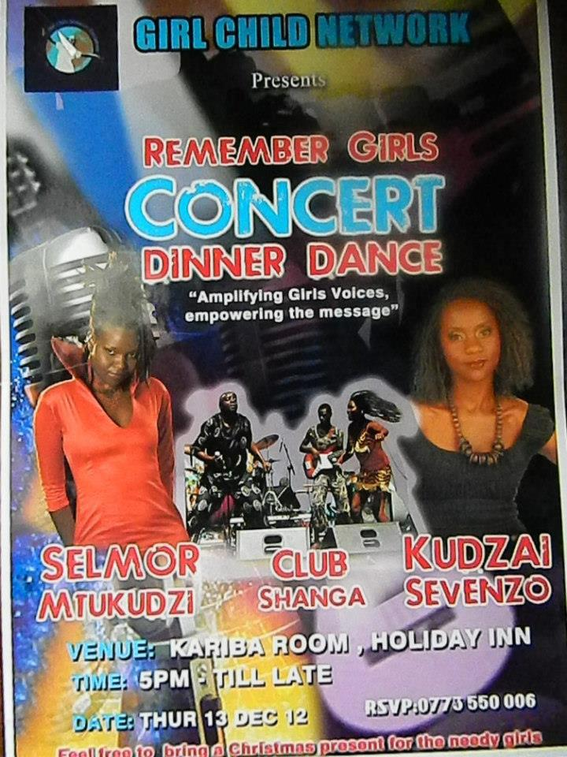
In November two leading girl musicians teamed up and hosted a concert and dinner dance for girls at a five star hotel in Harare. The event was sponsored by Mai Elizabeth Tsvangirai who donated food, refreshments and money for the event.
The girls, Selmor Mtukudzi and Kudzai Sevenzo composed a song called remember girls in which they called on society to remember girls in everything. The concert was held under the theme ‘Amplifying girls voices, empowering the message”.

As a result of the concert 10 girls will receive financial support for their education in 2013 from a local businessman and we have been invited to co-host a conference for 10 000 girls against human trafficking in February 2013.

- Press conferences

In 2012 GCNZ hosted a total 6 press conferences in which girls issues were put under the spotlight. Support from media personnel was overwhelming and we again thank journalists for coming out in full force to use their strategic position to advance girls rights.
GCNZ was also at the forefront for speaking through the media on issues affecting girls, commentary on general issues, providing expert opinion

Girls Empowerment villages
In mid 2012 we evaluated our GEV’s and strategically re aligned them.
Chihota GEV is now the hub of income generating activities for girls, Hwange serves as a place of safety, advocacy and empowerment centre for matebeleland and Chitsotso serve s as an advocacy, empowerment and place of safety for manicaland.
We also launched the book reading project at Chihota on Saturdays
for all girls. This helps girls in the centre to interact with girls from the community.
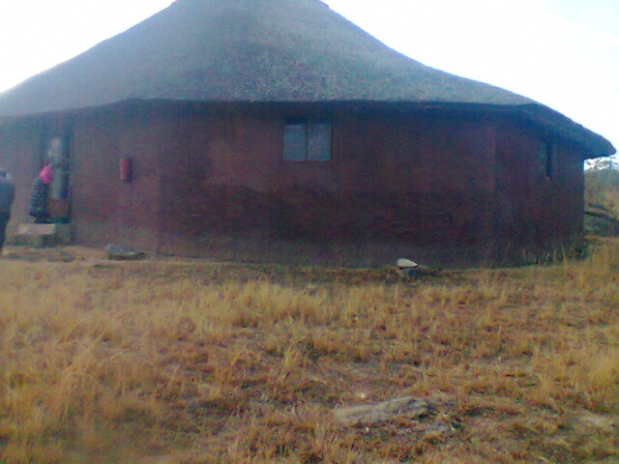
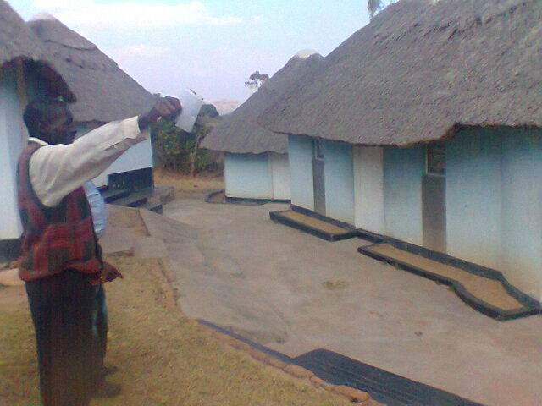

It was a wonderful year for GCNZ staff, trustees and volunteers

2012 GCNZ emerged stronger and ahead of the pack thanks to the dedication of our tireless volunteers, supportive and active trustees, donors and funders.
Special mention goes also to past staff members for the role they played in steering GCNZ to where it is now.
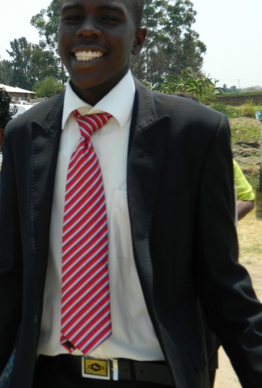
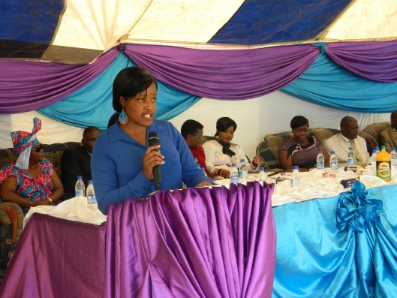
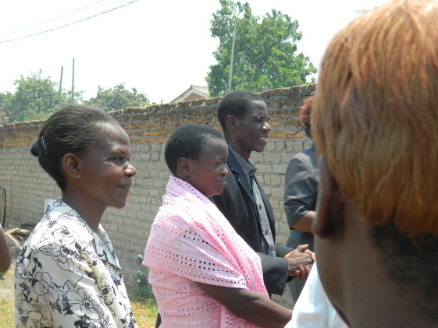

…………………………………………………………………………………..
Donors

GCNZ acknowledges the tremendous support that we received from the following organisations and individuals.
ORGANISATIONAL CAPACITY BUILDING AND
PROBONO AND VOLUNTEER CONTRIBUTIONS
- Betty Makoni
- Tavaziva Machigidi (Chartered Accountant)
- Buttler Nhepure
- Anonymous Donors
- Edinah Masanga
- Charlotte munemo
- Kurai murombedzi
- Johannes Hodzongi
- Brenda Chinho
- Saudzai gumbere
- Robina Chimowa
- Itai Mushaninga
- Leah Hdzongi
- Oliver
- Munyaradzi
- Angel Makore
- Hope
- Danai Ndawi (Legal Counsel)

- International Development Exchange
- Girl Child Network Worldwide
- World Children’s Prize
- Pink Papaya
- Girl Child Network USA
- Jolene Thomas
- Lexi Fallon
- Alec Eginli
- Olivia Lange
- Ellen Lange
- Elizabeth Tsvangirai
- Tantra Zawadi
- Girls Not Brides
- Mwonzora and associates
- Chizengeya and partners
- KPMG Auditors

…………………………………………………………………………………………………………………………………………..
Priorities for 2013
1. A national conference for girls to debrief and map strategies on the following issues;
-How to bring the girl’s story in a positive way and educate the public to better understand issues affecting girls
- Social challenges facing girls for example historic imbalances between girls and boys in our communities
- Human trafficking and girl child sex trade
- The New Media. Strategies to cover girls’ stories using the Internet, online pod casting, video broadcasting, blogs, social media and more
- The challenges in addressing sexual violence,
- The discrimination of girls based on their gender
- Network girls and create a safe space for them to bring personal experiences in male dominated society to the attention of other girls so that they may work together in a mutually supportive manner and elevate their voices
2. Workshops for communities to keep issues affecting girls in the limelight
3. Community talk shows to bring girls together so that they may share information and transform the information into knowledge.
4. Media research and monitoring
5. Intensify the enrolment and re instatement of girls in schools

Financial statement

See annex A
……………………………………………………………………………………………………..

Report compiled by

Edinah Masanga
Executive Director - GCNZ

