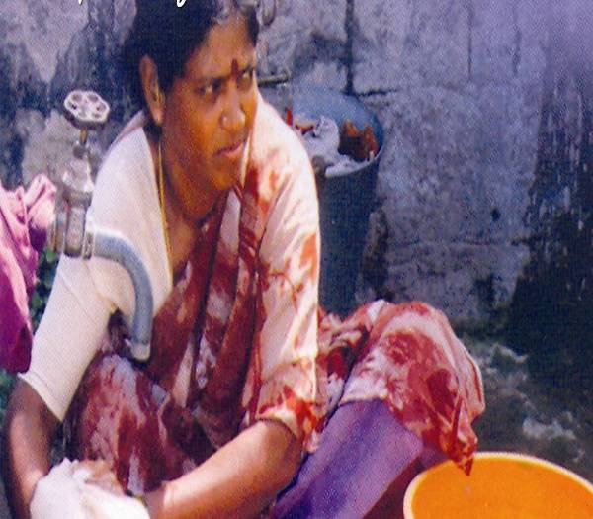
RDOET
(HAO India)

Women Empowerment in Borabanda slum, Hyderabad.
(Creating opportunity for women in skill development training)
When women move forward, the family moves, the village moves and the nation
– Jawaharlal Nehru

Project Summary

This project is aimed at empowering women in urban slum areas of Borabanda by providing free sewing and tailoring skill development training to make them self-sufficiency and self reliant. The project will enable 30 women creating opportunity to undergo free training in sewing and tailoring within 6 months duration and live on their own.
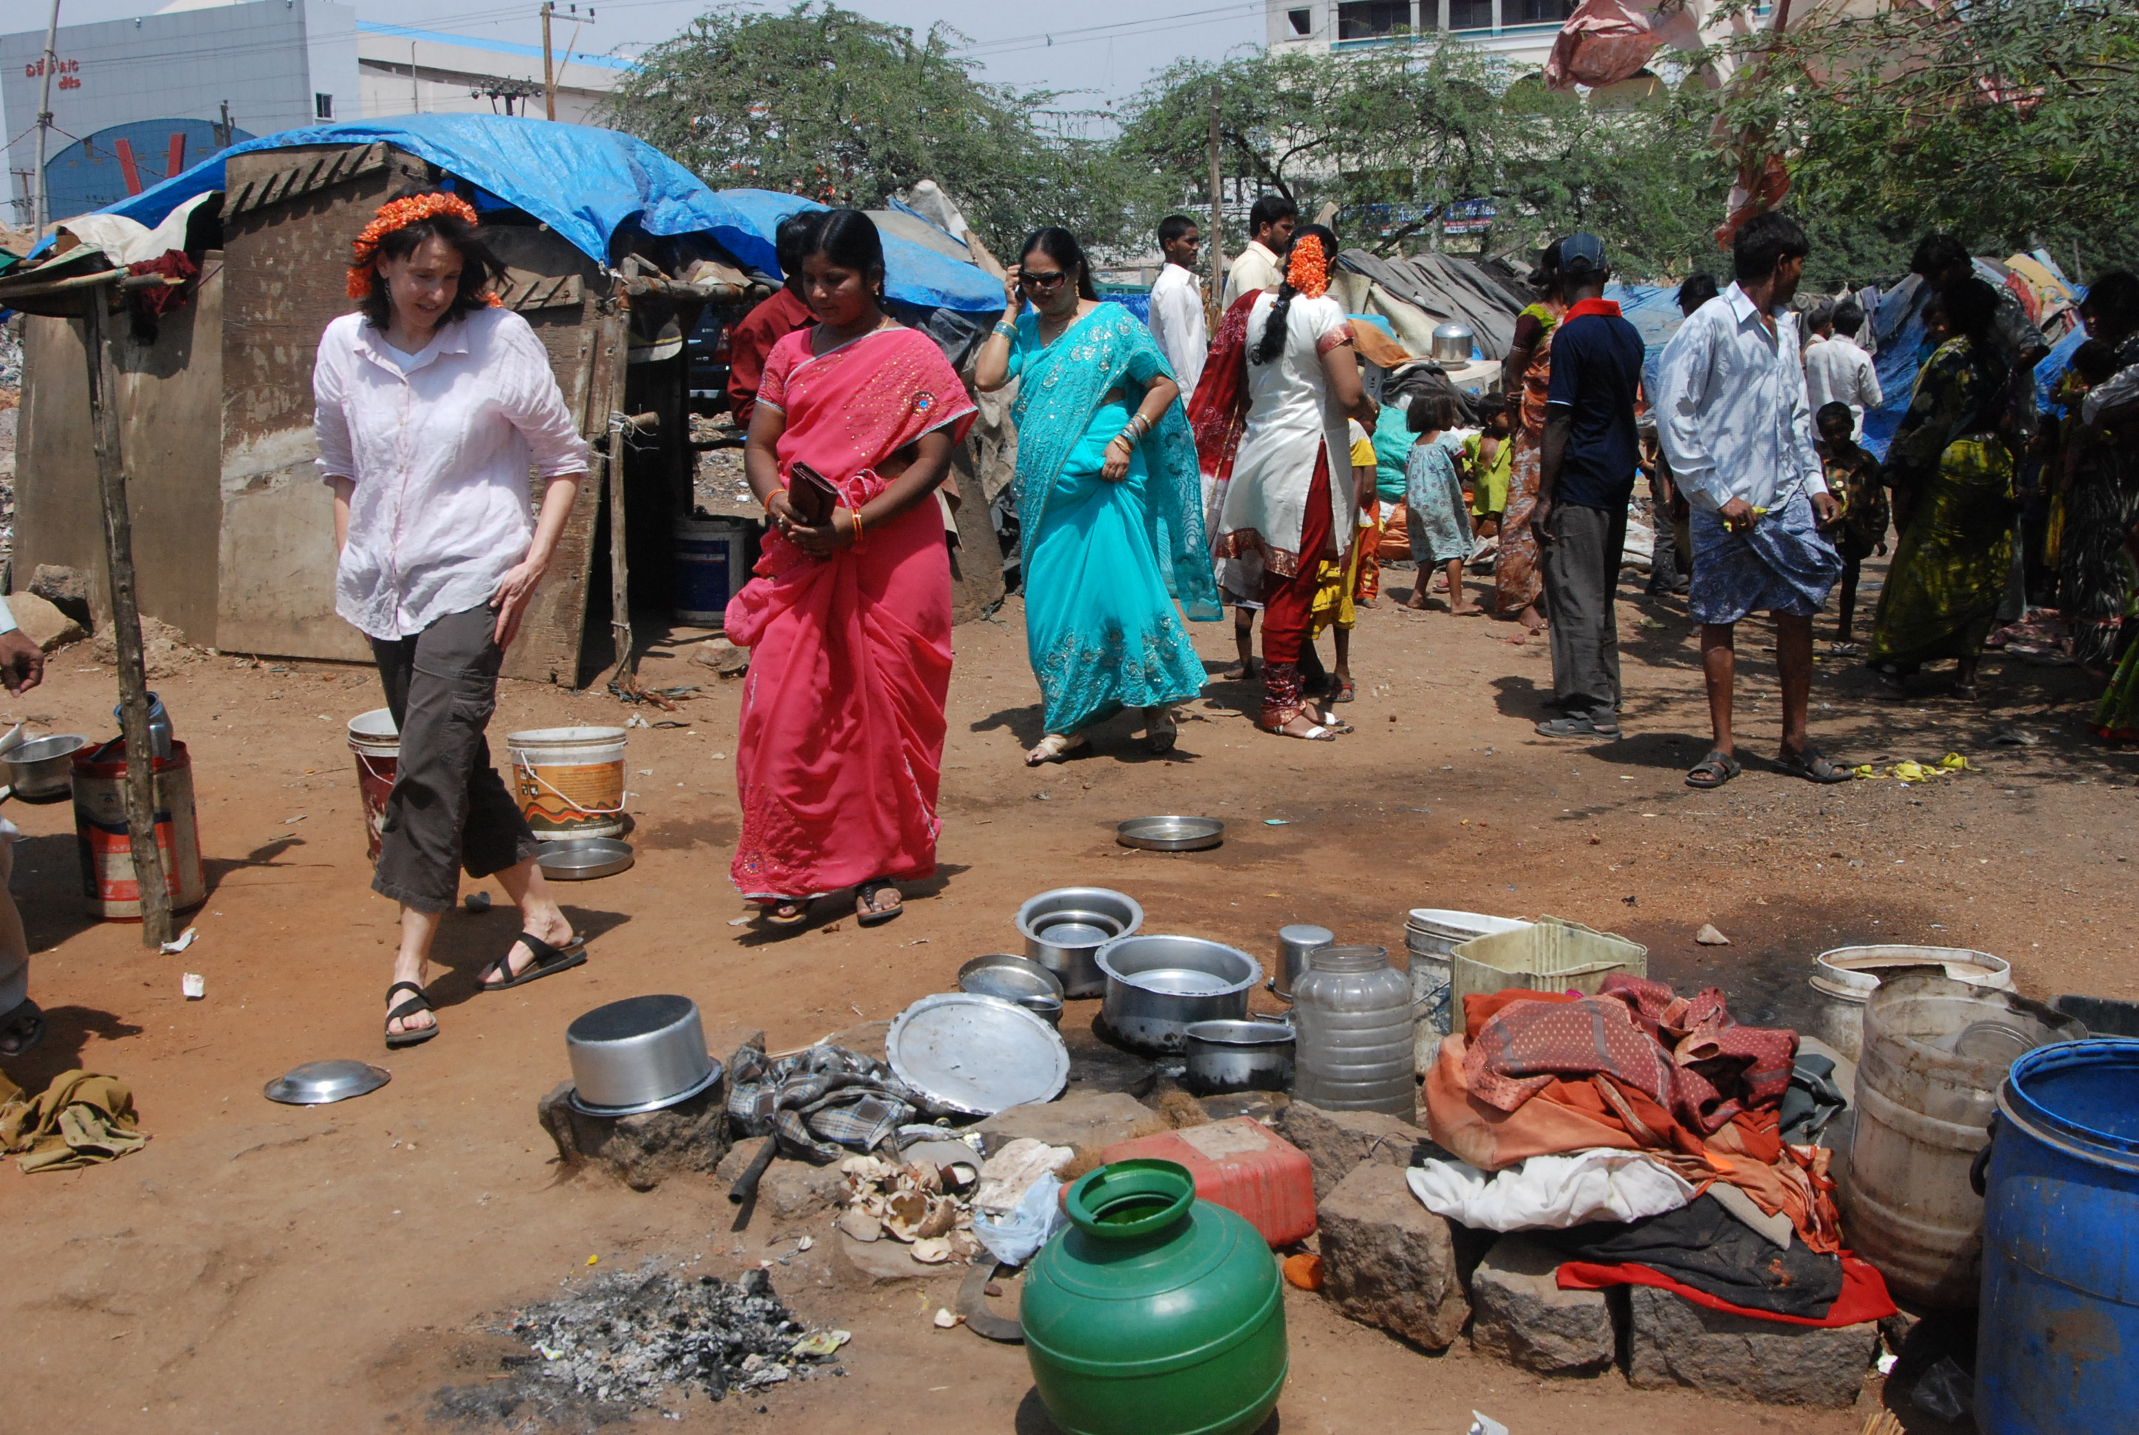
Identified Area:

A target sample of 30 women, identified from Borabanda slum area are given the opportunity to undergo training in sewing. They are given excellent skill training by already skilled professional women of the society. The training period duration is 6 months, strictly maintaining the timings for theoretical and practical approach to master the skills. The trained women in turn will be motivated to undertake such training programmes at their local areas to similar needy deprived women for sustainable development.

Sewing Training Centre:
Selection in the Target Group

- Selection of 30 women in three batches 10 in each batch.
- Selection of the sample in nearest training center will be identified almost like a community hall which can accommodate atleast 20-30 women or take a rented room for running the sewing centre.
- Opportunity will be given for deprived, need felt, single parents, widows, domestic servants, etc.,

The sewing centre will be satisfying all the necessary equipment and related infrastructure for proper training and skills to be inducted, and the women will be trained up also in minor repairs of the sewing machine to maintain on their own.

Objectives

- To train needy, desperate, poverty stricken women, single parent, widows and women working as domestic servants.
- To develop the capacity to build income generated activities
- To empower women and create conscious, greater gender equity.
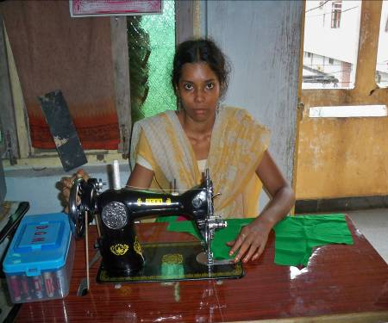
- To develop the consciousness to train other fellow women in already acquainted and trained skills.

Theme

Empowering women in Borabanda slum of Hyderabad through skill development training as a source of livelihood.

The Target Group

      - 3 batch of women, 10 in each will be selected for the opportunity provided by the donors.

Certificate

An examination will be conducted in both theory and practical. Based on the assessment an eligible certificate of skill training is awarded.

Funding Amount

$ 11,252 (6 months)

Donation Options
- $ 533 Provision of two sewing machines
- $ 222 Honorarium for Sewing instructors for one month
- $ 122 Sewing material, sewing kit and records and accessories to one
Qualified women.
- $ 267 subsidized sewing machine for one women
- $ 269 one free sewing machine
- $ 133 Sewing centre rent for one month
- $ 111 certificate (One time)
- $ 760 Administration overhead for one month (break-up of this item is
Given under budget)

Problem Statement
Identify 30 women slum dweller in Borabanda area who are migrated from different district of Andhra Pradesh in search of livelihood. Main occupation of these communities are domestic servants as men are without any job, the women are the main source of bread earning member in the family.

How will the project solve the problem?
Families will be benefited directly and creating a better source of livelihood, and live a sustainable life with self-sufficiency and self reliance.

Potential Long – Term Impact
The project will empower women for their families well being and for their sustainable living.

Message or Quote
To serve the deserving women and create a ray of hope. (Urban slum dweller working as domestic servant)

Project Continuity
Ongoing

Project Timeline
More than 3 years

Project Activity Type
Skill Development training a source of livelihood.

BUDGET ESTIMATES OF

Women Empowerment in Borabanda slum, Hyderabad.

SEWING & TAILORING
(FOR ONE BATCH OF 10 WOMEN)

S.No. | Particulars | Break-up | INR | In $ USD
1 | Sewing Centre (Rent) | Rs.6000 x 6 months | 36000 | 800
2 | Sewing Machines | Rs.12000x2x6 | 24000 | 533
3 | Sewing Instructors | Rs.5000x2x6 | 60000 | 1333
4 | Sewing Materials | Rs.1500 x 6 | 9000 | 200
5 | Sewing Kit | Rs.2500 x 10 | 25000 | 556
6 | Records & Accessories | Rs.1500 x 10 | 15000 | 333
7 | Certificates |  | 5000 | 111
8 | Subsidized Sewing machines | Rs.12000x8 | 96000 | 2133
9 | Free sewing machines | Rs.12000x2 | 24000 | 533
10 | Admin Cost – Break-up
10.1 | Office Assistant | Rs.10000x6 | 60000 | 1333
10.2 | Computer Operator | Rs.12500x6 | 75000 | 1667
10.3 | Travel & Conveyance charges | Rs.1200x2x6 | 14400 | 320
10.4 | Office maintenance | Rs.5000x6 | 30000 | 667
10.5 | Utilities | Rs.2500x6 | 15000 | 333
10.6 | Printing and stationery | Rs.1500x6 | 9000 | 200
10.7 | Photography expenses | Rs.1500x6 | 9000 | 200
Total : INR |  |  | 506400 | 11252
US $ 11,252



