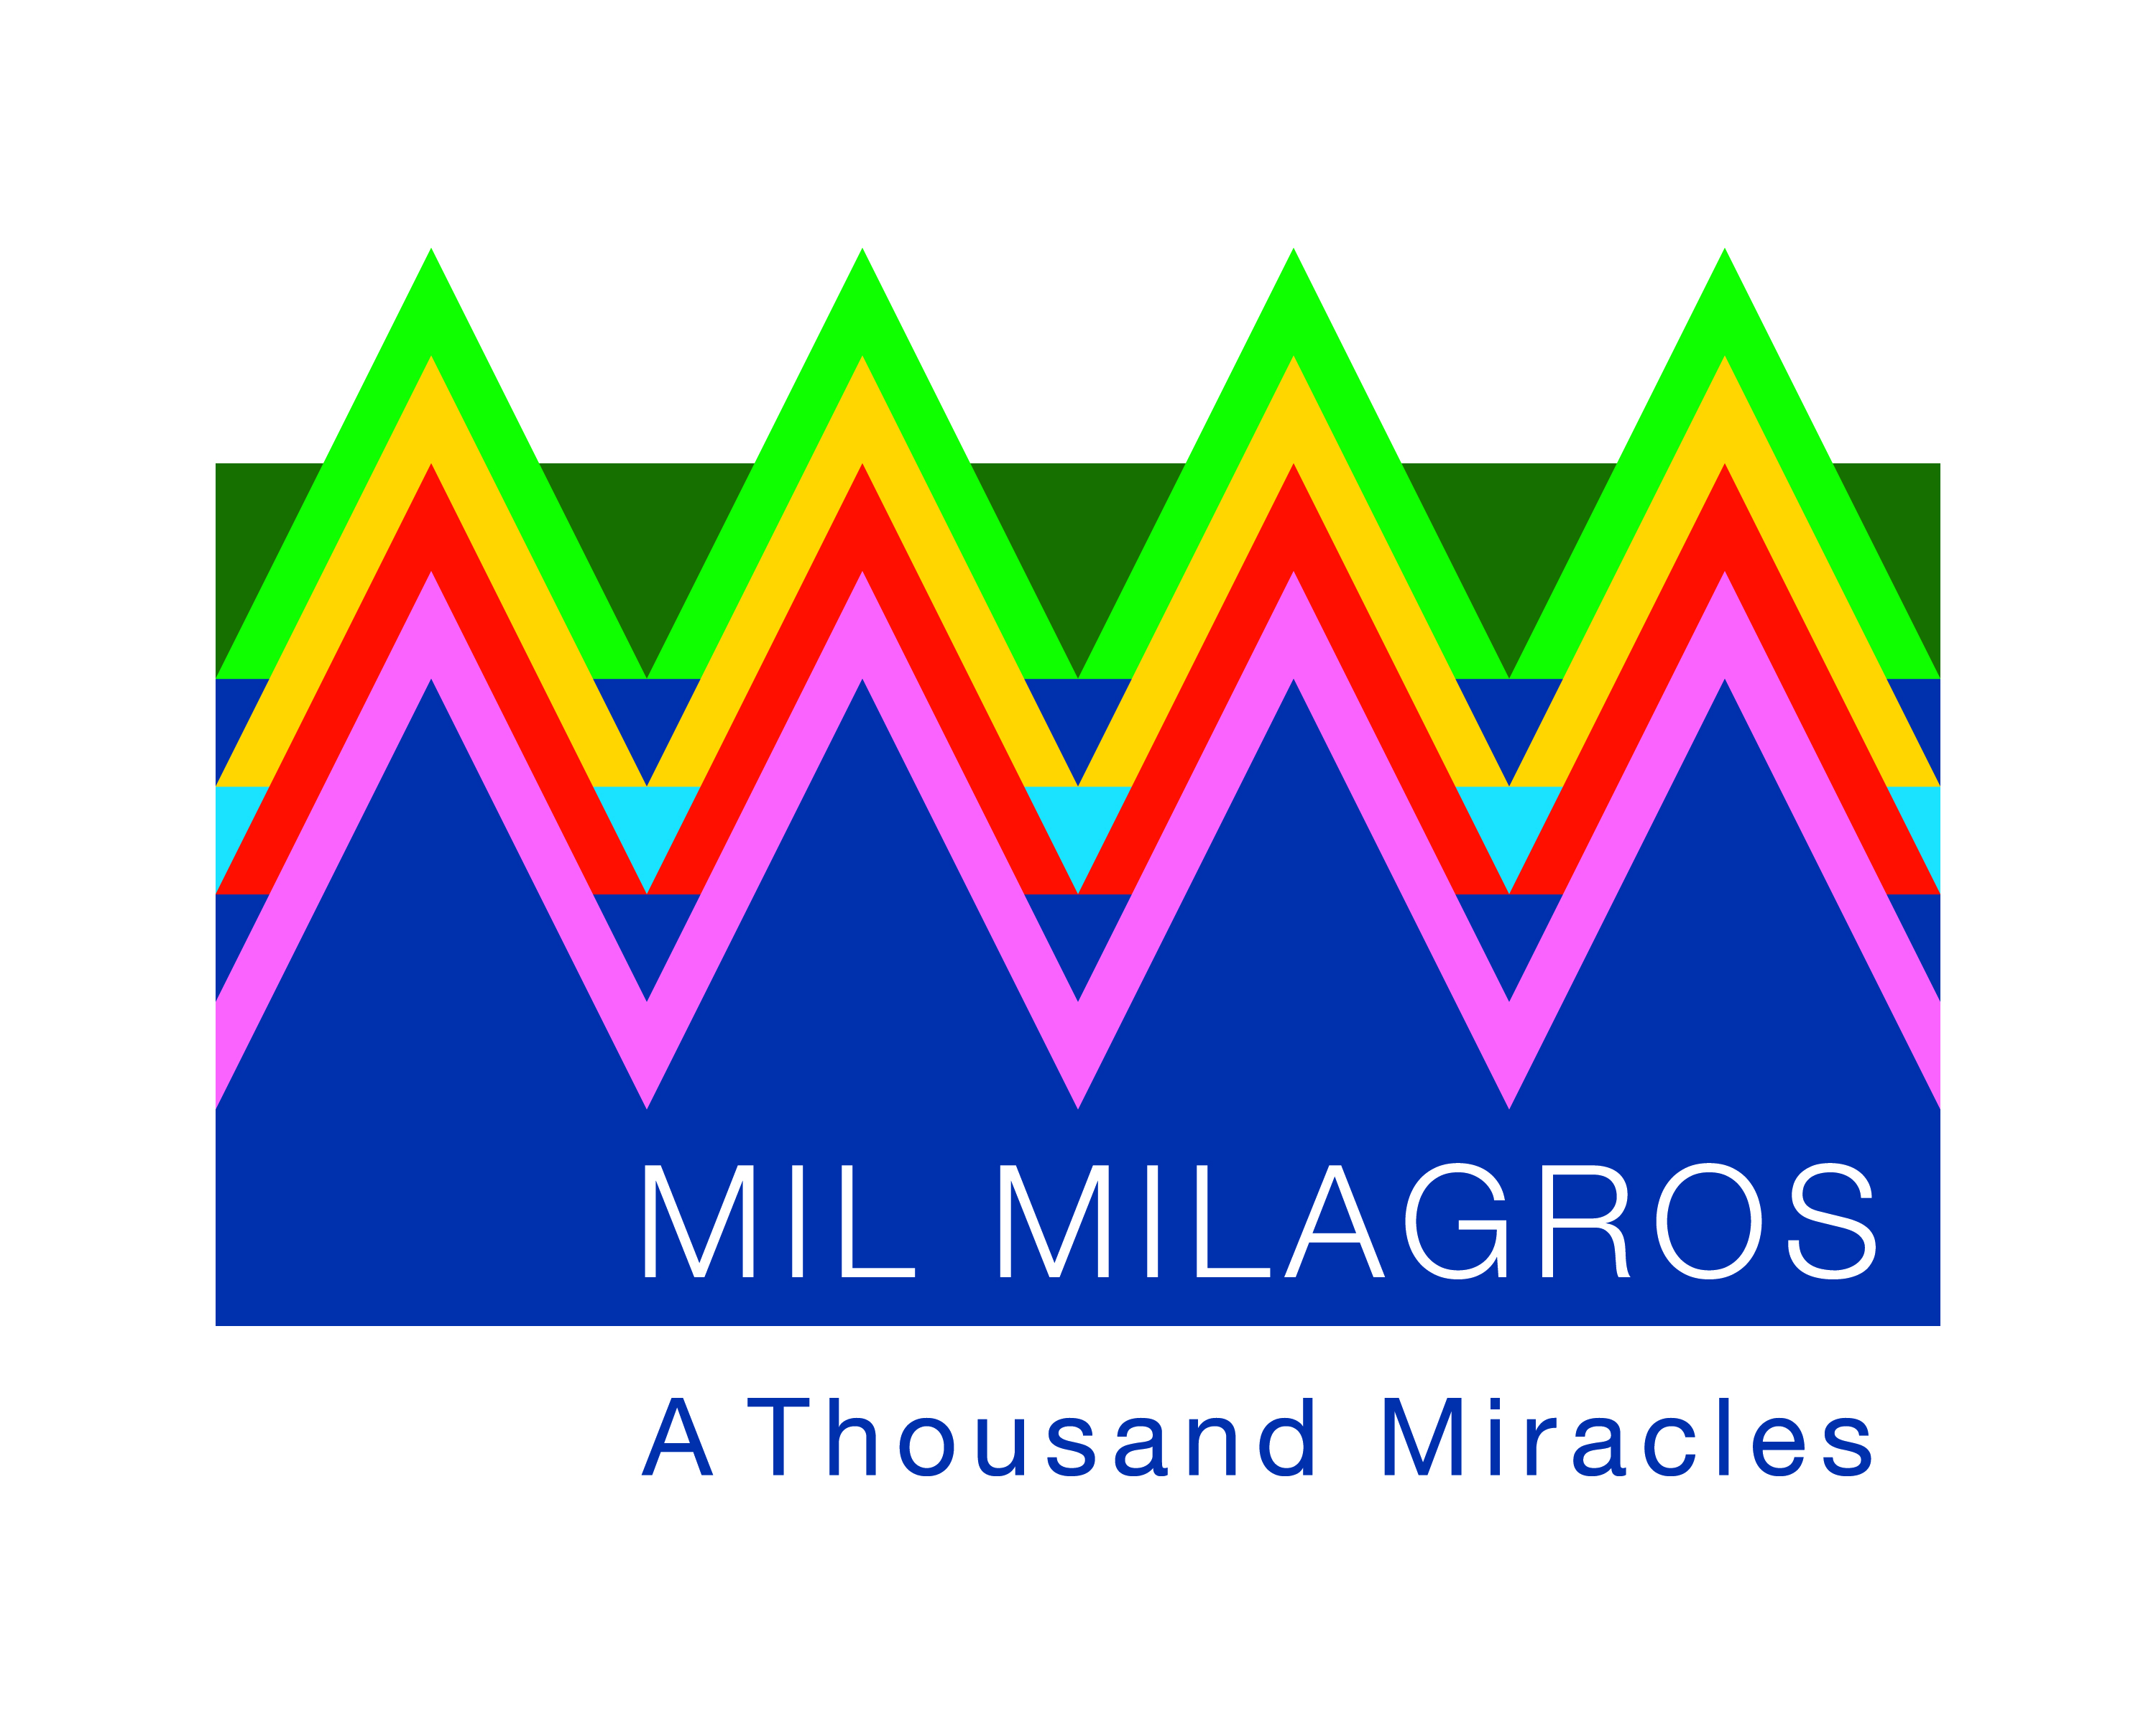

**Improving children’s health and education in Guatemala**

**Mission:** Mil Milagros is a

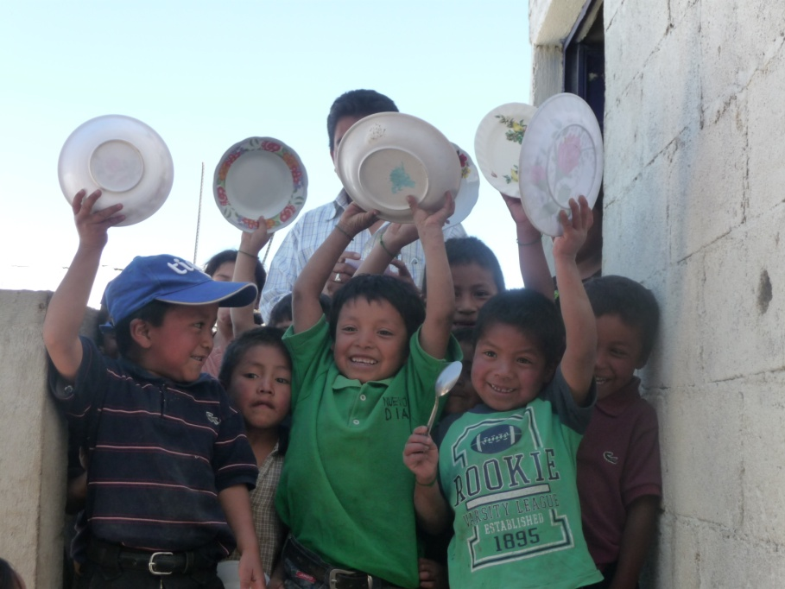

**Mission:** Mil Milagros works to ensure that children in Guatemala graduate from sixth grade **healthy, literate, and prepared** to continue their education. Guatemala has **the fourth highest rate   
of malnutrition** in the world, and only **40% of the children finish sixth grade**.

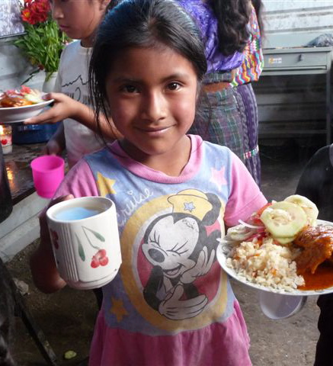

Mil Milagros partners with schools and communities in the state of Sololá supporting over **1,000 children at an average cost of $1.00 per child per school day. Since 2010, 96% of the sixth graders supported by Mil Milagros have graduated from primary school.**

Mil Milagros builds strategic alliances with other organizations committed to a shared vision of nutrition, health and education for all children. By 2020, Mil Milagros plans to reach 10,000 children.

***“Mil Milagros (A Thousand Miracles) is a miracle for our children.”***

*- mother volunteer*

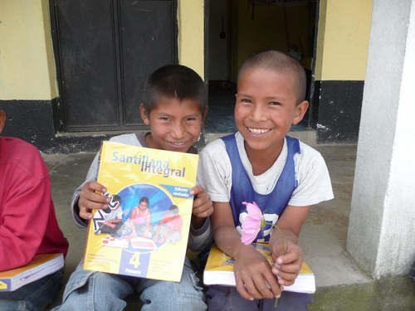

**Program strategies:**

* Nutritious meals at school prepared by   
  over 500 mother and grandmother volunteers
* Prevention of malnutrition in babies and young children
* Educational materials including textbooks
* Health and hygiene care
* Leadership development for the children, mothers, and grandmothers
* Measurement of program impact

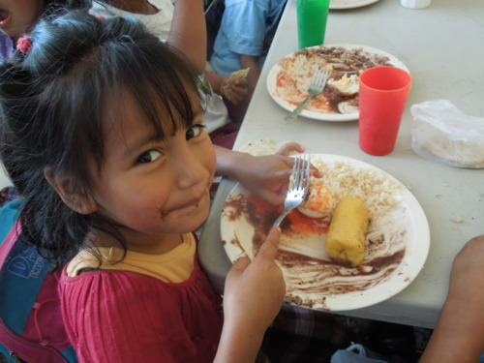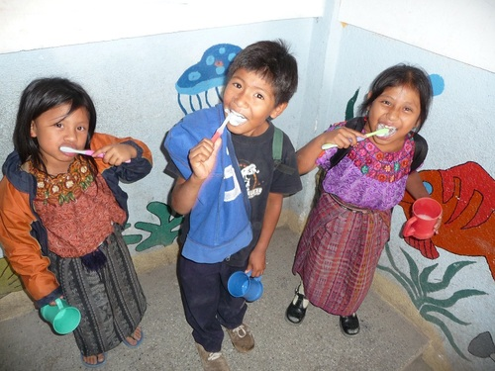

**Help ensure that children in Guatemala**

**graduate from sixth grade healthy, literate, and**

**prepared to continue their education.**

*Please make your tax deductible*

*donation at* [***www.milmilagros.org***](http://www.milmilagros.org)

*or send a check to: Mil Milagros, Inc.*

*400 Atlantic Avenue, Boston, MA 02110*

**Photo blog:** [**milmilagros.tumblr.com**](http://www.milmilagros.tumblr.com)

***“Thank you, Mil Milagros, for the lunches, textbooks, and hygiene care. Now we can be clean and healthy.”*** *- child leader*