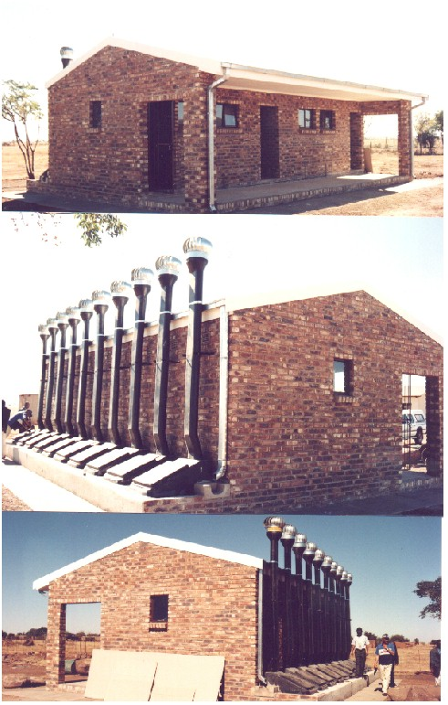
THE ENVIRO LOO

THE WATERLESS SOLUTION TO A GLOBAL NEED

Dr Brian La Trobe PO Box 13 Kya Sands South Africa , 2163

CONTENTS

EXECUTIVE SUMMARY 3
BUSINESS BACKGROUND 4
THERE IS A CRITICAL NEED FOR FRESHWATER RESOURCES AND SANITATION 5
THE ENVIRO LOO 6
THE CURRENT SITUATION 7
THE MARKET 8
THE COMPETITION 8
THE OPPORTUNITY 9
OUR AIMS AND OBJECTIVES 9
APPENDIX 1 – TECHNICAL DETAILS 10

EXECUTIVE SUMMARY

This is an opportunity to get in at the ground floor on a $Billion market with huge profit potential that simply has no current viable solution.

We have a successful product that has been tried and tested in numerous pilot installations. We are now looking for the financial and management resources to take the product to world markets.

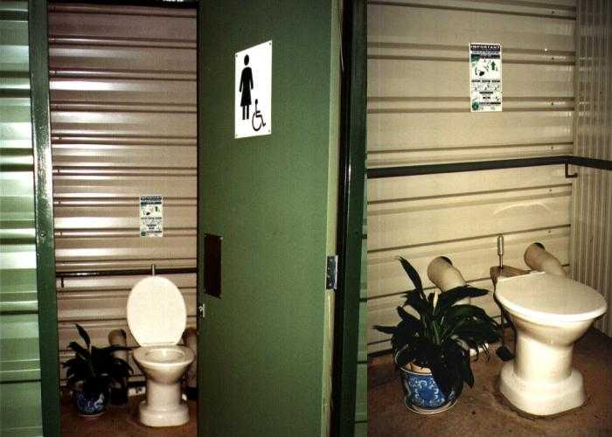
There is a critical situation in world economies due to the lack of clean drinking water and good sanitation.

Major countries, including those in the developed world, are under threat – and realise they need to take action sooner rather than later. The principle cause is poor sanitation, leading to raw untreated sewage finding its way into the water supply. The result is disease, death and erosion of economic growth.

The Enviro Loo solves these problems. It is an environmentally sound - zero discharge system, sealed so that it cannot leak.

Control studies show large reductions in water borne disease are obtained.

The world market for this product is conservatively estimated to be

US$ 2 BILLIONS

Enviro Options has been making this product since 1995. Over 22,000 units are installed in a number of countries.

Our 2005/2006 forecast is:
Our aim is to establish the Enviro Loo product in world markets.

We have enquiries from several countries.

The size of the opportunity means that a strong international management team will be required and that considerable financial resources will be essential.

The current management team recognises that it does not have access to these and our immediate objective is to find the right financial and management resources that will achieve the aims we have.

We are entirely flexible in the arrangements that will be necessary to achieve this, ranging from investment partnerships through to sale of licenses within specific territories.

This current approach is aimed at finding parties who are willing to create the options and to make serious progress forward.

Contact in the first instance should be via Dr Brian La Trobe.

BUSINESS BACKGROUND

Working for many years in government and university programmes concerned with sanitation and water quality, Dr Brian LaTrobe identified opportunities for a dry non-flush toilet and subsequently formed Enviro Options (PTY) Ltd, a Private Limited Company, in 1993.

In the last years the business has entered into limited series production of a number of products, the main one being the domestic Enviro Loo.

Numerous pilots have been done in many parts of the world.

Enviro Options (PTY) Ltd is located in Johannesburg and currently employs 15 people. We have had an annual turnover of about Rand 15 Million.

Dr Brian La Trobe, the Founder of Enviro Options Chairman, has degrees in Chemistry and is a retired Dental Surgeon. He has over 20 years’ experience in running research and development programmes in the Waste management field.

In Enviro Options, Brian LaTrobe and Gavin La Trobe are responsible for all Design and Development.

Mark La Trobe is the Managing Director and is responsible for all operational aspects of the business. He has been with the company for 9 years and has brought to Enviro Options (PTY) Ltd, General Management Skills.

Andrew Moorcroft is Financial Director

THERE IS A CRITICAL NEED FOR FRESHWATER RESOURCES AND SANITATION
All organisms need clean water to survive. It is a basic necessity! It is already scarce all over the world:

Human water consumption rose sixfold in the past century; double the rate of population growth.

People now use 54% of available freshwater resources and additional demand will further jeopardise all other ecosystems.

According to the World Water Forum in 25 years time people who live in 17 countries in the Middle East, Southern Africa and parts of Asia will not have enough water.

Another 24 countries, mainly in sub-Saharan Africa are classified as suffering from “economic water scarcity”.

Groundwater is falling by 1,5m per annum under the North China plain

In India groundwater is being extracted at twice the rate it is being replenished by rainfall.

Irrigation has been cut back in the Southern Great Plains of the US as aquifers fail

Texas is losing irrigated land at the rate of 1% per annum.

Water plays host to the major diseases of diarrhoea, hookworm, histosomiasis and trachoma.

Every eight seconds a child dies of a waterborne disease – approximately four million children die per annum.

World Health Organisation (1996) reports that approximately 3 000 million people lack even the most basic sanitation – half of humanity.

The short-term medical costs are estimated at approximately US$ 750 million per annum in South Africa alone. In world terms this amounts to US$ 2.25 billion per annum.

In excess of a million litres of raw sewage is pumped per minute into the Ganges River. (Time magazine – 1999)

In 1996 China’s National Environmental protection Agency concluded that over 78% of the water flowing through Chinese Cities was no longer safe to drink

95% of all sewage produced in developing countries is discharged completely untreated into surrounding water sources. (World Resources Institute).

The World Bank considers Africa to host 19 of the 25 “water crisis” countries in a near permanent state of drought.

United Nations estimates are by 2025 two-thirds of global population will be severely affected by water shortages.

This combination of disease and water shortage needs solutions and governments and world aid agencies are urgently seeking them.

The Enviro Loo is a Solution

THE ENVIRO LOO

The Enviro Loo is a waterless toilet system that provides a safe non-polluting, cost-effective solution to the sanitation crisis.

It offers a standard of respectability and convenience, comparable to a waterborne system, yet without the prohibitive costs and obvious strain on precious water resources.
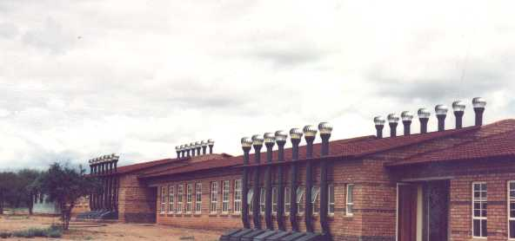

The system has been tried, tested and evaluated in the field since February 1993.

The evaluation period extended over five years and involved scientific, health and environmental impact studies, as well community feedback.

Over 22,000 units have been installed throughout South Africa, Botswana, Namibia, Mozambique, Zambia, Zimbabwe and in countries further afield, such as Ghana, Uganda, India, Greece, Cyprus, Brazil, New Mexico-USA and Australia.

ENVIRO LOO CHARACTERISTICS:

The system
- does not use water
- utilises no chemicals
- is closed circuit – zero discharge
- has no seepage into the environment
- prevents risk to human health and environment
- is odourless
- does not attract flies
- requires no power
- has minimal operating costs

ENVIRO LOO APPLICATIONS INCLUDE:

- Domestic / residential, urban, peri-urban and rural
- (both Western and Eastern designs)
- Communities / densely populated areas
- Schools and clinics
- National Parks, game farms and farms
- Holiday Cottages
- Caravans, boats, Leisure Centres
- Underground – Mines
- High water table and rocky areas
- Drought prone areas

THE CURRENT SITUATION
At present, we have the capacity to manufacture 1000 unit per month.

We sub-contract all the molded items in the product as well as all the ceramic items such as the toilet pan.

Our projections for FY 2005/2006 are that we should sell about 500 units per month to customers who have already registered intent to buy.

This would result in a net profit of about US$ 860 Thousands
We would need to spend about US$ 600,000 in new capital equipment to be able to acquire additional tooling for the new toilet design, which will reduce the cost of manufacturing. These funds are also required for continuing R & D on the product and marketing expansion.

BUT – there is a global opportunity to sell many more units – and we lack the financial and management resources to realise maximum potential.

THE MARKET
Based on analysis of data from world sources, the potential for the Enviro Loo is enormous.
A NUMBER OF COUNTRIES HAVE EXPRESSED INTEREST IN A PROGRAMME FOR THIS PRODUCT.

THE COMPETITION

Ventilated Improved Pit Latrines (VIP’s)

To date, the VIP has been seen as the
traditional alternative to waterborne sanitation. But this system has numerous disadvantages:

- Obnoxious odours and fly breeding
- Limited to outdoor installation and located away from the house
- Risk of pit collapse
- Relatively short life span with relocation of pits being costly and problematic on crowded sites
- Require periodic pumping resulting in relatively high operating and maintenance costs
- Extensive rainfall resulting in flooding and expulsion of raw sewage
Necessary hydro geological studies not undertaken resulting in VIP’s being constructed in inappropriate Areas e.g.. above underlying groundwater resources, within periodic flooding areas, high water tables and on rocky ground

THIS IS NOT A LONG TERM SOLUTION!

Chemical Toilets
NOT A SOLUTION – FOR EXAMPLE:
- Temporary “storage facilities” with waste still needing to be treated
- High operating and maintenance costs
- SA National Sanitation White Paper (June 1996) “These are no longer acceptable and are a serious health risk”

LIFE CYCLE COST COMPARISON:
Between waterborne systems compared to sustainable “dry Sanitation over a 20 year period

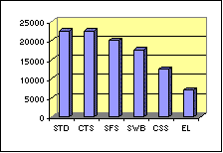

Ref: GTZ Urban Upgrading & Development Programme

STD – Septic Tank & Drainfield
CTS – Conservancy Tank System
SFS – Solids Free Sewe
SWB – Standard Waterborne
CSS – Condominial Sewer System
EL – Enviro Loo
VIP – Ventilated Improved Privy

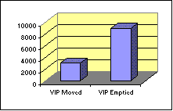

OUR AIMS AND OBJECTIVES

We aim to establish the Enviro Loo product in world markets and wish to set up the means to achieve this.

The size of the opportunity means that a strong management team will be required and considerable financial resources made available.

The current management team recognises that it is not capable of reaching these objectives and our immediate objective is to find the financial resources that will achieve the aims we have.

We are willing to be entirely flexible as to the means by which the Enviro Loo is made available to world markets.
In short, we are open to suggestions.

This current approach is aimed at finding parties who are willing to create the options and to make serious progress forward.

THE OPPORTUNITY

There is an opportunity to create a global business that will design, manufacture and install Enviro Loos in all of the world markets.

The scope of this business is large and it may well be that a number of approaches will have to be taken.

These are likely to include:

- Expanding operations in South Africa to cover Africa
- Opening manufacturing plants in countries where the financial and economic realities dictate
- New Products – for example, for ships, caravans, cold climates.
- Licence deals
- Forming Joint Ventures and Partnerships with
- Governments
- Industrial Groups
- Environmental Groups
- World Agencies such as the World Bank, United Nations and The World Health Organisation

APPENDIX 1 – TECHNICAL DETAILS

The Enviro Loo is an environmentally sound - zero discharge system. It is a sealed system that cannot leak nor can storm water penetrate and thus flood the container. It does not require electricity to operate.
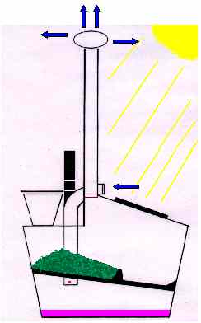
Separation of liquid and solid wastes occurs at the initial stage of the waste entering the container through the toilet pan.

The liquid drains to the bottom of the container from where it is evaporated due to the design of the ventilation system

Body waste falls onto a bed of organic matter on the plate

A simple to use agitator “flush” breaks up the waste to ensure adequate aeration and dehydration

As the waste migrates down the sloped, ridged, perforated drying plate, it is subjected to continuous ventilation

This forced extraction ventilation system results in a continuous airflow through the unit, allowing for rapid aerobic decomposition and evaporation of liquid waste. It also creates a negative pressure within the container, thereby preventing the escape of odours through the toilet pan.

The ventilation extraction unit positioned on top of the outlet vent pipe with air
being drawn into the container via the inlet vent pipes assists the airflow.

Sunlight absorbed by the black manhole cover increases the ambient temperature within the container.

The system provides the right environment i.e. sufficient heat, prolonged retention periods, adequate airflow and thus oxygen, to dehydrate and decompose the waste. The human waste is converted via the stimulated bacterial and biological activity, into an inoffensive compost-like material that is roughly 5% its original volume. The dried waste that is periodically removed is a stabilised matter that is safe to handle.

Loading, or number of users, is dependent on the type of system chosen. These numbers have been specifically determined to ensure adequate retention periods:

Domestic unit | 10-users per day
Commercial unit | 20 users per day

