“Medley Day” campaign: awards go to the best and enlightened
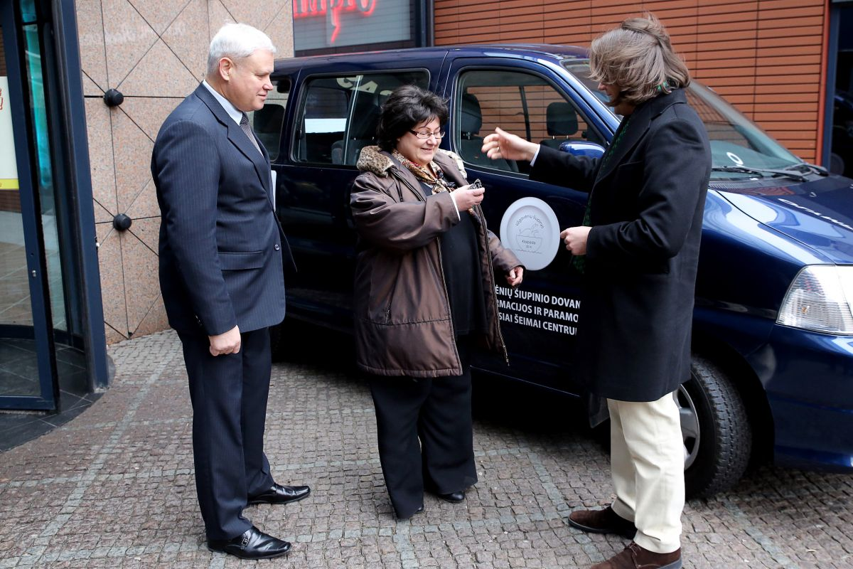
On Saturday, for the third time in the port city of Klaipėda, Medley‘s Day‘s charitable campaign culminated in giving a minibus for “Information and Support for Large Families Center” keys, reward for enlightened and the most delicious medley manufacturers.
Week before “Medley’s day” Tuesday was marked as this year’s port city’s good deeds marathon. In nine seaport’s restaurants and cafes ,while enjoying traditional Klaipeda’s and ”Žemaitija” area’s medley , city townsfolk could donate to large families and choose the most delicious stew .
The most delicious medley chefs were honored during the ceremony - which took place on Saturday, during the mayor of Klaipėda breakfast. Five seaport’s enlightened were rewarded. This year it was five large families, amongst which 25,000LTL were distributed. Nice results third year in a row were achieved not without the initiation and support from the company “Philip Morris”.
Readers of newspaper “Klaipėda” voted for their favorites on www.kl.lt and decided that the most delicious medley in the city was served “Ararat” hotel restaurant.
A specially gathered committee which consisted of president of Lithuanian hotel and restaurant association Evalda Šiškauskienė, participants in port city’s cultural life Gintaras Grajauskas and Valentinas Masalskis, patron of campaign Inga Grubliauskienė and the initiator of this campaign Edita Mildažytė.
The commitee decided that the most delicious medley was offered at bar “Senoji Hansa” .
This year’s enlightened became five large families from Klaipėda . Aistė and Marius Žalnieraičiai, Asta and Mindaugas Kelpšos , Ilona and Vytautas Vyščiūnai, Linas Švirinas, Julija and Romanas Gaiduk were awarded with cash prizes.
“Medley’s Day’s” soul E.Mildažytė said that this year’s campaign showed some great results .
“55,000LTL, which were donated by businessmen of the port city, were transfer into “Information and Support for Large Families Center” account, a minibus is already bought using them. 25,000LTL prize pool for enlightened of the year reward was collected. Well, later on, nine of participating restaurants and bars will prepare a feast for large families for around 15,000LTL" - said E.Mildažytė .

