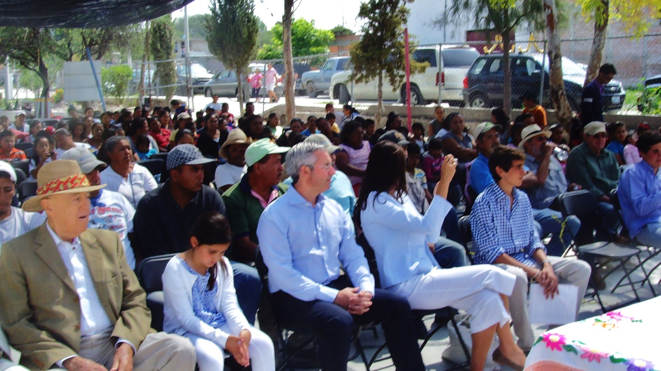
Alex Renaud and family preparing to address local children

