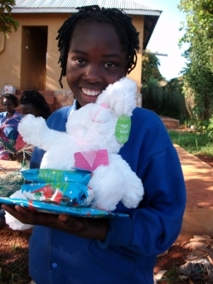
Progress Report on the Construction of Mountains of hope Orphanage
Construction Site – Kafumu village, 5 kilometers off Mpigi district headquarters

Orphanage - Project Background
Mountains of hope has commenced its construction of the Orphanage in Kafumu. It is in the suburban area of Mpigi district, 5 kilometers away from Mpigi town.

Project Update
The construction is being undertaken in phases on receipt of funds and donations. Till
date, structural skeleton is completed for the foundations

The following is a phase-wise update on the major milestones:
To date Status Remarks

Date | Status | Remarks
March 2013 | 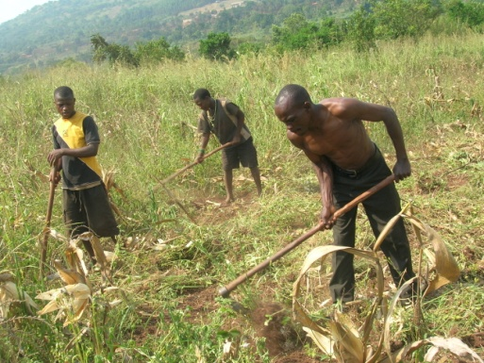 | Clearing the foundation ground
March 2013 | 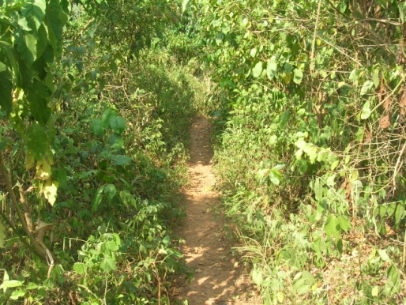 | Clearing the road leading to the site for easy transportation of materials
March 2013 | 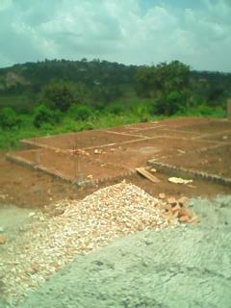 | Materials on site and structural skeleton of the foundations built

I just wanted to send you all a friendly reminder that March 13, 2013 beginning at 9 am ET Bonus Day begins! Globalgiving has provided $50,000 in matching funds! And $2,000 in prices, funds will be matched on all donations you will make on tha day, this is a great day to watch your donation expand as our project also progresses.

Thank you once again for your generous donations.

James Malinga

