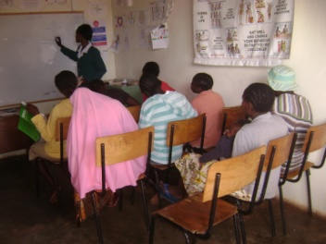 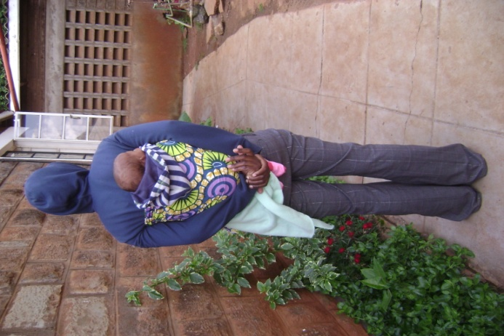

*Charo (not her real name) is a foreigner from Congo (with her 2 month old daughter born during her stay at the TAGS) is one of the current beneficiaries at the shelter, she came in when expecting a baby and the shelter took her in , paid all her bills incurred during delivery,*

T*he Shelter has a full time teacher who ensures that girls with high security risks and cannot attend the nearby primary school are not left behind with their school work.*

*This is Lavender, (not her real name) a victim of sexual abuse. The young girl is in class 8. She will be sitting for her final exam from 4th to 7th December 2012. The House mother has to walk with her to and from school every day due the nature of her case.* *The shelter does not own a vehicle that can be used to drop and pick the girls from school*

*If she qualifies she will join secondary school in 2013.*

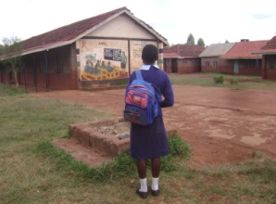

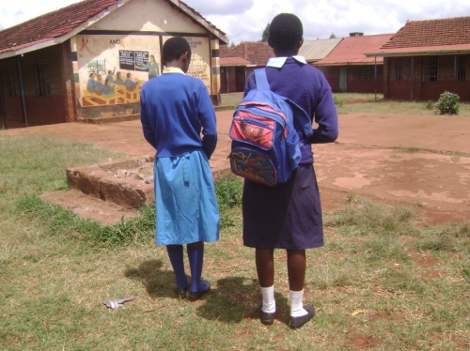 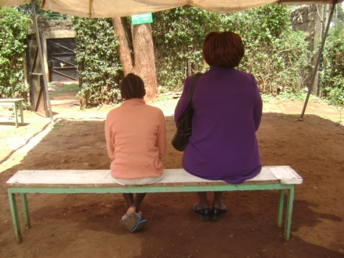

*These are some of the TAGS girls who have been enrolled in a local school where a partnership has been created to ensure that girls who have low security risk attend school.*

*Faith (not her real name) an 11 year old girl rescued from an abusive relative during a counseling session with a Case Worker at the TAGS..*