
AFRICAN CHRISTIANS ORGANIZATION NETWORK
KCB BUILDING MOI AVENUE P.O BOX 1284 -50200 BUNGOMA
1ST FLOOR TEL: +254-727 621841/ +254-723 313210 /+254 2021896449
BUNGOM A. E-mail: salimshaban2005@gmail.com
“Networking for spiritual nourishment, economic empowerment and sustainable development of appropriate initiatives and concepts.”

Facilitating TLUD models and Increasing Agricultural Production through the Manufacture and Use of TLUD Biochar Producing Kiln in Western Kenya
Project Background
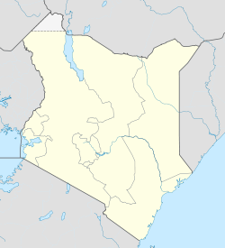
The African Christians Organization Network (ACON) has been working in Western Kenya since 2000 to empower villagers by providing opportunities for development that are environmentally sustainable. Since 2004, ACON has been focusing their work on how to reduce deforestation while improving soils for local farmers in the area. Part of this solution is Biochar Kiln and the use of biochar—a charcoal meant to be added to soils which can improve soil nutrient retention and water holding capacity as well as sequester carbon.
The Bungoma district in Western Kenya near Lake Victoria
The Bungoma district of Western Kenya is 30 miles from the Uganda border and near a national forest as well as Lake Victoria. Villagers living in the area are mainly farmers who rely on annual rains for all irrigation making water crucial during the dry season. Families generally use a traditional 3 stone open fire for cooking, requiring a great deal of firewood and creating smoke. When Salim Mayeki Shaban of ACON started investigating fuel use in Bungoma, he found that the population was getting its firewood from primary forests and at the same time burning agricultural waste in the fields. The high fuel demand was quickly deforesting the area and some villagers had been taking wood illegally from the national forest. To alleviate the pressure on the forest, ACON designed a project that worked with local villagers to promote energy conservation and reduce deforestation through the use of improved cooking stoves.
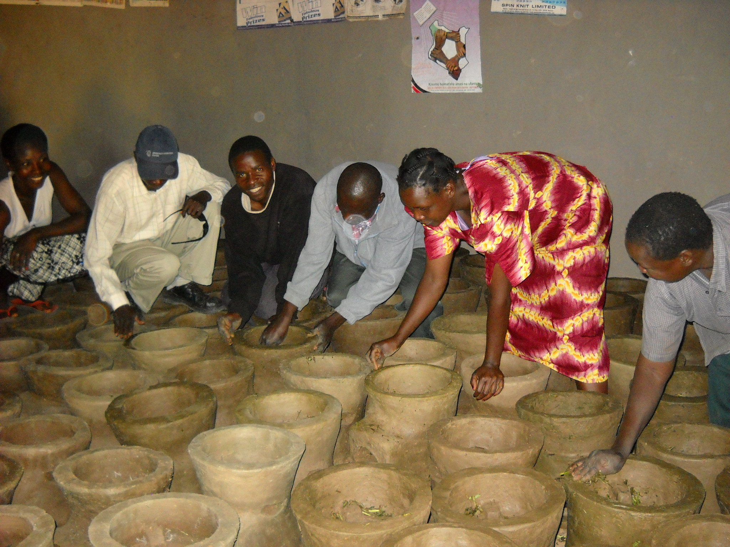
ACON did not have a great amount of financial or informational resources for this work, so Salim and his staff turned to the internet for a simple stove design that they could make onsite to reduce fuel wood consumption. Using plans found online and a stove model from Uganda, Salim designed a “clay” stove—which is actually clay mixed with chopped straw and the dirt from anthills to create a cement. After testing and reconfiguring, his group created a stove that reduced fuel wood consumption by 50% and created less smoke. Salim estimates that from 2004 – 2009, their group built over 10,000 improved stoves. To fund this work, ACON decided to sell the stoves to the villagers. The stoves were marketed as a money saving device that would pay for itself in just months due to the reduction in firewood costs. Initially, villagers were much more interested in purchasing a stove that was metal as they felt it would last longer and operate better. Salim and his team started to add metal stoves (imported) to their inventory, but also had village competitions between the stoves such as a water boiling test and kitchen performance test so villagers could decide which model would work best for them. The stoves use agricultural wastes as a feedstock or can burn compressed and dried Water Hyacinth briquettes, decreasing pressure on the forest not only through a more efficient stove, but also from the ability to use alternate feedstocks.
Improved cook stoves of “clay”: all photos courtesy of ACON
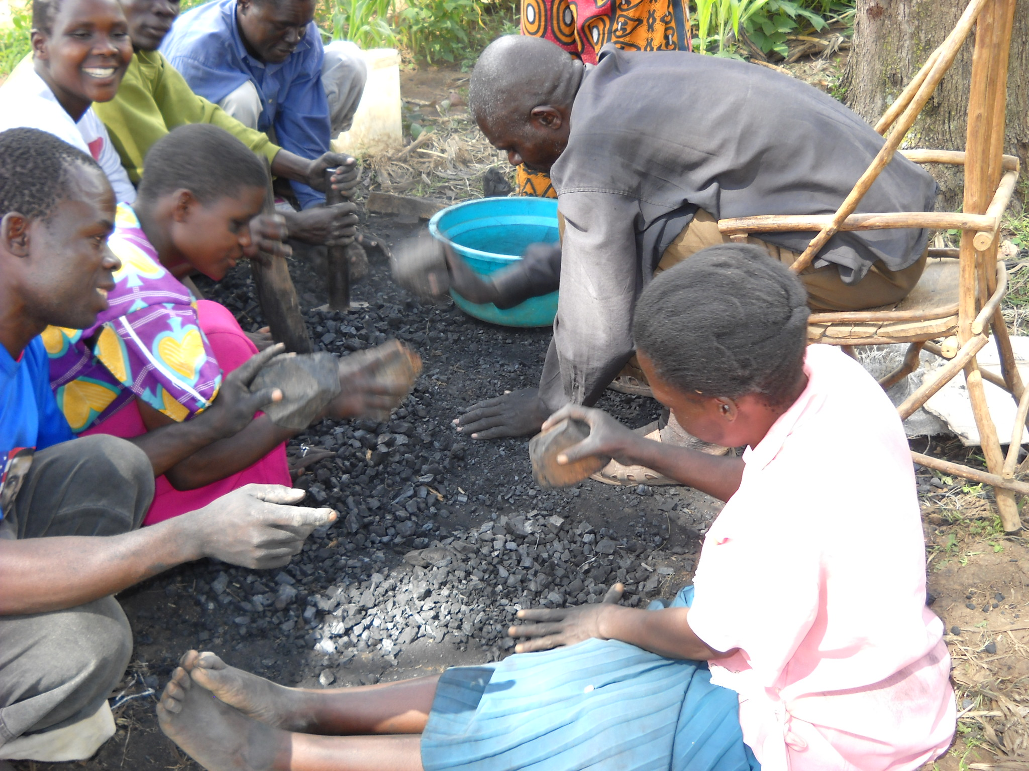
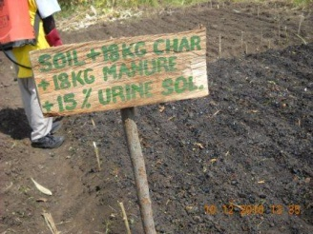
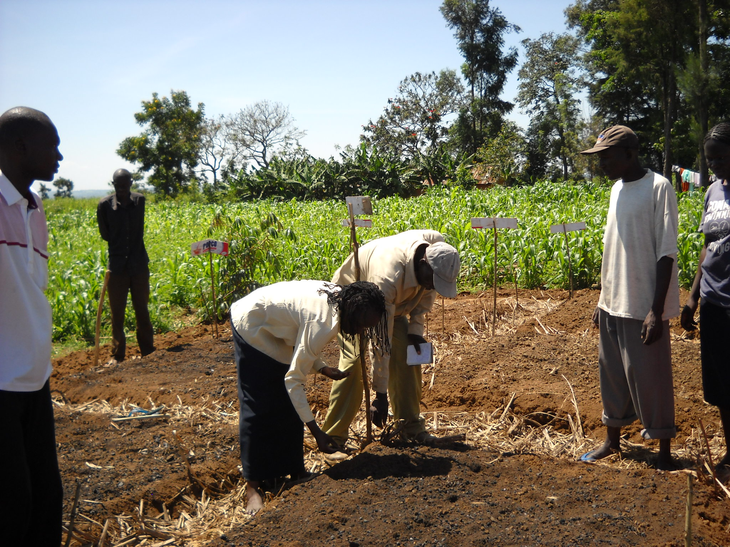
As this project took off, ACON went a step further and brought in some experts to help design and implement biochar field trials and to train local farmers on the application and utilization of biochar. Villagers in the region of Bungoma practice subsistence farming and depend on fertilizers for their crops. They have had recurring serious droughts and Salim wanted to see if using biochar could help with water and nutrient retention in the soil. Salim contacted Wayne Johnson and Rob Lavoie of AirTerra in Canada about using biochar. They had ongoing discussions for eight months over email and phone before Wayne and Rob went to the project area for two weeks in 2009 to work with ACON. Once in Kenya, the team helped set up a series of test plots to see how biochar worked in the local agricultural system. The initial improved cookstoves were not biochar-producing stoves, so the group made biochar by buying wood charcoal from the marketplace which was then crushed into small pieces. They created nine test plots varying from Kenyan soil alone to soil plus biochar to soil plus biochar plus manure plus urine. Biochar was added at a rate of 15% of overall soil mass. Using a moisture meter, they found that soil moisture in pure Kenyan soil (without biochar) was tested at level “2”—dry; while the soil with biochar was level “9”—wet. The project also tested the moisture at the root level of various crops (maize, yams, sweet potatoes and squash) and found similar results between the un-amended soils and the biochar-amended soils. Plant growth was also larger. This was tested by comparing the growth of plants in each of the test plots on a weekly basis and then weighing the final yield after harvest.
Crushing charcoal to produce biochar; field trials labeled with amendments; setting up new field trials.
Since this visit in 2009, ACON has been carrying out community training on the application and utilization of biochar and the importance of biochar in soil. Participants in a training group learn about biochar and set up field trials over the course of four days and then are given biochar to take home with them. Over 750 farmers now have biochar plots in their fields from biochar made in these sessions.
Moving Forward with Biochar Stoves
With the improved cooking stoves moving along, Salim and his team looked into how to build a biochar-producing stove so they would no longer need to rely on the charcoal from the market and could use non-forest wood feedstocks for biochar. To produce biochar, they needed a pyrolysis stove (pyrolysis is the heating of a feedstock with little or no oxygen) which for their purposes would need to be metal. Pyrolysis stoves are often more efficient and many can also produce biochar
ACON has made one of its main goals throughout the project a reduction in use of firewood from the forest and to find an alternative source of biomass for cooking and potentially for biochar production. To solve the feedstock challenges, they train participants to use certain types of agricultural waste and are focusing efforts on using the invasive Water Hyacinth from Lake Victoria. The lake is choking with Water Hyacinth to the point where the governments of Kenya and Uganda are asking locals to work hard at removing this material. Salim and ACON are doing this in an ingenious way, by pulling large amounts of this material on to the shores of the lake and sun drying it prior to transporting it to a location where the material is cut and mashed into a mix that can be briquetted for further drying and eventual use as a cooking fuel. ACON has now demonstrated how this material can be used in a TLUD Biochar Kiln to produce biochar as well.
When looking at better utilizing the skills and expertise of Biomass Energy Foundation (BEF) and the TLUD model, ACON could continue to manufacture the TLUD stoves as they have been, but at improved capacity through the infusion of much needed capital and with training from experts in pyrolysis stoves. The capital would be used to purchase the necessary tools to improve the construction of TLUD stoves, purchase the necessary raw materials, hire local artisans and metal workers to construct better quality TLUD Biochar stoves, test the stove operation, send the produced biochar for testing to be sure it is beneficial for soils, set up a biomass collection system, purchase additional briquette making presses, and develop a method of collection and verification of biochar amendment to soils in Western Kenya.
The proposed project expansion targets 40 villages within a three year period—including ten schools (a large demand for fuel wood)—with 50 biochar producing stoves per village for a total of 500 TLUD Biochar kiln. It involves training farmers on the application and utilization of biochar, building, manufacturing, operating and repairing biochar producing TLUD kilns, and training in business and project monitoring for schools, community organizations, and women’s and youth groups. Approximately 75 women and youth groups will be trained at a project workshop and will be involved in hands on production, repair and design of biochar systems TLUD models, promotion of the concept of application and utilization of biochar, as well as financial and business management. To facilitate monitoring, evaluation, reporting and information exchange, the group will form a Biochar Kenya Network which will help share the information across Western Kenya and with international organizations. The project will form a number of regional committees for information sharing, including committees on energy conservation, crop management, feedstock processing, leadership training, and overall primary and secondary education. There will also be 10 seed banks set up to assist farmers with their agricultural planning. To guarantee financial feasibility for participants, the project provides the TLUD stove through soft a loan which has worked well in the past—meaning that participants can pay by term rather than all upfront. The group is also looking for additional external funding to increase volume and training opportunities.
Project Benefactors: How TLUD Biochar Stove will Continue to Improve Lives
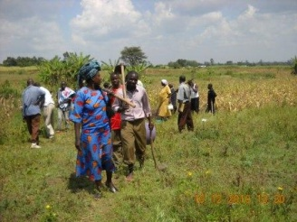
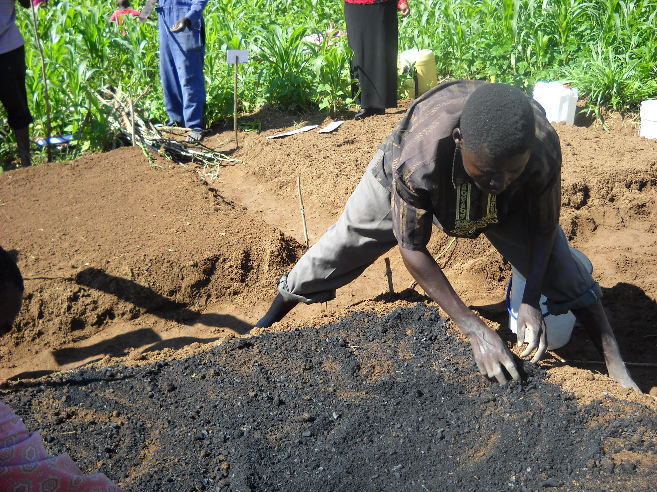
ACON has worked exclusively within communities in the Bungoma district for the past eleven years and this project is a broad expansion on the ideas, outreach, relationships, technology, and practices that have been tested and improved upon over the last six years. At this time, ACON has more than 750 farmers who have gone through the training and have biochar test plots in their fields and who are seeing results.
Adding biochar to soils during a training session; participants walk home from the fields after the session
Now, the project is ready to expand throughout the district to include more villages. ACON as a local organization is able to do all trainings onsite and specifically focus on representing all parties at trainings and meetings: farmers, women’s groups, community members and local government officials. This inclusive training atmosphere ensures that participants feel comfortable with the project and understand the technology and the desired results so they are able to replicate it in the future. Because trainings are done onsite and in the fields, they are set up to get things going immediately—preparing feedstocks, firing stoves, adding biochar and labeling fields are all done as a group activity. With villagers participating as a group, not only 2 – 3 people from a village are trained, the whole village is trained which makes future problem solving and collaboration an easier task.
The participants in this project will form a Biochar Kenya network hosted by ACON. The network members will carry out quarterly reviews, project site visits and group discussions on progress and impacts. The report will then be published and distributed among stakeholders as a quarterly bulleting or report managed by ACON staff to ensure that best practices, lessons learned, new innovations and ideas are shared among all the project participants. ACON has been working closely with the International Biochar Initiative (IBI) over time to help publicize their work, and IBI would be able to provide hosting assistance to the Biochar Kenya network.
Biochar improves over time in soils and does not need to be reapplied each year. This means that although the benefits will continue in soils, participants can also look at biochar as a financial gain to sell to other farmers. Biochar stoves will need to be replaced after a certain time but the benefits of the stove on indoor air emissions and decreased use of forest wood will continue.
The lasting benefits of this project are increased food and fuel security, lessened impacts on the forest, income creation and opportunity generation for households, and provision of a cleaner source of fuel (both for reduced CO₂ and black soot emissions and improved indoor air quality). The work increases food security through improved agricultural practices that can build up soils and reduce dependency on commercial fertilizers and irrigation, while fuel security increases through alternative feedstock options for heating and cooking, so rather than depleting forests, villagers can utilize waste feedstocks from agriculture and from Lake Victoria. All these programs tied together can help this region of Western Kenya become a hub for better organic farming practices and improved stove production.
Measuring Success and Impacts: Ensuring Favorable Environmental and Social Impacts
While Salim and his team at ACON have done some tests on soil moisture to measure biochar impact on water retention, conducted field trials to measure growth results with different biochar levels, performed stove testing (simple emissions monitoring and water boiling tests), and measured social acceptance, a large part of the project will be setting up more substantial and formal monitoring systems to measure results. Many of the environmental benefits can be measured precisely—some more easily than others—but ACON is ready to set up a tracking mechanism to more systematically record results of the project through:
- Reduced demand on the forest—measuring the amount of wood taken from the forest pre and post stove use
- Increased use of Water Hyacinth from Lake Victoria and the impact that reduction in the invasive plant has on overall ecosystem health
- Reduced in-field burning of agricultural waste and correspondingly, increased feedstocks available for cooking onsite
- Reduced CO₂ and black soot emissions from the stoves and the potential climate impacts of burying biochar in the soil
- Improved indoor air quality in households that were previously using the 3 stone fire method for cooking and heating
- Impact of biochar on soils—this would include any potential decrease in required irrigation, decrease in required fertilizer use, improved soil management practices, and crop response to the soil
- Increased demand for biochar stoves by households, villages, schools, and other institutions
- Increased financial security of stove producers and users, and the financial impact on the farmers with use of biochar—especially on women’s groups who are expected to be the major producers and users of the stoves
One important focus on the project monitoring will be biochar testing. Different biochars can have very different characteristics which will respond differently across soils and with crops. The IBI recommends performing specific pot and field trials before biochar is added to soils to ensure that the addition of biochar does not harm soils/crops. Farmers can perform simple tests to ensure that what they are putting into the soil improves plant performance and soil health, but need to be trained on how to conduct these tests. This testing will be an essential part of all the training and field trials.
As part of its current work, ACON is involved in project monitoring at the community level. To ensure that this project is implemented correctly—through technical stove production to correct biochar use in fields—ACON will appoint field officers to monitor the projects and record results. The field officers will work with community representatives to track data with pictorials on a sheet of paper indicating each homestead/institution’s target (as many community members are not literate). ACON has a long history in community relations and systems—through community gatherings to larger government meetings—and is looking to involve the international community as well through the project by working with the IBI to record progress and set the project as a model for other initiatives.
Funding Summary
To date, the project has been funded by National Geographic Society and the initiative of the local volunteers through small grants and work on the ground. After the manufacturing capability for local stoves was established in 2009, ACON began selling these models to raise money for more projects. Most of the current funding goes toward transporting the dried water hyacinth feedstock from Lake Victoria to project sites, food and materials for on-site trainings, travel to training and field sites, and materials for stoves. ACON has been generous with staff time to reach 5,000 local farmers on application and utilization of biochar and as many field sites and communities as possible, but is looking to expand its reach in the region.

Total Project Budget: $121,726 for 3 year implementation
Funding Services | Year 1 | Year 2 | Year 3 | Total US$
Amount Requested | 50,000 | 30,000 | 20,000 | 100,000
Community Contribution | 2,480 | 2,480 | 2,480 | 7,440
ACON Contribution | 4,762 | 4,762 | 4,762 | 14, 286
Total | 57,242 | 37,242 | 27,242 | 121,726
The total requested of $100,000 will be used as follows: $60,000 for advanced/increased Biochar stove production including fuel transport and testing, use and manufacture of new stoves—possibly using advanced TLUD stove models; the remaining $40,000 will go toward outreach and training to include travel, agricultural supplies, training workshops, meals and equipment for workshops, and outreach to local politicians.

Community Contribution
SOURCE OF CONTRIBUTION | TYPE OF CONTRIBUTION | PROJECTED US$
Volunteers | Unskilled labor | 1,440
Beneficiaries i.e. Institutions, | Local materials i.e. 15% urine solution, compost manure, char, biochar test plots for demonstration | 4,571
Women Groups | Extension services | 1,429
Totals |  | 7,440

ACON Contribution
 | SOURCE OF CONTRIBUTION | TYPE OF CONTRIBUTION | COMMITTED US$
1 | ACON staff | Labor | 8,571
2 | Administration costs | Facilities | 5,714
 | Total |  | 14,285

