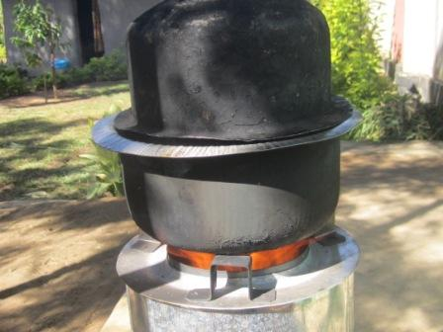The ACON sales team utilizes a traditional African form of savings and credit -- the Rotating Savings and Credit Association (ROSCA) – which is managed by local groups of women working together in loosely formed “Trust Groups” to purchase stoves. For example: a ROSCA could be 15 women who agree to meet weekly for 15 weeks to purchase one stove for one member of the group each week. Each woman would bring about 150 Kshs to each of the weekly meetings so that once a week, one woman receives a stove. The KEY ELEMENT that makes this form of savings and credit work is the TRUST the women have in each other as a form of SOCIAL CAPITAL available from the group.

ACON’s sales and distribution team has successfully implemented the ROSCA finance model, selling over 8,000 Moto stoves in less than two years. So far ACON has successfully trained thirteen artisans and tinsmiths in the construction of the Moto stoves. They currently have the capacity to manufacture 900 of these pyrolytic biochar-generating stoves per month. The Moto stove can save a family of peasant farmers around $300 per year in fuel expenses.
