
Food Crisis in Niger

CARE Seeks $5 Million from Private Donors

August 1, 2005

The Problem

In the best of years, survival in Niger is a difficult proposition. Some 80 percent of the landlocked nation’s 11.5 million people engage in subsistence farming or livestock-rearing, and must rely on the caprices of seasonal rainfall to produce the food and fodder on which their lives depend. But Niger lies in interior west Africa, across the dry Sahel zone and the arid Sahara, and boasts only a narrow strip of reliably cultivable land in the far south. Combining statistics on life expectancy, income and literacy, the United Nations ranks Niger the second-most unfavorable nation in terms of human development. In the best of years, according to the U.N., 40 percent of Nigerien children suffer chronic or acute malnutrition. About one in four will not survive until his or her fifth birthday.

Just a year ago, indicators pointed to a good agricultural season in the Sahel, but desert locusts – the worst infestation since the late 1980s – destroyed crops and the rains abruptly ended a few weeks early. Thus while some areas enjoyed comparatively good yields, many others saw no harvest at all. Up to 3.5 million people are suffering from the current food crisis.

Because most Nigeriens live in a state of chronic food insecurity, they have few alternatives to fall back on when crops fail. Having exhausted their food supplies and without enough cash to purchase grain on the market (as supplies dwindle, prices skyrocket), entire villages are foraging for wild plants and watching their most vulnerable members – particularly young children – grow weak and ill from hunger. A survey in spring of 2005 found that just over 60 percent of children showed signs of chronic malnutrition.

The 2005 crops of millet and sorghum are in the ground, and the rainy season is again underway. For farming households that had a poor harvest last year, the immediate problem is gaining access to enough food to nourish their children and to keep their adults healthy enough to work in the fields; for pastoralist families, food for both humans and animals is needed. If this year’s crops fail for lack of care, or livestock die for lack of fodder and forage, Niger’s crisis will catapult into calamity. The time to respond is now, and the need is urgent.

CARE’s Response

CARE is responding extensively to the food security crisis in Niger, and seeks $5 million from the American public to ensure that our urgent relief programs and livelihood rehabilitation work can meet the needs of as many people as possible.

Now and in the coming 18 months, CARE’s goal is to ensure the nutritional stability of approximately 850,000 people in 121,500 households in the hardest-hit districts of Tahoua, Maradi, Diffa, Zinder and Tillabéri regions. To meet that goal, we are concentrating our efforts in four arenas:

- Procurement: Where and as possible, we are purchasing bulk food (grain, pulses, oil) supplies in Niger and in the region for immediate distribution, to supplement commodities being shipped from more distant countries.
- Distribution: CARE will ensure professional, secure and rapid movement of up to 14,500 tons of food – procured locally or imported via the World Food Programme – from point of origin or receipt to interim warehousing to distribution sites and into the hands of vulnerable people. Similarly, we will provide animal fodder to pastoralist families at risk of losing their cattle or camels.
- Therapeutic Feeding: We are rapidly setting up systems to help communities detect and treat cases of moderate malnutrition in their own villages by creating “foyers nutritionnels,” or nutrition centers where children and lactating or pregnant women will receive supplementary food (typically fortified grains) and have their progress carefully tracked. Severe cases of malnutrition will be immediately referred for medical intervention.
- Livelihood Rehabilitation: It is essential that families in crisis do not lose their productive capacity by, for example, selling off their few remaining assets – the same assets, such as farm tools or land, that they will need to recover from this crisis. CARE is redoubling our regular programs’ efforts to protect vulnerable people’s assets and will build this into all our emergency activities.

In addition, given our long and in-depth experience in Niger (see below), CARE has been tasked by the Government of Niger and the U.N.’s World Food Programme to coordinate the international community’s emergency response activities throughout the country.

CARE in Niger

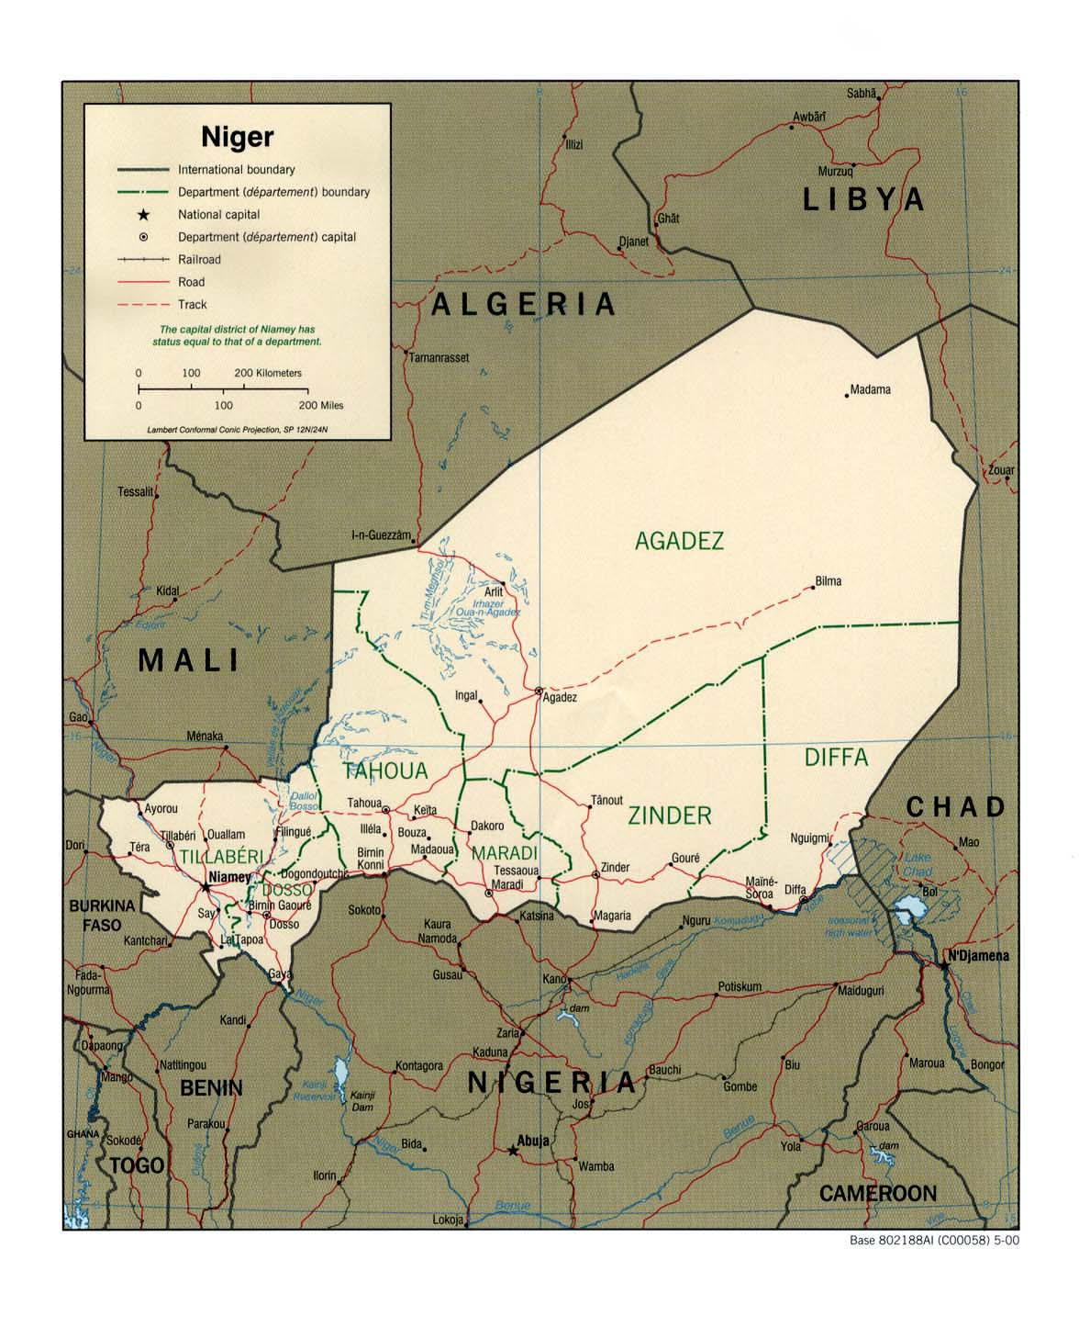
CARE has worked in Niger for 30 years. Beginning with emergency aid during the Sahel-wide drought in 1974, our work has evolved and we now engage communities in building their livelihood security and resilience to crisis; strengthening civil society; improving transparent governance and equity in access to public goods and services; bettering health; preventing HIV/AIDS and caring for those who are HIV-positive; and increasing income through small enterprise and our flagship Mata Masu Dubara women’s savings and credit groups program. CARE in Niger has solid experience in conflict resolution and community mobilization around water, food security and natural resources management. Our vision in Niger is to create a new spirit of development, working in partnership with families and communities. CARE currently manages more than a dozen development programs in all seven regions (Tillabéri, Dosso, Tahoua, Agadez, Maradi, Diffa and Zinder) of Niger and focuses on protecting households’ assets to increase their capacities to face shocks and food insecurity.

Thank You

Thank you for helping CARE meet our $5 million goal to support emergency response and livelihood recovery work with and on behalf of the people of Niger.

Data in this paragraph are from the UN’s Consolidated Flash Appeal of May 2005.
World Food Programme and Helen Keller International in Niger’s Maradi and Zinder regions.

