

Food Crisis in Niger:
A Report on CARE’s Emergency Response

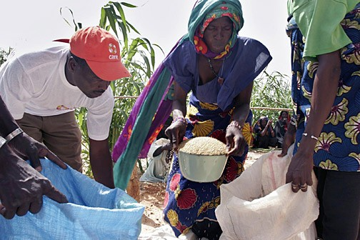

Since August 2005, CARE has distributed emergency food supplies to
almost 1.6 million people in Niger.

August 2005 – February 2006

Background

The 2004-2005 farming season was particularly harsh for agricultural communities in Niger due to significant rainfall shortages and a massive locust invasion. Hardest hit were the regions of Diffa, Maradi, Tahoua and Zinder (see map below), where food supplies for the season fell some 15 percent below consumer needs. While this shortfall might not seem significant in itself, the effects were staggering given that almost two-thirds of the largely rural population here lives in extreme poverty. This shortage had a dramatic impact on the food security of 2.68 million adults and children in over 4,000 communities.

Low agricultural production caused a rise in market prices for grains and produce, with a spike in prices in May 2005. The cost of animal feed, including bran and hay, significantly surpassed the average price of the last several years. At the same time, the value of people’s assets (primarily livestock) depreciated due to a lack of feed. Dry season gardening, which covers food needs from January to March, was hampered because lakes and rivers dried up earlier than normal. Where community food supplies existed, they were quickly depleted, forcing hungry farmers to sell off assets or seek loans simply to feed their families. As the prices of grain and feed rose, the food situation became extremely serious in hardest-hit areas.

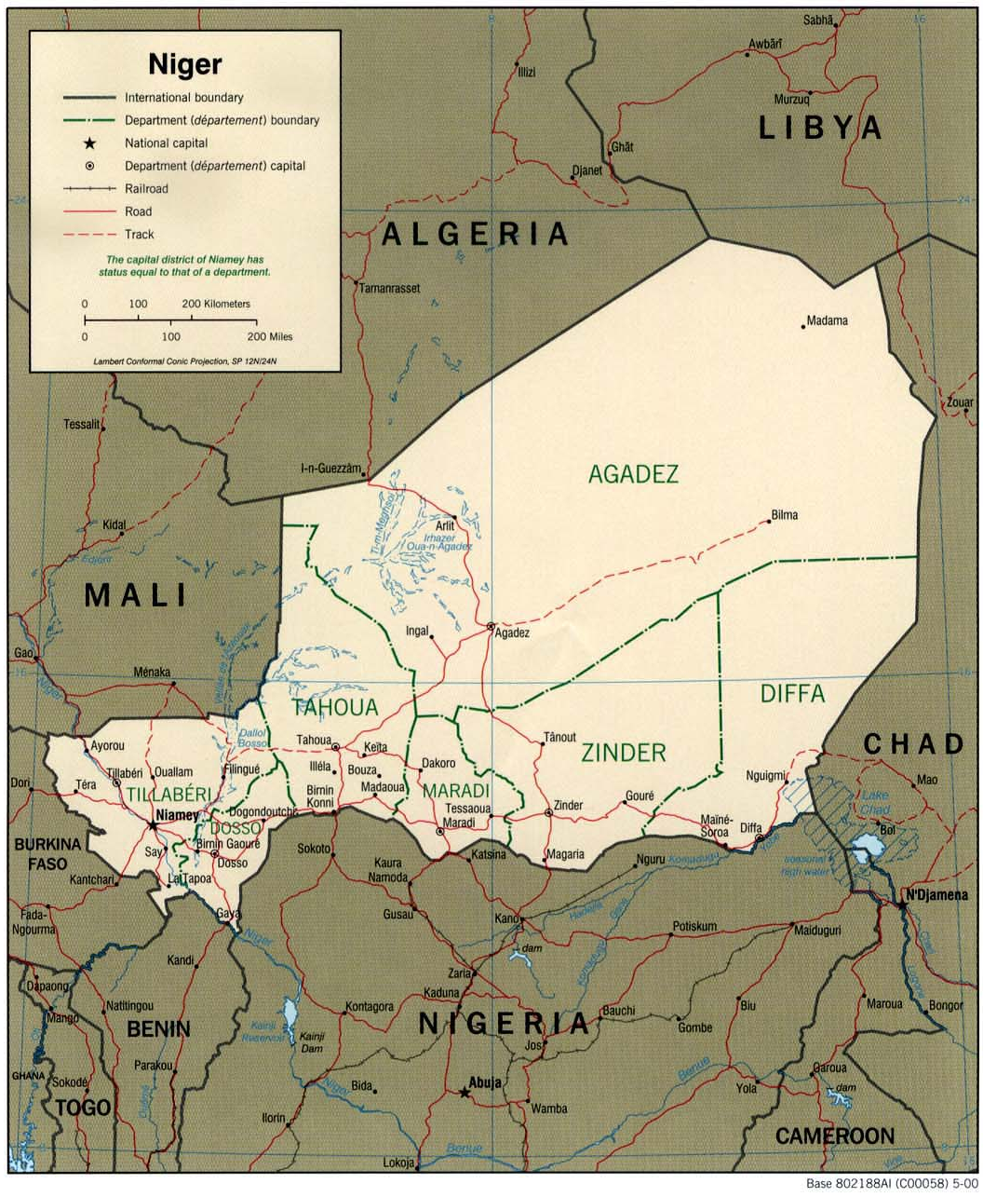
The 2004-2005 food crisis had serious and long-lasting negative consequences for vulnerable households. Because most Nigeriens live in a state of chronic food insecurity, they have few alternatives to fall back on when crops fail. Having exhausted their food supplies and without enough cash to purchase grain on the market, entire villages were foraging for wild plants and watching their most vulnerable members – particularly young children – grow weak and ill from hunger. A survey in spring 2005 found that over 60 percent of children showed signs of chronic malnutrition.

As the largest organization of its kind responding to the emergency in Niger, CARE has provided food aid to nearly 1.6 million people, helped thousands of moderately malnourished children recover, distributed animal fodder to prevent livestock deaths and redoubled our regular development programming to incorporate recovery and livelihood rehabilitation activities. To help families recover from the food crisis while also implementing long-term solutions to food insecurity, all of CARE’s development programs in Niger support the following objectives:

- Nutrition: Improve the nutritional status of malnourished children and promote positive changes in eating and sanitation behaviors;
- Agriculture: Help farming communities replenish their community cereal stocks and enable farmers to use profits from their harvests to support their families with essentials such as health care, housing, clothing and complementary foods; and
- Self-Sufficiency: Help families build their assets before the hungry season returns and food prices rise, through interventions such as animal husbandry, credit and savings groups, and food for work programs.

Thanks to contributions from generous donors like you, CARE’s Niger Food Crisis Fund provided important resources for life-saving emergency programs and longer-term rehabilitation efforts. This report provides an overview of CARE’s overall response to the food crisis during the August 2005 – February 2006 period.

CARE’s Response

In immediate response to the escalating food crisis, CARE headed a massive distribution of relief supplies and nutritional aid, detailed below, to help get affected communities back on their feet.

Food Distribution

During this phase of CARE’s response, from August – December 2005, we distributed 23,852 metric tons of food (grains, beans and oil) to 1,584,594 people in Diffa, Maradi, and Tahoua. To prepare for this significant effort, CARE trained local agents and warehouse managers on the specific tools and strategies needed to implement and monitor fair distributions. These included:

- Registering households to ensure that the most vulnerable families were targeted;
- Announcing distributions once commodities were physically delivered to regional warehouses. During the rainy season, roads are often impassable, causing delays in delivery and long, unnecessary, journeys to distribution centers for recipients;
- Matching food items to the needs and vulnerability levels of the recipients; and
- Monitoring and evaluating results in order to assess the actual level of need in the target villages and measure the impact of the distributions afterwards.

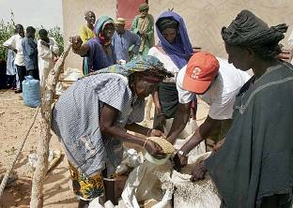
Our long-term presence in Niger and the geographic scope of our regular programs mean that CARE was in an ideal position to reach those in immediate need of aid. In close coordination with the United Nations’ World Food Programme (WFP) and the Nigerien government’s Food Coordination Cell (the two entities in charge of importing emergency food shipments into the country), CARE distributed emergency food items to roughly 226,370 households. According to government records, 14 percent of those households (31,691 families) were headed by women.
CARE distributed more than 23,000 tons of rice, beans and oil from August – December 2005.

Nutrition Monitoring

In September and December 2005, CARE conducted nutritional surveys of 991 households in Diffa, Maradi and Tahoua to monitor the impact of food distributions. The objectives of this survey were to:

- Evaluate the effectiveness of the distributions;
- Determine the potential impact of CARE’s projects on food security and the health of beneficiary households, and;
- Identify children suffering from malnutrition to ensure adequate health care.

Results of the survey showed an overall increase in the number of meals consumed, and an increase in the number of households eating at least two meals a day. The survey also noted an increase in the average number of cereal-based meals in Maradi and Tahoua, and a reduction in the frequency of diarrhea in all three regions. At the same time, however, the survey showed disturbing signs about the state of food security in the area. Most startling: severe malnutrition in Maradi more than doubled, from 3.2 percent to 6.9 percent in just three months.

Supplementary Feeding

If malnutrition is detected early enough, most children under 5 can regain weight and health without medical treatment; if let to slip into severe malnutrition, their care is much more complex and they risk permanent developmental impairment and even death. CARE is working directly with parents and community leaders to detect and reverse moderate malnutrition through supplementary feeding, and we work closely with government health services and Médecins Sans Frontières, to whose care severely malnourished children are immediately referred. In Diffa, Maradi and Tahoua, more than 25 percent of children are moderately malnourished; 7.5 percent suffer from severe malnutrition.

CARE is working to set up systems that help parents detect and treat cases of moderate malnutrition in their own villages by creating foyers nutritionnels. These nutritional support groups provide children and women who are pregnant or nursing with supplementary food (typically fortified grains).

To promote school attendance and ensure improved nutrition, CARE is helping form six community schools in the Diffa region and supplying them with 76 tons of food, as indicated in the table below:

Food | Quantity (tons)
Rice | 12
Sugar | 4
Milk | 6
Oil | 8.5
Yams | 37
Sardines | 6
Meat | 2.5
Total | 76

To facilitate the management of these distributions, CARE partnered with local organizations to assure proper implementation and monitoring.

Livelihood Development

It is essential that families in crisis do not lose their productive capacity by, for example, selling off their few remaining assets: farm tools, livestock, or even their crops in the ground – the same assets they will need to recover from this crisis.

In Diffa, CARE is implementing a cash-for-work program for 900 women and 500 men, where participants earn an income while improving their communities by building water systems, latrines and fire breaks to control bushfires. Training sessions are conducted by CARE staff, partner organizations, community leaders and women’s groups participating in CARE’s Mata Masu Dubara (MMD) project. Fifty-two team leaders were selected from the community to supervise the work and ensure proper payment.
As mentioned above, the selling and trading of livestock for food poses a great threat to the livelihoods of most agro-pastoralists in the area. In order to restore those lost assets, CARE will distribute more than 3,000 heads of cattle to 1,800 households. The main beneficiaries of this distribution include women’s groups of the Fulani, Toureg, and Haussa ethnic minorities, whose livelihoods depend on raising cattle. CARE is also distributing animal fodder to thousands of households, lest pastoral families lose their sole economic assets and be doubly compromised in their ability to recover from the crisis.

Emergency Planning and Preparedness


Villages in Maradi, Diffa, and Tahoua reported a deficit of up to 60 percent of their standard food supply during the worst of the food crisis. To help communities prepare for future shortfalls, CARE distributed 410 tons of food grains to be used as buffer stock in 107 villages in Tahoua. In Maradi, CARE will implement a similar buffer stock distribution, coupled with the creation of a cereal bank, where participants can “borrow” essential food items against what they have contributed.
In addition to food for rural communities, CARE also distributed animal feed to keep livestock alive.
Because underlying poverty was a contributing factor to the rapid deterioration of the hunger crisis in Niger, CARE is working with communities and local nongovernmental organizations (NGOs) to better identify and respond to key indicators of an emergency – in order to avert or alleviate crises before they happen.

In February 2006, CARE trained eight local NGOs in humanitarian program principles, the International Red Cross code of conduct and CARE administrative and financial procedures to ensure a seamless, unified approach to our collaborative response in Niger.

In March 2006, we will work with government partners and local NGOs to conduct a training and audit of the industry-standard SPHERE guidelines for emergency relief. And in April 2006, CARE will partner with a local NGO to establish and train community-based food crisis management committees to monitor food stocks, growing conditions and economic factors for signs of improvement or deterioration.

In support of the government of Niger’s efforts, CARE is working with government and U.N. agencies to share data in order to improve vulnerability monitoring and establish an early warning system at the local and regional levels. With confirmation of Niger’s first case of avian flu in the Magaria region in late February, such collaboration becomes even more critical. In an effort to combat avian flu, CARE is facilitating the spread of information among all concerned parties in Niger. CARE staff participate in national avian flu conferences and work with local prevention and management committees.

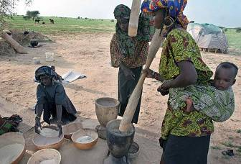
CARE is also monitoring how avian flu will affect already vulnerable households, where the loss of seven or eight chickens – valued at $3-$4 dollars per chicken – can have an extremely severe impact on families trying to survive on an average of less than $100 a year.
Niger's food crisis is far from over. CARE is working with partner organizations, government agencies and local communities to better prepare for future emergencies.

Looking Ahead

Only months after Niger’s food crisis came to the world’s attention last summer, the country faces yet another difficult year. As many as three in five families emerged from last year’s emergency with heavy debts and have had to sell much of their harvest to repay loans.

Food stocks are now running dangerously low in many parts of the country, and latest estimates indicate that 1 million people are currently short of food. This number will likely double: 2 million people, or one-fifth of Niger’s population, are expected to have run out of food by the time the next rains start in June. CARE continues to monitor the situation and to develop and adapt programming to meet local needs.

Conclusion

The work described in this report is funded by numerous governments, United Nations agencies, private foundations, corporations and individuals around the world – and by a great number of generous Americans who have supported CARE’s Niger Food Crisis Fund. On the behalf of the nearly 1.6 million vulnerable people you have helped us reach in Niger, we thank you for your support.

March 2006

The United Nations Human Development Index ranks Niger as the second poorest country in the world.
Though some increase in the price of grain is normal this time of year, the price of a100 kg bag of millet tripled by the beginning of July 2005.
World Food Programme.
In times of famine, many households are forced to forage food from their surroundings, leading to a diet of nutrition-poor roots and leaves; cereal-based meals offer a low-cost, nutrition-rich alternative.
Access to clean, potable water becomes even more crucial to children’s survival when they are malnourished or wracked by water-borne diseases.
MMD groups are basic savings and credit associations for women, where members mobilize their financial resources.
SPHERE is based on two core beliefs: (1) All possible steps must be taken to alleviate human suffering caused by calamity and conflict; and (2) Those affected by disaster have a right to life with dignity and therefore a right to assistance. Please see: www.sphereproject.org
Food insecurity continues to affect not only Niger but also other countries in sub-Saharan Africa, including those in the Horn of Africa and southern Africa. To allow us to mount a comprehensive response, CARE has created an Africa Food Crisis Fund with an $8 million fundraising goal to respond to these crises across Africa, including Niger.

