**DORMITORY CONSTRUCTION.**

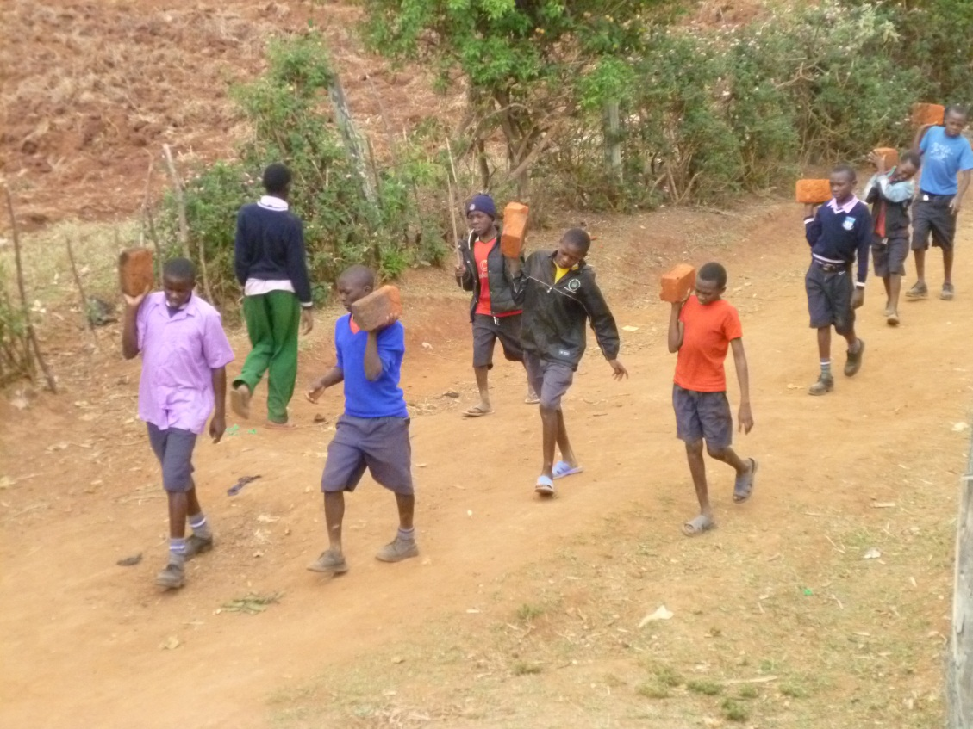

**Children help in carrying bricks**

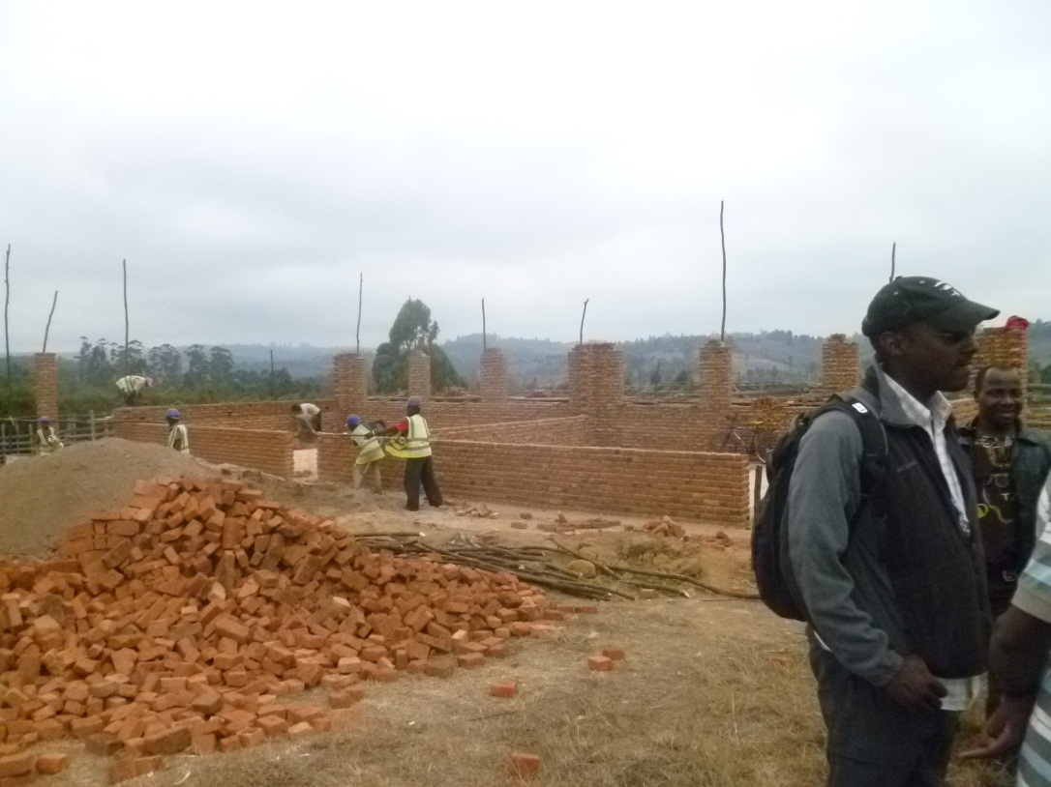

**Construction in process**

. 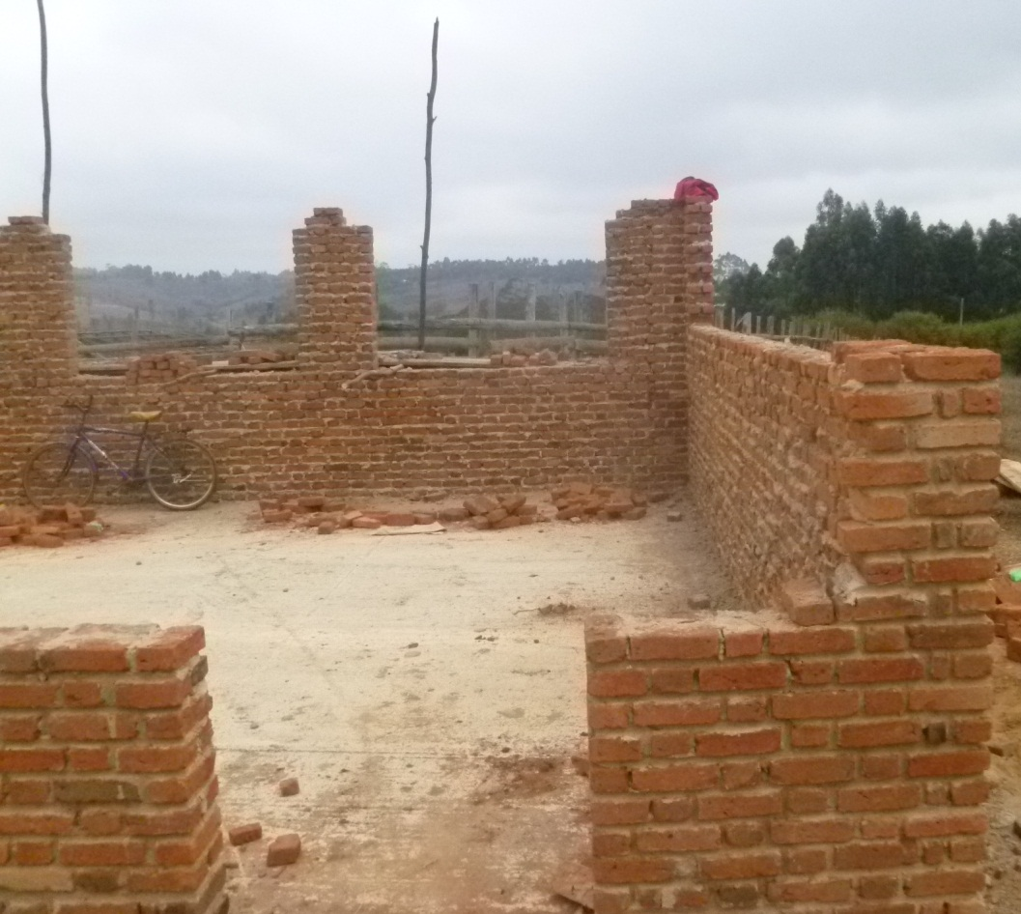

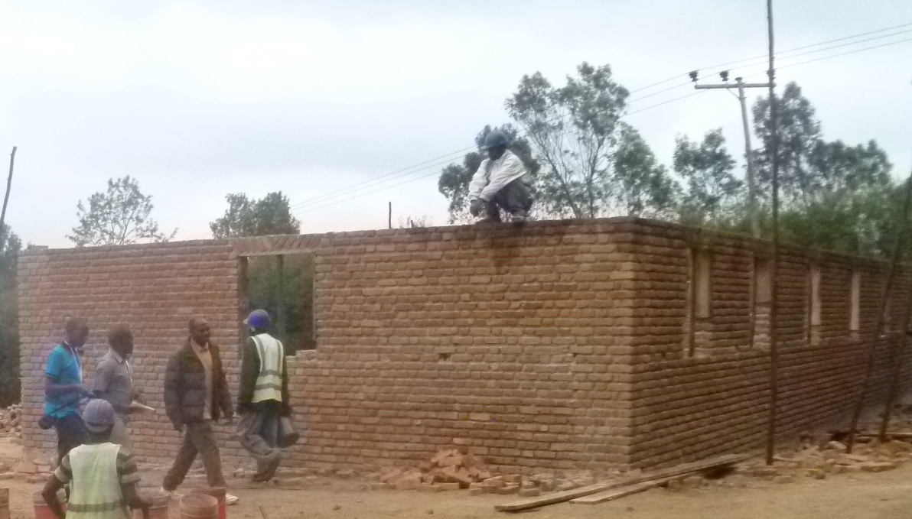

**Competed toilet site ready for roofing..**