Coral Restoration in the Dominican Republic
Reef Check Dominican Republic

Progress Report
Coral Nurseries Establishment
- Four coral nursery structures were built using metal wire mesh; concrete blocks were used as anchors. Metal frames were covered with resin to delay rust. Heavy-duty tie raps were used to secure frames to blocks. These nurseries were placed in sandy bottom areas in 30 feet of water depth at coordinates 18°26'18.96"N, 69°41'6.18"W. Fragments were transported wrapped in wet paper towels and inside coolers. Once frames were in place, collected coral fragments from the Punta Cana coral nursery were attached to the frames using tie-raps. Some fragments (A. palmatta) collected at Fronton beach, Samana, were secured to cement “cookies”, which were then secured to the frames using tie raps.
- Four metal frames coral nurseries were built and placed in Las Terrenas (NE DR) at coordinates 19°19'38.86"N and 69°30'51.05"W, as a duplicate for La Caleta MPA nursery. This coral nursery is an initiative financed by Balcones del Atlántico Hotel (Rock Resorts), which is supporting some of the marine conservation activities of Reef Check DR. The objective of this nursery is to share coral fragments between these two locations to distribute any risks and potential damages to either one.
- One rope coral nursery was built during the training workshop conducted in Punta Cana during April 2012. Due to storms during the 2012 and later availability of coral fragments from the Punta Cana nursery, this nursery will be placed in the water at La Caleta MPA during March 2013. It is estimated that this rope nursery can hold approximately 150 A. cervicornis fragments.
- Two PVC frames nursery for A. palmata were built during January 2013, and will be placed in the water in Las Terrenas during March 2013. It is estimated that these PVC nursery can hold approximately 75 A. palmata fragments each.
Coral Fragments Collection and Placement in Nurseries:
- Coral fragments of Acropora cervicornis were collected from the existing coral nursery in Punta Cana and placed in the coral nursery in La Caleta and some in Las Terrenas
- Coral “opportunity” (already broken and still not attached to the bottom) fragments of Acropora palmata were collected from Frontón beach and placed in the coral nurseries in la caleta and Las Terrenas
Initial Data Collection
- Initial count data has been collected from the Las Terrenas nursery on A. cervicornis fragments that came from Punta Cana with a stop over in La Caleta for a few days and A. palmatta fragments that came from Fronton Beach Reef (SW Samana). Regular predator and algae removal has been conducted.
- Initial growth data has been collected from the La Caleta nursery on 108 A. cervicornis fragments that came from Punta Cana and 4 A. palmatta fragments that came from Fronton Beach Reef (SW Samana) with a stop over in Las Terrenas for a few days. Regular predator and algae removal has been conducted.
Follow up Data Collection and Analysis
Follow up growth data has been collected from the La Caleta nursery on 81 surviving A. cervicornis fragments that came from Punta Cana and placed on 4 nursery frames, on January 17, July 18, 2012, and January 16, 2013. Summary data can be found on the following tables:

Summary Linear Length Growth Acropora cervicornis
Site: | La Caleta Marine Park
Frame: | 964
Tag | 1/17/12 | 7/18/12 | 1/16/13
892 | 22 | 59 | 80
933 | 32 | 34 | 32
893 | 15 | 23.5 | 21
932 | 20 | 19 | 22
931 | 15 | 27 | 36
814 | 17 | 15.5
930 | 11 | 24
929 | 14 | 25 | 32
802 | 14 | 52 | 9
926 | 21 | 34 | 38
928 | 17 | 30
927 | 18 | 19
925 | 26 | 10
897 | 44 | 58 | 33
1000 | 11 | 76 | 40
924 | 29 | 96 | 35
923 | 11 | 32 | 40
900 | 12 | 21.5 | 25
921 | 10 | 36
919 | 12 | 18.5 | 18
918 | 20 | 27 | 28
917 | 15 | 23 | 9
916 | 22 | 41
922 | 13 | 42
914 | 21 | 39 | 22
899 | 12 | 15 | 4
895 | 19 | 24 | 20

Summary Linear Length Growth Acropora cervicornis
Site: | La Caleta Marine Park
Frame: | 965
Tag | 1/17/12 | 7/18/12 | 1/16/13
988 | 52 | 110
915 | 44 | 28
885 | 15 | 66
913 | 55 | 35 | 11
912 | 20 | 43
884 | 37
883 | 26 | 36
911 | 30 | 41 | 15.5
909 | 17 | 32 | 48.5
910 | 14 | 40 | 46
908 | 22 | 49 | 70
907 | 33 | 49 | 52
906 | 32 | 34 | 38
870 | 20 | 52 | 76.5
905 | 24 | 46 | 32
904 | 11 | 55 | 45
871 | 31 | 52 | 40
873 | 25 | 52 | 78
872 | 15
903 | 17 | 23
902 | 16 | 140 | 168
901 | 11 | 33

Summary Linear Length Growth Acropora cervicornis
Site: | La Caleta Marine Park
Frame: | 966
Tag | 1/17/12 | 7/18/12 | 1/16/13
718 | 13 | 27.5 | 29.5
876 | 10 | 19 | 23.5
716 | 11 | 10 | 11
717 | 15 | 10 | 85
879 | 17 | 21.5 | 27
883 | 11 | 21 | 28
724 | 14 | 12 | 12
723 | 13 | 18 | 16.5
882 | 9 | 18 | 25
722 | 20 | 23 | 30
721 | 8 | 17 | 6
720 | 31 | 23 | 45
719 | 23 | 12 | 11.5
881 | 10 | 53 | 52.5
804 | 14 | 31 | 56
878 | 23 | 43 | 37
712 | 17 | 20 | 27
711 | 37 | 28 | 46
713 | 15 | 6.5 | 11
714 | 9 | 13.5 | 23
877 | 19 | 31.5 | 28
715 | 10 | 24 | 53.5

Summary Linear Length Growth Acropora cervicornis
Site: | La Caleta Marine Park
Frame: | 967
Tag | 1/17/12 | 7/18/12 | 1/16/13
701 | 14 | 31 | 16.5
702 | 15 | 14.5 | 21
703 | 9 | 16 | 28
704 |  | 13.5 | 21
705 |  | 39 | 19
706 |  | 28 | 6
707 |  | 39.5 | 9
708 |  | 24.5 | 25
709 |  | 16 | 22
710 |  | 5.5 | 23

Images (Higher resolution images provided upon request)

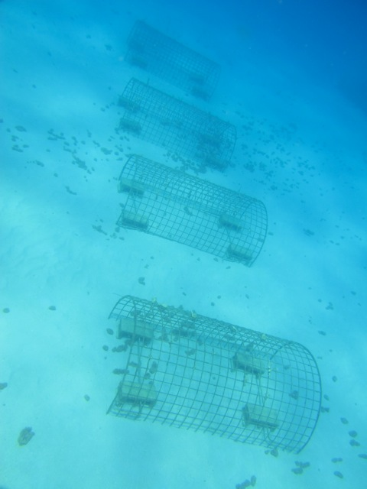 | 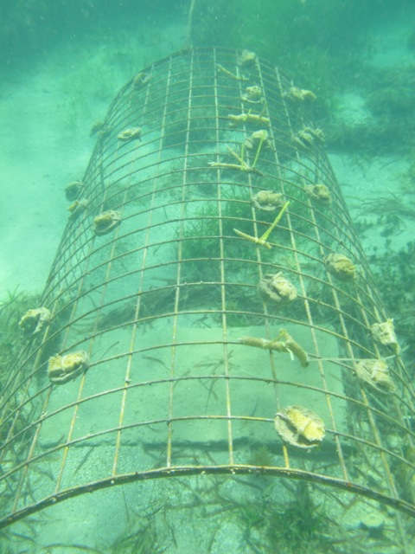
Metal frame coral nurseries in La Caleta Marine Protected Area | Metal frame coral nurseries in Las Terrenas (a single picture with all frames is not possible due to low depth)

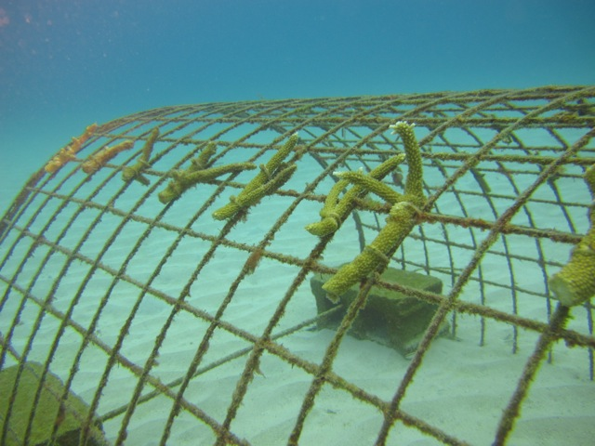 | 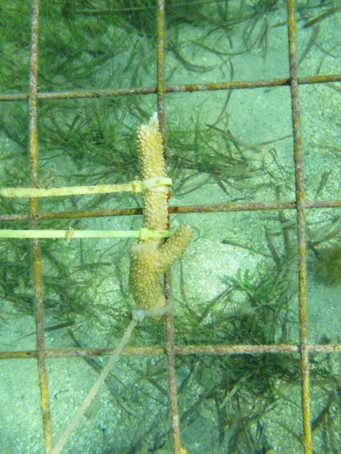
Acropora cervicornis fragments on La Caleta MPA coral nursery | Acropora cervicornis fragments on Las Terrenas coral nursery

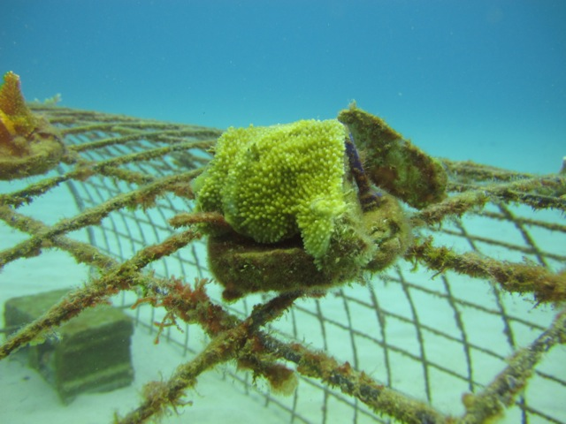 | 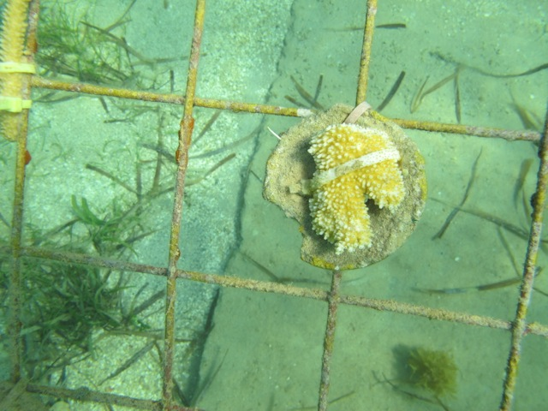
Acropora palmatta fragment on La Caleta MPA coral nursery | Acropora palmatta fragment on Las Terrenas coral nursery

Before and After comparison sample images of coral fragments grown in La Caleta MPA nurseries.

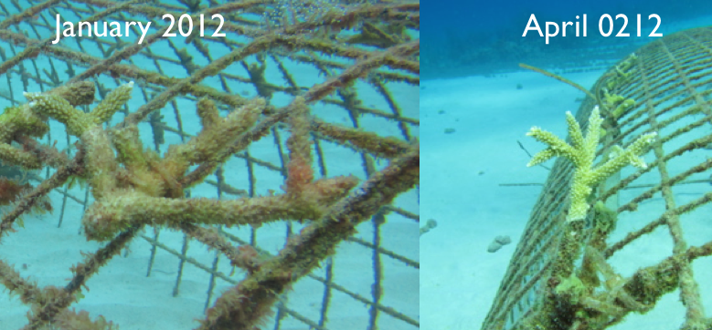

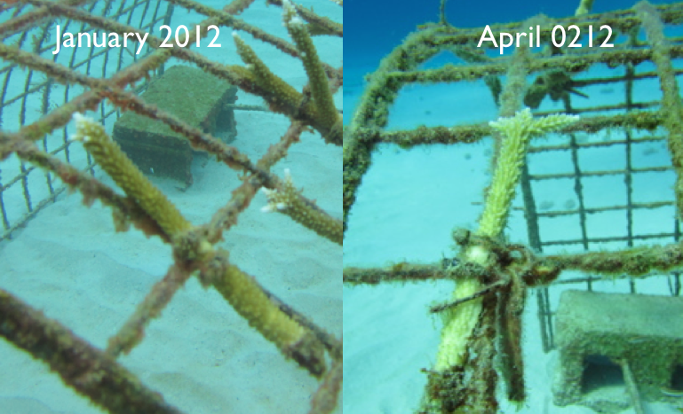

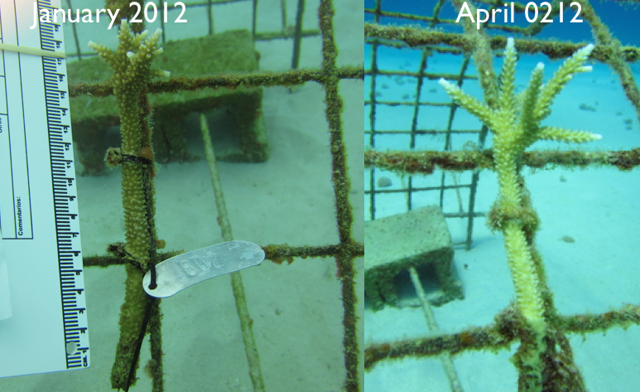

Before and After comparison sample images of coral fragments grown in Las Terrenas nurseries.

