Program History and Purpose
The Foundation for Community Development and Empowerment (FCDE) was founded to support and enhance efforts of indigenous grass roots organizations (GRO) who work to improve the welfare of their own communities. FCDE partners with these organizations to address the root causes of social inequity, poverty, hunger and poor health in their communities. FCDE provides these GROs with access to human resources, technical assistance and seed funds so that the each GRO can determine and act on the best approach to achieve success in their vital work.

FCDE’s Board and staff are comprised of individuals who have initiated, lead and supported grassroots community development organizations (http://internationalcommunitydevelopment.org/about/message-from-the-founder). Our organization understands that the challenges of Community Driven Development (CDD) are complex and multi faceted. Our approach and program teams have been put together to ensure that personal commitment and passion for development are combined with significant field experience and academic rigor.

Organizational Approach
FCDE collaborates with multiple established (CBOs) to increase their institutional capacity and efficacy in a wide range of programmatic and operational functions. FCDE utilizes the embedded knowledge, established institutions and best practice of professionals and community members in a region. By increasing the efficacy, sustainability and impact of its partner CBOs, decisions related to a community’s development remain in local hands and communities develop in a more even sustainable manner. By utilizing peer-based models for skills transfer, hiring personnel with significant local experience and investing in our target communities FCDE promotes sustainable community development and ensures that local voices direct development. FCDE realizes that communities need resources beyond their reach and development organizations, in turn, need the embedded knowledge and networks that communities can mobilize. Our partnerships reflect this reciprocity and trust.

FCDE collaborates with CBOs who work within our seven targeted program areas: education, women’s empowerment, health, small business development, HIV and AIDS, environment, and social justice.

Goals and Objectives:
FCDE’s program goals focus primarily on building capacity, increasing efficacy and enhancing the sustainability of CBOs within a community. In order to achieve these broad goals, FCDE has identified multiple objectives that are key indicators of an organization’s progress toward these goals. Increasing management skills, enhancing program design, business planning, developing grant writing capacity and integrating efficient fiscal controls all play a role in achieving FCDE’s goals. Table 1 provides a detailed summary of the specific goals, objectives and expected outcomes of the proposed project.
Table 1: Summary of Goals, Objectives and Expected Outcomes
Program Goals | Objectives/Expected Outcomes | Measurement or Evaluation
FCDE partner organizations will increase their ability to plan and provide quality services to the communities in which they work (capacity building). | - 75% of partner organizations will attend three or more FCDE provided capacity building workshops within 18 months of partnership.  - 80% of partners will host two or more interns within 24 months of partnership.  - 90% of partners will have five or more meetings with FCDE host-country national staff within 18 months of partnership.  - 100 % of partner organizations will complete an internal self-assessment identifying the areas that they want to increase capacity or improve upon. | - Sign-in sheets from meetings  - Intern placement logs  - FCDE staff reporting logs  - Review of partner files kept by FCDE
FCDE partner organizations will increase the number of people that they serve, services they offer and improve outcomes for program activities (efficacy/organizational growth). | - 35% of partner organizations will increase the number of clients served by 10% or more within 24 months of initial partnership with FCDE.  - 25% of partners will expand the services they offer within 30 months of initial partnership.  - 30% of partner organizations will improve outcomes among their clients within 30 months of partnership. | - Audit of partner records  - Audit of partner records  - Pre and post assessment of partner records
FCDE partner organizations will increase their ability to meet the long-term financial and organizational challenges (sustainability). | - 40% of partners will develop budgets before the start of their fiscal years.  - 65% of partner organizations will develop a business plan or strategic planning document within 24 months of partnership with FCDE.  - 35% of partner organizations will write grants to other organizations within 24 months of initial partnership with FCDE.  - 80% of FCDE partner organizations will still be providing services three years after their initial partnership. | - Audit of partner records  - Audit of partner records  - Audit of partner records  - Audit of partner records

Methodology
FCDE’s works with its partner organizations to better understand their organizational needs and initiate the process of capacity building. The FCDE site team uses approaches that involve institutional self-assessments, meetings with staff and clients and direct observation in a process that allows each CBO to identify where FCDE could best provide support.
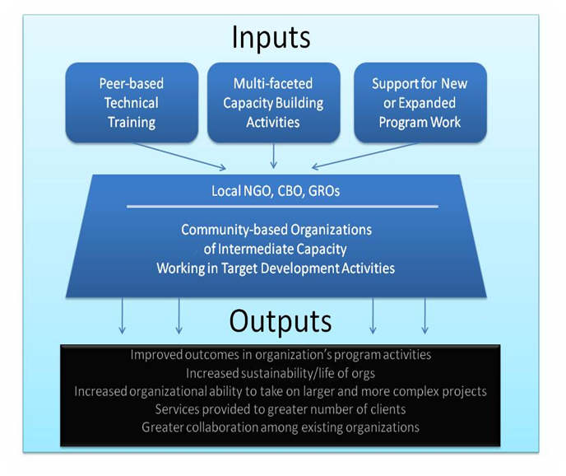
Once priorities are established the site team initiates a series of activities addressing the self-identified needs of the partner organizations. Specific work plans differ depending on needs, but are built around a core of workshops, preparation for the support and integration of interns and regularly scheduled meetings with key personnel. The site team also identifies external resources, such as short term contractors or program related materials that need to be integrated throughout our capacity building process. The employment of local Ugandans to make up the FCDE site team enables a peer-based approach to capacity building activities which we have found to be more effective in transferring skills sets, identifying obstacles and working towards sustainability.

Through these processes we facilitate project expansion, programmatic efficacy and help initiate new activities. FCDE provides multi-faceted support to ensure a higher likelihood of project success. FCDE uses interns, seed funds (grants) and site team support to work with the CBOs in pursuit of their objectives.
The longer term objectives of FCDE’s development approach are achieved as each organization develops the capacity to develop business plans, write grants, integrate program design and management skills, and implement sound financial tools. all work to enhance the long term financial viability, sustainability and impact of partner organizations.
Chart2: Methodology Flow Chart

Monitoring and Evaluation
Monitoring and evaluation (M & E) is a key component to ensuring that our organization is having the desired impact on the organizations we partner with and most importantly the end beneficiaries. Underlying FCDE’s monitoring and evaluation approach is the intent to create systems that are culturally and technologically appropriate for the areas in which we work, are empirical and evaluative in nature and that include both program evaluation and outcome evaluation. We also assess whether our partner organizations' capacity to meet those needs have increased as relevant to their goals and outcomes.
Indicators are determined by applicable measurement approaches coupled with FCDE’s organizational objectives. Indicators are based on the SMART (Specific, Measurable, Achievable, Realistic and Time-bound) concept. As information and data is gathered, it is reviewed against indicators with feedback being provided to appropriate personnel. Annual evaluation of data is done to determine progress towards objectives and to assess whether larger change to our methodology is warranted. The results will be used also to enhance resource allocation by facilitating prioritization of various activities to achieve organizational goals.
That being said, there are two primary foci for FCDE’s M&E approach. We will be assessing the change in organizational capacity of our partner organizations and working with these partners to develop the most appropriate areas and measures to assess impact on their beneficiaries.
FCDE looks at five sets of indicators related to organizational capacity. These include; an organizations ability to identify and obtain funding; the existence and use of internal organizational structures (like by-laws and personnel manuals); the use of financial management systems and whether an organization networks and creates partnerships that further their organizational objectives. These indicators have been developed to give insight to the overall capacity change of an organization and because of our ability to have a measure that can be easily verified (audited budgets, existence of organizational materials, signed MOUs, etc.) and is common to all of our partners.
The next level of assessments (out to the level of the beneficiary) is developed in conjunction with each of our partner organizations. The work with these organizations is two-fold. We identify and work with them to establish M&E regimes that helps each organization gather information that allows for their continuous improvement. We will also work to determine commonalities in their beneficiaries that could be measured to assess broad-based impact on community development.
Request
FCDE is asking for $10,000 to provide support for our Kasese Uganda program. We have worked diligently and successfully to establish support for this program and need the requested funds to ensure the success of the program in Kasese. The resources we have already received commitment for can be broken into financial, organizational and in-kind support.

Financial support comes from a three-year, $60,000 per year grant and funds raised by FCDE’s US-offices. In addition to providing support for staff, program and operations in Uganda, these funds cover all the US-based expenses of the organization allowing 100% of potential Global Giving funds to be used in Uganda for local program support and work.

FCDE’s organizational resources consist of a highly trained, educated and capable staff in addition to physical resources such as our business offices and resource center. Our Ugandan staff (http://internationalcommunitydevelopment.org/about/staff) has extensive academic backgrounds and experience carrying out capacity building projects. With backgrounds in education and gender in development, our staff’s personal interests and experience are well-aligned with achieving our community development goals. Our US staff has over 35 years experience in non-profit management, fund development and program design.

FCDE’s in-kind support consists of internship placements with partner organizations, partner organizations access to the FCDE grant fund and support for our partner organization’s own fund development initiatives.

FCDE is a 501 (c)(3) organization which can be verified through Guidestar or other similar organizations.

For more information about the work of FCDE, you may visit our website at: www.internationalcommunitydevelopment.org

We really appreciate your time and consideration given to this request.
FCDE Staff and Supporters

